/' Thin Film Interference
/·

Thin film interference occurs when the light waves reflected by the two sides of the film add together:

sin(ωt + π) + sin{ω(t-2d/(c/n))} where ω = 2πc/λ
n= 4/3
C = 3 X 10⁸ m/s

Using the Trigonometric identity,

sin A+ sin B = 2sin (½(A + B))cos(½(A - B))

and setting A = ωt + π and B = ω(t-2d(c/n)) = ωt - 2ωd(c/n)

we get,

d

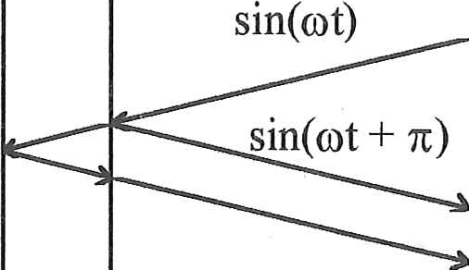
sin{ω(t - 2d/(c/n))} where n = index of refraction

total wave= 2cos{½(π + 2ωd/(c/n))}sin(function of time)

hence, the amplitude of the total wave is found. The intensity of the reflected light is proportional to the square of the amplitude:

Intensity is proportional to [cos{½(π + 2ωd/(c/n))}]² = [cos{( π/2 + 8πd/3λ)}]²

A program could be written which accepts the thickness of the film as input and then plots this intensity for wavelengths from 380 nm to 720 nm.

Then one could also multiply this intensity by the curves describing the sensitivity of the Blue, Green and Red cones. This can then be integrated and scaled giving the percentage of the cones stimulated for each kind of cone. These percentages can then be used to estimate the color of the film for the given thickness.

