About the A bomb Mike DeMarco Buffalo State College Physics Department Fall 2018
Some Reference Books:
- The Making of the Atomic Bomb— Richard Rhodes Pulitzer Prize
- Robert Serber--- Los Alamos Primer –Technical notes delivered at the actual time at Los Alamos
- Simple calculation of the critical mass for highly enriched uranium and plutonium-239 Christopher F. Chyba and Caroline R. Milne, American Journal of Physics 82, 977 (2014)

Talk
- Discovery of fission
- Energy of fission
- Cross Sections for Fission
- Critical mass For Fission
- Methods for Explosion of Bombs and their Destructiveness

- Discovery of fission --- Strassman and Hahn 1939 --- Lise Meitner and Otto Frisch 200 MeV comes from fission
What is an eV? 1 eV = 1.6 x 10⁻¹⁹ Joules ---small energy --- Joule = N x m = ?

2.2 lbs. = 10N so, 0.22lbs = 1 N ----- 1 N x m = 0.22 lbs x 3 ft = 0 .6 ft -lbs.

So you can lift a 0.6 lb weight 1 foot with 1 joule of energy or work
So, 10⁻¹⁹ J is very small
eVs are also the energy of electrons in atoms ----for instance the electron in Hydrogen is attached to the proton by -13.6 eV in the ground state ------ to ionize an electron in a hydrogen atom takes this much energy

- Classical description for energy derived from fission of Uranium ------ ²³⁵U + ¹n = X +Y + 2 ¹n
PE for two nuclei close together gets changed into Kinetic energy
PE =k q₁q₂ / r so 9 x 10⁹ x 46 x 46 x e x e /1.5 x 10⁻¹⁴ , e = -1.6 x 10⁻¹⁹C
5.4 x 10⁻¹¹ X 10⁺¹⁹ J x eV /(1.5 x 1.6 J ) = 200 MeV

This is assuming the ²³⁶U splits into two 46 proton nuclei and the spacing between nuclei is 15 F(1F = 10⁻¹⁵m) by using R = 1.1 A ^{1/3} = 1.1 x (236) ^{1/3}
R = 6.7 F, two radii distance apart is about 15 F
Each time a ²³⁶U nucleus splits it lets lose 200 MeV

Or another way of thinking using the Binding Energy curve per nucleon

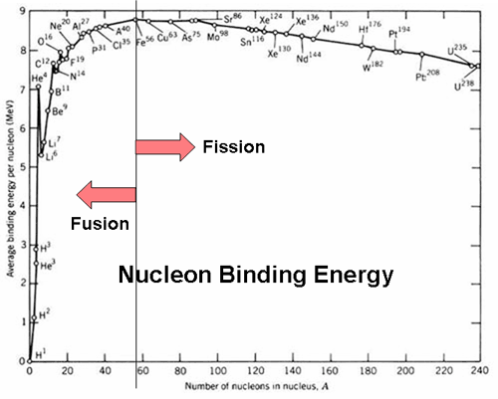

The relativistic explanation (which is unnecessary) is shown below where mass is changed into energy by E = mc²

²³⁵U + n = ²³⁶U* = ⁹³Rb + ¹⁴¹Cs + 2 n +E
typical fission

235.043925 = 92.92172 + 140.91949 + 1.008665 + E

E = .0194 u = 0.194 u x 931.5 MeV/u = 181 MeV

So, you can see that from the curve that the change in binding energy per nucleon is about
1 MeV from iron to Uranium so the energy difference is 200 x1Mev or about 200 MeV.
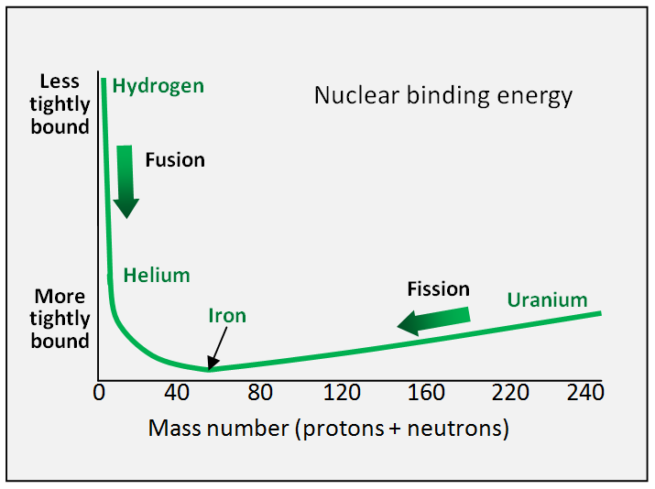

The above graph answers the question of why fusion/fission can occur. If a there is possible lower stable energy state in nature, then any system will eventually go to that state. So, Uranium forming two other nuclei will release energy and the two nuclei will be at a lower energy and more stable.

- Cross sections for Fission ²³⁵U ,²³⁸U and ²³⁹Pu
A British scientist explained cross sections as the process of throwing a ball at a window. It has a 9/10 chance to bounce off the window and 1/10 chance to break into the window This is like a neutron hitting a nucleus. If it goes into or through the window it can get into the nucleus and disrupt or rearrange what is inside the nucleus. Most of the time it bounces off the window.

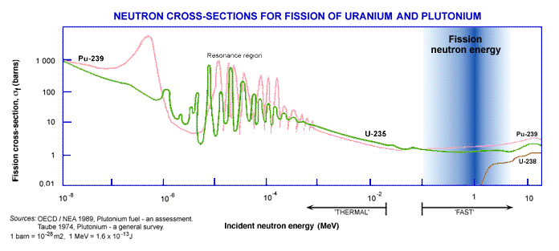
So, you can see that if the neutron energy is less than 1 MeV ²³⁸U will not fission. The cross section or probability for a hit is tiny (less than .01) at 10⁻³ MeV whereas for ²³⁵U ----it is about 5 barns which is considerably higher. Now for a fast neutron, say 1 MeV the cross section for ²³⁵U is 1.3 barns whereas for ²³⁸U it is 0.75 barns. For ²³⁹Pu the cross section is 3.0 barns ----larger than ²³⁵U for a fast neutron.
The median energy is 0.75 MeV for neutrons released in fission. This is less than 1 MeV necessary to produce fission in 238. Also, in a Uranium the energy of the neutrons will be lowered by making collisions with the U whether it be 235 or 238 as they move outward from the center of a sphere and this will further exclude 238 from the fission process. 238 will not make a bomb because it will not be able sustain a chain reaction. In the cases of 235 and 239 the cross sections are high enough to sustain a chain reaction for the neutrons as they progress through the 235 or 239. Another device aiding the fission process is a tamper. It could be some dense material such as U or Tungsten which surrounds the bomb material and reflects neutrons back into the U or Pu.
Cross sections –There are cross sections for capture that do not produce fission. 235 can capture a neutron and become 236 likewise 238 can capture a neutron and become 239. In both cases these produce other products. At lower energies 238 captures neutrons and takes them out of the process of fission. This is not good if you are trying to produce a bomb or make a nuclear reactor.

- Critical mass for a sphere --- Neutrons are growing in number and many are escaping from the sphere of U ------if the mass of the U 235 is large enough the number of neutrons will keep increasing and each neutron will produce more fissions -----and the energy released will be large because each neutron is finding a nucleus to fission
(In a reactor to create a chain reaction each fission must create another fission to sustain what is called a controlled chain reaction – each fission must produce a neutron that causes another fission---- this will cause production of energy in a controlled way and is the basis for producing energy for electricity in many countries)
But in a bomb the growth of neutrons is exponential in time N(t) = N₁ e^{tv’ /T} where N is the number of neutrons, V = number of neutrons in every fission which is about 2.5, V’ is the effective number of neutrons, t = time, and T is the critical time constant for the explosion to proceed—it is about 10⁻³s, D is the diffusion constant – this equation results from the diffusion equation for neutrons in a sphere of ²³⁵U

V’ = ( V-1) - π² D T / R ² the turning point of N(t) = N₁ e^{tv’ /T} is when V’ =0
You can see this from the exponential –if V’ is less than zero than the effective number of neutrons will be less than 0 ---the number of fissions will slow down and the reaction will stop with very little energy being released---if V’ is greater than zero than the exponential will be positive and therefore the number of neutrons will be created in great abundance ---many fissions can be created and a great amount of energy can be produced in a short period of time so V’ =0 determines the critical radius
Serber’s book explains this above result and gives some numbers --- density = 19 g/cm³, R = 9cm, mass = 50kg
The critical mass diameter is R = 9 cm, R < 9 cm neutrons leak out and don’t create a chain reaction, R> 9cm creates enough neutrons to sustain a chain reaction--- more than one neutron is producing another fission ----the number of fissions increase exponentially in a short time and even if it uses say 1 kg of mass in the T ( time constant) the energy released will be enormous
Energy released in a time T = (1 / 236) x 6x x 10²⁶ fissions = 2.5 x 10²⁴ x 200 MeV = 5x 10 ²⁶ MeV = 5 x 10¹³ J = 3x 10¹³ ft-lbs and 1 kiloton = 4.2x 10¹² J
Compare explosiveness of TNT to A Bomb --- 2 kg of 235 would provide 20,000 tons of TNT explosive---- typical bombs in WWII were 500 or 0.25 ton with a maximum total capacity of 5 tons TNT per airplane------ 1 kiloton = 4.2x 10¹² J so 1 kg of 235 produces about 10 kilotons TNT ----- for 2 kg we get 20,000 tons equivalent of TNT ----at Hiroshima this equaled the payload of 4000 B -29 planes carrying maximum payload all dropped at the same time!

- Methods for Explosion of Bombs and their Destructiveness

- Gun type set up for ²³⁵U
The U 235 projectile had to shot into the other piece of U 235 in short amount of time so that the bomb would have the critical mass during a short time interval (10⁻³ s). The mass of the U used was on the order of 70 kg enriched to about 80% 235. There is an initiator of neutrons placed at the center.
- Implosion device for ²³⁹Pu
In the Pu device the density of the Pu was increased enough by the implosion (volume diminished) so that the critical mass and radius necessary was smaller and made the Pu core fission. The mass for Pu was considerably smaller about 10 kg and Pu was much easier to produce than U 235.There is an initiator of neutrons placed at the center.

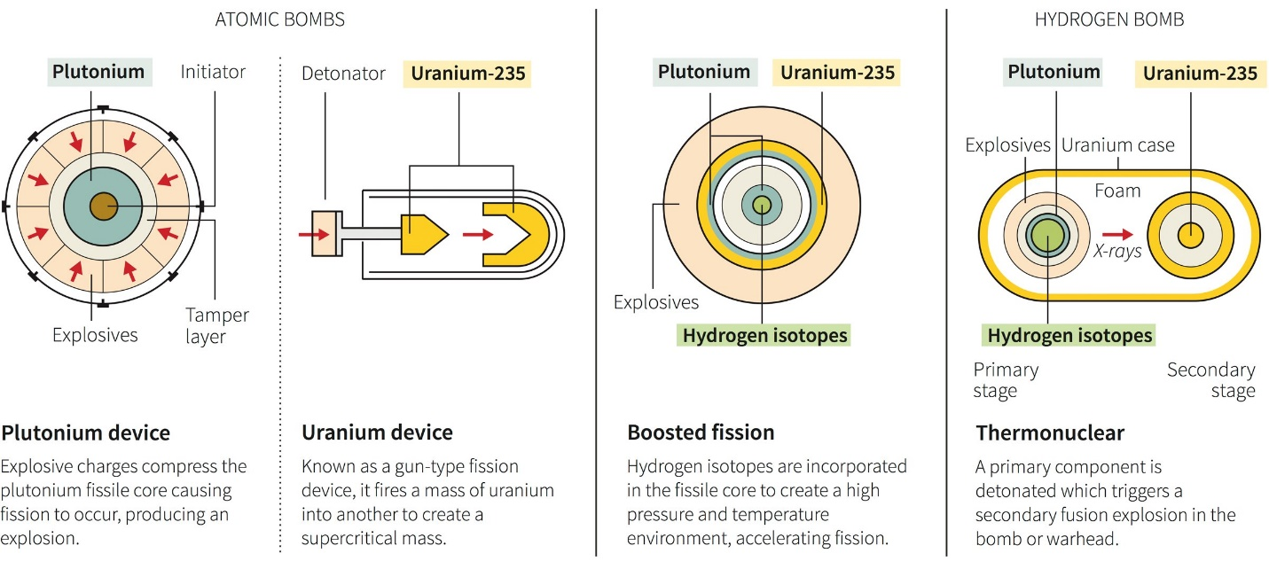

20 kiloton A Bomb Destructive Capability
The direct blast damage from a nuclear explosion can be considered as a rapidly expanding spherical wave front carrying a sudden increase and a following decrease in air pressure. The increase is of the order of 1 Atmosphere at 1km which is enough to destroy most brick buildings. At 2 km the change would be 0.25 Atmospheres which is enough to destroy wood buildings and to send debris flying at 100mph. The heat radiation wave(fireball) at 2 km (which arrives 2s after the explosion) is still hot enough to produce 3rd degree burns on exposed skin and ignite wood and other flammable materials. An indirect effect (non-nuclear) is a fire storm which sucks all the oxygen out of the air. Neutrons and gamma rays will be produced and at 2km these are lethal. Smaller doses of radiation can have long term effects such as cancer, leukemia and genetic effects. The atmosphere may be poisoned by the radioactive fallout from ⁹⁰Sr and ¹³⁷Cs. In both Hiroshima and Nagasaki over 100,000 people were killed.

