Learning Trajectories: Fostering Learning of Introductory Physics via Student Interactions

Dan MacIsaac, Ph.D.
SUNY- Buffalo State College Dept of Physics, <macisadl@buffalostate.edu>
Kathleen Falconer, M.S.
SUNY- Buffalo State College Depts of Physics and Mathematics, <falconka@buffalostate.edu>

This talk will be available on or before Monday 9 December, 2013 from http://PhysicsEd.BuffaloState.Edu/pubs/AAPT/EdmontonDec2013

We analyze introductory physics student learning, interpreting student experiences by analogy as a series of individual trajectories through a multi-dimensional learning space. We model this learning space or envelope as bounded by and consisting of the student’s prior knowledge, the formal curriculum , the textbook, the classroom and laboratory learning environments, and the interactions between students and the instructor. A phenomenon akin to an average student drift velocity resulting in standard paths between conceptual structures within the learning space can be postulated and observed. Strategies for making learning trajectories more explicit to instructors and students by externalizing student thought, interaction and reflection will be discussed. Implications and strategies for classroom instructor preparation and behavior for small and large scale classes will be presented and discussed.

Thank you for inviting me, and for enduring my opening theoretical musings. I hope to repay with much interesting food for thought and discussion, and practical commentary for classroom practice by presentations’ end.

We do not teach physics; physics does not learn.
We teach human beings, or rather we foster the learning of physics by people.
Learning is inefficient. Teaching and learning physics are rich, complex but predictable and at least partially ultimately understandable endeavours.
Sometimes the teacher has to shut up to allow students to learn.

Some background on my use of analogies for learning physics and the juxtaposition of individual learning and the construction of science.

Analogy
I use the term analogy as an incomplete but helpful mapping between familiar and unfamiliar models and ideas (Eg oranges are like apples) for the purpose of learning. Analogies are never exact; rather exactness characterizes a tautology (oranges are oranges), which has no learning power. Knowing the domain and range (limitations) of analogies is as important as knowing the domain and range of a scientific model.

Physics Example: DC circuits and water circuits

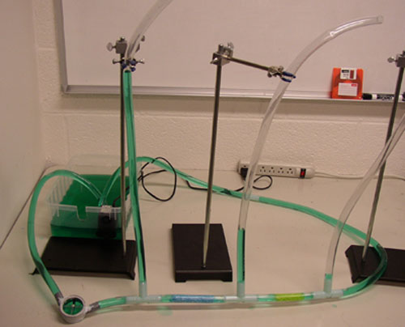
Image from http://www.cns.cornell.edu/cipt/labs/lab4.html

Utilities (helpful mapping)
Common intro physics analogy comparing water and simple DC circuits
Water is analogous to (<>) charge (q conserved)
Current (flow of water) <> flow of charge (Kirchhoff junction; I cons; v must change)
Water velocity akin to e- drift velocity, reflects pressure, charge velocity must change
Water height (pressure; head; ‘liftage’; GPE / m) <> Voltage (EPE / q)
Sponges and friction in pipes <> resistors (remove energy from system)
Fountain pump <> source of electric potential (battery or EMF)
Bucket of water <> Ground reference plane (Kirchhoff loop; energy cons)
Can extend to AC, introduce transient phenomena (‘breaks’ Kirchhoff laws)

Un-useful mappings
Can’t shake electrons out of a Cu wire; water will readily drain from pipes
Accreted e- on surface charge distributions drives current, not water pushing water in column
drag at edges doesn’t match (even) Drude-like models with positive Cu ions in lattice

Saeli, S. & MacIsaac, D.L. (2007). Using gravitational analogies to introduce elementary electrical field theory concepts. The Physics Teacher, 45(2), 104-108.

Juxtaposing individual learning and the construction of models in physics.
(Not only Dan’s weird idea )

Work of Li Bao and E.F. Redish comparing physics student standardized test responses to quantum mechanics – student can hold multiple ideas at once (superposition of states), many variables can probabilistically determine which final bubble is selected (wavefunction collapses to a single location in space). ALSO: much to be learned from wrong answers.

L. Bao and E. F. Redish, "Concentration Analysis: A Quantitative Assessment of Student States," PERS of Am. J. Phys. 69 (7), S45-53, (2001).

L. Bao, K. Hogg, and D. Zollman, "Model Analysis of Fine Structures of Student Models: An Example with Newton's Third Law," Am. J. Phys. 70 (7), 766-778 (2002).
L. Bao and E. F. Redish, "Understanding probabilistic interpretations of physical systems: A pre-requisite to learning quantum physics", Am. J. Phys. 70 (3), 210-217, (2002)

http://en.wikipedia.org/wiki/Schrödinger%27s_cat
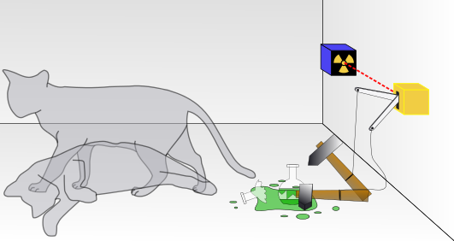

Piaget, J. & Garcia, R. (1989). (Trans H. Fielder; orig 1983). Psychogenesis and the history of science. New York: Columbia University Press.

In this work, the authors advance psychological theory for the development of proto-scientific and scientific knowledge in individuals that they then map onto historical activities advancing the history of science and mathematics -- on the topics of pre-Newtonian Mechanics and momentum transfer, geometry and algebra.

Photo of cover of Piaget book?

This theory advances the mechanism of equilibriation and identifies three (!) stages of transition from an
INTER-objectal schema to a
INTRA-objectal concept, and finally a
TRANS-objectal conception.

Some physics analogies to human learning

Originally from a conversation with Daiyo Sawada (UA Math Ed); extended on 2010 sabbatical observing and reflecting @ U Helsinki / Rutgers / Estrella Mtn CC

Consider a multidimensional “learning space” occupied and traversed by students learning physics. This would be analogous to a multi-dimensional space in physics, a complex environment whose dimensions can be somehow operationalized (measured either qualitatively or quantitatively). Relationships could be described by taking various 2D dimensional simplifications (like PV slices in thermodynamics) where the simplified slices might sometimes be of dimensions that are not independent of on another (like physics phase space plots of momentum vs position, Energy vs position etc).

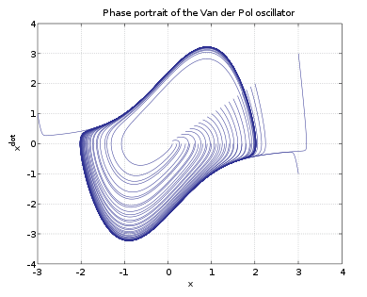http://en.wikipedia.org/wiki/File:Limitcycle.svg

For us, the theory started as an outgrowth the RTOP instrument development effort – an attempt to recognize and value the very many complex kinds of interactions that can and should be manipulated by teachers in a “reform STEM classroom” as measured by the RTOP instrument. Effective teachers can create and foster classroom environments with classroom culture, activities, expectations, agenda setting, apparatus, artifacts, assessment, collaborations, mental tools - especially analysis methods, multiple representations (Free Body diagrams, Energy Pie charts, Circuit diagrams), reflection are ALL INTENDED to foster active student physics learning. These would be our learning space dimensions. Some variables (SES, Glashow’s hierarchy of needs outside the classroom) are critical to student learning but are not amenable to teacher manipulation. Student curricular activities, textbooks, internet resources, simulations, animations are teacher-controlled, vocabulary and interpersonal interactions less so and prior knowledge even less (possibly by student section).

A.E. Lawson et al., “Reforming and evaluating college science and mathematics instruction: Reformed teaching improves student achievement,” J. Coll. Sci. Teach. 31, 388–393 (March/April 2002).
Lawson, A., Benford, R., Bloom, I., Carlson, M., Falconer, K., Hestenes, D., Judson, E., Piburn, M., Sawada, D., Turley, J. & Wyckoff, S. (2002). Evaluating college science and mathematics instruction: A reform effort that improves teaching skills, Journal of College Science Teaching, 31 (6) 388-393.
MacIsaac, D.L. & Falconer, K.A. (2002). Reform your teaching via the Reform Teaching Observation Protocol (RTOP). The Physics Teacher. 40(8), 479-486.
Piburn, M., Sawada, D., Turley, J., Falconer, K., Benford, R., Bloom, I., & Judson, E. (2000). Reformed teaching observation protocol (RTOP) Reference manual. ACEPT Technical Report No. IN00-03. Tempe, AZ: Arizona Collaborative for Excellence in the Preparation of Teachers. <http://purcell.phy.nau.edu/pubs/RTOP/RTOP_ref_man_IN003.pdf>
Sawada, D., Piburn, M., Falconer, K., Turley, J., Benford, R., Bloom, I., & Judson, E. (2000). Reformed teaching observation protocol (RTOP) ACEPT Technical Report No. IN00-01. Tempe, AZ: Arizona Collaborative for Excellence in the Preparation of Teachers. <http://purcell.phy.nau.edu/pubs/RTOP/RTOPform_IN001.pdf>

Aircraft flight envelope analogy
Daiyo’s (Math Ed Professor) suggestion was a “flight envelope” like space for a working aircraft – including fuel, range, max and min speeds and altitudes, aircraft movement and attitude restrictions like stall speed, crew fatigue etc. Instructor can deliberately direct student thought even without direct instruction by controlling the flight envelope – establishing, controlling and fostering a safe “learning space.”

http://en.wikipedia.org/wiki/Flight_envelope

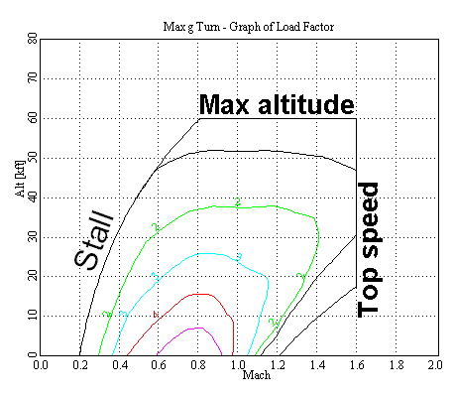

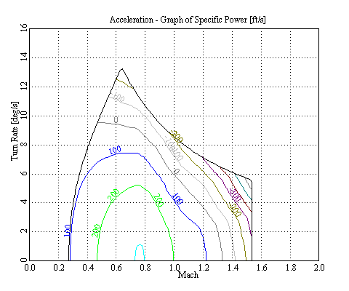

Projectile motion and learning trajectories
My initial thoughts were of projectile motion – an object flies through space according to models that can be highly predictive, though we teach simplified models (parabolae vs sections of ellipses, air resistance etc). Though more akin to a projectile shot through a maze of vertical wires such that the projectile travelled mostly in one direction (diffusion?) and an average velocity could probabilistically describe most (all?) paths. One could then picture individual students taking individual paths through the learning space with individually unique paths determined by many variables, sometimes moving sideways or backtracking. Students could arrive at different final locations (levels of end of course conceptual sophistication) having traveled different overall distances. Assessment of student learning could be considered as check lines through space, a standard could be set with room for students to surpass or come up short (75yds is not satisfactory, 100yds is satisfactory, 120yds surpasses and students can surpass some goals while falling short elsewhere.

Other possible models: gas diffusion, semi-random walks, RMS learning

Phil Sadler’s analysis of ‘wrong answers’ on standardized instruments and some of my own work (with Xiufeng Liu) on the same describe the evolution of student physics model use from semi-random responses, through developed misconceptions and on to standard models. Misconceptions can be identified through such analysis. One can do science with ‘wrong’ models (technically I’d include incomplete models and claim we only do science with ‘wrong’ models) and be partially successful. So “backwards” motion as measured by wrong answers may indicated more sophisticated use of models that are inappropriate (eg impetus over random guessing on the FCI)

Lui, X. & MacIsaac, D.L. (2005). An investigation of factors affecting the degree of naïve impetus theory application. Journal of Science Education & Technology, 14(1), 101-116.

Discussion with Dwain Desbien (Estrella Mtn CC) led to a description of student group activity through the modeling curriculum as dumping groups of students into the Arizona Canal system canals – students seem to mill about randomly and make hesitant progress from moment to moment (with some backtracking and exploration of blind alleys) but the research-proven and/or informed curricular activities deliver them 5km downstream in 40mins, or 10km in 2 days of class. Hence
- Even though it looks messy, trust in research-based and informed curricular design such as modeling activities, and
- There is a process analogous to Drude model electron drift velocity in a well-designed activity. There will be student retrograde and random motion, instructors much have patience.

http://people.seas.harvard.edu/~jones/es154/lectures/lecture_2/drude_model/drude_pic_1.gif
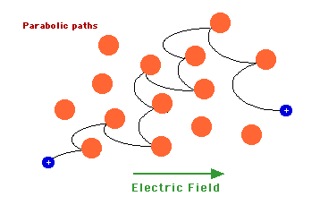

http://en.wikipedia.org/wiki/Drude_model
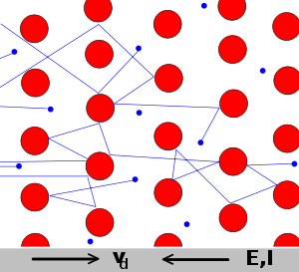

Another model: Chaos / Complexity Theory

small perturbations in initial conditions can produce widely different outcomes – the so called “butterfly effect” (student teachable moments / critical events)
extremely strong interventions can have little impact in final conditions (student is disengaged; has not established a “need to know”)
in a complex environment, interventions can and often do have progressive and regressive results simultaneously along different dimensions

http://en.wikipedia.org/wiki/Butterfly_effect

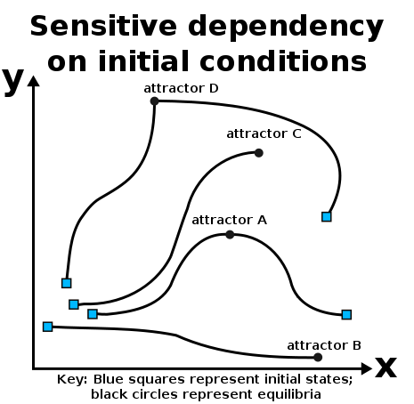

My classroom applications of some of these ideas:

1. Dealing with the text and setting expectations
To do reformed learning activities (as operationalized by RTOP) in my class, I must stop doing other things, starting with lecture. Hence I expect and require my students to read their text on their own outside of class, and one letter grade (10%) is predicated on turning in a reflective Reading Log on every chapter of our text (roughly weekly). I strongly and regularly encourage but do not assign credit for the out-of-class viewing of related physics video lectures and programs from MIT (Walter Lewin’s lectures) and CalTech (www.learner.com, the Mechanical Universe and Beyond – especially the calculus programs). Some others have called this a “flipped class” or a “post-Gutenburg class.”

Show Reading Log form.

2. Group discourse on few but well-selected PER-based / informed activities
I’m a huge fan of student discourse (Vygotsky), including guided controlled and grounded discourse and language, hence “discourse on day one” in my classes, much small group discourse anchored by inexpensive whiteboards. Every significant (PER based or informed) curricular activity worth doing is worth discourse, and there is a daily expectation for discourse and/or activity. I log student comments and read them back daily, track who says what, and read back student descriptive language (harsh vs gentle light; a Dan vs a Jason filament). In larger classes, I will warn quieter individuals and groups of my expectation for their participation, seeding information the whole class needs, and calling on fewer groups to present. (Note comparison to Mazur’s Peer Instruction.)

Discourse is where Vygotskian scaffolding (ZPD), developing a need for and then possible introducing new representations and tools (if not naturally emergent), student personal vs standardized vocabulary and locutions, agenda setting, scientific reasoning are introduced. Individual reflective activities review the daily activity and discourse.
Note interplay between individual reflection -> small group discourse -> whole class discourse and reverse. Groups are reconstituted every midterm (roughly 3X / semester) usually to provide wide ranges of abilities.

http://physicsed.buffalostate.edu/AZTEC/BP_WB/index.html
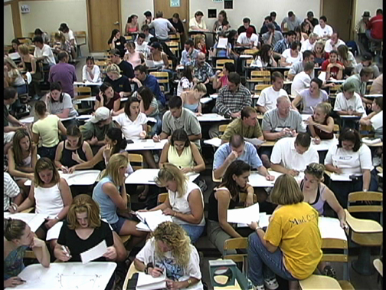

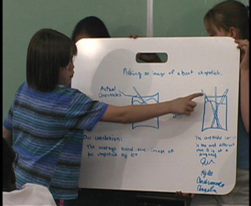

3. Deliberately Reflective practices: Journaling & Learning Commentaries
My students keep a physics journal collected about every three weeks. Given the immense planning and valuation I place upon lengthy discourse on a few well-chosen activities, I want my students to intensively reflect on their work. Every midterm exam my students also prepare a Learning Commentary. These are collectively worth another 20% of the course grade. Typical syllabus copy:

REFLECTIVE WRITINGS AND JOURNAL (20% OF GRADE):
Reading Logs. A conscientiously completed one page reading log for each chapter, graded as satisfactory or unsatisfactory.
Course Reflective Journal. Written in your own hand in a separate book with bound pages. Put your name prominently on the cover, and do not put your name on your daily entries. No more than one entry per page. Not to be written in or during class. Do not erase entries; strike through and start a new entry, sentence or line. Can be checked on any date during the regular course and will be checked at the end of the course during the final exam.
0) Start with the date.
1) Summary list of activities from that day’s class.
2) What did I learn? Please explain your reasoning. Include sketches, figures, diagrams, equations, graphs (or any other multiple representations) as appropriate and sufficient.
3) What questions do I have to guide my thinking?
If you are absent: Indicate date as ABSENT, list steps taken to make up the activity, and address the entry elements as best possible.

Learning Commentaries. A brief three paragraph formal essay written three times during the semester (at exams) reflecting upon your learning in the course. A learning commentary is a story describing the evolution of your thoughts on ONE (per LC) single scientific idea. You will describe your initial thoughts, activities, discussions that change or confirm how you think about the idea together with examples and your final scientific interpretation. Learning commentaries are word-processed and you will hand in a paper copy in class and an electronic second copy through Angel. I will give more detail in class. Write your learning commentary starting from your diary and notes. Learning commentaries are graded based upon the quality and quantity of your comments and examples, together with how you support claims for your final scientific ideas with specific data taken from classroom observations and activities. In particular, I will be looking for:
a description of your ONE initial scientific idea based upon your previous life experiences, together with a description of your supporting evidence (with your original supporting evidence):
a substantive discussion of how various class discussions and activities promoted change in your idea (with examples and supporting evidence); and
a brief description of your final scientific idea

SHOW rubrics and examples of reflective activities

Motivation: Final projects

PROJECT AND PRESENTATION (10% OF GRADE): You will be expected to complete a project related to a course topic (E&M or Optics) of your choice, and present it in class. This project will consist of a brief 5-10 page double spaced word processed paper submitted both on paper and as an electronic attachment at the end of the course describing the construction of a device, or analyzing an effect related to a course topic. You will use reviewed literature (journals) and the web as references. You will make a 10-15 minute presentation upon your project to your peers in the last week of class. A physical constructed artifact is typical, more details and rubrics will be forthcoming.

References:

A.E. Lawson et al., “Reforming and evaluating college science and mathematics instruction: Reformed teaching improves student achievement,” J. Coll. Sci. Teach. 31, 388–393 (March/April 2002).
D.L. MacIsaac and K. A. Falconer. "Reforming physics instruction via RTOP," Phys. Teach. 40 (8), 479-485 (Nov 2002).
Falconer, K.A., Joshua, M., & Desbien D. (2003) (Authors & Producers; SUNY-BSC Production; MacIsaac analysis). RTOP Video 4: Modeling via Intensive Student Discourse. [QuickTime Web Streamed Video 10:15]. Buffalo, NY: Authors. Retrieved December 6, 2013, from
<http://PhysicsEd.BuffaloState.Edu/pubs/AAPT/EdmontonDec2013>.
Falconer, K.A. & MacIsaac, D.L. (2004) (Authors & Producers; SUNY-BSC Production). Reformed Teaching Methods: Think Pair Share. [QuickTime Web Streamed Video 12:02]. Buffalo, NY: Authors. Retrieved December 6, 2013, from
<http://PhysicsEd.BuffaloState.Edu/pubs/AAPT/EdmontonDec2013>.
M. Piburn, D. Sawada, K. Falconer, J. Turley, R. Benford, and I. Bloom. "Reformed Teaching Observation Protocol (RTOP)." ACEPT IN-003. (ACEPT, 2000). The RTOP rubric form, training manual, statistical reference manuals, and sample scored video vignettes are all available from <http://PhysicsEd.BuffaloState.EduAZTEC/rtop/> under RESOURCES.
Piaget, J. & Garcia, R. (1989). (Trans H. Fielder; orig 1983). Psychogenesis and the history of science. New York: Columbia University Press.
Sawada, D., Piburn, M., Falconer, K., Turley, J. Benford, R., Bloom, I. (2000). Reformed Teaching Observation Protocol (RTOP). ACEPT IN-01, http://physicsed.buffalostate.edu/pubs/RTOP/ .
Sawada, D. and Piburn, M. (2000). Reformed Teaching Observation Protocol (RTOP) Training Manual. ACEPT IN-02,http://physicsed.buffalostate.edu/pubs/RTOP/.
Thornton, R.K. (2002). Uncommon knowledge: Student behavior correlated to conceptual learning. Unpublished manuscript available from the author.
Vygotsky, L.S. (1997). (Revised and edited, A. Kozulin). Thought and language. MIT: Cambridge.
Wells, M., Hestenes, D. & Swackhamer, G. (1995). A modeling method for high school physics instruction. American Journal of Physics, 64, 114-119.

