NYSS-AAPT
2014 Spring Meeting
March 29, 2014
RIT
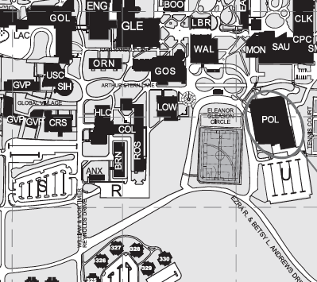
The NYSS-AAPT Spring 2014 Meeting will be held at RIT in Rochester on March 29th 2014 from 8:00AM to 4:00 PM in Gosnell Hall (Building 08, aka Science Building: GOS).

Closest parking Lot is S, about a 5 minute walk to Gosnell
Route 252, Jefferson Avenue is to the north of campus. On the east side is John Street, turn from John onto Wiltsie. It ends at Andrews Drive, make a left.
Continue around. There is a stop sign. Go straight, at second stop sign turn right and that is Lot S.

8 – 9 am | Registration | Coffee, juice, etc. | Meet and Greet
9 :00 | Opening Remarks |  | Gosnell Hall 08-3305
9:15 – 9:45 | Steve Henning | How to build a paper rocket launcher | Gosnell Hall 08-3365
9:45 – 10:15 | John Johnston | More physics demos | Gosnell Hall 08-3305
10:15 – 11:15 | Ben Zwickle | PER talk | Gosnell Hall 08-3305
11:15 – 11:30 | Break
11:30 – 12:30 | Dan MacIsaac | New Science Standards | Gosnell Hall 08-3305
12:30 – 1:30 | Lunch
1:30 – 2:00 | RIT lab tour
2:00 – 4:00 | Steve Henning | Video analysis | Gosnell Hall 08-3305
The additional fee for the Video Analysis presentation includes a copy of Vernier’s Physics with Video Analysis , a $48 value.
Registration: Email a copy of the registration form to rstewart1@hvc.rr.com and send payment to the address on the form.
Fees for members are: Early Bird: $20 and $25 day of meeting. Non-Members: Add $10 for membership
Undergraduate/Graduate Students: $10 (includes 3 year membership as a welcome to the Physics teaching community).
NYSS-AAPT
2014 Spring Meeting Registration
March 29 2014
RIT
Name:______________________ Email Address ____________________
Address: _____________________
_____________________
_____________________
Meeting Fee: Circle One
Early Bird $20 Day of $25 Student $10

Membership: Circle One
Current Member $0 Non-member $10

Video Analysis Workshop Materials $20

Total__________ Make Checks Payable to NYSS-AAPT
Mail To: Robert Stewart 14 Valley Rd, Forestburgh NY 12777.
Also email a copy of this form to rstewart1@hvc.rr.com

