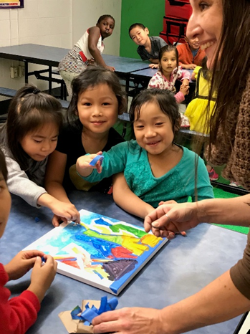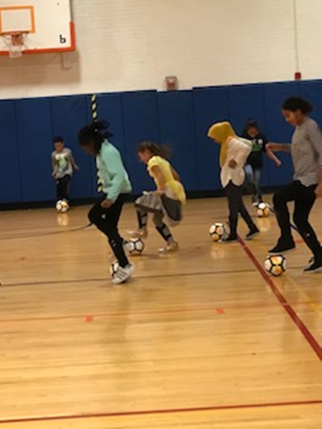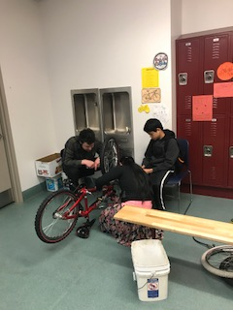

|  |
| --- |
| **Earn** **$11.10** **-** **$12** **hr.**  **Develop** **Professional** **Expertise**  **Build** **Professional** **Networks**  **Quality** **Professional** **Development** |
| **CENTER** **FOR** **EXCELLENCE** **IN** **URBAN** **AND** **RURAL** **EDUCATION**  Chase 201 716-878-3610  **Mrs. Keisha Brandy** |

|  |  |  |
| --- | --- | --- |
|  | | |
| **LEARNING TOGETHER CHANGING LIVES**  **AFTER-SCHOOL TUTORING PROGRAM** | | |
| **Are** **you** **passionate** **about** **working** **with** **youth** **in** **urban** **settings?**  **Are** **you** **committed** **to** **impacting** **the** **community?**  **Do** **you** **have** **expertise,** **hobbies,** **or** **interests** **you** **would** **like** **to** **teach** **children** **ages** **5** **–** **14?**  CEURE is looking for **10-15 undergraduate/graduate** **students** to provide **enrichment/recreation** activities, **homework** **support**, and intensive **math &** **literacy** **tutoring**.  **Apply** to be an **academic** **or** **enrichment** **tutor** at Buffalo Public International School #45. (**10** **minutes** **from** **campus** by bus).  For more information, **email** [brandykl@buffalostate.edu](mailto:brandykl@buffalostate.edu), **scan** the QR Code, or **call** the CEURE Office today!  [**brandykl@BuffaloState.edu**](mailto:brandykl@BuffaloState.edu) | | |
|  |  |  |

