Assessing elementary and middle school students' understanding of electric current

Michael Jabot, SUNY Fredonia

jabot@fredonia.edu

David Henry, Buffalo State College

henryd@buffalostate.edu

Abstract

The Path of Electric Current Assessment (PECA) was developed to probe students’ understanding of a variety of direct current (DC) resistive electric circuit concepts. The PECA was used to explore the mental models that grade 3-8 students use in explaining the direction of electric current and how electric current is affected by different configurations of simple battery and bulb circuits. Consistency of applying mental models was also analyzed. Students analyses of current flow direction was categorized into one of two mental models: (1) bidirectional and (2) Unidirectional. We found an increase in the consistency of what current flow direction mental model use coinciding with grade 4 instruction of batteries and bulbs. The proportion of students using a bidirectional flow model was similar in grades 3-8. Students analyses of current flow was categorized into one of four mental models of resistance: (1) More electric current flows through a short circuit, (2) Equal electric current flows through bulb and short circuit, (3) bulb draws electric current, and (4) electric current is blocked by short circuit. Little difference in grades 3-8 was observed in the models of resistance that the students used. Little consistence was found in the use of resistance mental models, indicating a dependence on superficial circuit characteristics such as the orientation of the bulb and battery, the relative distance of the battery, bulb and short circuit, and the smoothness of the connections.
.

Introduction
The overarching goal of science education is to develop scientific literacy (AAAS, 1989, 1993; NRC, 1996) including conceptual understanding of the content presented. Research on students’ conceptual understanding has focused on students’ alternative conceptions of specific scientific concepts (Driver, Guesne, & Tiberghien, 1985; Duit, 2002; Helm & Novak, 1983; Novak, 1987; Wandersee, Mintzes & Novak, 1994) and has become a driving force for reforming all aspects of science education including curriculum and instruction, teacher education, and assessment (Fraser & Tobin, 1998; Treagust, Duit, & Fraser, 1996; Wandersee et al. 1994).
In recent years, physics educators in particular have begun to look more closely at the conceptual understanding that students at all levels demonstrate in explaining a given phenomena or in making predictions. This research has benefited from the development of test instruments such as the Force Concept Inventory (FCI) (Hestenes, Wells et al. 1992) and the Test of Understanding Graphs in Kinematics (TUG-K) (Beichner 1994). As these assessments have brought more effective ways to evaluate students’ conceptual understanding. Also new curricular materials have been developed as a result of the information gained through the use of these assessments. However, more instruments need to be developed in a variety of areas to allow instructors to better evaluate students’ understanding of physics concepts and to evaluate the effectiveness of instruction as measured by its impact on conceptual understanding.
This article explains the development of the Path of Electric Current Assessment (PECA) which was developed to evaluate students’ understanding of a variety of direct current (DC) resistive electric circuits concepts. PECA has been designed for elementary and middle-level students.
Science educators agree that simple concepts of electricity should be included in the elementary and middle school curriculum. Basic electricity, in the form of batteries and bulbs, is commonly taught in elementary and middle school. In memorable videotape clips, the physics education community has shown college graduates with engineering degrees unable to light a bulb using a battery and wire. This research has had an impact on curriculum in the elementary and middle schools, so that currently many students complete tasks similar to those in the research requiring students to discover how to light a bulb with one or two wires and a battery. Researchers have developed innovative research-based curricula to teach electricity (National Science Resources Center, 2002).
The purpose of this paper is to explore the mental models elementary and middle school students use to describe how electric current flows through simple circuits. We describe an assessment designed to explore students’ thinking about electric current in simple circuits and present a range of data from students in grades 3 through 8 demonstrating the mental models they used in explaining electricity.
Our first research question was: What mental models do students use in explaining how electricity flows through simple battery and bulbs circuits? For the purposes of this paper we specifically categorized the mental models that students used in two areas: direction of electric current flow, and the effect of a resistive load or low-resistance path in a simple circuit. Our second research question was: How do these mental models vary with grade level?

Theoretical Background
Our research is based on previous explorations of students’ thinking about electric circuits and mental model theory used to summarize the thinking patterns of large groups of students.

How Students’ think about Electric Circuits
The extensive body of research examining students’ understanding of circuits indicates that students have two prominent misconceptions regarding DC electrical circuits: (a) current is consumed(Fredette and Lochhead 1980; Osborne 1981; McDermott and van Zee 1984; Shipstone 1984; Arnold and Millar 1987) and (b) the battery is a source of constant current (Cohen, Eylon et al. 1983; Dupin and Johsua 1987; Licht). When analyzing circuits, novices have been found more likely to view the circuits in a piece-meal fashion rather than in a global overview. There is some evidence to indicate that students change their reasoning patterns depending on characteristics of the circuit. For example, students may view a light bulb close to the battery differently than they view a light bulb farther away from the battery. Students often do not appear to use a single, consistent model to analyze circuit phenomena.
Several investigations have been done to examine student understanding and beliefs concerning electricity (Tiberghien and Delacote 1976; Osborne 1981; Osborne 1983). These investigations have found that often the understanding of students is largely unchanged over time, even after receiving formal instruction. It is also important to note that most existing research has evaluated student understanding based on their ability to construct a circuit, identify a complete circuit or predict whether a simple circuit will light. This research has yielded information about students’ understanding of the concept of a complete circuit and some models that students have used to describe current flow. Physics education research has just begun to study the development of concepts about resistance, primarily through the study of teacher understanding of resistance. Some key findings in each of these areas are summarized below.

Concept of a Complete Circuit
The concept of a complete circuit is quite simple and its definition is often quickly learned by the students. Because of this, it is often given little time in instruction (Osborne 1983). While students may in fact have adopted a scientific definition of complete circuit, their application of the definition often seems to be quite different. Students who lack an understanding of how a bulb is wired often fail to recognize the role that the different parts of the bulb play in the circuit. They will draw a circuit which has wires coming to the metal base of the bulb as well as exiting from the metal base. In this case they have a model of complete circuit which does not take into account the concept of resistance and the role of insulators in the complete circuit. Someone who has a greater understanding of the concept of resistance knows that in order for current to flow in the circuit, the bulb needs to be considered part of the complete circuit with the two terminals of the battery making contact with the two terminals of the bulb in a manner which allows the current to flow through the filament.

Models for Electric Current Flow
Many of the difficulties that students have concerning electric circuits can be traced back to difficulties concerning the concept of current. Past studies of how students think about electric current flow tended to use the same basic structure. Children were given a battery, some wires and a bulb and then asked to light the bulb. While they were involved in the task, their actions and behavior were recorded or observed (Tiberghien 1983, Osborne and Freyberg 1985). They were then interviewed and asked to explain what they had done and what they were thinking while they were doing it. From the protocols generated, researchers were able to infer the students’ underlying ideas about simple circuits. This type of task has been used with individuals from primary school up to university level to elicit their understandings of electricity. For instance, Fredette and Lochhead (1980) used it to assess university students’ conceptions of simple circuits, and Osborne used it in a number of studies involving secondary school students in New Zealand and in the UK (Osborne 1983, Osborne and Freyberg 1985).
This research has yielded the discovery of several mental models used by novices to explain electric current flow. These models are delineated below:
- Consumption Model: The battery is seen as the “giver” of the electricity, juice, voltage, power; whatever term was used to describe what the battery did and the bulb is seen as consuming the electricity (Maichle 1981). In explaining how the electricity is used up, students turn to a variety of models based on circumstances.
- Unipolar Model: Students report that no current exists in the return path. In this model, the student often does not include a wire returning from the bulb back to the battery (Osborne, 1983).
- Clashing Current Model: The flow of electricity is described as coming to the bulb from both ends of the battery and getting “used up.” Students explain that both kinds of electricity are needed to make the bulb light (Osborne, 1983). This is also called the Two-component model when students describe “plus” and “minus” current traveling from the battery terminals to the bulb where they meet and produce energy, lighting the bulb up. Shipstone (1984) called this Model 1. Such a model is particularly popular among children from 10 to 13 years old, but it is practically absent by the end of secondary education (Osborne and Freyberg 1985).
- Attenuation Model: The electric current is viewed as flowing in only one direction, but some of the electricity is used up by the bulb. As the current passes through a series of identical bulbs connected in series, each bulb receives less and less current. Shipstone, et al (1985) called this the Current consumption model, and labeled it a ’sequence model.’ It implies a compromise between the notions that a current circulates the circuit and that it is used up as it goes through each component of the circuit.
- Closed circuit model: All the circuit elements are viewed as having two connections. Current circulates around the circuit in a given direction and the circuit only functions when the switch is closed. Current flow through a resistive circuit element liberates energy (Shipstone, et al, 1985). This model recognizes the bipolarity of circuit elements but it suggests that current is not conserved, perhaps because of a lack of differentiation between current and energy.
- Constant current source model: This model properly encompasses bipolar circuit elements, the circulation of current in a cycle and the need for a closed circuit. However, the battery is seen as a source of constant current, that is, the current supplied by the battery is always viewed as the same regardless of the circuit features. It is recognized that the battery “wears out” with time and that this is the only source of current variation. According to this model, two bulbs share the current, whether they are connected in series or parallel. A similar model is described by Cohen et al. (1983) and it shows most of the features of Shipstone’s (1984) ’sharing model’. According to Shipstone (1984) this model results from the assimilation of some rules about circuit functioning into children’s models, for instance, the rule that identical bulbs connected in series (or parallel) shine equally brightly.
- Ohm’s model: A current flows around the circuit transmitting energy. Current is conserved and well differentiated from energy. The circuit is seen as a whole interacting system, such that a change introduced at one point of the circuit affects the entire system. This corresponds to the ’scientific view’ and has also been found by Osborne (1983) and Shipstone (1984). This model becomes increasingly popular as students grow older, perhaps as a result of instruction.

Resistance
There is sparse research on the mental models that students use to explain how a resistive load in a circuit affect the electricity current flow. In their work with elementary and middle school teachers, Heller and Finley (1992) explored the mental models that the teachers used to explain how electricity flowed through simple series and parallel circuits. In additional to confirming the models of electric current flow described above, they found that one mental model is based on the idea that “wires use up electricity.” So in this model, the farther the bulb is from the battery, the dimmer it is. For parallel circuits, this mental models leads to a prediction that the bulb farthest from the battery will be dimmer. When they showed the teachers a circuit with a short circuit (an extra wire from one side of the bulb to the other side) around one of the bulbs in the circuit, the responses of the teachers included that the shorted bulb would “dim because some of the electricity is used up traveling the extra distance through the copper wire” or the bulb would “get brighter because copper is an excellent conductor of electricity, so it increases the flow of current.” These responses are evidence of mental models that do not incorporate a correct conception of resistance.

Mental Models
Mental models are mental representations used in making sense of the physical world (Coll & Treagust, 2003a&b). Mental model theory has a long history (Craik, 1943) but only recently has been used in science education as a way of making sense of students’ alternative conceptions (Chiu, Chou, & Liu, 2002; Gilbert & Boulter, 2000; Taber, 2003) Mental models theory assumes that students’ conceptions in science are internal representations or mental models of natural phenomena.. This approach has its root in mental model theories developed in cognitive psychology (Gentner & Stevens, 1983; Johnson-Laird, 1983; Rogers, Rutherford & Bibby, 1992). Johnson-Laird (1983) asserts that explanation involves understanding of a phenomenon, and the core of understanding is building a working model of the phenomenon in the mind, i.e. the mental model. The mental model theory implies that the explanations and predictions people give to a same problem in different contexts should be consistent, although the degree of consistency remains a topic of debate in the literature (e.g. Anderson, Tolmie, Howe, Mayes, & MacKenzie, 1992; diSessa, 1988).
Mental models provide a theoretical framework for describing and explaining students’ conceptions and conceptual change in science, and a growing number of studies have adopted this approach. Research examining children’s mental models of electricity has mainly been restricted to the functioning of simple circuits, rarely examining the nature of electric current, resulting in at best a partial picture of students’ mental models of the domain of electric current. Many of these studies make use of quite similar probes, usually predicting brightness of light bulbs, leading to very similar outcomes. It is possible to infer from such studies, for instance those of Osborne and Freyberg (1985) and Shipstone (1985), that children’s understanding of simple electrical circuits improves with age and instruction, from simple intuitive mental models towards some version of the correct model. Only a few studies, by White and Frederiksen (1987) and by Eylon and Ganiel (1990), address the issue of possible mental model progression within the context of cross-age studies. In contrast, the studies by Osborne (1983) and by Shipstone (1985) show the popularity of different mental models as a function of age, but do not address explicitly what may be changing across these models.
What has emerged from such studies is that children’s mental models of electricity involve a number of different aspects. These are the:
(1) differentiation of basic terms used to speak about electricity, like current, electricity and energy;
(2) recognition of the bipolarity of batteries and other circuit elements;
(3) recognition of the necessity of a closed circuit if a current is to circulate in it;
(4) issue of the conservation or non-conservation of current;
(5) effects of electrical resistance on current;
(6) models for current circulation;
(7) nature of electric current.
Most of the proposed models of electricity deal with only few of such aspects. For instance, items 1, 3 and 5 predominated in the early studies (Osborne 1983, Tiberghien 1983). With the use of slightly more complex circuits, the other aspects were considered a little later (Shipstone 1984, Karrqvist 1985, McDermott and van Zee 1985). Some aspects are likely to occupy a more central place in children’s mental models so that instruction may affect them to different degrees. A child who cannot differentiate between current and energy properly is unlikely to adopt a view in which current is conserved, for instance. Research findings also suggest that instruction can help children to change their views about some of the above mentioned points more than about others (Osborne 1983, Shipstone 1984, Arnold and Millar 1987). Thus children can, after instruction, recognize batteries and other circuit elements as well as the need for a closed circuit if current is to circulate in it (Osborne 1983, Psillos et al. 1987, Cosgrove 1995).
Other aspects of children’s models of electricity, however, are more resistant to change, for instance those involving the conservation of current. This becomes increasingly problematic as students progress in their studies to consider more complex situations, such as those involving combination of resistors in series and parallel (McDermott and van Zee 1985, Shipstone 1985), and when they start to learn about the microscopic processes occurring in a circuit (White and Frederiksen 1987, Eylon and Ganiel 1990). Some researchers point out that the problem exists in the students failing to differentiate between current and energy (Arnold and Millar 1987), while others suggest that what needs to be addressed is how children think of the nature of current (White and Frederiksen 1987, Eylon and Ganiel 1990).

Pilot and Instrument Development
We began this research in an attempt to describe the mental models that students use to explain how electricity flows through simple battery and bulbs circuits. Our work began with a qualitative exploration of students’ thinking and led to a larger, multiage study.

Pilot setting and participants
Two heterogeneous fifth grade classes, each with 26 students, from a large, predominately middle class, suburban, public school participated in the initial phase of this study. Of the original sample 27 were boys and 25 were girls. The participants ranged from 9-11 years old. Participants were first given an informed consent form to sign. It was clearly stated that individual responses to the student survey would in no way affect their science grade and that the researchers were interested only in student thinking. The teacher agreed to include some exercises in batteries and bulbs prior to a planned unit about electromagnetism.
These students had been instructed in basic electricity using batteries and bulbs during fourth grade. This instruction had included activities such as lighting a bulb with a battery and wire, using battery and bulb holders, using schematic symbols to draw simple circuits, constructing series and parallel circuits, and exploring resistance using NiCr wire.

Pilot Methodology
Each of the students completed an 8-item survey that included a series of exercises where they were given arrangements of a single battery and bulb and asked “Do you think the light bulb will light up?” and to explain their answer. Students were to draw the path of electricity and explain their reasoning. The results of the initial survey confirmed that the majority of the students had procedural knowledge of how to light a bulb with battery and wire. See Figure 1 for the results of this initial survey. As you can see, the two bulbs that would light were chosen by 92% and 85% of the students.
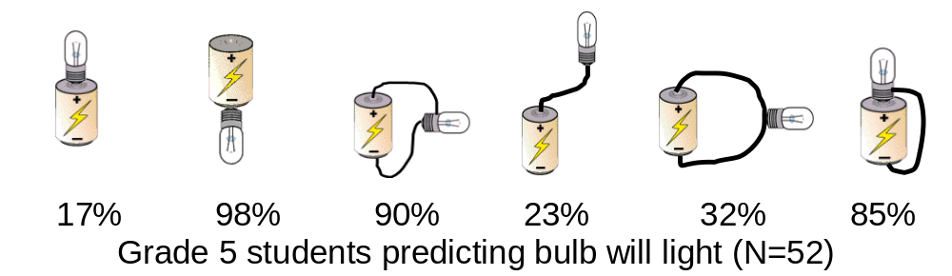
17% 2% 92% 23%32% 85%
Figure 1. Percent of grade 5 students (n=52) correctly predicting which circuits will light the bulb.

Exploring extra wires in circuits
A set of six circuits was used to explore how the students thought about short circuits. The pictures showed a circuit made of a bare miniature Christmas light bulb connected to a battery. Additional wires were added to the circuit. The students were asked to predict whether the bulb would light and also to use colored pencils to sketch how they though the electricity moved through the wires of the circuit. The results of these prompts were quite surprising. Three of the circuits had a wire “shorting” the bulb. That is, the wire provided an alternative path from one side of the battery to the other without going through the bulb. The responses to these prompts exposed many ideas about how students expected the electricity to move through a circuit and the expected effect of extra wires. However, the student responses were difficult to fully understand and the colored wires were hard to interpret. Figure 2 show these circuits and some sample student responses.
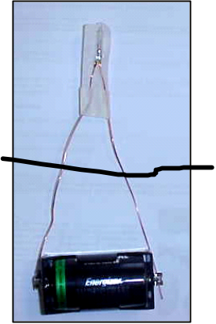 | 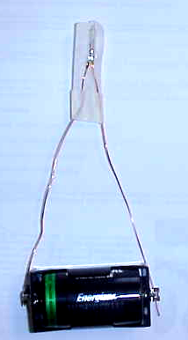 | 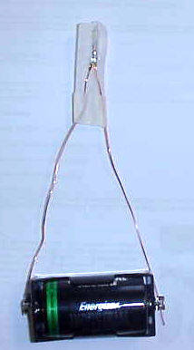
No-won’t light. “The electricity is going to the middle wire and it isn’t going to the top.” | No-won’t light. “It is going below the battery. That’s why it won’t work.” | Yes-will light. “It is going around the bulb and going down again.”
Yes-will light. “I think the 3rd wire is being skipped and just keep flowing through it.” | No-won’t light. “It is going up and around and back into the battery.” [ The student has the extra wire colored.] | Yes – will light. “ It goes into the wires and flows through the wires and into the bulb.”
No- won’t light. “Because the wire is interfering with the electricity.” | No-won’t light. “It’s interfering. It is stopping the flow.” | No-won’t light. “Because the extra wire is going right through it.”
Yes- will light. “It is going around the straight wires and it is going through the curved wire and goes back on the straight wire.” | Yes-will light. “It is going through the outside wire.” | No-won’t light. “It won’t light because the wire that is sticking up blocks the electricity.”
Figure 2. Items used to explore mental models of current flow.

Two ideas were distilled from the students’ responses to these prompts: (1) students did not apply a “path of least resistance” idea to the three short circuits and (2) many students had the idea that extra wires “block” the flow of electricity. To explore these ideas further we redesigned the assessment so that the students would draw arrows on the wires to indicate the direction of flow and also give an indication of the amount of electricity that was flowing through the wires. We designed new prompts based on these initial ideas, resulting in a new assessment called the Path of Electric Current Assessment (PECA).

The Path of Electric Current Assessment
The complete Path of Electric Current Assessment (PECA) included 20 different items. Items 1 and 2 compared a simple one bulb – one battery circuit with a shorted battery circuit. The students were asked to draw arrows showing the direction and amount of electric current flowing through the wires. The remaining items depicted a battery and bulb circuit designed to elicit specific ideas about electricity flow in a simple circuit and ideas about how specific characteristics of the circuit affect the electric current flow. The complete PECA is given in the appendix.

Model Analysis using the PECA
The PECA was used to measure a number of constructs of student understanding of simple electric circuits. For the purposes of this paper, we will discuss how we used the PECA to analyze the mental models of students for the two concepts of particular interest uncovered in the first phase of the pilot study: electric current flow and resistance.

Current flow
We used PECA items 1, 14, 18, 19, and 20 to categorize students’ mental models about the direction of electric current flow in simple circuits. Responses to the five items were analyzed based on the direction of arrows representing the electric current in different parts of the circuit. If a student did not draw arrows on the circuit, the item was not given a current flow model classification. Together, these yielded up to five current flow model scores for each student. Each response was classified as representing one of the models described in Figure 3.

Resistance
PECA items 1, 2, 3, 12, 13 and 20 were used to categorize students’ mental models about resistance. Items 1 and 2 were analyzed together, yielding one score. Items 3, 12, 13 and 20 were analyzed individually. Responses to the six items were analyzed based on the density of arrows representing the electric current in different parts of the circuit and on whether the student indicated that the bulb would light or not light. Together, these yielded five resistance model scores for each student. Each response was classified as representing one of the resistance models shown in Figures 4 and 5.

 | CF model 1 (correct model): Unidirectional flow  Electric current flows in one direction from one end of the battery to the other end of the battery. We did not distinguish between positive to negative or negative to positive flow. If the student drew arrows indicating one direction flow, the item was categorized as CF model 1. | 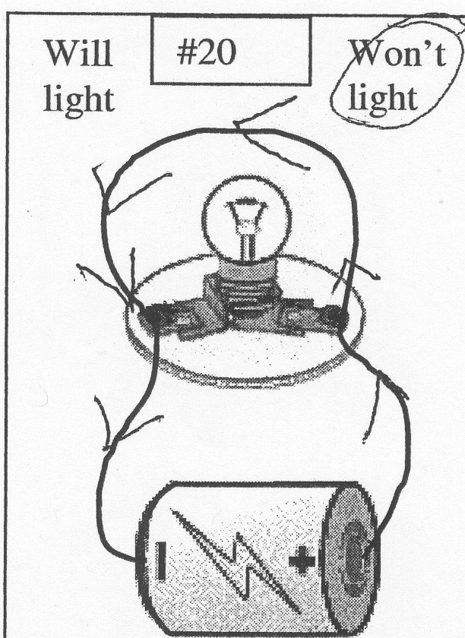
 | CF model 2: Bidirectional flow  Electric current flows out of both ends of the battery. If the student drew arrows that showed flow coming out of both ends of the battery the item was categorized as CF model 2. | 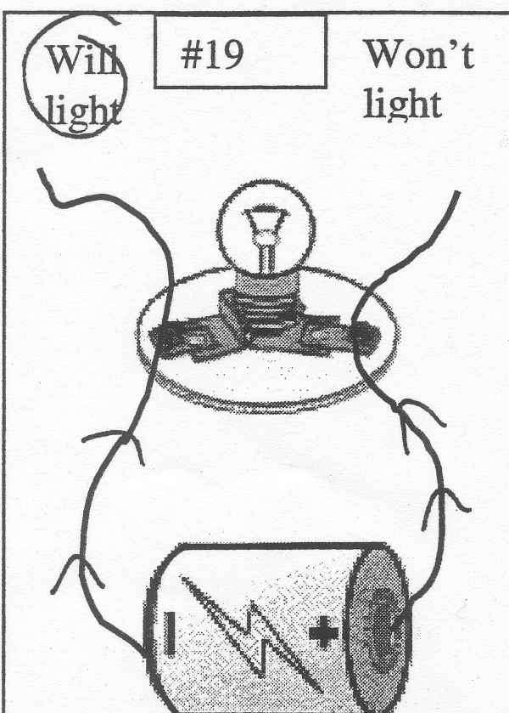
 | CF Model 3: null current flow model  If the student drew arrows that couldn’t be categorized as CF model 1 or 2, the item was put in this category. | 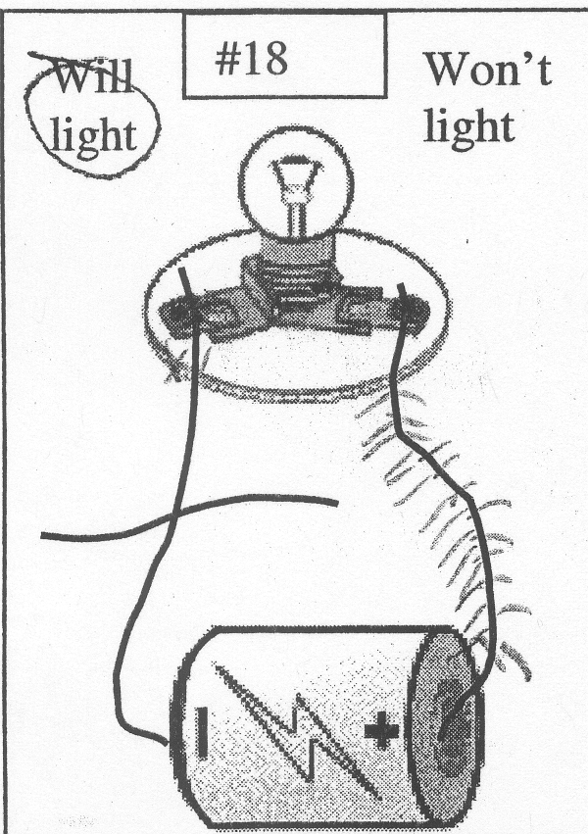
 | Figure 3. Current Flow Models and sample PECA item demonstrating the mental model
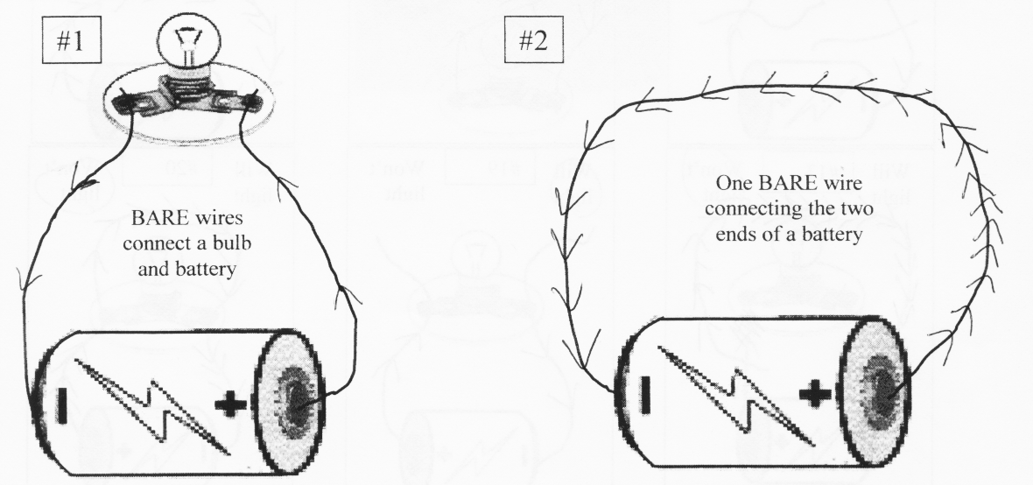
R model 1: (correct model) Bulbs Have More Resistance than Wires
These responses reveal an understanding that the bulb has more resistance than a wire. When comparing items 1 and 2, respondents correctly predicted that more electricity would flow in 2 because the resistance was less. In items 3, 12, 13 and 20, the responses revealed an understanding that the bulb won’t light because the electricity can get around the bulb easily (through a wire) without going through the light bulb. Some electricity may go through the bulb, but probably not enough to light it. Students had “Won’t Light” circled and drew more arrows going through the short circuit than through the bulb. They may also have included no arrows going through the bulb portion of the circuit.

R model 2: Equal Current  The responses demonstrated the idea that the bulb didn’t affect the circuit any differently than a wire and predicted that electricity would travel equally through a bulb or a wire. A student using this model drew equal arrows in items 1&2. In items 3, 12, 13 and 20, they drew equal arrows in both paths - through the bulb and through the short circuit. “Will Light” was circled. Responses that fit this model can be interpreted two ways: as a belief that the bulb and the wire have the same electrical resistance, or that electricity will always split equally, regardless of characteristics of the paths. |  |  | 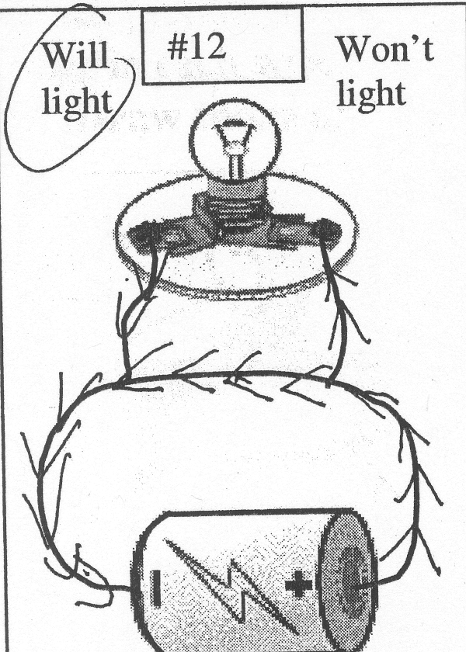
Figure 4. Resistance Models and sample PECA item demonstrating the mental model.

R model 3: Electricity is “Drawn to the Bulb”  These responses reveal a belief that electricity is always drawn to the bulb. Given two paths, all or most of the electricity will go in the path that includes the bulb. Students using this model drew more arrows in item 1 than in item 2. This student may have written “no” electricity in item 2. In items 3, 12, 13 and 20, “Will Light” was circled, and there were noticeably more arrows in the bulb path than in the short circuit path. | 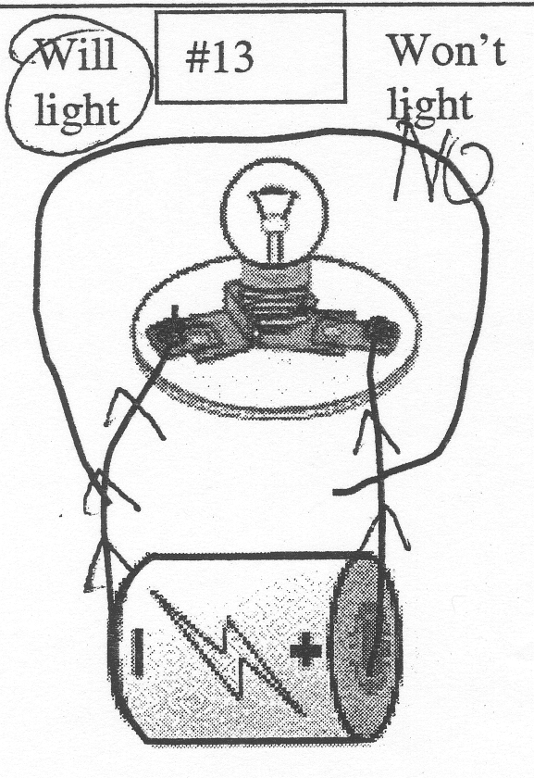
R model 4: Alternative Paths “Block” Electricity  This model reflects a misconception that an alternative path or crossing wires will block the electricity from moving through a circuit. A student using this model drew arrows in items 1, and had “no” written on the wires in item 2. In items 3, 12, 13 and 20, there was “no” written on all the wires, or on the wires after the short circuit. “Won’t Light” was circled. | 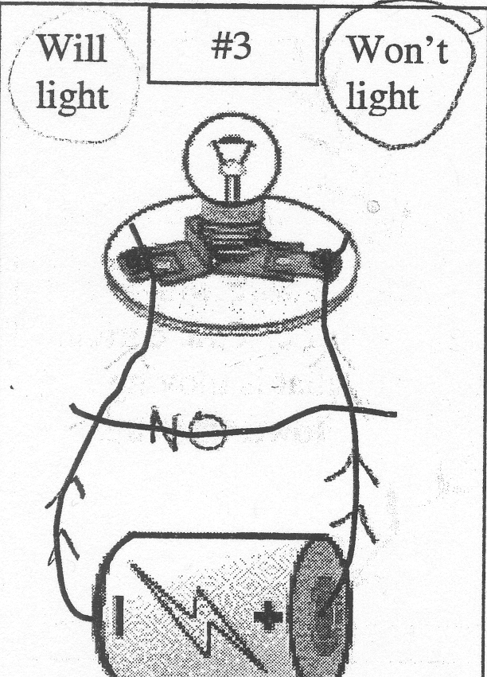
R model 5: Null Resistance Model  Items were categorized as model 5 if there were arrows drawn, but there was not enough evidence to categorize the response as reflecting one of the four models described above. | 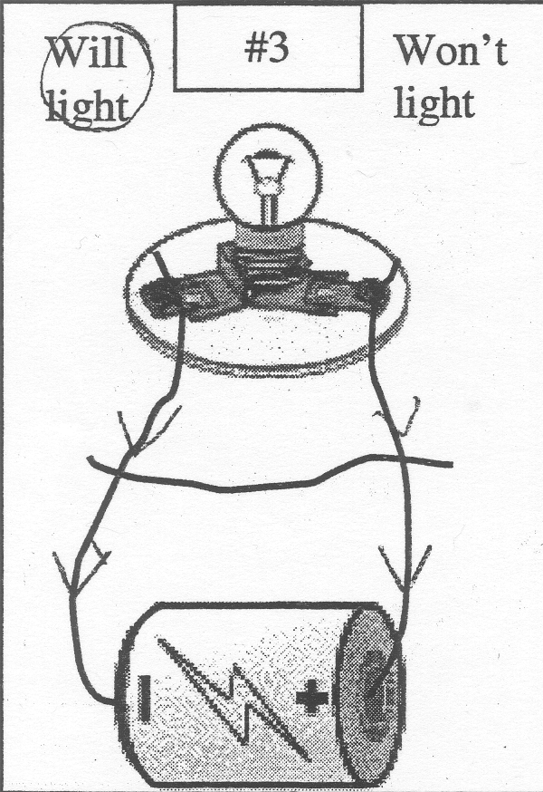
Figure 5. Resistance Models and sample PECA item demonstrating the mental model.

Validating PECA through interviews
The PECA was administered to all of the grade 5 students in the two pilot study classes. Papers were analyzed by both researchers. The few responses that were not classified the same by both researchers were discussed, and a final classification was decided upon.
We interviewed 10 students representing a range of PECA responses across both concepts (current flow direction and resistance) from the original two classes of fifth grade students and videotaped them. Students were shown a simple battery and bulb circuit and asked, “Why does the light bulb light?” Follow-up questions probed for student thoughts on the flow of electricity. Next, the interviewer held an extra wire up to the circuit in four different locations, and asked the students to predict what would happen to the circuit with the extra wire in that location. Both researchers were present at all of the interviews. Each researcher then watched the videotapes and classified each prediction offered by a student as demonstrating the use of a particular model CF 1, 2, or 3 for the first two predictions and R 1, 2, 3, or 4 for each of the following predictions. The two researchers agreed 100% of the time on the models demonstrated. These scores matched the scores given on the written PECA with a 100% accuracy. From this, we concluded that the PECA was a valid way to elicit and score these ideas from these students.

Method for the Multi-age Study
The subjects included in this study were 722 students from grades 3 through 8 in a rural school district. The reported demographics for the population studied are as follows:

Gender 46% female 54% male
Native American population 1.25%
Black 1.6%
Hispanic 3.6%
English language learners 1.5%
Poverty rate 15.6%

The PECA was administered by the classroom teachers to all of students. Using the rubrics described above for each model, the papers were analyzed by both researchers. Inter-rater reliability for the analysis of student responses was .91.

Description of grade 4 and 5 electricity instruction
The fourth graders in the district described receive kit-based instruction focusing on the development of student understanding of the concepts underlying electric circuits. These include the concepts of a complete circuit; parallel and series circuit arrangements; conductors and insulators; resistance effects of length and/or thickness of wire; the parts of the light bulb; short circuits; and finally are asked to apply their knowledge to make predictions about different circuit arrangements. Some activities focus on student predictions in the form of “mystery boxes”. The general format of the lessons is a teacher focus question, which is used to guide the activity followed by student activity sheets, completed individually or in groups by the students.
In the fifth grade, students in the district complete an electromagnetism unit. During this unit, the students complete activities designed to develop an understanding of the concepts of magnetism; the properties of electromagnets; and finally the motor/generator effects. As in grade four, the approach is kit-based with the students being guided by teacher focus questions and the students completing a series of activity sheets.
The time to complete both the electric circuit and electromagnetism units is two weeks on average. The amount of time allotted to the units is generally based on the teachers’ level of comfort in presenting the material and the amount of time available for science.

Results

Data Analysis
This multiage study used anonymous aggregate data and as such did not identify individual subgroups for comparison. All items for the concepts of Current Flow and Resistance were categorized as described above. If a student drew arrows representing electric current flow but the student’s work couldn’t be classified as one of the identified mental models, then it was considered a Null Model. If a student did not draw arrows for the item, it was considered a blank response.
Each concept was measured with five items. If a student had four or blank items for a concept, they were not included in the data set. This results in different numbers of students for each concept. For example, the total number of grade 3 students who complete the PECA was n = 108. But, because of blank responses, the number of grade 3 students used in the current flow concept was n=63, whereas the number of grade 3 student used in the resistance concept was n=83. The number of grade 4 students was lower than the other grades because two classes who were in the process of teaching the Batteries and Bulbs unit were excluded. The grade 4 classes included had not yet started the Batteries and Bulbs unit. None of the grade 5 student had begun instruction in electromagnetism when the PECA was administered.
Table 1 gives, by grade level, the number of students included in the study, the overall score on the Light/Won’t light responses (PECA items 3-20), the number of students included in the current flow concept data and the number of students included in the resistance concept data.
Table 1. Number of students included in study and the number of students included in the data for each concept studied.
 | Total PECA papers | Number of students included in Current Flow data | Number of students included in Resistance data
Grade 3 | 108 | 63 | 83
Grade 4 | 85 | 49 | 64
Grade 5 | 120 | 108 | 116
Grade 6 | 118 | 78 | 92
Grade 7 | 147 | 121 | 129
Grade 8 | 144 | 125 | 133

Consistency data
An important aspect of studying mental models is whether a student consistently uses a model for given situations that are physically equivalent, but have different physical characteristics. For example, PECA items 3, 12, 13, and 20 are equivalent circuits, but look different quite different. A student who is characterized as using the same mental model for all of these items demonstrates powerful evidence of holding the mental model as we describe. A student consistently using the scientifically correct mental model is a goal of instruction. A student who is categorized as using different mental models on these items, provides evidence that they are taking into account aspects of the circuit that are not included in our mental models. Such students need further study in order to describe the mental models they are using.
In order to determine how consistent the students are in applying their mental models, we classified each student as inconsistent or consistent in one model. For the two concepts studied, a student was considered as consistently using mental model if they were categorized as using the same model for 4 or 5 of the five items. Otherwise, the student was classified as inconsistent for that concept.

Light/Won’t light
Table 2 shows the percentage of items where the student correctly predicted whether the bulb will light or won’t light. The results indicate a reasonable ability to correctly predict whether a bulb will light or not in a given circuit. Other than as increase from grade 3 to grade 5, the results do change with grade level. Part of this increase may be attributed to the grade 4 instruction in batteries and bulbs.

Table 2. Percent of students predicting Light/Won’t Light.
 | Correct Light/Won’t Light Prediction
Grade 3 (n=108) | .61
Grade 4 (n=85) | .65
Grade 5 (n=120) | .71
Grade 6 (n=118) | .72
Grade 7 (n=147) | .73
Grade 8 (n=144) | .71

Current Flow Models
Table 3 presents the data on current flow models for each grade level. Figure 6 shows these same data graphically. When classifying students’ responses to the appropriate items from the PECA, we found that responses demonstrating use of the CF model 1 (unidirectional flow) increased steadily from 18% in third grad to 52% in eighth grade. The increase from in CF model 1 from 21% in grade 4 to 46% in grade 6 maybe due to the grade 4 and 5 instruction in electricity. The responses demonstrating CF model 2 (bidirectional flow) decreased from 60 % and 64 % in third and fourth grade to 36% in eighth grade. The items categorized as CF model 3 (null) remained at a negligible level.
Table 3. Proportion of items categorized in each current flow model
Grade Level | CF Model 1 | CF Model 2 | CF Model 3
3 (n=63) | 0.18 | 0.60 | 0.02
4 (n=49) | 0.21 | 0.64 | 0.00
5 (n=108) | 0.31 | 0.55 | 0.02
6 (n=78) | 0.46 | 0.46 | 0.02
7 (n=121) | 0.40 | 0.48 | 0.03
8 (n=125) | 0.52 | 0.36 | 0.02

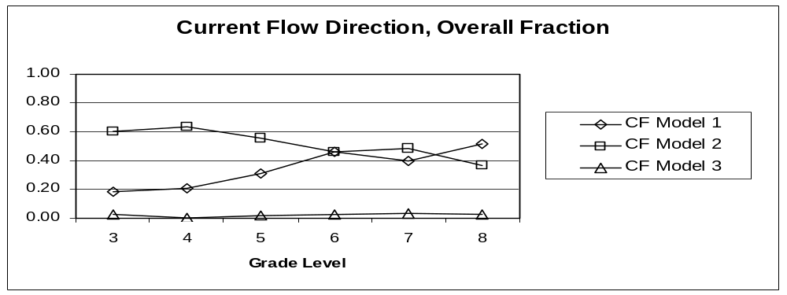
Figure 1. The proportion of items categorized in each current flow model.

When classifying the student responses, it became apparent that many students were not consistently applying any one model, but varying according to different contexts. Table 4 presents the percentages of students who demonstrated use of a consistent model for each grade level. The same data is presented graphically in Figure 7. For third grade, 32% of the students used a consistent model, with the majority consistently using CF Model 2 (Bidirectional flow) and only 2% consistently using the correct CF Model 1 (Unidirectional flow). In fourth grade, the fraction of students using a current flow model consistently was largely unchanged from third grade. Fifth grade demonstrated a great increase in overall consistency as 67% of the students used the same model consistently across four or more of the items examined. 21% consistently used the correct model CF 1, and 45% consistently used CF model 2. This increase in total consistency remained through eighth grade, but the use of CF model 1 increased, while CF model 2 decreased.
The large increase in students using a consistent model in the direction of electric current coincides with the grade 4 instruction in batteries and bulbs. The increase was across both CF model 1 and CF model 2.
Table 4. Proportion of students holding consistent current flow models
Grade Level | Consistent CF Model 1 | Consistent CF Model 2 | Consistent CF Model 3 | Consistent CF Total
3 (n=63) | 0.02 | 0.30 | 0.00 | 0.32
4 (n=49) | 0.06 | 0.31 | 0.00 | 0.37
5 (n=108) | 0.21 | 0.45 | 0.00 | 0.67
6 (n=78) | 0.33 | 0.28 | 0.00 | 0.62
7 (n=121) | 0.31 | 0.31 | 0.00 | 0.62
8 (n=125) | 0.40 | 0.26 | 0.00 | 0.66

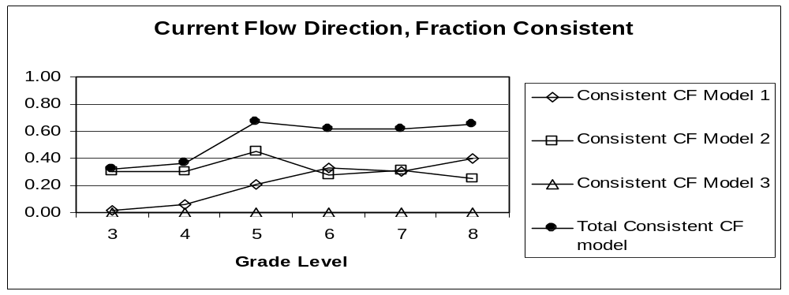
Figure 7. The proportion of students holding consistent current flow models.

Resistance Models
The results from the resistance models are given in Tables 5 and 6 and graphically in Figures 8 and 9. Only 2% of the third grade students used R model 1 (electricity flow through short circuit), compared to 25% using R model 1 (equal currents), 35% using R model 3 (electricity drawn to bulb), and 25% using R model 4 (electricity is blocked). As with the current flow models, the resistance models changed most significantly between grade 4 and grade 5 with the decrease in R model 4 being the most dramatic, 33% to 15%. The only change from grade 5 to grade 6 was a slight decrease in R model 2 in favor of the correct R model 1. From grade 6 to grade 7 the data was virtually unchanged. Grade 8 shows a shift up from R model 4 to R model 2, but no increase in R model 1.
The number of students who used a consistent R model was small and shows few patterns. A possible significant change is the increase between grade 4 and 5 from 19% to 29% of students using a consistent R model. But this increase doesn’t hold through grade 8. Virtually no students used the correct R model 1 consistently in any grade.

Table 5. Proportion of items categorized in each resistance model
Grade Level | R Model 1 | R Model 2 | R Model 3 | R Model 4 | R Model 5
3 (n=83) | 0.02 | 0.25 | 0.35 | 0.24 | 0.03
4 (n=64) | 0.03 | 0.25 | 0.31 | 0.33 | 0.02
5 (n=116) | 0.06 | 0.36 | 0.37 | 0.15 | 0.01
6 (n=92) | 0.10 | 0.30 | 0.35 | 0.15 | 0.01
7 (n=129) | 0.11 | 0.31 | 0.36 | 0.17 | 0.01
8 (n=133) | 0.11 | 0.38 | 0.32 | 0.11 | 0.03

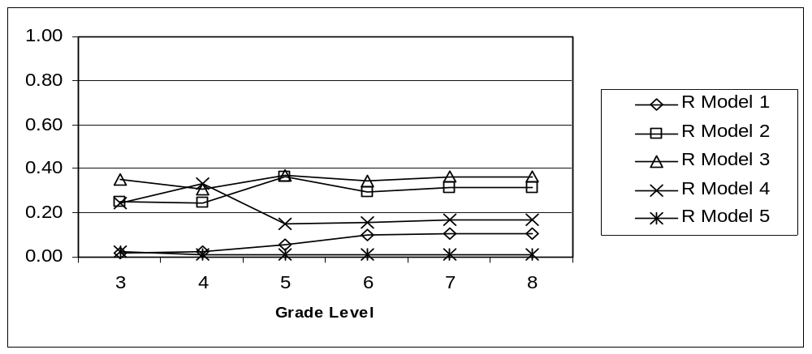
Figure 8. The proportion of items categorized in each resistance model.

Table 6. Proportion of students holding consistent resistance models
Grade Level | Consistent R Model 1 | Consistent R Model 2 | Consistent R Model 3 | Consistent R Model 4 | Consistent R Model 5 | Consistent Total
3 (n=83) | 0.00 | 0.05 | 0.06 | 0.02 | 0.01 | 0.14
4 (n=64) | 0.00 | 0.03 | 0.02 | 0.14 | 0.00 | 0.19
5 (n=116) | 0.00 | 0.17 | 0.09 | 0.03 | 0.00 | 0.29
6 (n=92) | 0.01 | 0.12 | 0.11 | 0.02 | 0.00 | 0.26
7 (n=129) | 0.00 | 0.05 | 0.05 | 0.02 | 0.00 | 0.12
8 (n=133) | 0.01 | 0.14 | 0.07 | 0.02 | 0.00 | 0.23

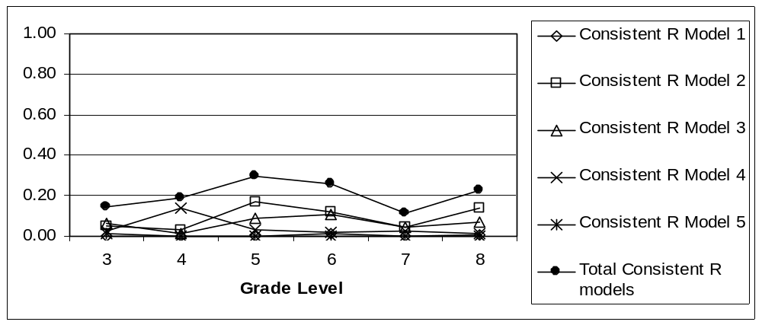
Figure 9. The proportion of students holding consistent resistance models.

Discussion

Model Analysis
The primary goal of our research was to classify students’ thinking based on our estimates of their mental model was the primary goal of our research. The evidence we used to classify the students’ mental models was their response to a set of simple battery and bulb circuits where the student was asked to predict if the light would light of not and then to draw arrows representing the amount of electric current and the direction of the current flow. As shown in tables 3 and 5, we successfully classified the mental models for approximately 98% of the items where students drew arrows. This high rate of model estimation gives us high confidence in our data and the inferences stemming from our data.

Light/ Won’t Light Assessment
The students’ ability to predict whether a light bulb will light or not is routinely used as a measure of the students’ understanding of the current electricity concepts presented during instruction as well as a measure of teacher effectiveness in presenting the material. Based on the results of this study, it appears that the use of these student predictions may not be a sufficient measure of either of these constructs.
First, as shown in Table 2 it should be noted that there was little change across the age groups studied in their ability to correctly predict whether the light bulb would light or not and that 61% of students were able to make this prediction successfully in grade three prior to any formal instruction on this topic. Secondly, the findings of this study indicate that students were able to make correct predictions about Light/Won’t Light based not only on correct understandings but also by applying incorrect reasoning.
A compelling example of such a case is shown in Figure 5, Resistance model 4. The student in this situation, an eighth grader, was able to correctly predict that the bulb would not light. This was not based on an understanding of resistance and the existence of a short circuit, but rather on the student’s belief that the short circuit wire would “block” the flow of current so the bulb would not light. In addition to this, the student in this example also holds a “clashing current” model for the flow of electricity. Neither of these incorrect models would be revealed through a simple Light/Won’t Light assessment and in fact, this student would have been seen as understanding the material due to correct responses to the questions.

Blocking Idea
One of the most surprising of our findings was the prevalence of the Blocking Idea. This is an idea that many students used as a primary characteristic of a circuit in determining how the electric current flowed in the circuit, predicting that current stops flowing when an extra wire is crossing the circuit. Instruction in simple electric circuits usually doesn’t include any investigations of blocking wires. This is an area that would benefit from future research using instruments such as the PECA that specifically elicit this idea.

Consistency data
One of the important aspects of this research was the analysis of the consistency of the students thinking. We believe that using a mental model consistently in different situations is a sign of scientific thinking. We found a range of consistency in the mental models that the students used. In the Current Flow modeling, we found that many students did come to use one model consistently, while the categories of resistance models showed little consistency. The Current Flow consistency increased across grades, especially after instruction, demonstrating that students were coming to develop robust models of Current Flow and were able to apply these to novel situations.
The lack of consistency in the application of resistance models may be an indication that students were not using resistance ideas, but rather applying other models based on the characteristics of the circuit. The blocking mental model might be an example of this. One could argue that if a student thinks that electric current is blocked by a wire that crosses its normal path then that student is not thinking about resistance at all, but using some other model to analyze the electric circuit.

Instruction Effect on Current Flow Models
The large data set across many grade levels allowed us to observe the effects of grade 4 instruction. This effect was observed in the Current Flow Models. Most notable was the effect on the consistency that the students used in applying the current flow mental models. As shown in Table 4, the number of students using a single mental model for at least four of the five items increased from 37% to 67% and remained at 65% through grade 8. It appears that one effect of instruction is that students did not become distracted by unusual characteristics of a circuit when using a current flow model. If they used a bidirectional flow model on a shorted circuit, then they would use a bidirectional flow model on a circuit with no extra wire. However, the increase in the consistency was not accompanied with a decrease in the incorrect bidirectional flow model. Our data did not reveal any effect of instruction in changing the mental models of students who were consistently using a bidirectional flow model. Future research could more carefully study sets of students who hold a bidirectional flow model before instruction, and track the effects of different types of instruction on modifying this model.

Implications for Instruction

We found that these students in grade 3 through grade 8 used a small number of mental models when thinking about how electric current flowed through simple circuits. We believe that knowledge of these models can inform instruction. Certainly, knowing that some students think electric current is blocked by a wire crossing the circuit can lead educators to design activities to allow the students to explore how an extra wire affects the current flow (as indicated by the light bulb).
This research also reveals the problems in assessing students through simple Light/Won’t Light predictions, so educators will want to be cautious in interpreting student responses to Light/Won’t Light assessments. We have shown that the student may predict correctly but be using an incorrect mental model. Teachers may instead instruct the students to show the current flow and reveal much richer data about their understanding.
Our research demonstrates that developing the concept of resistance is not a simple matter. It may be beneficial to have students make observations of shorted-out bulbs and make sense of their observations.

Conclusion
The Path of Electric Current Assessment (PECA) proved to be a valuable tool in allowing us to elicit and classify the mental models students used in explaining how electricity flows through simple battery and bulbs circuits and led to significantly more information than the Light/Won’t Light predictions. Model analysis allowed us to classify the student responses and to identify three models of current flow and five models of resistance. The mental models for Current Flow became more consistent somewhat more accurate and as the grade levels increased. The models for Resistance did not become more correct nor more consistent. These results provide us with many implications for instruction and suggestions for future research.

REFERENCES

American Association for the Advancement of Science. (1989). "Science for all Americans." New York: Oxford University Press.

American Association for the Advancement of Science. (1993). "Benchmarks for science literacy." New York: Oxford University Press.

Anderson, A., Tolmie, A., Howe, C. J., Mayes, J. T. and Mackenzie, M. (1992). Mental models of motion. In Y. Rogers, A. Rutherford and P. Bibby (eds.) Models in the mind: Theory, Perspective and Application. London: Academic Press, 57-71.

Arnold, M., Millar, R. (1987). "Being constructive: An alternative approach to the teaching of introductory ideas in electricity." International Journal of Science Education 9(5): 553-563.

Beichner, R. J. (1994). "Testing student interpretation of kinematics graphs." American Journal of Physics 62(8): 750-762.

Chiu, M. H., Chou, C. C., & Liu, C. J. (2002). "Dynamic processes of conceptual change: Analysis of constructing mental models of chemical equilibrium". Journal of Research in Science Teaching, 39(8), 688- 712.

Cohen, R., Eylon, B., Ganiel, M. (1983). "Potential difference and current in simple electric circuits: A study of students' concepts." American Journal of Physics 51: 407-412.

Coll, R.K., & Treagust, D.F. (2003 a). "Learners’ mental models of metallic bonding". Science Education, 87, 685-707.

Coll, R.K., & Treagust, D.F. (2003 b). "Investigation of secondary school, undergraduate and graduate learners’ mental models of ionic bonding". Journal of Research in Science Teaching, 40(5), 464-886.

Cosgrove, M. (1995). "A study of science-in-the-making as students generate an analogy for electricity." International Journal of Science Education 17(3): 295-310.

Craik, K.J.W. (1943). The nature of explanation. Cambridge, England: Cambridge University Press.

DiSessa, A. A. (1988). Knowledge in pieces. In G. Forman & P. Pufall (Eds.), Constructivism in the computer age (pp. 49-70). Hillsdale, NJ: Erlbaum.

Driver, R., Guesne, E., & Tiberghien, A. (1985). Children's ideas in science. Philadelphia, PA: Open University Press.

Duit R. (2002) Bibliography – Students’ Alternative Frameworks and Science Education. IPN, Kiel.

Dupin, J. J., Johsua, S. (1987). "Conceptions of French pupils concerning electric circuits: structure and evolution." Journal of Research in Science Teaching 24(9): 791-806.

Eylon, B. S., Ganiel, U. (1990). "Macro-micro relationship: the missing link between electrostatics and electrodynamics in students' reasoning." International Journal of Science Education 12(1): 79-94.

Fraser, B.J. & Tobin K. (Eds). (1998). International Handbook of Science Education. Dordrecht, The Netherlands: Kluwer.

Fredette, N. H., Lochhead, J. (1980). "Student conceptions of simple circuits." The Physics Teacher 18(3): 194-198.

Gentner, D. & Stevens, A.(1983). Mental Models. Hillsdale, NJ: Erlbaum.

Gilbert, J.K. and C.J. Boulter, Eds. (2000). Developing Models in Science Education. Dordrecht, Kluwer Academic Publishers.

Heller, P. M., Finley, F. N. (1992). "Variable uses of alternative conceptions: A case study in current electricity." Journal of Research in Science Teaching 29(3): 259-275.

Helm, H. and Novak, J.D. (Eds) (1983). Proceedings of the International Seminar: Misconceptions in Science and mathematics, Ithaca NY : Cornell University.

Hestenes, D., Wells, M. , Swackhamer, G. (1992). "Force concept inventory." The Physics Teacher 30(3): 141-166.

Johnson-Laird, P. N. (1983). Mental Models: Towards a Cognitive Science of Language, Inference and Consciousness. Cambridge University Press, Cambridge

Licht, P. (1990). A microscopic model for a better understanding of the concepts of voltage and current. Relating macroscopic phenomena to microscopic particles: a central problem in secondary Science Education. P. L. Lijnse, Licht, P. , Vos, W. de, Waarlo, A. J. Utrecht, CD-ß Press: 316-327.

Maichle, U. (1981). Representation of knowledge in basic electricity and its use for problem solving. Proceedings of the international workshop on "Problems Concerning Students' Representation of Physics and Chemistry Knowledge". W. Jung, Pfundt, H. , Rhoeneck, C. von. Ludwigsburg, Paedagogische Hochschule: 174-193.

McDermott, L.C. & van Zee, E.H. (1984). Identifying and addressing student difficulties with electric circuits. Proceedings of the International Workshop: Aspects of Understanding Electricity (pp. 39-48), Pädagogische Hochschule Ludwigsburg, W. Germany.

National Research Council (NRC), (1996). National Science Education Standards (NSES). National Academy Press. Washington D.C.

Novak, J.D. (1987). Proceedings of the second international seminar on misconceptions and educational strategies in science and mathematics, July 26-29, 1987. Vol. III. Ithaca, NY: Cornell.

National Resources Center (2002). Electric Circuits. Science and Technology for Children (STC) series. Burlington, N.C.: Carolina Biological Supply.

National Resources Center (2002). Electrical Energy & Circuit Design. Science and Technology for Children (STC) series. Burlington, N.C.: Carolina Biological Supply.

Osborne, R. (1981). "Children's ideas about electric current." New Zealand Science Teacher(29): 12.

Osborne, R. (1983). "Towards modifying children's ideas about electric current." Research in Science and Technological Education 1(1): 73-82.

Osborne, R., Freyberg, R. (1985). Children's science. Learning in science. The implications of children's science. R. Osborne, Freyberg, P. Auckland, Heinemann: 1-14.

Psillos, D., Koumaras, P. , Valassiades, O. (1987). "Pupils' representations of electric current before, during and after instruction on DC circuits." Research in Science and Technological Education 5(2): 185-199.

Rogers, Y., Rutherford, A. and Bibby, P.A. (1992) (eds.), Models in the Mind: Theory Perspectives and Applications. London: Academic Press.

Shipstone, D.M., Rhoneck, C., Jung, W., Karrqvist, C., Dupin, J.J., Johsua, S. Licht, P.
(1988). A study of student understanding of electricity in five european countries. International Journal of Science Education, 10(3):303-316.

Shipstone, D. M. (1984). "A study of children's understanding of electricity in simple DC circuits." European Journal of Science Education 6(2): 185-188.

Tiberghien, A. (1983). "Critical review of research concerning the meaning of electric circuits for students aged 8 to 20 years." Summer Workshop "La Londe les Maures": 1-18.

Tiberghien, A., Delacote, G. (1976). "Manipulation et representations de circuits electrique simples chez des enfants de 7 a 12 ans." Review Francaise de Pedagogie 34: 32-44.

Treagust, D.F., Duit, R. & Fraser, B.J. (1996). Overview: Research on students’ preinstructional conceptions– The driving force for improving teaching and learning in science and mathematics. In Treagust, Duit and Fraser (Eds.), Improving Teaching and Learning in Science and Mathematics (pp 1-14.) New York: Teachers College Press.

Wandersee, J. H., Mintzes, J. J., & Novak, J. D. (1994). Research on alternative conceptions in science. In D. Gabel (Ed.), Handbook of Research on Science Teaching and Learning : A Project of the National Science Teachers Association (Chapter 5 pp. 177-210). New York: Macmillan.

White B.Y., Frederiksen J.R. (1987). " Qualitative Models and Intelligent Learning Environments ", in Lawler R., Yazdani M. (Eds.) (1987). Artificial Intelligence and education, vol. 1, Norwood, NJ: Ablex p. 281-305.

Appendix
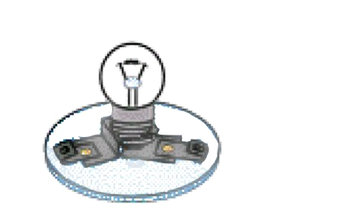
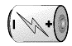
For each picture, use arrows on the wires to show how much electricity you think is moving in each wire. If you think no electricity is moving in the wires, write NO on the wire. Draw more arrows if you think there is more electricity moving through the wire.
BARE wires connect a bulb and battery
One BARE wire connecting the two ends of a battery
#1
#2

TeacherDateStudent Code
The picture below shows how a student has used arrows to show how much electricity is moving in bare wires that is part of a circuit. Look carefully at how the student showed the electricity moving in the wires.
A wire with a lot of electricity that is moving down the wire.
NO
A wire with not very much electricity moving up the wire.
Wire with no electricity moving in it.
NO
Path of Current Electricity Assessment

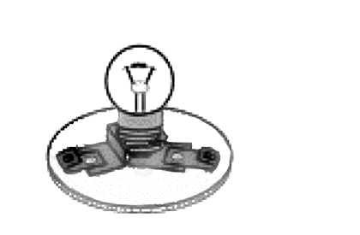
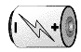
Directions: For each of the pictures below, a bulb is connected to a battery with BARE wires. The wires don’t have any plastic coating on them. For each picture, circle if you think the light bulb will light or won’t light. Then use arrows on the wires to show how you think the electricity is moving in the wires. If you think no electricity is moving in a wire, write “NO” on the wire.

#3
Will light
Won’t light
#4
Will light
Won’t light
#5
Will light
Won’t light
#9
Will light
Won’t light
#11
Will light
Won’t light
#15
Will light
Won’t light
#17
Will light
Won’t light
#10
Will light
Won’t light
#16
Will light
Won’t light

Wire with no Wire withWire with
electricitysome electricity a lot of
moving in it.moving downelectricity up
the wire. the wire.

NO
#6
Will light
Won’t light
#7
Will light
Won’t light
#8
Will light
Won’t light
#12
Will light
Won’t light
#13
Will light
Won’t light
.
#14
Will light
Won’t light
#18
Will light
Won’t light
#20
Will light
Won’t light
Will light
Won’t light
#19

