The NSF-Noyce WNY Partnership for New Science and Math Scholars

WNY Partnership

Colleges and Centers
SUNY Buffalo State College
Center for Excellence in Rural and Urban Education

School Districts
Buffalo Public Schools
Niagara Falls School District

The following BOCES and component School Districts:
Chautauqua-Alleghany BOCES
Erie 1 BOCES
Erie 2 BOCES
Genesee Valley BOCES
Niagara-Orleans BOCES
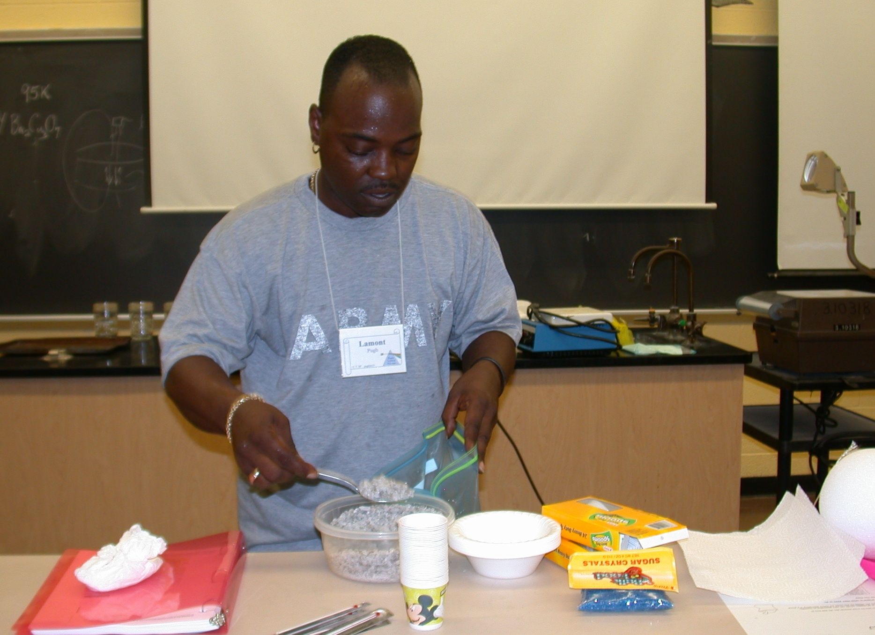

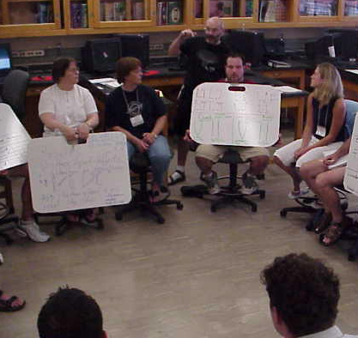

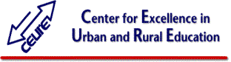


DUE0434103

NSF-Noyce WNY Partnership for

New Science and Math Scholars
Science Building #222
1300 Elmwood Avenue
Buffalo, New York 14222-1095
Phone (716) 878-3802
Fax (716) 878-4524

NOYCE SCHOLARSHIPS AND STIPENDS FUNDING NEW MATH AND SCIENCE TEACHERS at
Buffalo State
Supporting career-changing individuals today who will become the math and science teachers of tomorrow



Interested in financial and collegial support as you bridge into a math or science teaching career? We can help!

For more information:
http://physicsed.buffalostate.edu/noyce
SCHOLARSHIPS AND STIPENDS FOR NEW MATH AND SCIENCE TEACHERS
Your background in mathematics & science (or STEM: Science, Technology, Engineering and Math) makes you an ideal candidate for switching into a career in math or science teaching. The two areas of greatest shortage in New York State teacher supply are mathematics and science.

Teacher certification
New York State certification requirements may be met through traditional or alternative certification programs at Buffalo State College. Additional information may be found at:
http://physicsed.buffalostate.edu/noyce
http://www.buffalostate.edu/teachercertification/
Touch the future – teach!

Noyce Funding
Noyce scholarships support STEM major students transferring into Bachelors degree science or math teacher preparation programs as either a Junior or Senior. Noyce scholarship recipients may receive a maximum of $8500 per year for up to two years.
Applicants who already hold a STEM Bachelors degree and who enter either a post-baccalaureate or Masters Degree teacher certification program may be eligible for a one year maximum
Noyce stipend of $10,000.
Noyce scholarships and stipends are intended to recruit new science and mathematics teachers by defraying real study costs (tuition, room, board etc. ) for individuals transitioning to a STEM teaching career. Noyce scholarship and stipend recipients are expected to teach two years in high needs districts for every year of scholarship or stipend support received. Participants must complete their certification program within two years; and they must meet their teaching commitment within six years of completion of the program. Participants who fail to meet the teaching requirement will be expected to repay the NSF the amount of their Noyce support plus 5% (fixed annual interest).
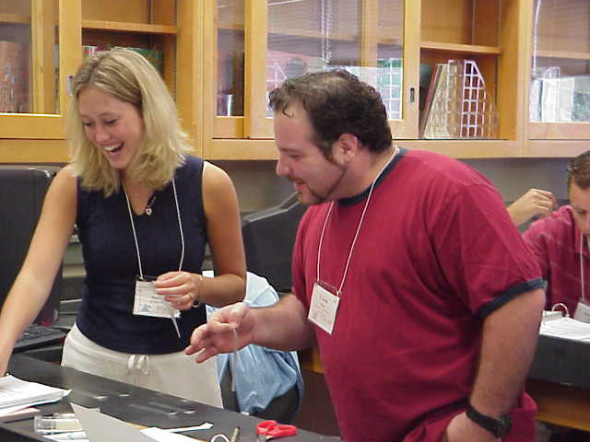
While the shortage of NYS STEM teachers is great, the shortage of STEM teachers is particularly acute for minority teachers, and minority candidates are particularly encouraged to apply for Noyce support.

Partnership Information
Additional information can be obtained by contacting the following individuals:
Principal Investigator:
Dr. Dan MacIsaac
danmacisaac@mac.com
(716) 878-3802
222Science Bldg
Co-Investigators:
Dr. Joseph L. Zawicki
zawickjl@buffalostate.edu
(716) 878-3800
Dr. Sue McMillen
mcmillse@buffalostate.edu
(716) 878-4523
Dr. David Henry
henryd@buffalostate.edu
(716) 878-5619
Dr. David Wilson
wilsondc@buffalostate.edu
716) 878-6218

Call (716) 878-3802
To ensure the fullest review, please submit applications for the
Spring semester by November 15th
Fall semester by June 15th
Summer session by April 15th

