Encouraging Reflection in the Physics Classroom
Charles Abramo

A project submitted in partial fulfillment of the requirements of the degree of
Master’s in Physics Education

State University of New York College at Buffalo
Dr. Dan MacIsaac
17 April 2014

Supervisory Faculty: Associate Professor Daniel MacIsaac
Assistant Professor Luanna S. Gomez
Physics Department, Buffalo State SUNY

Abstract
High school students should be encouraged to reflect on their own learning (Bercher, 2012). Reflection is a process of considering a concept specifically with respect to learning (Schön, 1987). Reflection will enhance student metacognition, the awareness and knowledge of one’s own learning and the ability to communicate about one’s own learning (Johnson & Johnson, 1998), (Metcalfe & Shimamura, 1994), and help students become the independent learners they will need to be in order to be successful in a university setting (Vygotsky, 1978) and later in life (Schön, 1987). Such tools as described herein assist the physics teacher to encourage students to reflect. I present three examples of reflective tools within a mechanics topic context. The first example is small group collaboration to graph position versus clock reading (Johnson & Johnson, 1998), (Megowan, 2007). The second example is learning commentary for two dimensional motion (Novak, Gowin & Butler Kahle, 1984), (physicsed, 2014). The last example is solving a rich-context problem as a summative assessment after two dimensional motion (U MN PER Group, 2014). I include what prior knowledge I expect students to have, difficulties I expect to arise related to reflection, and instructional strategies to overcome these difficulties. I also relate the mechanics topics to the NYS Physics Core Curriculum. According to the work of Hestenes, Liem, Megowan, Schön, and Vygotsky, these tools are useful for encouraging high school students to reflect on their own learning (see appendix B – List of Reflection Tools).

Table of Contents
Title page 1
Supervisory faculty 2
Abstract 2
Table of contents 3
Background 4
General tools 7
Small group collaboration 8
Learning commentary 15
Rich-context problem 18
Conclusion 23
Appendices 26
A – Know Scale 26
B – List of Reflection Tools 27
C – Learning Commentary Rubric 28
D – Learning Commentary Example 29
E – RTOP Information 31
F – Glossary 32
G – Annotated References 38
Bibliography 44
Biography 47

Background
Throughout this document, words followed by an asterisk are defined in the included glossary (see appendix F – Glossary). The glossary includes citations and provides context for the words.
Reflection* is an amazing human tool, capable of raising each of us to greater ability. According to Schön, “thinking [of] what they are doing while they are doing it,” called reflection-in-action*, leads to constructive* insights (1987, p. 26-31). Reflection in general will focus attention on the factors involved in an action thus allowing one to remember the activity and judge it in respect to similar activities. Reflection on learning*, specifically, will enhance a student’s metacognition*, the awareness and knowledge* of one’s own learning and the ability to communicate about one’s own learning (Metcalfe & Shimamura, 1994). Thus reflection will help him/her become an independent learner (Schön, 1987).
The problem in education*, as pointed out by Schön (1987), is that instruction communicates specific techniques but the choice of applying such techniques requires judgment in ethics. Problem-solving requires a wider understanding* of the society and conditions in which the problem exists than specific techniques alone. Thus metacognition plays a role in deciding what factors are to be included in the problem to be solved. Of course, different professions have different roles, so it is to be expected that different people will choose a different set of factors to consider. However, it can be expected that a true professional will not solve a problem in a manner which will violate a law, or rights of people affected by his/her solution. More is required from education than familiarity with isolated facts; understanding of systems and ability to make inferences with new data is vital. Thus, independent learning skills are essential (Schön, 1987).
A personal reflection of Carl Rogers to a group of teachers assembled at Harvard University in 1952 included the observation that the “only learning which significantly influences behavior is self-discovered, self-appropriated learning.” (Schön, 1987, p. 89). Reflection is a powerful tool in equipping students to be independent learners. Reflection is the bridge between knowledge and the uncertainty students will face (Schön, 1987).
Reflective* learning is an extensive process but worth the effort as it generates student confidence (Pidgeon, 2011). The general learning process consists of several steps. Not all steps lend themselves to reflection. In all, the steps would include confronting a novel situation, recognizing the situation as novel, identifying the phenomenon, establishing a context for the phenomenon, finding a means of predicting the phenomenon and codifying the circumstances under which the means of prediction is valid. Confronting novel situations and recognizing the situation as novel is traditionally ignored in education. Efforts have been made by Tik Liem (1989), David Hestenes (2011) and others to create awareness in education of the necessity to provide experiences for discrepant events which lead to confront and recognition. Traditional education relies on instructor lecture. Regardless of these experiences being provided or not, such steps are not purely reflective.
The reflective parts of the learning cycle are four; they should include identifying the phenomenon, establishing a context for the phenomenon, finding a means of predicting the phenomenon and codifying the circumstances under which the means of prediction is valid. Identifying a phenomenon is also referred to as “naming”* (Arons, 1997). Establishing the context for a phenomenon is referred to as “framing”*(Arons, 1997) (Megowan, 2007). Finding a means of predicting a phenomenon is embraced by traditional scientific methods but to do so reflectively requires an awareness of reason for the prediction (Arons, 1997, pp. 5-8). Codifying the circumstances under which the means of prediction is valid usually takes a great deal of experimentation. In a physics classroom, some reflection on limiting conditions are qualitatively useful (Arons, 1997). Regardless of the sequence, a perfect reflective tool would ideally contain all six components of learning (confronting a novel situation, recognizing the situation as novel, identifying the phenomenon, establishing a context for the phenomenon, finding a means of predicting the phenomenon and codifying the circumstances under which the means of prediction is valid). It would be ideal because a student could apply the sequence itself to problem solving – it is a scientific method (Hestenes, 2011) (Mason & Singh, 2010). But any tool designated as reflective must incorporate at least one of the four reflective parts of the learning cycle (identifying the phenomenon, establishing a context for the phenomenon, finding a means of predicting the phenomenon and codifying the circumstances under which the means of prediction is valid). These are reflective because they lend themselves to a “how do I know*?” analysis (Nowak & Gowin, 1987) (Schön, 1987). My focus is on reflective tools for use in instruction of mechanics. I leave perfect reflective tools to curriculum designers who can embrace more class time.

General tools
An obstacle to becoming a reflective individual resides in the belief that there is one correct route (Gearhart, 2009) or one correct answer. Explicitly directing a student to be reflective, thus creates an additional task, in the student mind, to add to other requirements. Such is unnecessarily overwhelming. Using the tools which follow will create a reflective student without challenging the student to know the right way to do it or making the student do something extra.
Similarly, an educator is overwhelmed with entreaties to practice a certain methodology or use best-practices. In spite of this, professional development is generally desired. “Teachers, who often resent becoming targets of blame for the perceived failures of public education, tend nevertheless to advocate their own versions of the need for professional development and renewal.” (Schön, 1987, p. 15). The tools I describe below may be used as a physics teacher sees fit. They can be used once or repeatedly. One or many can be incorporated into a curriculum or unit. In contrast to something extra, the tools provided are in common use and considered best-practices. This document serves to qualify the reason for the tools’ success with respect to reflective instruction.
There are three main types of tools which will assist the teacher to encourage students to reflect*. These types are arranged by application. One type is for an instructor to apply. Another type is for either an instructor or a student to apply. The third type of tool is for a student to apply to himself. All of my examples are instructor applied tools: small group collaboration, learning commentary and rich-context* problem. A list of all tools is included in Appendix B – List of Reflection Tools.

Small Group Collaboration
The goal of self-reflection as a learner is assisted by practice of reflective thought. As such, employment of communication skills toward expression of reflective thought is useful. The instructor can direct small groups to collaborate on physics problems (Mason & Singh, 2010) and later explain their findings to the class. Groups of three or four students, whether heterogeneously or homogeneously constructed are given a task to explore and explain a physics problem. Content and problem-solving strategies are learned* while reflection takes place. See Appendix E – RTOP* Information. Collaboration is assisted by use of white boards (Megowan, 2007). Hence, a “board meeting” is held after students complete collaboration. Student dialogue attempts to elicit any useful prior knowledge and agree on a method of solution. A method toward a solution can be attempted and abandoned with group understanding of why the method would fail. Instructor attention is placed on asking why students are choosing an approach, how they know it is valid, and reminding them that they will need to explain what they are doing to the larger group (Johnson & Johnson, 1998, p. 7:2-14). Students coach each other to be better students by “observing student performance, detecting errors of application, pointing out correct responses” (Schön, 1987, p. 39), and explaining reasoning (the reflective part). Both experimental and logical methods must be coordinated before a sensible mathematical approach can determine a solution (Knight, 2004). The group is responsible for each group member to understand the process used and reasons for decisions (Megowan, 2007). Thus, small group collaboration will encourage reflection by identifying the phenomenon, establishing a context for the phenomenon, finding a means of predicting the phenomenon and codifying the circumstances under which the means of prediction is valid.
In the context of graphing position versus clock reading (Arons, 1997, pp. 25-30), students are given the task to create graphs of position with respect to time and to explain the results as a group, to the class as a whole. Range finders and a clock are made available, or, alternatively, either tape measures and watches are made available, or a computerized range finder and some data collection and analysis program (e.g. Logger Pro©, a Vernier product) is provided to each group. If a computerized range finder and some data collection and analysis program is provided to each group and dry-erase white boards (2’ X 3’ size) are available, a kinesthetic approach is possible (Megowan, 2007). One student holds the white board toward the range finder to provide a good signal and walks toward and away from it while another student is collecting data (McDermott, 1987). The observed motion coupled with the graphical display “register the concepts” (Arons, 1997, p. 29). Instructor emphasis is on directing the students to show the motion and graph on the white board, and making sure that each student in a group can explain how the motion corresponds to the graph (not just one student) (Megowan, 2007). Although such an activity as described herein is followed by group presentation of results to the class as a whole, I limit my comments to the small group collaboration part of the activity, for simplicity.
Prior to beginning a unit on rectilinear kinematics, a student is expected to have some knowledge of mathematics and science. Particular to mathematics, a student should have some understanding of change (difference) and graphing (McDermott, 1987). Particular to science, a student should have some understanding and at least some experience with the range finder, the data collection and analysis program, group work, white board presentation, relative position, and clock reading. In addition, it would be helpful if students have been exposed to the difference between a position (point in space) and a length (difference between points), and similarly to the difference between an instant (point of time) and an interval or duration (difference between instants), these being the physical applications of mathematical differences. The concept of change is pertinent to finding lengths and durations (Arons, 1997, p. 25). The process of graphing is a fundamental skill which, if absent, will result in serious misinterpretations of the graph and communication between students. Familiarity with equipment and programs is useful for rapidly moving from task orientation to data acquisition to analysis. The faster the students can progress, the more likely they are to stay interested and focused. Familiarity with group work and white board presentations falls under mode of learning. Transitions consume time when they are not drilled beforehand. The concept of relative position is important to avoid confusion about the location in the room represented by the origin of the graph as well as clarifying dimensions; the activity as described has one dimension (position measured from the range finder) regardless of the direction it is pointed (McDermott, 1987). The concept of clock reading is important to differentiate time as an instant and time as an interval as well as to avoid confusion about the instant represented by the origin of the graph (Arons, 1997, p. 25).
While graphing position versus clock reading, it is expected that students will have trouble with technology, giving verbal interpretations of lengths in their position versus clock reading graph (vertical, horizontal or diagonal) (Arons, 1997, p. 28-30). Trouble with technology can occur when settings are changed or defaults are restored. These troubles are more frequent if the students are not familiar with the technology and/or the students are particularly curious (not a bad thing). Instructor familiarity with the equipment is essential in preventing such setbacks and correcting them quickly when they crop up. Student difficulties in verbal interpretation of lengths in their position versus clock reading graphs result from lack of prior knowledge, misunderstanding of prior knowledge, inattentiveness during data collection, or an inability of the student to bridge the gap from the concrete event to the abstract representation of the event. Lack of prior knowledge can be determined by careful questioning, working back until a certainty of concept is ascertained and the working forward again until the student grasps current events. For example, “What motion did you do? When did you do that? What point on the graph represents this? What does this change in the graph mean? What would a horizontal line mean here? (Arons, 1997, p. 22-26, 28-30). Misunderstanding of prior knowledge is also determined by careful questioning but while the instructor is working back to a certainty of concept, the student will originate a false datum. Continued questioning of how the student believes this while pointing out known contradictions will eventually overcome the false belief preventing learning. For example, a student may claim an object moved three meters when the lab bench is only two meters long. Asking, “How do you know that?” would reveal the use of the number on the graph. Pointing out the length of the bench would result in student confusion and embarrassment. Asking how the graph shows distance would likely displace the student’s misunderstanding to the graph (“the graph is wrong”). Emphasizing the graph is right, and asking again how the graph shows distance would disclose the misconception that the “position” shown on the graph is understood to be “distance” “like in math class last year” (Megowan, 2007). Thus the misconception can be addressed explicitly (Arons, 1997, p. 25). Inattentiveness during data collection can be determined by questioning what the student did (maybe nothing as the other group members worked). If questioning does not produce recall of events (student may have been texting or daydreaming), the activity will have to be replicated. An inability to bridge the gap between a concrete event and the abstract representation of the event may be overcome by encouraging students to work forward from the motions observed to the graph they drew and backward from the graph to the motion (Vygotsky, 1978). If this continues difficult, an exercise of using the hand to describe motions given by a particular graph will scaffold* the students into developing the appropriate concepts (Arons, 1997, p. 28). Positioning the hands vertically to match the graph can further scaffold conceptual development (Arons, 1997). Thus, any difficulty the student encounters may be remedied and lead the student from concrete* to formal operation*.
Graphing position versus clock reading meets the requirements of the NYS Physical Settings Physics Core Curriculum (2011).
Standard 1: Analysis, Inquiry, and Design
Students will use mathematical analysis, scientific inquiry, and engineering design, as appropriate, to pose questions, seek answers, and develop solutions.
Mathematical Analysis
Key Idea 1: Abstraction and symbolic representation are used to communicate mathematically.
M1.1 Use algebraic and geometric representations to describe and compare data.
• Use scaled diagrams to represent and manipulate vector quantities.
• Represent physical quantities in graphical form.
• Construct graphs of real-world data (scatter plots, line or curve of best fit).
Key Idea 2: Deductive and inductive reasoning are used to reach mathematical conclusions.
M2.1 Use deductive reasoning to construct and evaluate conjectures and arguments, recognizing that patterns and relationships in mathematics assist them in arriving at these conjectures and arguments.
• Interpret graphs of real world data to determine the mathematical relationship between the variables.
Key Idea 3: Critical thinking skills are used in the solution of mathematical problems.
M3.1 Apply algebraic and geometric concepts and skills to the solution of problems.
• Explain the physical relevance of properties of a graphical representation of real-world data, e.g., slope, intercepts, area under the curve.
Scientific Inquiry
Key Idea 1: The central purpose of scientific inquiry is to develop explanations of natural phenomena in a continuing, creative process. Students:
• develop extended visual models and mathematical formulations to represent an understanding of natural phenomena
• clarify ideas through reasoning, research, and discussion
• evaluate competing explanations and overcome misconceptions
Key Idea 2: Beyond the use of reasoning and consensus, scientific inquiry involves the testing of proposed explanations involving the use of conventional techniques and procedures and usually requiring considerable ingenuity. Students:
S2.1 Devise ways of making observations to test proposed explanations.
• Design an experiment to investigate the relationship between physical phenomena.
S2.2 Refine research ideas through library investigations, including electronic information retrieval and reviews of the literature, and through peer feedback
obtained from review and discussion.
S2.3 Develop and present proposals including formal hypotheses to test explanations; i.e., predict what should be observed under specific conditions if the explanation is true.
S2.4 Carry out a research plan for testing explanations, including selecting and developing techniques, acquiring and building apparatus, and recording observations as necessary. (Note: This could apply to many activities from simple investigations to long-term projects.)
Strategies
Key Idea 2: Solving interdisciplinary problems involves a variety of skills and strategies, including effective work habits; gathering and processing information; generating and analyzing ideas; realizing ideas; making connections among the common themes of mathematics, science, and technology; and presenting results.
• Collect, analyze, interpret, and present data, using appropriate tools.
• If students participate in an extended, culminating mathematics, science, and technology project, then the students should:
§ work effectively
§ gather and process information
§ generate and analyze ideas
§ observe common themes
§ realize ideas
§ present results

While this topic is covered early in the course and provides for few standards, it contains concepts which are fundamental and which are built upon later (Arons, 1997, p. 1), in providing for more standards. Furthermore, it is advisable to continue construction of concepts by spiraling back to more fundamental concepts in later units (Arons, 1997, p. 1). Thus, while instructing required material, an instructor may be providing for his/her students’ continued reflective development (Megowan, 2011).
An instructor can assess students’ reflective development by noting the degree of involvement during the data collection and graphing. Positive indicators while collecting data will be student originated questions and explanations of importance of starting or ending position, speed, etc. Positive indicators during graphing would be discussions of meaning of origin, axes, etc. and how the meaning can be effectively communicated. Development can also be gauged by responses to instructor inquiries as to how the group knows something that is written on the white board.
Teacher administration required to use this technique in class varies with students. Expectations of 80 to 100 minutes to develop this activity prior to group presentation of results to the class would be reasonable. Group presentation in the form of a “board meeting” or “circle white board” is an additional time investment (Megowan, 2007).
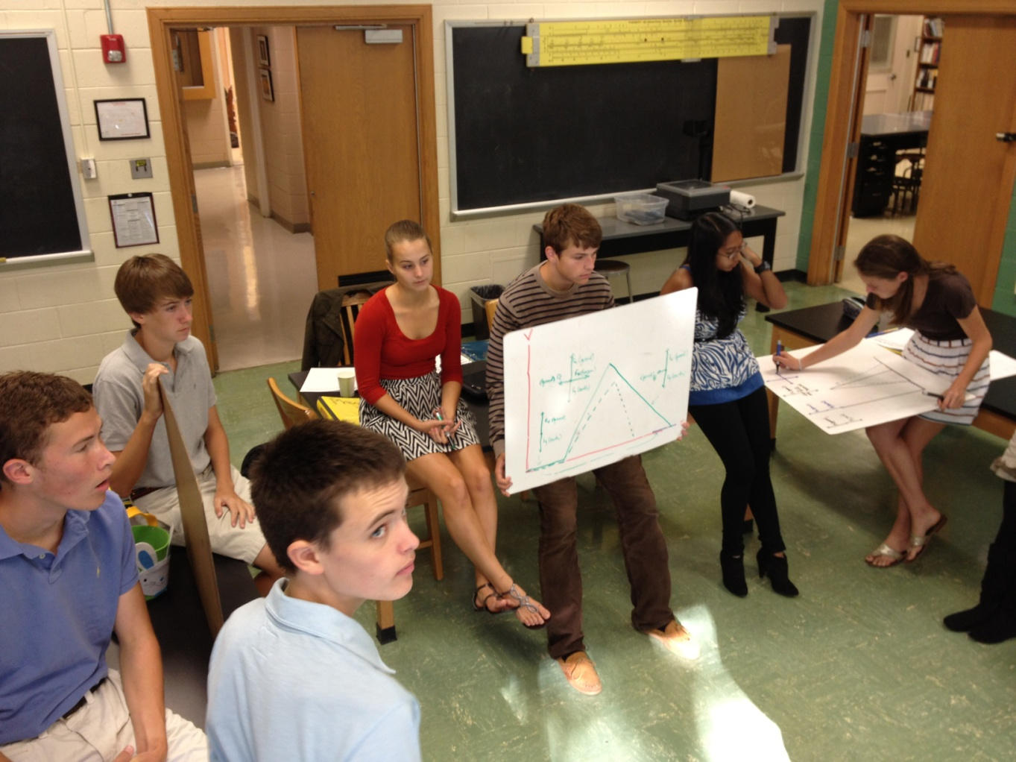
Photograph of Circle White Board in progress (O’Shea, 2014)

Learning Commentary
My second example for a tool to encourage reflection in the classroom is a learning commentary (Novak, Gowin & Butler Kahle, 1984), (physicsed, 2014) for a unit on two dimensional motion. A learning commentary* is a type of reflective writing. The student must think about what was learned and how it was learned, subjectively. Thoughts, memories, valuations, learned concepts, notes on difficulties, ah-ha* moments, etc. are written. In addition to developing communication skill and improving literacy, a commentary is a student reflection. It may later be compared to summative assessment results and thus used to identify weaknesses in student thinking. The rubric for scoring a learning commentary is provided in Appendix C. An example of a graded learning commentary is provided in Appendix D.
A number of tools exist to facilitate learning this concept. One example is a cart with a plunger in a cup. As the cart is pulled along at constant velocity, the plunger shoots a ball up which then falls back into the cup. This works at any speed, even standing still. How does the ball know where the cup is? Analysis of the motion requires separating the velocity of the ball into rectilinear components. The horizontal velocity is constant. The vertical acceleration is constant. The two motions are independent. Two dimensional motion addresses the Physical Setting Physics Core Curriculum (2011).
The Standard 4 Process Skills Checklist is intended to be a tool for curriculum development. These process skills should be incorporated into core-based physics curricula. These skills are tied to specific content in the core. During assessments, students will be presented with new situations to analyze and new problems to solve using these process
Mechanics
The student will be able to:
construct and interpret graphs of position, velocity, or acceleration versus time
determine and interpret slopes and areas of motion graphs
determine the acceleration due to gravity near the surface of Earth
determine the resultant of two or more vectors graphically or algebraically
draw scaled force diagram using a ruler and protractor
resolve a vector into perpendicular components: both graphically and algebraically
sketch the theoretical path of a projectile
use vector diagrams to analyze mechanical systems (equilibrium and nonequilibrium)
verify Newton’s Second Law for linear motion
determine a spring constant
Energy
The student will be able to:
describe and explain the exchange between potential energy, kinetic energy, and internal energy for
simple mechanical systems, such as a spring, a freely falling object
predict velocities, heights, and spring compressions based on energy conservation
determine the energy stored in a spring
observe and explain energy conversions in real-world situations
recognize and describe conversions among different forms of energy in real devices

After an introductory unit on Newton’s Laws of Motion, a student may decide to write a learning commentary on two dimensional motion. Such a learning commentary makes explicit the process the student went through to develop the concept of independent dimensions and demonstrates the student’s prior knowledge which can be invaluable for the teacher to update the next year’s lesson plan (Novak, Gowin & Butler Kahle, 1984). This benefits both student and teacher.
Prior knowledge will likely include ideas about motion and forces as well as gravitational potential although it would not be expected that these ideas would be well organized or very useful to the student prior to a lesson. The student may admit he knows an unsuspended object would fall due to force of gravity but this student’s knowledge of forces is not necessarily precise (Arons, 1997).
Expected difficulties include constructing accurately graphs of each dimension’s motion, and relating the following analysis to prior instruction with constant velocity and constant acceleration (spiraling back) (Arons, 1997). Questioning the students regarding the drawing of the graphs and their meanings should remind students of familiar graphical representation (Arons, 1997). Asking students to find the notes with similar graphs can result in awareness that the motions are already known separately (Hubbard, 1951) (Vygotsky, 1978). The learning commentary here could disclose an initial naïve conception (e.g. no conservation of momentum expected [Arons, 1997]), confusion over an unexpected observation (e.g. the ball lands in the cup even though the cart is moving), and a final statement of learned concept (e.g. horizontal motion is independent of vertical motion). Thus, a learning commentary of an appropriate concept could encourage reflection by identifying the phenomenon (e.g. independent dimensions of motion), establishing a context for the phenomenon (e.g. vertical acceleration of object moving at constant horizontal motion), finding a means of predicting the phenomenon (e.g. separation of motion into rectilinear components) and codifying the circumstances under which the means of prediction is valid (e.g. only with a constant velocity horizontal component).
One means of assessment for student reflection at the instruction phase is to monitor student recording of observations. Questioning students can redirect attention to phenomenon under study. The submitted learning commentary will demonstrate what level of understanding the student has (see Appendix A – Know Scale). The commentary can be annotated by the teacher before returning to the student, to further the student’s progress in reflection. For example, asking when a particular realization occurred can help the student to understand the importance of sketches, self-demonstration, or self-questioning which (as learning tools) can be dismissed by naïve students. A learning commentary also provides a check that the intended concept is acquired.
The learning commentary takes up no class time or resources as it is written by the student outside of class and also graded/annotated by the teacher outside of class. Considerable time can be spent on the grading and annotations for each student depending on the detail and writing ability of the student. Number of students submitting commentaries also factors into grading time.
Rich-context Problem
The last example, for an instructor tool to develop reflective thinking, is solving a rich-context* problem as a summative assessment after mechanics (Heller & Heller, 1999). Collaboration on rich-context problems is generally more motivational than independent work on simple problems (Mason & Singh, 2010). Groups of three or four students, whether heterogeneously or homogeneously constructed are given a task to explore and explain a problem. Problems are best ill-defined*, complex*, and incoherent* because the students will impose a coherence of their own, either an experimental design or a familiar conceptual model (Schön, 1987, p. 42). Content and problem-solving strategies are learned while reflection takes place.
Collaboration is assisted by use of white boards (Megowan, 2007), discussed earlier. The students are motivated by the real-world components. Dialogue attempts to elicit any useful prior knowledge (Vygotsky, 1978). A method toward a solution can be attempted and abandoned with group understanding of why the method would fail (Megowan, 2007). Instructor care is placed on asking why students are changing an approach and reminding them that they will need to explain what they are doing to the larger group (Megowan, 2007). Students coach each other to be better students by “observing student performance, detecting errors of application, pointing out correct responses” (Schön, 1987, p. 39), and explaining reasoning (Arons, 1997). Both experimental and logical methods must be coordinated before a sensible mathematical approach can determine a solution (Johnson & Johnson, 1998). “The cooperative group process … gives students the collective ability to check whether their approach to the problem makes sense and provides possible alternatives. It is just this self-monitoring, now supplied by the others in the group, which is most lacking in beginning problem solvers.” (Heller & Heller, 1999).
A typical rich-context problem is to predict the landing location of a steel ball released on a ramp on a table. The equipment is available for measuring lengths and masses but no trial runs are allowed. The group must then decide what data to collect, what to do with the data, what calculations to perform and actually pinpoint a location before doing the experiment. Accuracy has a nominal effect on the final grade; most of the credit is earned by explanation of the choice of location (using diagrams and calculations on the whiteboards). The interaction of the students convincing each other of the correctness or relevance of choices is remarkably reflective (Johnson & Johnson, 1998).
This lesson is useful as a summative assessment and covers NYS Physical Setting Physics Core Curriculum (2011).
Standard 1: Analysis, Inquiry, and Design
Students will use mathematical analysis, scientific inquiry, and engineering design, as appropriate, to pose
questions, seek answers, and develop solutions.
Mathematical Analysis
Key Idea 1: Abstraction and symbolic representation are used to communicate mathematically.
M1.1 Use algebraic and geometric representations to describe and compare data.
• Manipulate equations to solve for unknowns.
• Use dimensional analysis to confirm algebraic solutions.
Key Idea 2: Deductive and inductive reasoning are used to reach mathematical conclusions.
M2.1 Use deductive reasoning to construct and evaluate conjectures and arguments, recognizing that patterns and relationships in mathematics assist them in arriving at these conjectures and arguments.
Key Idea 3: Critical thinking skills are used in the solution of mathematical problems.
M3.1 Apply algebraic and geometric concepts and skills to the solution of problems.
• Explain the physical relevance of properties of a graphical representation of real-world data, e.g., slope, intercepts, area under the curve.
Key Idea 1: The central purpose of scientific inquiry is to develop explanations of natural phenomena in a continuing, creative process. Students:
• develop extended visual models and mathematical formulations to represent an understanding of natural phenomena
• clarify ideas through reasoning, research, and discussion
• evaluate competing explanations and overcome misconceptions
Key Idea 1: Engineering design is an iterative process involving modeling and optimization (finding the best solution within given constraints) which is used to develop technological solutions to problems within given constraints. Students:
T1.1 Engage in the following steps of a design process:
• Generate creative solutions, break ideas into significant functional elements, and explore possible refinements; predict possible outcomes, using mathematical and functional modeling techniques; choose the optimal solution to the problem, clearly documenting ideas against design criteria and constraints; and explain how human understandings, economics, ergonomics, and environmental considerations have influenced the solution.
• Develop work schedules and working plans which include optimal use and cost of materials, processes, time, and expertise; construct a model of the solution, incorporating developmental modifications while working to a high degree of quality (craftsmanship).
• Devise a test of the solution according to the design criteria and perform the test; record, portray, and logically evaluate performance test results through quantitative, graphic, and verbal means. Use a variety of creative verbal and graphic techniques effectively and persuasively to present conclusions, predict
impacts and new problems, and suggest and pursue modifications.
Systems Thinking
Key Idea 1: Through systems thinking, people can recognize the commonalities that exist among all systems and how parts of a system interrelate and combine to perform specific functions. Students:
1.1 Define boundary conditions when doing systems analysis to determine what influences a system and how it behaves.
Models
Key Idea 2: Models are simplified representations of objects, structures, or systems used in analysis, explanation, interpretation, or design. Students:
2.1 Revise a model to create a more complete or improved representation of the system.
2.3 Find and use mathematical models that behave in the same manner as the processes under investigation.
• Physical and mathematical models represent the behavior of real-world systems.
2.4 Compare predictions to actual observations, using test models.
• Experimental data can be collected to either validate or reject a model.
• A model can be used to predict the behavior of a system.
Patterns of Change
Key Idea 5: Identifying patterns of change is necessary for making predictions about future behavior and conditions. Students:
5.1 Use sophisticated mathematical models, such as graphs and equations of various algebraic or trigonometric functions.
• Mathematical models such as graphs and equations can be used to predict the behavior of physical systems.
Optimization
Key Idea 6: In order to arrive at the best solution that meets criteria within constraints, it is often necessary to make trade-offs. Students:
• Determine optimal solutions to problems that can be solved using quantitative methods.
Strategies
Key Idea 2: Solving interdisciplinary problems involves a variety of skills and strategies, including effective work habits; gathering and processing information; generating and analyzing ideas; realizing ideas; making connections among the common themes of mathematics, science, and
technology; and presenting results.
• Collect, analyze, interpret, and present data, using appropriate tools.
• If students participate in an extended, culminating mathematics, science, and technology project, then the students should:
§ work effectively
§ gather and process information
§ generate and analyze ideas
§ observe common themes
§ realize ideas
§ present results

Some preparatory time must be devoted to setting up this practical. All resources are available in class but it must be out and ready for the students. While fitting in a 40 minute period and using simple materials already in the classroom, the lesson covers a lot of material in an interesting way. A formal presentation of results and error analysis in writing or in circle white board will include those process skills as well. Grading can be done in class during circle white board, or time taken outside of class to read written reports.
Few problems should emerge during this lesson. Any that do arise can be addressed by teacher encouragement to refer to earlier lessons’ notes and labs (Vygotsky, 1978) (Hubbard, 1951). No single action is new but this is the first time all have been assembled into a whole. The action of assembling a whole action from parts is a practice of transfer*. By requiring student transfer of knowledge in a group environment, verbal reasoning is made a natural part of the process (Arons, 1997) (Heller & Heller, 1999).
Thus, rich-context problems will encourage reflection by identifying the phenomenon (e.g. potential vs. kinetic energy and two-dimensional motion), establishing a context for the phenomenon (e.g. the ball will roll down the ramp gaining speed which is horizontal velocity and fall off the end of the table which develops vertical velocity until it hits the floor at the location to be predicted), finding a means of predicting the phenomenon (e.g. a series of equations neglecting air resistance) and codifying the circumstances under which the means of prediction is valid (e.g. for short falls). Students can predict such a point with astonishing accuracy and doing so is a great confidence booster (Bercher 2012).

Conclusion
I have presented three instructor tools for encouraging student reflection in contexts of typical topics of a mechanics unit. Small group collaboration was exemplified as an instructor tool for use in graphing position versus clock reading. Learning commentary was exemplified as an instructor tool for use in a two dimensional motion lesson. Rich-context problem solving was exemplified as an instructor tool for use in summative assessment of two-dimensional motion. The expected prior knowledge of students has been presented, along with expected difficulties. Some instructional strategies to overcome the listed difficulties have been presented. Reference to the NYS Core Curriculum and means of assessing student reflection has been presented. The expected administrative costs, in terms of class and prep time have been presented. While many possible instructor and/or student tools exist to promote reflection within this unit and any combination may be used, the use of these three tools has been detailed.
It is increasingly true that new university students have graduated from secondary education without independent learning skills. These students, in great numbers, require remedial education in basic mathematics and English language arts. For the most part, such students are taking five or more years to complete a four year degree program. One challenge such students face is the vastly different environment from which they are familiar. In high school, a student can expect to be told what is important to know and what it is and how it is used in each stated situation. For example, a formula is worked out by the teacher for each component as the unknown. If the given formula is “y = mx + b,” then the teacher expects to work out four examples, one for each component being unknown. In contrast, a university student must organize his/her own time, decide what is most important, study what he/she can of it and how this subset of a larger body of knowledge can be applied to varying situations. For example, the formula for gravitational potential energy is derived by the professor from more fundamental data. It is then the student’s responsibility to memorize the formula, learn the meaning of the components of the formula and how to apply the formula and under what circumstances it would be valid. Reflection would certainly help a student transition from a secondary to post-secondary setting. “The dean of a well-known school of management observed [around 1962] that ‘we need most to teach students how to make decisions under conditions of uncertainty, but this is just what we don’t know* how to teach’ (William Pownes, personal communication, 1972 [cited in Schön, 1987, p. 11]).”
Since we live in an entirely technological world today, it must be expected that any adult will need to continue learning about advances in technology, changing relations between nations, and his/her changing body and family relations as well. Since reflection is an important aspect of a student’s ability to be successful in any situation which requires learning (Bercher, 2012), it becomes evident that reflection is an important aspect to all people’s ability to be successful in life, not just those about to enter college.
Metacognition plays a role in deciding what factors are to be included in any problem to be solved. The problem of learning is a self-imposed one which must be overcome to allow success in our technological society. Reflection on learning will help a student become an independent learner by developing metacognition. Reflection is therefore a powerful tool in equipping students to be independent learners, useful in education not just for metacognitive* development but developing ability to gather useful information and apply knowledge to problem-solving. Reflection is the bridge between knowledge a student has and the uncertainty he/she will face (Schön, 1987).
Reflective skill is developed mainly by discussing what one does and listening to what others do in a problem-solving context. A dialogue is necessary for feedback and feedback is necessary for rapid development. Schön encourages a reflective practicum whose “main features are learning by doing, coaching rather than teaching, and a dialogue of reciprocal reflection-in-action between coach and student (1987, p. 303). While a coordinated curriculum taught through such a practicum is an ideal held up by many other educational professionals (among them Arons (1997), Hestenes (1992) (2011), Liem (1989), Megowan (2007), and Vygotsky (1978)), reflective elements may be incorporated without complete overhaul of curriculum or methodology.
I have provided a list of tools which are in common use and many of which are themselves considered best-practices. The tools are organized in three sections: those tools for an instructor to apply, those tools for either an instructor or student to apply, and those tools for a student to apply to him/herself (see Appendix B – List of Reflection Tools). I have shown three examples of using an instructor applied tool within the context of a specific mechanics unit.
I have described the assessment of students pertinent to their reflective ability based on instructor observations of writing and dialogue of the student. The plotting of observed statements against a gradient scale of knowing (Hubbard, 1951), over time, shows reflective development (see Appendix A – Know Scale).
Reflection is a vital component of problem solving in a complex, ill-defined, incoherent context. Such problems abound in the real world. The use of reflective tools in a secondary education science classroom is likely to produce students much more capable of applying their knowledge and skills to their post-secondary life.

Appendices

Appendix A – Know Scale:
I know
I understand
I am trying to understand
I will not understand
I am afraid to understand
I cannot understand
I know not
(Hubbard, 1951)
Appendix B – List of Reflection Tools:
Instructor tools:
Assign learning commentaries.
Assign observation logs on demonstrations or videos of phenomenon.
Assign reading logs of chapter readings.
Context-rich problems.
Develop interactive lectures.
Direct small group collaboration.
Direct students to explain consequences of a hypothesis.
Explicitly instruct on a pattern of developing a solution.
Explicitly teach a problem-solving strategy.
Hold a board meeting.
Use open-ended questions.
Instructor or student tools:
Compare and contrast analogies.
Consider limiting cases.
Convert one representation into another.
Correct work.
Develop an operational definition*.
Interact with peers.
Student tools:
Practice.
Take notes.
Use self-explanation.

Appendix C – Learning Commentary Rubric:

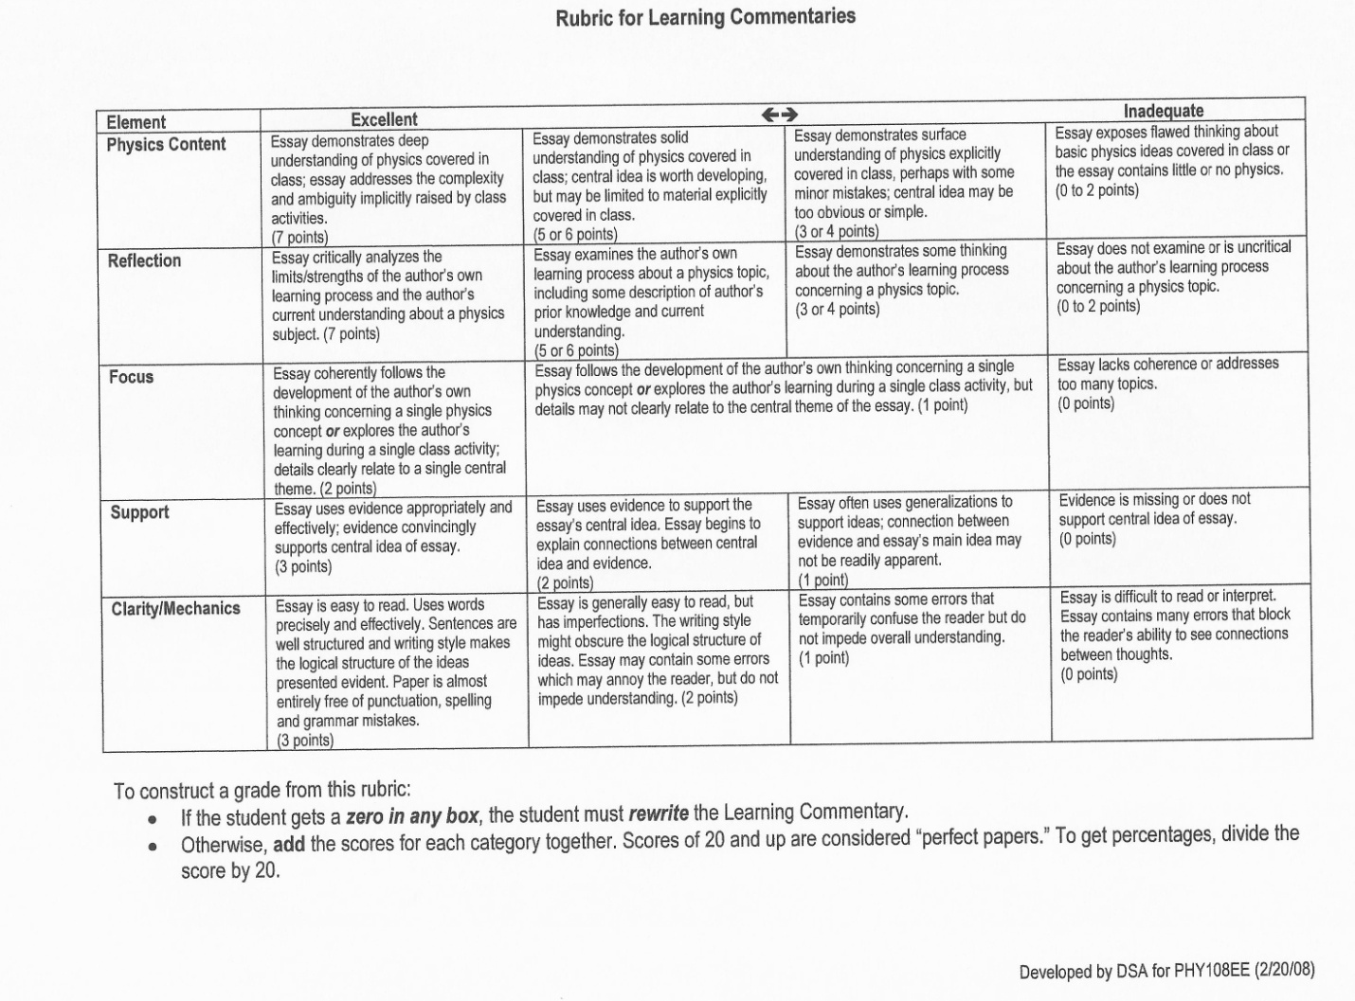
(physicsed, 2014)
Appendix D – Learning Commentary Example

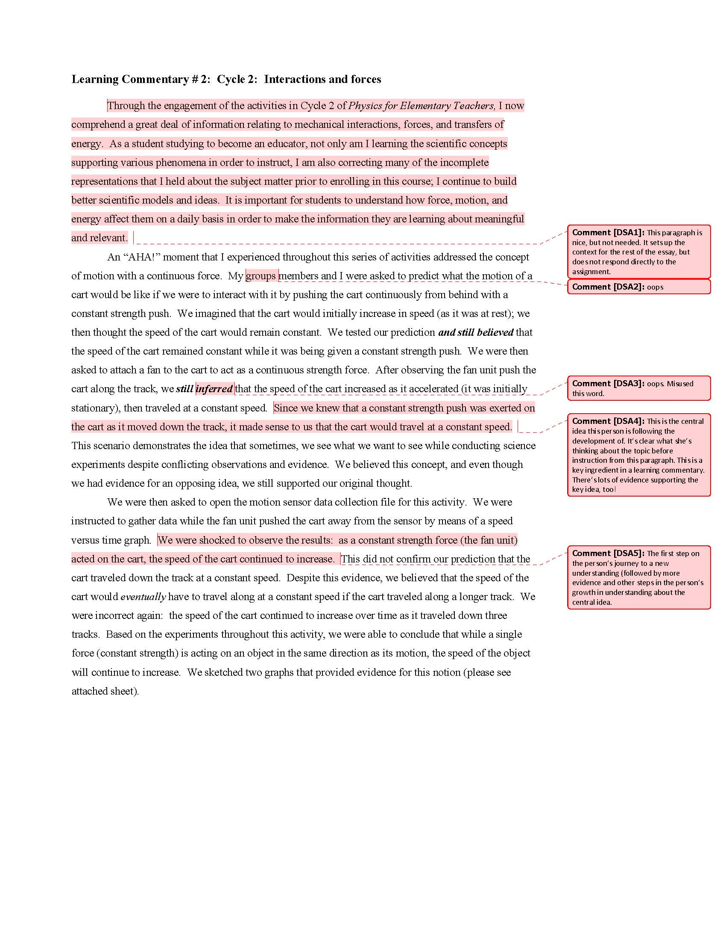
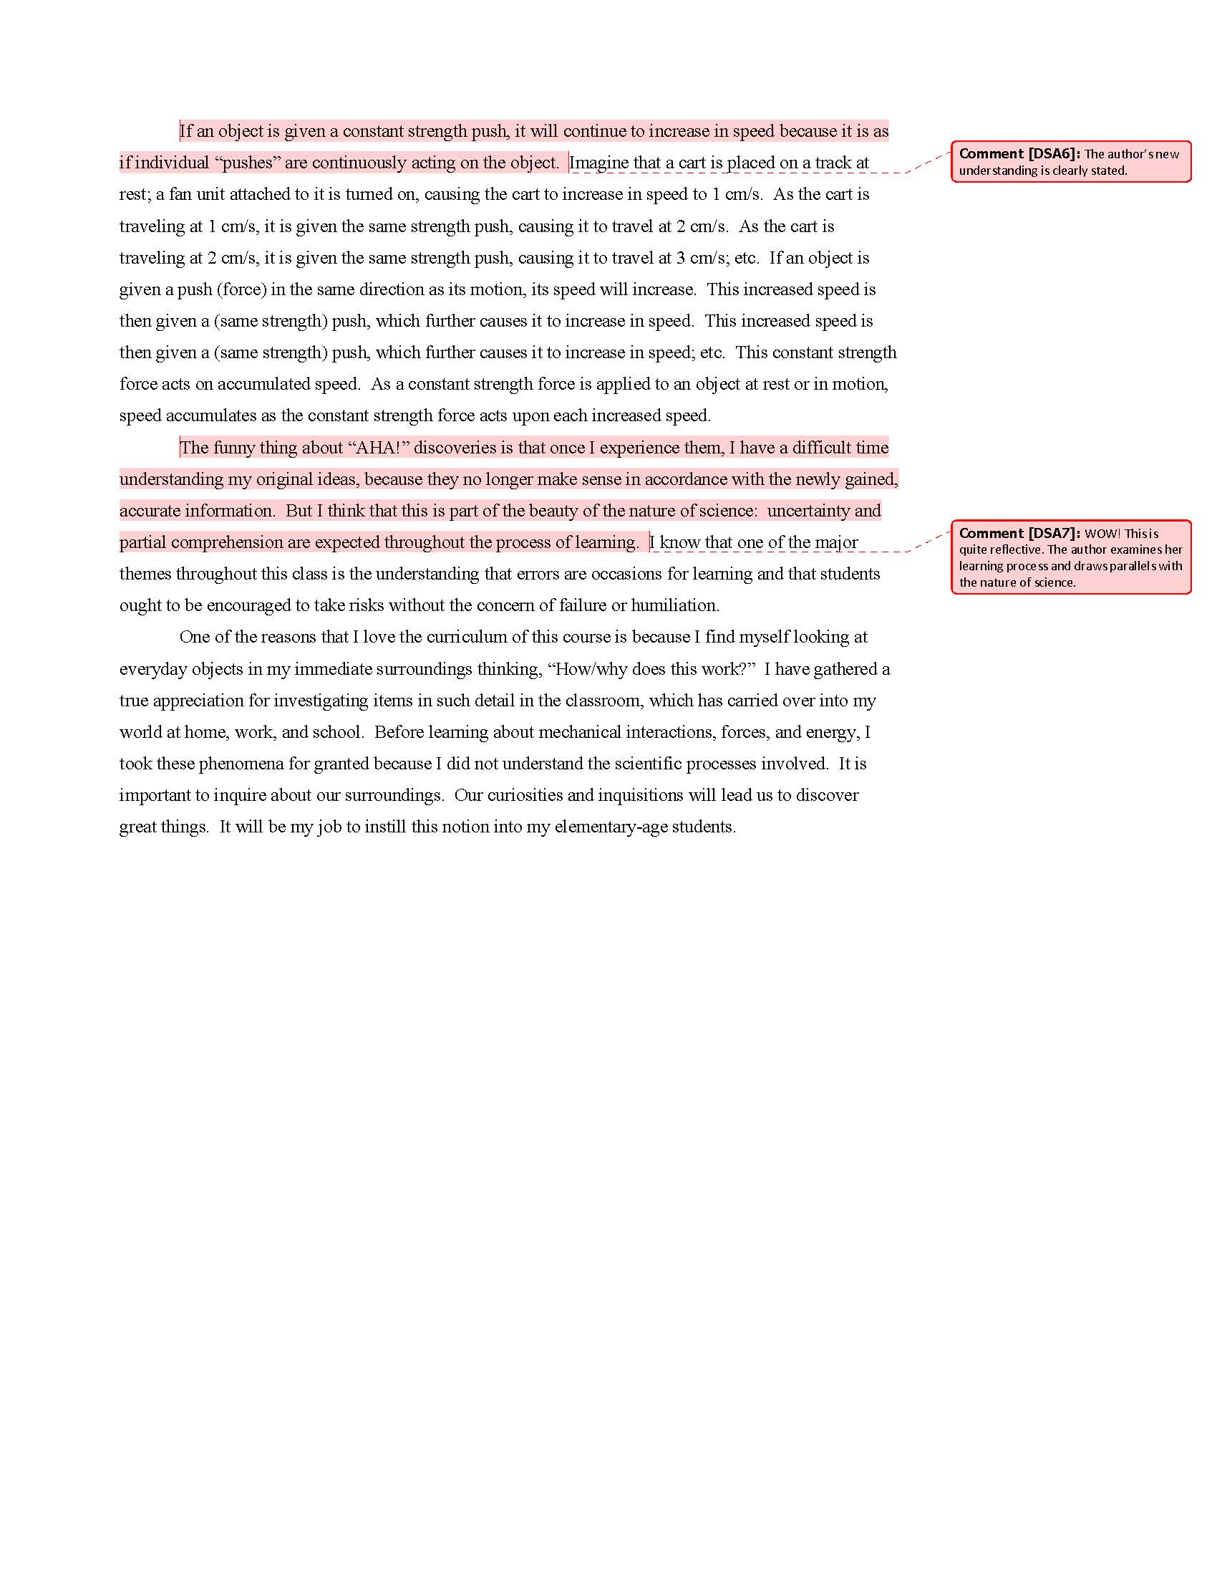Example of a graded and annotated Learning Commentary (physicsed, 2014)
Appendix E – RTOP Information

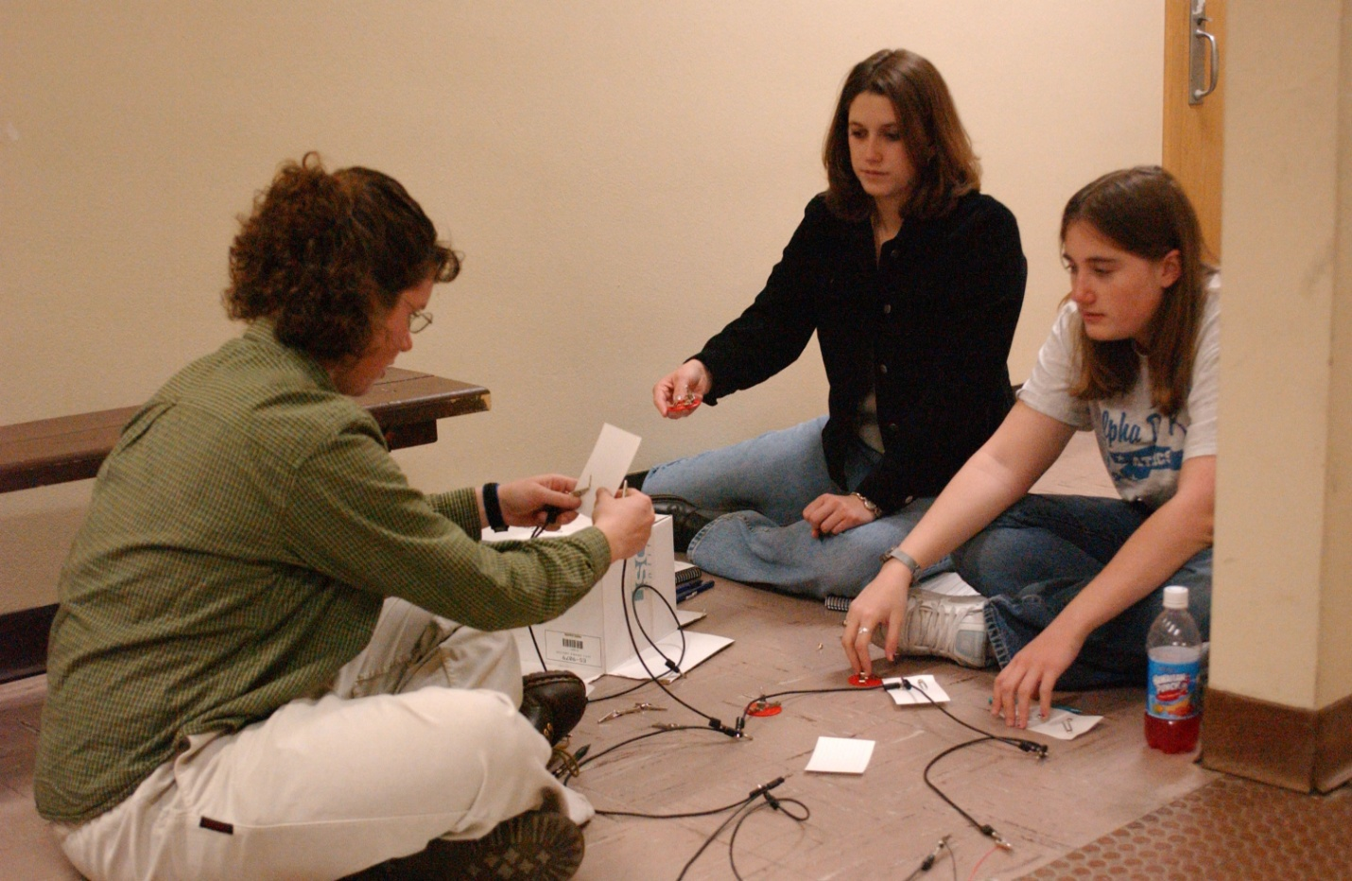
Photograph demonstrates students actively working together to accomplish a task. (RTOP, 2014)
“The Reformed Teaching Observation Protocol (RTOP) is an observational instrument that can be used to assess the degree to which mathematics or science instruction is ‘reformed.’ It embodies the recommendations and standards for the teaching of mathematics and science that have been promulgated by professional societies of mathematicians, scientists and educators.
The RTOP was designed, piloted and validated by the Evaluation Facilitation Group of the Arizona Collaborative for Excellence in the Preparation of Teachers. Those most involved in that effort were Daiyo Sawada (External Evaluator), Michael Piburn (Internal Evaluator), Bryce Bartley and Russell Benford (Biology), Apple Bloom and Matt Isom (Mathematics), Kathleen Falconer (Physics), Eugene Judson (Beginning Teacher Evaluation), and Jeff Turley (Field Experiences). …Reformed teaching allows students to build complex abstract knowledge from simpler, more concrete experience.” (Sawada & Piburn, 2000)

Appendix F – Glossary:
Each term is asterisked the first time it appears after the Abstract. Definitions (and example sentences where necessary) are included with the first context and page on which it appears in brackets <>.
ah-ha – description of the moment of breakthrough; a new understanding < Thoughts, memories, valuations, learned concepts, notes on difficulties, ah-ha moments, etc. are written. p. 15>
commentary – see learning commentary
complex – requiring multiple steps each of which is not necessarily difficult <A problem with mixed units is complex.> <Problems are best ill-defined, complex, and incoherent. p. 19>
concrete operation – reference to Piagetian* learning stage characterized by physical actions and/or mechanical understandings in contrast to formal operations (which uses abstract concepts) <Investigations are useful to develop concrete operations for students to begin handling a topic.> <from concrete to formal operation p.12>
constructive – promoting improvement or development (Merriam-Webster, 1994); describing something in reference to the theory of learning wherein concepts build on each other <Thinking [of] what they are doing while they are doing it leads to constructive insights. p. 4>
context – see rich-context
development – see zone of proximal development
education – the act or process of mental, moral or aesthetic development, especially under formal instruction (Merriam-Webster, 1994) <The problem in education … is that instruction communicates specific techniques but the choice of applying such techniques requires judgment in ethics. p. 4>
formal operation – reference to Piagetian learning stage characterized by mental abstraction in contrast to concrete operations (which uses physical actions) <Use of the compare and contrast analogies, and consider limiting cases tools will further hone an operational definition and lead from concrete to formal operation of the definition.> <from concrete to formal operation p. 12>
frame – context for a given situation which influences the way the situation is perceived and treated <Reflection which refers to a completed activity in reference to a frame or result is referred to as reflection-on-action* by Schön (1987).> <creating a frame p. 33>
framing – creating a frame*, specifically consciously creating a frame within which the given situation may be resolved < Establishing the context for a phenomenon is referred to as framing. p. 5>
ill-defined – purposely provided without vocabulary; no naming clues given to a phenomenon <An ill-defined gravity problem will often fool students into using a wrong model.> <Problems are best ill-defined, complex, and incoherent. p. 18>
incoherent – purposely provided without a frame; no framing clues given to situation <An incoherent problem is open to student interpretation and requires stated assumptions in the solution.> <Problems are best ill-defined, complex, and incoherent. p. 18>
know – to have certainty of knowledge*; to be able to comprehend a concept in any context in contrast to understand <I know how to speak English.> <How do I know? p. 6> <This is just what we don’t know how to teach. p. 24>
knowledge – set of skills, information and concepts able to be used; fact or condition of being aware of something (Merriam-Webster, 1994) <knowledge of one’s own learning p. 4> <to have certainty of knowledge p.33>
lab – see paradigm lab
learn – gain knowledge by practice, observation or analysis; come to realize (Merriam-Webster, 1994) <Content and problem-solving strategies are learned while reflection takes place. p. 8> <ongoing action to learn p. 34>
learning – ongoing action to learn* <High school students should be encouraged to reflect on their own learning. p. 2> <Reflection on learning, specifically, will enhance a student’s metacognition, the awareness and knowledge of one’s own learning and the ability to communicate about one’s own learning. p. 4>
learning commentary – a reflective writing explaining or interpreting one’s own process of learning <The second example is learning commentary for two dimensional motion p. 2> <A learning commentary is a type of reflective writing. The student must think about what was learned and how it was learned, subjectively. p. 15>
metacognition – ability and willingness to think about one’s own thoughts and thought processes <Reflection on learning, specifically, will enhance a student’s metacognition. p. 4>
metacognitive – having to do with awareness of one’s own thinking; contributing to metacognition <Reflection is therefore a powerful tool in equipping students to be independent learners, useful in education not just for metacognitive development but developing ability to gather useful information and apply knowledge to problem-solving. p. 24>
Modeling Instruction – A teaching method developed from a social constructivist perspective (Hestenes, 2011) <There are multiple labs in a sequence, within a unit of Modeling Instruction.> <first lab of a sequence of labs in a unit of Modeling Instruction p. 35>
naming – creating a name, a group specifically consciously agreeing on a name for an observed phenomenon < Identifying a phenomenon is referred to as naming. p. 6>
operational definition – a meaning composed of a series of activities which construct a concept in contrast to a meaning which only describes or one which purports a purpose <An operational definition of down is given by the direction of a string held fixed at one end and attached to a free plumb bob on the other when the plumb is not swinging. (Arons, 1997, p. 2)> <Develop an operational definition. p. 27>
paradigm lab – an experimental activity which serves as an archetype example for the basic problem to be solved in a unit (Merriam-Webster, 1994); first lab of a sequence of labs in a unit of Modeling Instruction* (Hestenes, 2011) <The paradigm lab serves as a concrete experience on which to construct an abstract model.> <to what extent are modeling paradigm labs reflective p. 40>
Piaget – Jean Piaget, a Swiss developmental psychologist and philosopher known for his epistemological studies with children; Piaget developed a stage theory of intellectual development that included four distinct stages within a social constructivist theory of learning <having to do with Piaget’s constructive theory of learning p. 35>
Piagetian – of or having to do with Piaget*; specifically, having to do with Piaget’s constructive theory of learning <reference to Piagetian learning stage characterized by physical actions and/or mechanical understandings p. 32>
reflect – to think about, specifically to think about with respect to learning <Students should be encouraged to reflect on their errors.> <There are three main types of tools which will assist the teacher to encourage students to reflect. p. 7>
reflection – “a thought, idea, or opinion formed or a remark made as a result of meditation” (Merriam-Webster, 1994); process of reflecting, specifically reflecting with respect to learning < Reflection is an amazing human tool. p. 4>
reflection-in-action – process of reflecting on an action sequence which one is performing <Reflection-in-action, according to Schön (1987) is “thinking [of] what they are doing while they are doing it.” p. 4>
reflection-on-action – process of reflecting on an action sequence either prior to or after completing performance of the sequence <His reflection-on-action after making the jump led him to believe he could jump farther.> <Reflection on the learning process solidifies the content knowledge, increases motivation, and improves ability to reflect as a reflection-on-action (Schön,1987).> <Reflection which refers to a completed activity in reference to a frame or result is referred to as reflection-on-action by Schön (1987). p. 33>
reflective – having to do with reflecting; contributing to reflection <Reflective learning is an extensive process. p. 5>
reformed teaching observation protocol (RTOP) – an instrument designed to quantify the instructional method of a teacher which assumes maximal student activity and participation prior to instruction is best; “reformed teaching allows students to build complex abstract knowledge from simpler, more concrete experience.” (Sawada & Piburn, 2000); reference to this type of instruction (RTOP, 2014) <RTOP Information p. 8>
rich-context – also context-rich – including multiple real-world components in contrast to an unrealistically simplified version <All of my examples are instructor applied tools: small group collaboration, learning commentary and rich-context problem. p. 7> <The last example, for an instructor tool to develop reflective thinking, is solving a rich-context problem as a summative assessment after mechanics p. 18>
RTOP – see reformed teaching observation protocol
scaffold – to provide a lower gradient step as a bridge from the student’s zone of proximal development* to the desired functional level <An instructor may therefore scaffold appropriate behavior for student suppositions by implicit modeling.> <An exercise of using the hand to describe motions given by a particular graph will scaffold the students into developing the appropriate concepts. p. 12>
transfer – use of a concept outside the constraints in which it was learned <The action of assembling a whole action from parts is a practice of transfer. p. 21>
understand – ability to comprehend a concept in a context in contrast to know <I understand the constant velocity model in an inertial reference frame.> <Each student’s defense is a fallback to learned concepts and constructed understandings.> <Problem-solving requires a wider understanding of the society. p. 4>
zone of proximal development – the range of student function which is optimal for learning: not too easy but not impossibly difficult (Vygotsky, 1978) <Intrinsic motivation is highest in the zone of proximal development.> <Provide a lower gradient step as a bridge from the student’s zone of proximal development to the desired functional level. p. 37>
Appendix G – Annotated References:

Arons, A. B. (1997). Teaching Introductory Physics. New York: John Wiley & Sons, Inc. Text aimed at High School and College Physics teachers for the improvement of teaching quality. Emphasis is on introducing material in a student sensible sequence, providing concrete experience to lay a constructive foundation, and spiraling back to prior concepts to continue constructing knowledge.
Bercher, D.A. (2012, May/June). Self-monitoring tools and student academic success: When perception matches reality. JCST 41(5), 26-32. This article addresses reflection and dependence of academic success on it.
Gearhart, B. (2009). A quick start guide to reflection in the physics classroom. Unpublished manuscript, State University of New York College at Buffalo. He expresses his experience in both the role of a student and in the role of a teacher learning what reflection means. He discusses some of the benefits of reflection in the physics classroom. Characteristics of reflective practices and examples of pedagogically effective reflective methods to learning are presented.
Heller, Patricia & Heller, Kenneth (1999). Cooperative Group Problem Solving in Physics. University of Minnesota. Dowloadable at http://groups.physics.umn.edu/physed/Research/CGPS/GreenBook.html . Seminal text on context rich problems in Minnesota Model (standard lecture course with labs and recitations).
Hestenes, D. (2011). Modeling Instruction materials. Downloaded from http://www.modelingteachers.org. Materials for Modeling Instruction curricula in sciences are posted after development and testing. References for parents, students, and educators regarding Modeling Instruction and its research are included.
Hestenes, D., Well, M., & Swackhamer, G. (1992). “Force Concept Inventory.” The Physics Teacher 30(3), 141 – 157. Paper introduces Force Concept Inventory as a tool for identifying student misconception and curriculum performance.
Hubbard, L. R. (1951). Advanced Procedure and Axioms. Los Angeles: Bridge Publications, Inc. Text written for use to improve the mental capacity and self-determinism of others. Gradient learning model is assumed throughout.
Johnson, David W., Johnson, Roger T. and Smith, Karl A. (1998). Active Learning: Cooperation in the College Classroom. Interaction Book Company, MN. Text includes research-based data on cooperative learning, basics for group learning, tips on application and checklists for effective group participation.
Knight, R. (2004). Physics for Scientists and Engineers. San Francisco: Addison Wesley. Text book series using qualitative concepts and multiple representation transformations.
Liem, T. L. (1989). Invitations to science inquiry. (2nd edition). Chino Hills, CA: Science Inquiry Enterprises. He writes about discrepant events and gives many examples which introduce science topics and address common misconceptions.
Mason, A., & Singh, C. Helping students learn effective problem solving strategies by reflecting with peers. American Journal of Physics volume 78, No. 7, July 2010. They studied how introductory physics students (university level) engage in reflection. Guidance in peer reflection and effective problem solving heuristics are described. Usefulness of diagramming is quantified.
McDermott, L. C., Rosenquist, M. L. & van Zee, E. H. (1987). Student Difficulties in Connecting Graphs and Physics: Examples from Kinematics. American Journal of Physics, 55(6), 505-513. Paper discusses kinematics learning specific to student conceptual development from concrete to formal operation.
Megowan, M. C. (May 2007). Framing Discourse for Optimal Learning in Science and Mathematics. Unpublished doctoral dissertation, Arizona State University. She reports on her study of collaborative thinking and learning that occurred in physics and mathematics classes where teachers practiced Modeling Instruction. To examine the distributed cognition that occurred in this unique learning setting, not just among students but also in connection with their tools, artifacts and representations, she included small groups and their collaborative work with white-boarded representations of contextual problems and laboratory exercises.
Megowan, M. C. (2011, July 31). to what extent are modeling paradigm labs* reflective. Message posted to electronic list service for physics modelers through MODELING@LISTS.ASU.EDU . She answers Jane Jackson’s question regarding the extent to which paradigm labs encourage reflection.
Merriam-Webster’s collegiate dictionary (10th ed.). (1994). Springfield, MA: Merriam-Webster. Dictionary of modern English language.
Metcalfe, J., & Shimamura, A. P. (1994). Metacognition: knowing about knowing. Cambridge, MA: MIT Press. Cognitive psychology studied self-awareness of thinking since the 1970's. They have selected a representative sample of the field up to 1994. The selection includes basic and applied research focused on memory monitoring, problem solving monitoring, metacognition development, and some classic methodological issues.
Novak, J. D., Gowin, D. B., Butler Kahle, J. (1984). Learning How to Learn. Cambridge University Press. This text of 199 pages redefines learning. For almost a century, educational theory and practice have been influenced by the view of behavioral psychologists that learning is synonymous with behavior change. In this book, the authors argue for the practical importance of an alternate view, that learning is synonymous with a change in the meaning of experience. They develop their theory of the conceptual nature of knowledge and describe classroom-tested strategies for helping students to construct new and more powerful meanings and to integrate thinking, feeling, and acting. In their research, they have found consistently that standard educational practices that do not lead learners to grasp the meaning of tasks usually fail to give them confidence in their abilities. It is necessary to understand why and how new information is related to what one already knows.
O’Shea, Kelly (2014). Retrieved 16 April 2014 from http://kellyoshea.files.wordpress.com/2013/03/whiteboard-faceoff-2.jpg . A physics teacher’s blog. She uses modeling instruction (see Hestenes, 2011).
Physical Setting Physics Core Curriculum (2011). Retrieved 8 September 2011 from http://www.p12.nysed.gov/ciai/mst/pub/phycoresci.pdf 8 . The official New York State Education Department updated core curriculum document.
physicsed (2014). http://physicsed.buffalostate.edu/pubs/AAPTmtgs/AAPT2011Jan/ StuRdgLogLrngCommPoster1.ppt . This webpage shows a poster of a learning commentary rubric and an example of a graded learning commentary. Copy used with permission.
Pidgeon, F. (January/February 2011). Motivating Your Students So They Can Become Better Learners. STANYS Newsletter, 46, 3. He expresses the importance of motivation and references work on motivational approaches. He connects confidence and self-esteem with reflection.
RTOP (2014). http://physicsed.buffalostate.edu/AZTEC/RTOP/RTOP_full/pic_galleries/batt-bulb/class/images/AS-011_JPG_jpg.jpg . This photograph and others in the folder represent group collaboration under reformed teaching observation protocol. Image used with permission.
Sawada, Daiyo; Piburn, Michael; et al (2000). “Reformed Teaching Observation Protocol (RTOP) TRAINING GUIDE.” Arizona Board of Regents. Paper detailing the rationale and application of RTOP. Reformed teaching allows students to build complex abstract knowledge from simpler, more concrete experience.
Schön, D. A. (1987). Educating the Reflective Practioner. San Francisco: Jossey-Bass Publishers. He shows how professional schools (university level) can use “reflection-in-action” to prepare students to handle the complex and unpredictable problems of actual practice with confidence, skill, and care.
U MN PER Group (2014). http://groups.physics.umn.edu/physed/Research/CRP/crintro.html . This website provides access to the work of University of Minnesota Physics Education Research Group. The site covers the creation and application of context-rich problems for use in collaborative group work in class and laboratory settings.
Vygotsky, L.S. (1978). Mind and society: The development of higher psychological processes. Cambridge, MA: Harvard University Press. He writes about learning and the use of gradients in education. He adheres to social constructivist models of learning.

Bibliography
Arons, A. B. (1997). Teaching Introductory Physics. New York: John Wiley & Sons, Inc.
Bercher, D. (2012, May/June). Self-monitoring tools and student academic success: When perception matches reality. JCST 41(5), 26-32.
Gearhart, B. (2009). A quick start guide to reflection in the physics classroom. Unpublished manuscript, State University of New York College at Buffalo.
Heller, P. & Heller, K. (1999). Cooperative Group Problem Solving in Physics. U of MN.
Hestenes, D. (2011). Modeling Instruction materials. Downloaded from http://www.modelingteachers.org .
Hestenes, D., Well, M., & Swackhamer, G. (1992). “Force Concept Inventory.” The Physics Teacher 30(3), 141 – 157.
Hubbard, L. R. (1951). Advanced Procedure and Axioms. Los Angeles: Bridge Publications, Inc.
Johnson, D., Johnson, R. & Smith, K. (1998). Active Learning: Cooperation in the College Classroom. Interaction Book Company, MN.
Knight, R. (2004). Physics for Scientists and Engineers. San Francisco: Addison Wesley.
Liem, T. L. (1989). Invitations to science inquiry. (2nd edition). Chino Hills, CA: Science Inquiry Enterprises.
Mason, A., & Singh, C. (July 2010). “Helping students learn effective problem solving strategies by reflecting with peers.” AJP 78(7).
McDermott, L., Rosenquist, M. & van Zee, E. (1987). “Student Difficulties in Connecting Graphs and Physics: Examples from Kinematics.” AJP, 55(6), 505-513.
Megowan, M. C. (May 2007). Framing Discourse for Optimal Learning in Science and Mathematics. Unpublished doctoral dissertation, Arizona State University.
Megowan, M. C. (2011, July 31). to what extent are modeling paradigm labs reflective. Message posted to electronic list service for physics modelers through MODELING@LISTS.ASU.EDU .
Merriam-Webster’s collegiate dictionary (10th ed.). (1994). Springfield, MA: Merriam-Webster.
Metcalfe, J., & Shimamura, A. P. (1994). Metacognition: knowing about knowing. Cambridge, MA: MIT Press.
Novak, J., Gowin, D. & Kahle, J. (1984). Learning How to Learn. Cambridge University Press.
O’Shea, K. (2014). Retrieved 16 April 2014 from http://kellyoshea.files.wordpress.com/2013/03/whiteboard-faceoff-2.jpg .
Physical Setting Physics Core Curriculum (2011). Retrieved 8 September 2011 from http://www.p12.nysed.gov/ciai/mst/pub/phycoresci.pdf8 .
Physicsed (2014). http://physicsed.buffalostate.edu/pubs/AAPTmtgs/AAPT2011Jan/StuRdgLogLrngCommPoster1.ppt .
Pidgeon, F. (January/February 2011). “Motivating Your Students So They Can Become Better Learners.” STANYS Newsletter, 46, 3.
RTOP (2014). Retrieved 17 March 2014 from http://physicsed.buffalostate.edu/AZTEC/RTOP/RTOP_full/pic_galleries/batt-bulb/class/images/AS-011_JPG_jpg.jpg .
Sawada, D.; Piburn, M.; et al (2000). “Reformed Teaching Observation Protocol (RTOP) TRAINING GUIDE.” Arizona Board of Regents.
Schön, D. A. (1987). Educating the Reflective Practioner. San Francisco: Jossey-Bass Publishers.
U MN PER Group (2014). Retrieved 17 March 2014 from http://groups.physics.umn.edu/physed/Research/CRP/crintro.html .
Vygotsky, L.S. (1978). Mind and society: The development of higher psychological processes. Cambridge, MA: Harvard University Press.

Biography
Charles Abramo was born in Western New York. He attended Hamburg Senior High School where he developed an interest in science and tutoring. After high school graduation, he immediately attended Clarkson University where he earned a bachelor’s degree in Chemistry. He briefly pursued an advanced degree in analytical chemistry at Florida State University before employment with Ecology & Environment in Lancaster as a lab technician operating high performance liquid chromatography equipment. After changing career paths to the teaching profession, he tutored many students through troubled subjects. Through Buffalo State College, he is certified to teach general sciences grades 7-12, physics and chemistry in New York State and has been teaching in Western New York schools since 2004. He is currently attending Buffalo State College for a Master degree in Physics Education.

