A Novel Regents Physics Review Exercise: Rutherford Backscattering
For submission to the STANYS bulletin

Nick Childs
Department of Physics, SUNY – Buffalo State College, 1300 Elmwood Avenue, Buffalo, NY 14222
Department of Physics, Montana State University, P.O. Box 173840 Bozeman, MT 59717-3840

Acknowledgements

This manuscript was created to address the requirements of a PHY 690 Masters project at Buffalo State College under the supervision of Dan MacIsaac
Data and photos were taken at Montana State University in the Ion Beam lab under the supervision of Richard J. Smith

Abstract
This paper will lay out a review exercise suitable for introductory physics ( NTSED Regents Core 4.1 b,e,j & 5.1 b,d,k,r,s) while exploring the concept of Rutherford Backscattering Analysis (RBS). Our ability to conduct such analysis arises from the fundamental concepts that are developed in a high school physics classroom. The concepts are reviewed through a worksheet that leads students through the basic physics concepts involved in RBS. The concepts addressed are directly related to New York State Regents standards for Physics. Many of the questions found in the worksheet are similar to those found on previous Regents examinations.
Rutherford Backscattering Review Exercises

Background

In 1911 Ernest Rutherford published the results that would change our view of the atom forever. Prior to his analysis of alpha particles incident on gold foil, the atom was thought of as a “plum pudding” in which electrons, the plums, resided in a pudding of positive charge. The experiments conducted starting in 1909 by Hans Geiger and Ernest Marsden, under the supervision of Ernest Rutherford, would disprove this model and create a newly accepted view of the structure of the atom.
In this famous experiment, commonly called the gold foil experiment, alpha particles (Helium +2 ions) were incident on a very thin sheet of gold foil. The expectation was that most of the alpha particles would have been deflected by a very small angle. The results were that most alpha particles passed right through the gold foil, however a small percentage of these alpha particles were reflected by angles up to 90 degrees. Rutherford described these reflected particles with the following quote “as if you fired a fifteen-inch shell at a piece of tissue paper and it came back and hit you". This led to the conclusion that since most particles passed right through; the atom was mostly empty space. The fact that some alpha particles went through a large deflection angle led to the conclusion that there was a very dense nucleus to the atom. The nucleus was also determined to be positive in charge as a result of this experiment. For a flash animation of expected results and actual results go to:
http://www.mhe.com/physsci/chemistry/essentialchemistry/flash/ruther14.swf
From Essential Chemistry by Raymond Chang

The results of this experiment changed our views of the atom forever. This was not the end of this type of analysis however. This type of analysis is still used today. The depth that is accessible by RBS is in the general range of 1-10 microns (1 x 10⁻⁶ m = 1 micron). The actual depth, however, is dependent on the target composition, also dependent on the energy and mass of the particle used for analysis (Chu, Mayer, & Nicolet, 1978 p. 193). A table of sample depths showing penetration depth for different alpha particle energies on various targets is provided below. Protons, another commonly used incident particle, can reach depths of up to 15 microns at energies of 2 MeV.
 | Accessible depth (microns)
Alpha Particle Energy | Al | Ni | Ag | Au
0.5 | 0.6 | 0.3 | 0.3 | 0.3
1 | 1 | 0.5 | 0.6 | 0.5
2 | 1.7 | 1 | 1.1 | 1
Table 1 Depth as a function of Alpha particle energy, Chu, Mayer, Nicolet 1978

Part I
Generation of high energy particles
In order to conduct more precise experiments than the ones conducted by Rutherford, the energy of the particles is controlled. A large Van de Graff generator is used to accelerate charged particles instead of getting these particles from a radioactive source. Information on the fundamentals and applications of electrostatic generators can be found in the book Electrostatic Accelerators: Fundamentals and Applications, by Hellborg and Ragnar. In this manner the energy of the particles can be controlled by the voltage of the generator. This voltage is used to set up an electric field that in turn accelerates these charged particles. For the purposes of this activity we will use alpha particles (He+2), which is commonly used in Rutherford backscattering analysis. More information on alpha particles can be found at:
http://en.wikipedia.org/wiki/Alpha_particle
The typical voltage differences produced by the generator are on the order of millions of volts, much larger than Van de Graff generators that are used in classrooms! (MSU accelerator below can produce a potential difference of 2 MV)
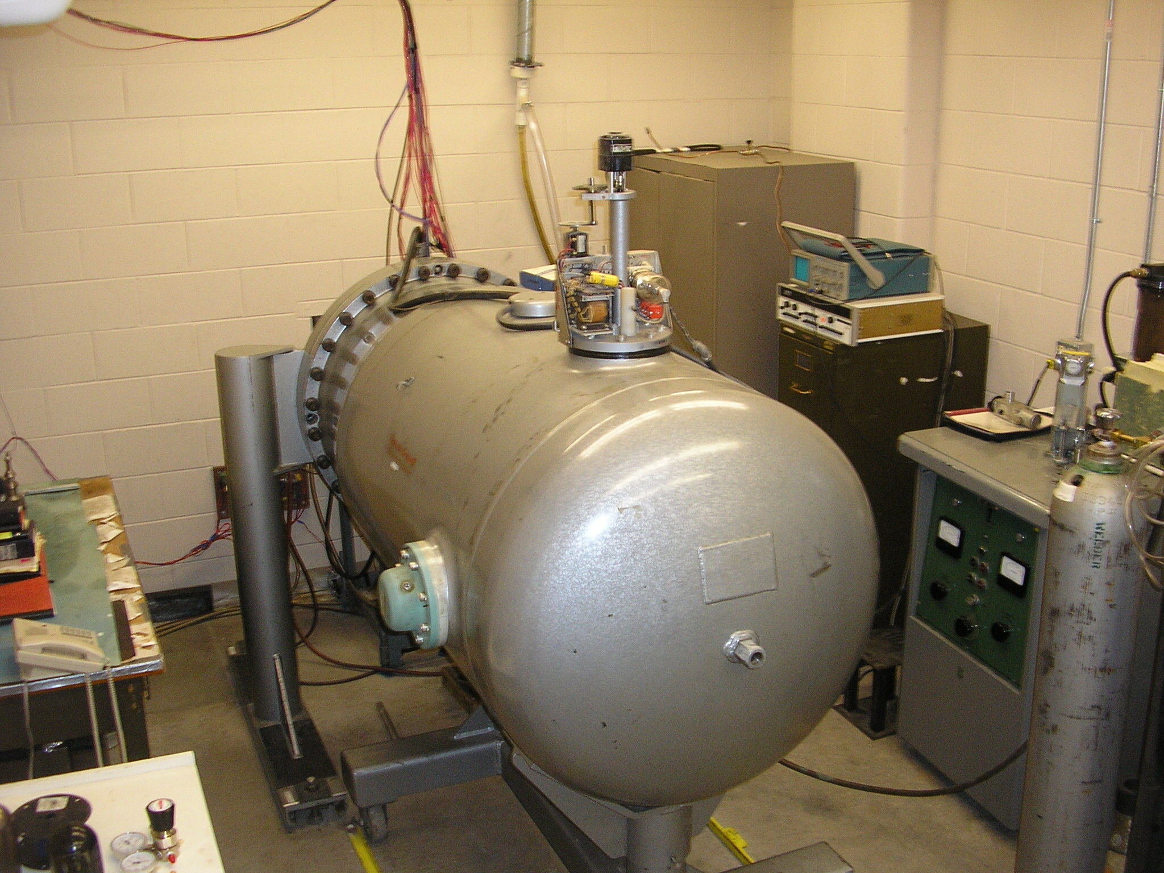
Picture 1 Van de Graff accelerator at Montana State University
To better understand how these particles are conditioned, we will analyze the result of a charged particle in an electric field created by the generator.
1.5 meters
2 x 10⁶ Volts 0 Volts
He+2

Figure 1 Depiction of potential difference inside a typical Van de Graff generator

- On the diagram above draw in lines to represent the electric field

- Calculate the electric field strength between the two plates.

- Draw a vector to represent the force on the particle due to the electric field.

- Calculate the force on the particle.

- Calculate the energy of the particle when it reaches plate B.

- Calculate the particle’s velocity when it reaches plate B. (Mass of a alpha particle is 2 protons + 2 neutrons)

Part II
After the initial conditioning of the particles they are directed to the sample to be analyzed. Between the accelerator and the target the particles are focused into a beam through the use of magnetic fields. Sketch the appropriate curve or line on the displacement, velocity and acceleration versus time graphs below. The time when the particles leaves the accelerator and when they hit the target are indicated by dotted lines on the graphs. Consider there to be no acceleration after the particles have left the accelerator.
Displacement (m)
Leaves accelerator Reaches Target
Time (s)
Velocity (m/s)
Leaves accelerator Reaches Target
Time (s)
Leaves accelerator Reaches Target
Time (s)
Acceleration (m/s²)
Figure 2 Displacement, Velocity and Acceleration vs. Time graphs

Part III
Using the concepts of conservation of momentum and energy we arrive at three separate equations:
- Conservation of Energy
Energy of Alpha particle before = Energy of Alpha particle after + Energy of Surface atom
Since there is no potential energy:
KE of Alpha particle before = KE of Alpha particle after + KE of the Surface atom
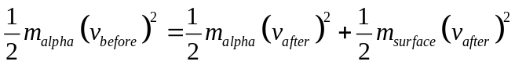 (1)

- Conservation of Momentum in the X direction
Momentum of alpha before = Momentum of alpha after + Momentum of surface atom after

(2)

- Conservation of Momentum in the Y direction
(Momentum_{Y-Before} Alpha) = (Momentum_{Y-After} Alpha) + (Momentum_{Y-After} Surface Atom)

(3)

After the alpha particles collide with the surface atoms, they are reflected back and a detector measures the energy of these alpha particles. This energy is compared to the original energy of these particles before the collision through a kinematic factor (K). K is just the ratio of energy after the collision to the energy before (K = E_{a}/E_{b}). Using this kinematic factor and the three equations listed above, the mass of the surface atoms can be determined and consequently identified through atomic mass and the periodic table. K is related to mass of the alpha particle and the surface atoms by the following relation (Marion and Thornton, 1995, p. 358):
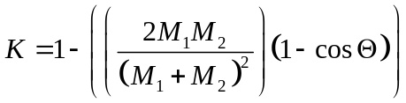 (4)
For example if a alpha particle comes in with 4 MeV and leaves with a scattering angle of 170 degrees and an energy of 3 MeV then K = (3 MeV)/(4 MeV) = .75 which corresponds to the atomic mass of Iron (Fe).

Other Kinematic Factors for 170 degrees
K | Corresponding Element
0.55 | Al
0.74 | Cr
0.75 | Fe
0.84 | Y
0.86 | Ag
0.92 | Pt
Table 2 Table of kinematic factors and corresponding elements, Chu, Mayer, Nicolet 1978

After millions of alpha particles collide with the surface of the sample being analyzed, there is a good distribution of collisions with the variety of atoms near the surface of the sample. This distribution is used to calculate concentrations of atoms as a function of depth. This can be used to determine the composition of corrosion layers or to determine how far a certain element has penetrated into a surface. This technique is used today to do surface analysis on a broad spectrum of materials.

A sample data collection is displayed below:
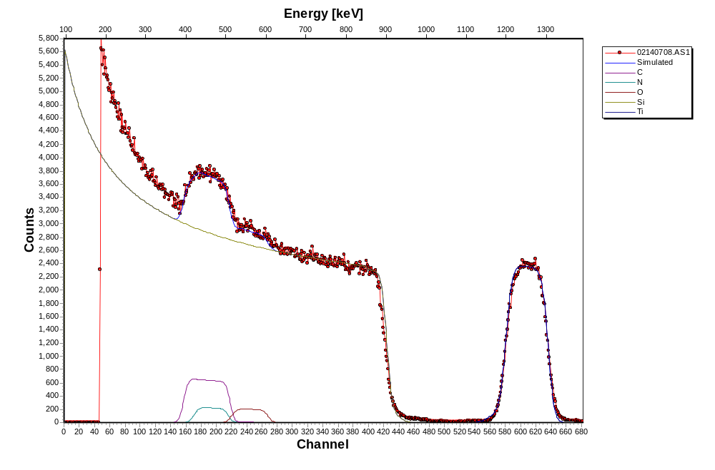
Thin layer of Titanium
Titanium is on a thick layer of Silicon. Nitrogen, Carbon and Oxygen are also present
Figure 3 Sample data from RBS lab at Montana State University, Childs 2006

Part IV

Now we will analyze the collision of these particles with the surface of the target. The collision is considered to be perfectly elastic, which means that both momentum and energy are conserved during the collision. With the concepts of conservation of energy and momentum, the change in energy for the alpha particle can be related to the mass of the particle it collided with. This mass is related to a specific element on the periodic table. In this manner we can measure the energy of the alpha particles after the collision and determine what elements are present near the surface of the target. For this exercise we will consider two dimensions, x and y. The figure below depicts the incident alpha particle after it has left the accelerator and is about to collide with an atom on the surface of the target to be analyzed. Coordinates are labeled below.
X
Y
Alpha Particle
(known mass)
Atom on near the surface of the sample (mass unknown)
Velocity →
Figure 4 Alpha particle prior to collision with surface to be analyzed

Consider that the alpha particle’s velocity is all in the X direction, with no Y component to the velocity. The atom on the surface of the target to be analyzed does not have any initial velocity.
- Using a velocity of 2 x 10⁷ m/s and the mass of an alpha particle, calculate the momentum in the X direction for the particle.

- What is the total momentum in the x direction for the system of alpha particle and surface atom?

- What is the total momentum in the y direction for the system of alpha particle and surface atom?

- Using the velocity and mass you calculated in the first section, calculate the kinetic energy of the alpha particle.

- What is the energy of the system of alpha particle and surface atom?

- In an elastic collision energy and momentum are conserved.
  - What is the total momentum in the X direction for the system of alpha particle and surface atom after the collision?

  - What is the total momentum in the Y direction for the system of alpha particle and surface atom after the collision?

  - What is the total energy of the system of alpha particle and surface atom after the collision?

Part V

X
Y
Alpha Particle
(after collision)
Atom on near the surface of the sample
Velocity = 1.5 x 10⁷ m/s
Velocity unknown
40 degrees
Figure 6 Alpha particle after collision with surface to be analyzed

- With the velocity provided (1.5x10⁷ m/s) determine the vertical component of the Alpha particle’s velocity.

- With the velocity provided determine the horizontal component of the Alpha particle’s velocity.

Conclusion:

Concepts learned in an introductory physics class are often the basis for advanced analysis techniques such as RBS. Often there is a gap between the concepts learned in the classroom and the application to the “real world”. As we see throughout this exercise the concepts developed in an introductory physics class are the basis for advanced topics in physics.

References
New York State Education Department. Core Curriculum for the Physical
Setting/Physics. Retrieved August 22, 2007 from:
www.emsc.nysed.gov/ciai/mst/pub/phycoresci.pdf

Chu, W., Mayer, J., & Nicolet, M. (1978). Backscattering Spectrometry. New York,
NY: Academic Press, INC

Marion, J., & Thornton, S. (1995). Classical Dynamics of Particles and Systems 4th
Edition. Orlando, Florida: Harcourt Brace & Company

Hellborg, Ragnar (2005). Electrostatic Accelerators: Fundamentals and
Applications. New York, NY: Springer

