An Analogy between solutions of electrostatic and gravitational nature in hollow spheres

by

Pratibha Chopra-Sukumaran

A project submitted in partial fulfillment of the requirements of the degree of

Master’s in Education

State University of New York College at Buffalo

2009

Approved by

Program Authorized to Offer Degree

Date
State University of New York College at Buffalo

Abstract

An Analogy between solutions of electrostatic and gravitational nature in
Hollow Conducting Sphere

by Pratibha Chopra-Sukumaran

Supervisory Faculty: Dr. Luanna Gomez, Associate Professor, Physics Department

Dr. Dan MacIsaac, Associate Professor, Physics Department Assistant Professor Dr. Luann S. Gomez

ABSTRACT

The purpose of this paper is to relate the solutions of a conducting shell with uniform charge density to that of hollow earth of uniform mass density. Both problems involve the use of vector superposition within the empty space within each shell. The mathematical form, as a function of densities, positions and directions in which they act, allows form similar solutions inside and outside their respective shells. General solutions of the two problems for which points are chosen off-center will be described. The importance of these solutions is to demonstrate to the high school teacher, and to motivate the use of quasi-qualitative use of vector superposition in the physics classroom. The resulting force inside and outside each sphere takes on a surprising, but of a significant mathematical nature.

INTRODUCTION
In this paper, the effect of charges on a conducting surface of a hollow sphere of radius R_{c} is compared to that of a hollow earth whose total mass is uniformly distributed on a spherical shell of the radius equal to the earth’s mean radius R_{e} The solutions to the net forces inside and outside the shells will be reproduced from several physics teaching resources. (See list of references.)

The analogy between a hollow conducting sphere and a hollow earth arises from the nature of each force as function of positions between points on the sphere and a position inside or outside the sphere (Crowell, p 102; Chabay, and Sherwood, 1995, pp14-15.) The earth is typically modeled as a solid sphere of uniform volume mass density. Inside the respective spheres, Coulomb’s, Gauss’s (Fleisch, pp.1-3) and Universal Gravitation laws will be applied (Chabay, and Sherwood, 1995, 14; 15.) Outside the spheres, the concepts of an electric and gravitation flux passing through a closed surface (a sphere of radius r), and the electric and gravitational forces outside the sphere will be introduced (Saeli, and MacIsaac, 2007, pp.104-106.)

- COULOMB’S LAW AND GAUSS’S LAW WITHIN A SPHERICAL CONDUCTING SPHERE

When a charge is enclosed in a uniform shell as shown in Fig. 1, the net field inside the

shell is zero (Chabay, and Sherwood, Electric and Magnetic Interactions (1995), 146) This can be argued with the use of Coulomb’s law and Gauss’s law. According to Coulomb’s law, the electric force due to charges at a distance falls off rapidly as. The equation for electric force is
(1)

where, is the distance in meters between the charges, is the unit vector and is the permittivity of free space. In SI unitsis equal to 8.8542 x 10⁻¹² C²N⁻¹.m⁻² (McQuarrie, 2002.)
Consider an enclosed point charge B near the inside surface of a charged hollow sphere (see Fig. 1.) Imagine that the point charge is so small that it does not alter the distribution of charge placed on the outside of the sphere itself. The charges to the upper left of the location B on the surface are closer to B. Therefore, each exerts a greater force to pull the charge towards the surface. However, there are many more charges farther away from B and this result inpointing to the right and downwards towards the surface.
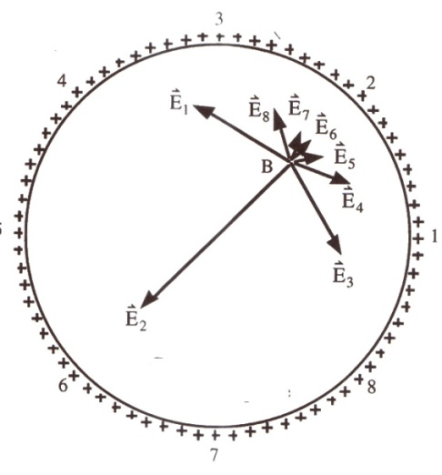
Fig. 1
Gauss’s law for electric fields relates the spatial behavior of the electrostatic field with the charge distribution that produces it and relates patterns of electric field over a closed Gaussian surface to the amount of charge inside the closed surface. According to Gauss’s law, electric charge produces an electric field, and the flux of that field passing through any closed surface is proportional to the total charge contained within that surface. The integral form taken from Maxwell’s equations (Fleisch, D., 2008, P) is given in eq. 3 below,
(3)

where is the electric field, is the unit vector (outward) normal to the surface, and is the charge in coulombs. The left side of equation 3 is electric flux that can be thought of as the number of electric field lines passing through a closed surface. The right side of the equation is the total amount of charge contained within that surface divided by the permittivity of free space.

Gauss’s law is completely equivalent to Coulomb’s law. Thein Gauss’s law represents the total electric field at each point on the surface. The magnitude of electric field at all locations on the surface is given by Coulomb’s law. The electric field is not absorbed by space and can come out from a positive charge and end at a negative charge. This is analogous to flow of water from a sink to a drain. The charge is conserved and not lost on the way!!

GRAVITATIONAL FIELD

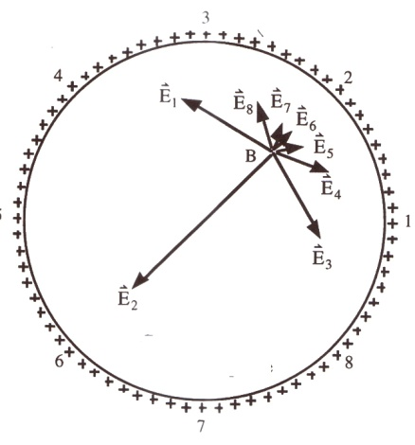

Consider hollow earth represented above, with a mass near the inside surface of the
hollow sphere (point B) (see Fig. II.) The gravitational force between the hollow earth of
mass and point mass is
(2)
where, is the distance in meters between the masses, is the unit vector and G is the Gravitational constant, with a value of in SI units. The negative sign indicates that the force is attractive. The magnitude of gravitational force is (Saeli, MacIsaac, pp.104-1067)
(3)
The point mass is so small that it does not alter the mass distribution and density of the hollow sphere. Each point on the hollow earth nearer to B exerts a greater force to pull the mass towards the surface. However, there is a greater surface area of the hollow sphere farther away towards left and downwards from B and results inpointing downwards towards the surface. The greater mass below balances the greater force per unit charge. The gravitational field on test mass, a mass much smaller than that of the earth very near the earth’s surface) is
This is defined as the gravitational force per unit mass, labeled as with a value of or in more familiar terms it is the acceleration due to gravity. Since the gravitational field falls off rapidly as this results in the forces to the right and left cancelling each other out, leading to a net zero field inside the sphere.

This has also been proved mathematically by Crowell, (Crowell, pp.101-102.) Without going into mathematical derivation (Crowell, 1998, pp101-102), it can be shown that the gravitational field of a uniform hollow earth of mass, interacting with point like mass outside the hollow earth is

where is the center to center distance. If mass is inside the shell, then the energy is constant, i.e. the shell’s interior gravitational field is zero, given by

for mass inside the hollow earth sphere

There is similarity between the gravitational energy of a uniform spherical shell of mass , interacting with a point like mass outside it and electric field due to a point charge inside and outside a hollow sphere of charge. The gravitational energy equals, where is the center to center distance between the two masses, and is the gravitational constant. In Gauss’s law for electrostatics, is replaced by, which equals. The value of in SI units is

(Saeli, and MacIsaac, pp.104-106.) If mass is inside the shell, then the energy is constant, in other words, the gravitational field in the shell’s interior is zero. The electrostatic energy on the interior of hollow shells is zero. By knowing the electric field due to charges on the outer surface, and expressing the electric field on a surface quantitatively in terms of electric flux, the charge inside the closed surface can be obtained.

The gravitational energy and electrostatic energy both follow a 1/r dependence, as shown in 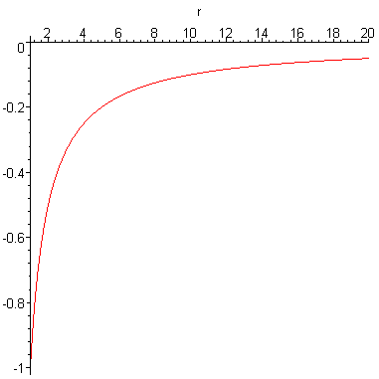
the graph below graph from Crowell (Crowell, p 102)

ELECTRIC FIELD DUE TO A CHARGE INSIDE A HOLLOW SPHERE WITH A GAP

Consider a charged hollow sphere of radius R and with a gap s. This surface behaves as the charged hollow dome of the Van de Graff generator without a conveyor belt. A Van de Graff generator is a device that generates static electricity. It consists of a dome, a silicone belt and two rollers are made of nylon. As the belt moves, the positive charge moves to the dome and the negative charge is drained to the ground. There is no charge inside the dome and all the positive charge is spread on the dome.

Students will observe the demonstration of working of Van de Graff generator and observe the electric field in the vicinity of the instrument. They will conduct a few activities that will demonstrate that all of charge is on the spherical surface and there is no charge inside the dome. For the working of the Van de Graff, students will work through the virtual demonstration at the University of Virginia virtual labs.

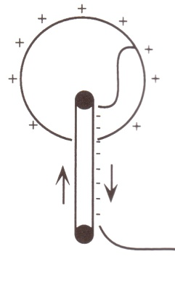

BIBLIOGRAPHY

Chabay, R. W. and Sherwood, B. A., Electric and Magnetic Interactions (1995), P 14- P15,

P146, P404

Crowell, Simple Nature, 102

Fleisch, D., A Student’s Guide to Maxwell’s Equations, Cambridge University Press (2008)

McQuarrie, D.,

