A Lesson Progression Using Ray Tracing Diagrams Analyzing Shadow Images to Introduce Gaussian Thin Lens Formulas in Introductory Optics
Christine Colson

Affiliations: Canisius College, Buffalo State College
This manuscript was written in partial fulfilment of PHY 690 at Buffalo State College under the guidance of Associate Professor Daniel MacIsaac
Abstract
Optical phenomena, such as shadows and images from mirrors and lenses, follow simple geometric relations which can be uncovered by high school or introductory college-level students with only Algebra I and Geometry (NYSED, 2016). In this manuscript I describe Learning Progressions where students determine the geometry of optical phenomena uncovering these relationships, leading to the Gaussian Thin Lens formula.
Christine Colson is a graduate of Canisius College in Buffalo New York, where she received a Bachelors of Science in Physics. She is currently teaching at Canisius College while obtaining a Masters Degree in Physics Education at Buffalo State College.
Background
While many high schools (i.e. those using New York State Regents Curricula) do not include geometric optics as part of the curriculum, both the International Baccalaureate (IB) program and AP Physics 2 program include optics in their curricula (see Tables 1 and 2) (College Board, 2019); (International Baccalaureate Organization, n.d.).
Enduring Understanding | Science Practices | Description
6.4  Reflection and  Refraction | 1.1 | Creating representations of phenomena
 | 1.4 | Using representative models qualitatively/ quantitatively
 | 6.4 | Making claims from theories/ models
 | 7.2 | Connecting concepts across domains
6.5  Lenses and Mirrors | 1.4 | Using representative models qualitatively/ quantitatively
 | 2.2 | Use Mathematical routines to describe phenomena
Table 1. Advanced Placement Physics 2 concepts
Topic | Subsection | Description
Wave Behavior | 4.4 | Reflection and Refraction
Table 2. International Baccalaureate Concepts
Optics is a great way to make connections between math and science. Ray diagrams lend clear recognition to the geometry of optics. A primary example would be that students can derive magnification equations based only on the application of similar triangles to simple observation. While some college texts do state this similar triangle relationship, not all of them emphasize the correlation between geometry and principles of magnification (Knight, Jones, and Field, 3e Chapter 18 p 589).
The geometric approach in this Learning Progression (LP) using light rays only requires principles from NYSED Algebra I (A-CED.A.4, F-BF.A.1-1a) and NYSED Geometry (G.SRT.A.2, G.SRT.B.5) (see Table 3). This LP makes a very powerful statement about how the world around us can be analyzed to discover science, even at the high school level (NYSED, 2012).
Algebra 1: CCLS | Description
A-CED.A.4 | Rearrange formulas to highlight quantity of interest
F-BF.A.1 | Write a formula describing relationships between two quantities
Geometry: CCLS | Description
G.SRT.A.2 | Identify components of similar triangles
G.SRT.B.5 | Using triangle congruence to prove relationships
Table 3. NYSED Algebra 1 and Geometry learning standards
Optics lends itself to an inquiry-based approach because light moves in straight lines, making ray tracing intuitive, and optical phenomena (such as magnification and clarity of images) can be found only using principles of triangle geometry and first-year algebra.
Creating a Learning Progression
A Learning Progression refers to a long term, intentional sequencing of teaching and learning expectations (Glossary of Educational Reform, 2013). Duschl (2019) demonstrated that this alternative approach can create richer conceptual understanding. The Learning Progression discussed in this manuscript is based around student inquiry. Groups of students were presented with several observable behaviors of light, and challenged to come up with an explanation for them. Each new situation used the previous ones as scaffolding (van Uum, Verhoeff, & Peeters, 2017).

Inquiry Approach with White Boarding
Inquiry-based physics instructional approaches have shown positive results. For example, the Force Concept Inventory (FCI) demonstrated increased retention in both the short term (end of semester) and the long term (one to three year later) in students who were instructed through an inquiry-based approach in physics (Francis, Adams, & Noonan, 1998, p 489). Hence, we applied this methodology to teaching optics. Informal exploration is also a key component of constructivist evaluation, such as Reformed Teaching Observations Protocol (RTOP) (MacIsaac and Falconer, 2002).
Whiteboarding is one effective method for inquiry. Each group is given a whiteboard (approx. 2 ft by 2.5 ft) and students draw out their models using diagrams, words, colors, or however they want to describe it. The instructor is there to act as a guide, directing students toward the main ideas and providing standard representations. These whiteboards are useful both for the students to diagram their thought process to the class, and for instructors to formatively monitor their progress (Megowan-Romanowicz, 2016).
Issues with Ray Diagrams Identified in the Literature
Interpreting diagrams poses a frequently minimized issue in science education. While the intention of the diagram is easy for the designer to see clearly, a lot can get lost in translation between the image and the reader. Colin, Chauvet, & Viennot (2002, p 314) identified and analyzed learning issues in optics figures. The common misinterpretations were split into four groups:
- Real World Objects vs Schematic/Symbolic Entities: When an author used real world objects to act symbolically, students could confuse what was real with what was just used as a symbol. For example, if a diagram used an image of a magnifying glass to “zoom in” on atoms, students could mistakenly believe it is possible to see atoms with a magnifying glass.
- Selection and Salience: Authors would often leave parts of a set up to be assumed by the reader. This was often done for clarity, as parts of a system could be irrelevant and drew focus away from the target. However, this could cause confusion if the reader was not making the same assumptions. I.e.: Only drawing in the light rays that gave us an image
- Similarity of Symbols: Objects like arrows could have many different meanings in the same diagram. Also, similar-looking letters or symbols could be misinterpreted as the same. I.e.: Use of an arrow to demonstrate light rays, and separately to show direction of motion
- Reading Composition Structures: Western cultures promote a left, up bias. As a result, an unintended cause and effect could be implied. (Colin et al, 2002 p 314)
Since optics is an inherently visual field of study, these issues with diagrams come to the forefront. For example, a student who has developed a ray-tracing model often will proceed to think of light as a finite number of rays, instead of rays going in all directions (Solokoff, 2016, p20), a misconception due to Selection and Salience.
Prompting and Guiding Student Ray Tracing: Cues for Instructors.
The Learning Progression discussed in this manuscript uses the relationships between similar triangles to demonstrate optical relationships. In the process of finding the triangles, students should begin to develop models for ray tracing. Instructors should point out to students that the boundaries of the triangles that they drew were limiting rays, or rays that just miss the object, outlining the shadow. Possible follow up questions include:
- What happens to the light rays that hit the object?
- Where does the light that does not hit the object go?
- What happens to the light rays on the edges?
Instructors should ensure that students are familiar with ray tracing. Several simulations are available for use with lenses for ray tracing. The Optics Bench Refraction Interactive from The Physics Classroom (https://www.physicsclassroom.com/Physics-Interactives/Refraction-and-Lenses/Optics-Bench/Optics-Bench-Refraction-Interactive) and The Geometric Optics Simulation (https://phet.colorado.edu/en/simulation/legacy/geometric-optics ) from PhET can be helpful supplements, and some sample worksheets such as “Optics Online” (https://phet.colorado.edu/en/contributions/view/3231) can be paired with the simulation (McCurdy, 2009).
The topic of optics is ideal for student discovery. Since laws of reflection and shadows can be determined using only the background of NYSED Geometry and Algebra 1, students should be able to derive them on their own. The prediction is that having students personally discover methods of ray tracing, with some guidance, will help them to apply these concepts in more complex situations.

The First Learning Progression: Shadows
Shadows demonstrate the ray model of light in its simplest form (Galili, Goldberg, & Bendall, 1991). In this five-part Learning Progression, students: (1) informally explored shadows, (2) found the limiting cases of shadow size, and (3) constructed a geometric explanation of the ray model of light.
Materials
Point source of light (the tiny filament of most flashlights with reflectors removed will work E.g. Mini Maglite, Mag Instruments); irregular 2D shape; dark/dim room; white boards/markers.
Part I
Part I consisted of an informal exploration of the materials. The goal of this activity was to have students become familiar with the equipment and informally observe how shadows behave. This was also a good opportunity for the instructor to listen in and gauge student familiarity with the topic. The worksheet in Appendix A was used for students to record their predictions and other notes. The worksheet is divided by activities and general prompts are given for students to address.
Students were divided into groups of two or three students and the room lights were dimmed. Each group was given a flashlight and prompted to, “Have your partner trace your shadow profile on the whiteboard” (large sheets of paper can also be used if students want to use them for reference later). The use of the students’ profile provided intrinsic motivation for the groups. Some guiding questions posed to students included, “Where do we see the shadows?” or “How are the shadows made?” Results of one group are shown below.
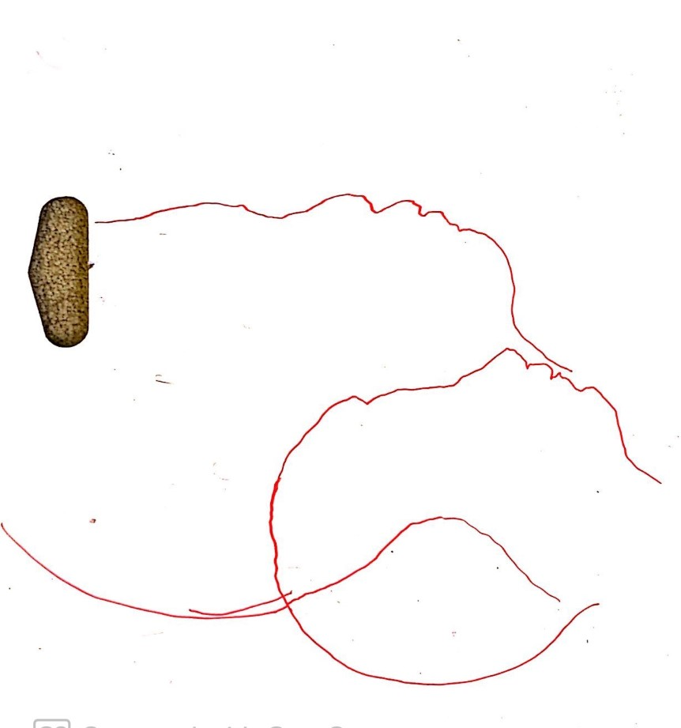
Figure 1. Profile tracings of student shadows.
Part II
The goal of this activity was to have students develop the bounds of a shadow, and recognize that it can be infinitely large, but only as small as the object itself. The set up used is shown in Figure 2.
Students were shown the activity set up and asked to make a prediction based on the prompt, “If I have this object here, how big and small can I make its shadow?”
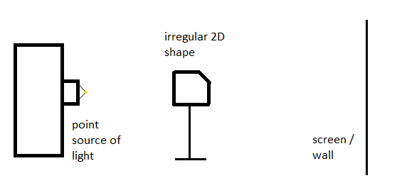
Figure 2. Part II Set Up for simple shadows, side view.
Students made predictions about the limiting cases of shadows. Then, the students worked in small groups to evaluate their predictions. Each group had a setup from Figure 2.
One of the clearer ways to see the limiting cases was by looking at and drawing the scenario from the side (as shown in white boarded figures). Many students intuitively knew where to start, but others moved along less productive paths, such as tracing the shadow on the whiteboard at different flashlight heights.
Some helpful prompts for students included:
- “Have you tried drawing the apparatus from the side?”
- “Try tracing the light on the very edges of the shadow”
- “Can you draw the geometry?”
By the end of this activity, students should have been able to state that shadows can become infinitely large, but can only get as small as the object itself.
The importance of the irregular shape was to identify left/right, up/down inversion and reversal patterns. This became more relevant in Part III.

Part III
There were three goals for this activity. First, students started to develop ray diagrams by drawing the limiting light rays. Second, students identified the geometry of the of the light rays (two similar triangles). Third, students derived an expression for M (Magnification).
Now that students had an idea about how shadow sizes work, the posed challenge became, “I want you to come up with a picture that explains why a shadow can become infinitely large, but only so small.” Students were led to trace out the path the light took to obtain a geometric representation.
When the limiting rays were discussed and established, $h_{i}$ and $h_{o}$ were labeled and students were asked, “What other relationship can we find between these triangles?” This led the students to relate $d_{o}$ to $d_{i}$.
The first goal here was that students would come up with a diagram similar to Figure 3, displaying the light source, the object, and the shadow.
Secondly, students were able to separate out the similar triangles between the point source, object, and shadow (Figure 4).

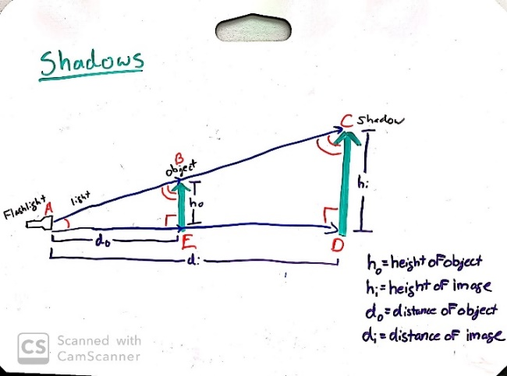
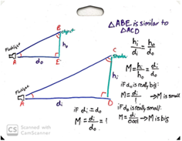

Figure 3. Ray Diagram of shadow set activity, white boarded example
Figure 4. Isolated similar triangles from Figure 3. Also shows magnification when object distance, d_{o}, changes. If $d_{o}$ is big, M is small. If $d_{o}$ is small, M is big. If $d_{i}=d_{o}$, $M=1$.

From here, the geometry produces:
$\frac{h_{o}}{d_{o}}=\frac{h_{i}}{d_{i}}$. (Eq. 1)
Defining M, we can rearrange Equation 1 to find the distance relationships:
$M≡\frac{h_{i}}{h_{o}}=\frac{d_{i}}{d_{o}}$, (Eq. 2)
to obtain magnification of the object’s shadow. Students again investigated with these values to confirm the limiting cases they found.
As a note to the instructor, the diagrams are set up such that everything was measured from the point source of light. This meant that all distance values were positive. Up was also taken as positive as the sign convention.
Limiting Cases.
When the object is close to the light source, $d_{o}$ is very small and $M→∞$. As such, we see almost no light on the screen and the shadow gets “infinitely large.” When the object is in contact with the screen, $d_{i}=d_{o}$ and $M=1$, so we see a shadow the size of the object. These limiting cases are explored in Figure 4.
By the end of this activity, students were able to state that magnification of a shadow can be anywhere between $1→∞$, prove and calculate magnification geometrically, and give an approximate size of a shadow given the distance from a light source.
Part IV
Part IV is centered around a pinhole camera. A pinhole camera was constructed (see Appendix B for construction details). Ultimately, one camera was made for each group of 2-3 students.
The last part of this activity was analyzing a pinhole camera (Kunselman, 1971). The goal was for students to find a statement for magnification in a pinhole camera and develop ray tracing techniques to determine that light was being reflected in all directions from every point on an object.
A picture of a red arrow was brought up on a bright LCD screen in the back of the dim classroom. A computer monitor could have been used as well. An arrow was used here, but another image such as a checkmark or another asymmetric shape can demonstrate left/right, up/down inversion as well.
Initially, the students were shown a set-up of the camera, and instructed, “Make a prediction about what you will see on the wax paper.”
After each group had made their predictions, students tested out the camera. They noticed a faint, black and white image that is inverted left and right. In the next step, students were asked to write an explanation, using light rays, about how the image was formed upside-down.
Another question the students could answer following this step includes, “Do you see color in the image?” This can be brought back to a biology perspective. The retina of the human eye is made up of both many rods and fewer cones. Rods help us see in low light conditions, providing a black and white image. Cones are activated when it is brighter, allowing us to see color (Mukamal, 2017). When there is enough light entering the pinhole, color will be visible. Otherwise, a black and white image will be formed.
The goal here was for the students to recognize that the rays creating the image cross each other at the position of the pinhole, creating an inverted image [Figure 5].
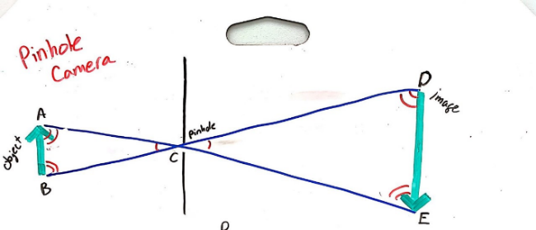

Figure 5. White boarded model of pinhole camera ray trace.

In this part, the instructor highlighted for students that light is coming off of every part on the arrow in all directions. This idea of light moving in all directions was further analyzed to explore the geometry of the light. Figure 6 shows the similar triangles.
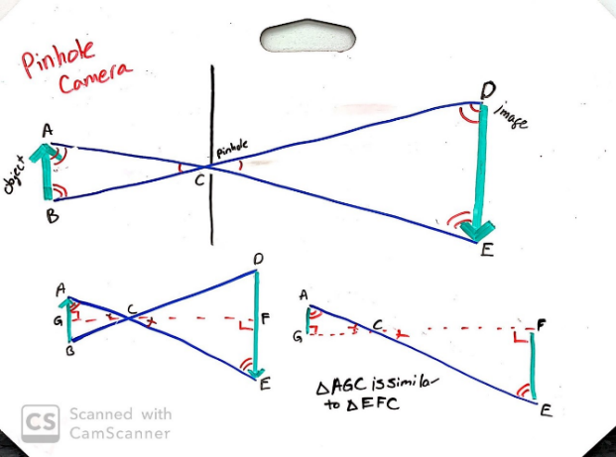
Figure 6. White boarded geometry of pinhole camera

The principle axis is an imaginary line extending out perpendicularly from the pinhole. The object does not need to start or end on the axis. The same geometry and magnification will hold if the object has its tail on the principle axis [Figure 7]. This is because the light from the top of the object will have a steeper angle to travel to go through the pinhole. This steeper angle will have its light go higher than the previous location (when the object was on the axis). While the head of the arrow will be higher than before, the tail of the arrow will travel straight through the pinhole. This maintains the same magnification.
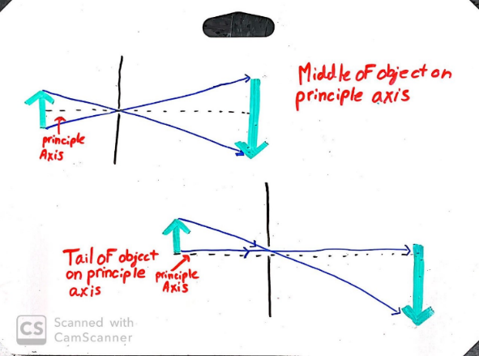

Figure 7. Two different object placements on the principle axis. Note that the image size is the same.
Now, students were told to stand in one place while looking through the camera. Then they were prompted, “Hold the camera at an object and gently squeeze the sides in a little.” The purpose here was to have the wax paper get closer to the pinhole and observe the change in the image.
The image became smaller as it approached the camera hole, and larger as it moves away. The magnification was analyzed in a similar way to Part II, with the key difference being that the distance that determined the magnification was the distance between the pinhole and the screen, not the screen and the object.
Again, $M≡-\frac{h_{i}}{h_{o}}=\frac{d_{i}}{d_{o}}$. Now, we introduced a new sign convention for magnification: if M was negative, that meant the image was inverted. This was consistent with the coordinate system that had been set up previously. Since “up” (above the optical axis) was taken to be positive, then “down” (below the optical axis) would be negative. If M was positive, the image was upright (Knight et. al. chapter 18).
This is shown through white boarding in Figure 8.
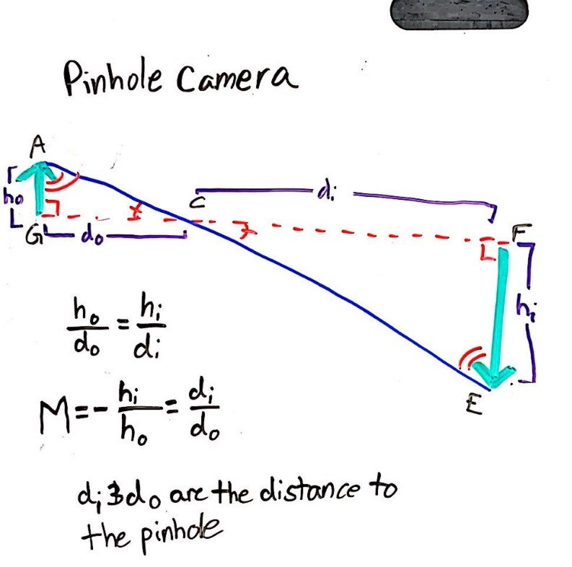
Figure 8. White boarded magnification example for pinhole camera.
After this, students should have been able to see that light is being reflected in all directions, not just along the path of the principle rays, debunking a common misconception (Solokoff).
Part V (Optional)
This final learning progression of the thin lens equation is optional and completes the Gaussian Formulas. Students worked their way through the worksheets found in the Appendix C.
In this learning progression, students deconstructed the geometry of lenses. Ultimately students discovered the derivation of Gauss’s Thin Lens Equation:
$\frac{1}{d_{o}}+\frac{1}{d_{i}}=\frac{1}{f}$. (Eq 3)
In this worksheet, students drew out two of the three standard light rays (the parallel and chief rays). These rays were traced, and then students found the right triangles these rays created. Students then identified which triangles were similar and used similarity to relate $d_{i}, d_{o}$, and $f$.
The third standard (focal) ray was omitted from our analysis to make the geometry more clearly visible.
Technical Note on Notation and Sign Convention
There are several widely used notations with optical systems -- some common notations for object and image distance include $s$ and $s'$, $d_{o}$ and $d_{i}$, $p$ and $q$, and $o$ and $i$. Here, I used what I consider to be the clearest notation, using $d_{o}$ to refer to the distance between the object and camera/lens and $d_{i}$ for the image and lens distance. Ultimately the Thin Lens Equation
$\frac{1}{d_{o}}+\frac{1}{d_{i}}=\frac{1}{f}$ (Eq.1)
was obtained. It should be noted that most notations use $f$ to signify the focal length.
Sign conventions are very important when dealing with optics and ray diagrams. With the example of the pinhole camera, both sides along the optical axis are taken to be positive (in this case, left/right). If an object is located on the principle axis (such as in Figure 3), the positive direction is taken to match that object’s placement. For example, if the object is above the principle axis, then up is taken to be positive and anything below the axis would have a negative value.
When dealing with converging lenses there is a different set of sign conventions: $d_{o}$ is always positive, but now $d_{i}$ is negative when it is on the same side as the object. All of this is measured with respect to the center of the lens. The table below (Table 4), adapted from Chapter 18 of Knight (2014), shows the sign conditions. Magnification keeps its previous convention.

Quantity | Positive When: | Negative When:
$$d_{o}$$ | - Always | - Never
$$d_{i}$$ | - On opposite side of lens from object | - On same side of lens as object
$$f$$ | - Converging Lens | - Diverging Lens (not addressed here)
$$m$$ | - Image is upright | - Image is inverted
Table 4. Sign conventions for converging lenses

Units.
Because these are all analyzed by ratios of similar triangles, any consistent length units (feet, meters, angstroms (if you are looking for some fun), etc.) work for the Gaussian Formula. However, the SI unit of meters (m) is privileged in that it leads to the standard unit of diopter $\left(≡\frac{1}{m}\right)$.
Findings
Our LP was run in a class at the beginning of the optics chapter in an introductory lab session, before any content had been covered. The lesson succeeded in laying the groundwork for future applications.
Activity 1: Shadows
Most students seemed to find the activity interesting and attractive, really enjoyed the lesson and were highly engaged for its duration.
Part I/II.
All of the groups were able to identify the limiting cases of magnification.

Part III.
When finding the magnification, some students struggled with the math (relationships between triangles and implications of similarity.) Most were still able to work through the problems once scaffolding was provided.
One of the more difficult intellectual leaps turned out to be students coming up with a mathematical definition for magnification $\left(M≡\frac{h_{i}}{h_{o}}\right)$.
While reconvening at a midpoint, the concept of magnification was more explicitly directed. The students were asked, “What does it mean to say that something has a magnification of 2?” From here, values were assigned to the size of the shadow and object, and a definition of magnification was reverse engineered. This part of the learning progression was delivered through explicit instruction to provide scaffolding for struggling groups.
Once this definition was set in place, all groups were able to then relate $d_{o}$ and $d_{i}$ to limiting conditions. Students were the instructed to confirm the limiting cases they found in Part II using these conditions.
Activity II: Pinhole Camera
Part IV.
Students were very excited with the use of the pinhole cameras. Some students had a difficult time seeing the image at first, but all students were eventually able to see the image. Students asked many questions about specific cases or modifications to the camera set up such as, “What would happen if there were two holes?” Or, “What would happen if the hole was bigger?” These situations were explored as much as time would permit.
Part V.
Students were given the option to complete the Thin Lens Equation activity on their own time (in this case, it was for extra credit). This seemed to appeal to a different subset of students.
The previous activities were more successful with students who preferred hands-on engagement. Some of the students who were less enticed by the group work aspect preferred this individual assignment.
A wide range of student performance levels was represented (with varying degrees of success). Most of the higher achieving students completed the activity correctly. The most common point of confusion was when the points on the triangles were mislabeled in the third question.
Many other experiments can build on these described activities. Similar principles can be applied to ray tracing in refractive mediums (Ferrero, 1998), or even examining how light rays split with diffraction (Logiurato, Gratton, & Oss, 2007).
Conclusions
This guided inquiry-based learning progression is designed to guide students towards discovering the Thin Lens Equations via the theory of light ray tracing and magnification.
Often, optics is either covered too quickly or insufficiently. Goldberg and McDermott (1986 p. 472) state that even after covering optics, if you were to ask a student if their distance from a mirror effected how much of their own image they could see, most would answer incorrectly. This implies limited deep comprehension.
While many students can solve their way through simple optics word problems, Arons reflects that many students are unable to apply their knowledge to more complex set ups, particularly with lenses (Arons, 1996. P 259).
The students who participated seemed to enjoy the learning progression, finding the phenomena appealing and fun. Students demonstrated engagement through group communication, teamwork contributions to the white boards, and exploration of their own questions unprompted by the assignment. All of the groups obtained the desired results and were able to explain their process and methodology. This indicated that students had a deeper conceptual understanding of the material. This methodology shows strong promise in physics education and should be explored in other topics.

Bibliography:

Arons, A. B. (1997). Teaching introductory physics. New York: Wiley.
Colin, P., Chauvet, F., & Viennot, L. (2002). Reading images in optics: Students’ difficulties and teachers’ views. International Journal of Science Education, 24(3), 313–332. https://doi.org/10.1080/09500690110078923
College Board. (2019). AP physics 2 course and exam description. Retrieved 04 17, 2020, from College Board: https://apcentral.collegeboard.org/courses/ap-physics-2?course=ap-physics-2-algebra-based
Duschl, R. A. (2019). Learning progressions: framing and designing coherent sequences for STEM education. Disciplinary and Interdisciplinary Science Education Research, 1(1). doi: 10.1186/s43031-019-0005-x
Ferraro, P. (1998). What breaks the shadow of the tube?(experiment in surface tension). The Physics Teacher, 36(9), 542–543. https://doi.org/10.1119/1.880129
Francis, G., Adams, J., & Noonan, E. (1998). Do they stay fixed? (student learning). The Physics Teacher, 36(8).
Galili, I., Goldberg, F., & Bendall, S. (1991). Some reflections on plane mirrors and images. The Physics Teacher, 29(7), 471–477.
Geometric Optics. (2016, February 22). Retrieved from https://phet.colorado.edu/en/simulation/legacy/geometric-optics
Glossary of Education Reform. (2013, August 29). Learning Progression Definition. Retrieved from https://www.edglossary.org/learning-progression
Goldberg and McDermott, 1986 F. Goldberg, L. McDermott. Student difficulties in understanding image formation by a plane mirror. The Physics Teacher, 24 (8) (1986), pp. 472-481, 10.1119/1.2342096
International Baccalaureate Organization. (n.d.). Topic 4: Waves. Retrieved from IB Diploma Program: https://ibpublishing.ibo.org/server2/rest/app/tsm.xql?doc=d_4_physi_gui_1402_1_e&part=3&chapter=4
Knight, R. D., Jones, B., & Field, S. (2014). College physics: A strategic approach. 3rd Edition. San Francisco: Pearson/Addison Wesley.
Kunselman, R. (1971) NOTES: pinhole camera experiments. The Physics Teacher, 9 193.
Logiurato, F., Gratton, L., & Oss, S. (2007). Making Light Rays Visible in 3-D. Physics Teacher, 45(1), 46–48. https://doi.org/10.1119/1.2409510
MacIsaac, D., & Falconer, K. (2002). Reforming physics instruction via RTOP. The Physics Teacher, 40, 479-485.
McCurdy, S. (2009, October 16). Optics Online. Retrieved from https://phet.colorado.edu/en/contributions/view/3231
Megowan-Romanowicz, C. (2016). Whiteboarding: a tool for moving classroom discourse from answer-making to sense-making. The Physics Teacher, 54(2), 83–86. https://doi.org/10.1119/1.4940170
Mukamal, R. (2017, September 29). How Humans See In Color. Retrieved May 12, 2020, from https://www.aao.org/eye-health/tips-prevention/how-humans-see-in-color

NYSED. (2012, October 26). New York state p-12 common core learning standards for mathematics. Albany, New York. https://www.engageny.org/resource/new-york-state-p-12-common-core-learning-standards-for-mathematics
NYSED. (2016). NYS p-12 science learning standards. Albany, New York. http://www.nysed.gov/curriculum-instruction/science-learning-standards
Physics Simulations at The Physics Classroom. (n.d.). Retrieved May 11, 2020, from https://www.physicsclassroom.com/Physics-Interactives/Refraction-and-Lenses/Optics-Bench/Optics-Bench-Refraction-Interactive
Sokoloff, D. (2016). Active learning strategies for introductory light and optics. The Physics Teacher, 54(1), 18–22. https://doi.org/10.1119/1.4937966
van Uum, M., Verhoeff, R., & Peeters, M. (2017). Inquiry-based science education: scaffolding pupils’ self-directed learning in open inquiry. International Journal of Science Education, 39(18), 2461–2481. https://doi.org/10.1080/09500693.2017.1388940

Appendix A: Observations student hand out
Activity 1: Shadows
Part I: Informal exploration
Draw a picture of the materials you used and how it was set up:

What did you see?

Part II: Magnification
Prompt: How big and small can you make the shadow of this object?
Prediction:

Draw a picture of the materials you used and how it was set up:

What is your final conclusion about the sizes of shadows?

Part III: Limiting Cases
Draw a diagram showing why these size conditions exist.

Activity 2: Pinhole Camera
Part I: Pinhole Camera
Draw a picture of the pinhole camera given to your group. Label all parts.

Prompt: Make a prediction about what you will see on the wax paper/ screen
Prediction:

What did you see on the wax paper?

Using light rays, try and explain what you see:

Part II: Magnification
Prompt: If the screen got closer or further from you, what would happen?
Prediction:

What did happen to the image?

Appendix B for Student Pinhole Camera Activity
Building a pinhole camera
Materials:

- Large box (Eg. from copy paper) With its lid
- Wax paper
- Tin Foil
- Box cutter knife
- Duct tape (black or gray only)
- Pin

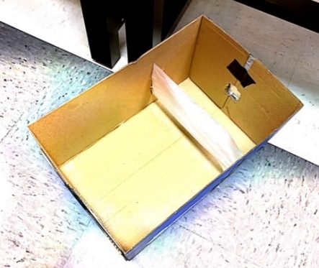
- In the box, cut two slits along either side about 2/3s the way down
  - They should be about the width of the wax paper
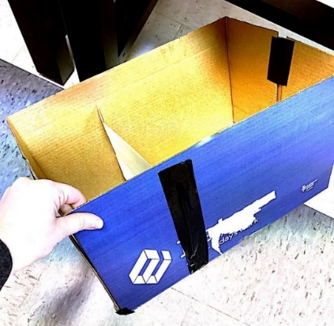

- Cut a piece of wax paper longer than the width (short way) of the box

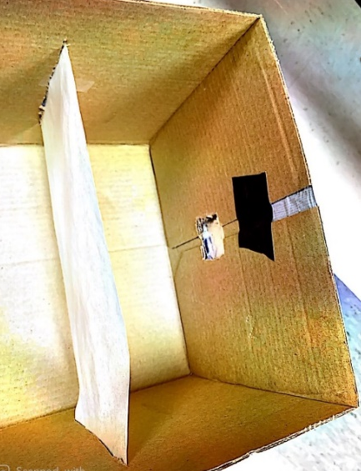

- Thread the wax paper through the slits
  - Pull it taught and tape them on the outside

- On the side closed to the wax paper, cut a hole in the box (around 1-inch x 1 inch)
  - The hole you cut should align with the center of the wax paper

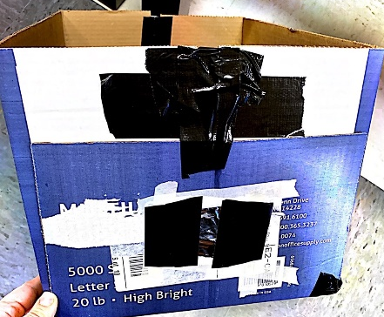
- Cover this hole with aluminum foil
- With a pin, poke a small hole in the tinfoil

- Black out the corners of the box to make it “light tight”

Appendix C for Thin Lens Equation: Instructor Version
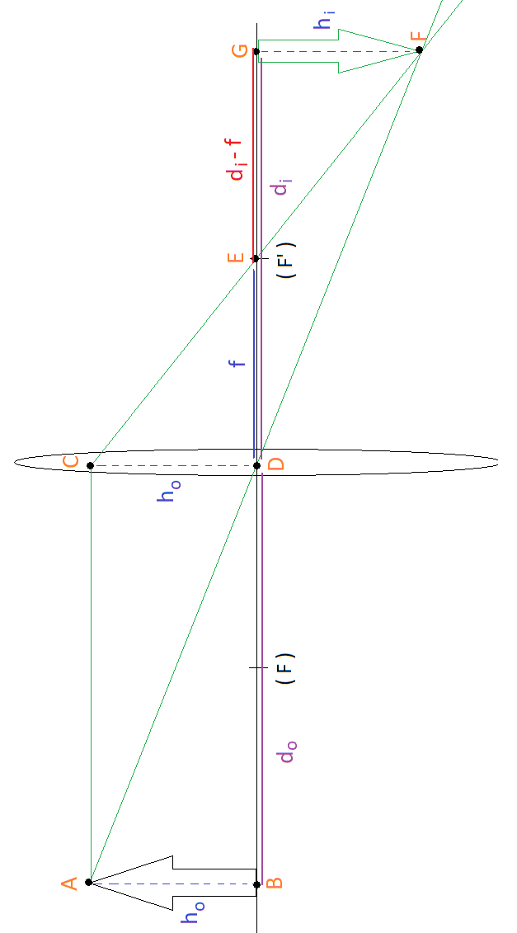
Gauss’s Thin Lens Equation:
- Trace two light rays starting from the tip of the object arrow:
#1) Parallel to the optical axis. When it hits the center of the lens, draw a new line through the far focal point $\left(f^{'}\right)$. Extend it out further. (We will call this whole line the Parallel Ray).
#2) Through the center of the lens. Extend to other side. (We will call this the Chief Ray).

- Extend both lines until they meet. At this point, draw the image of the arrow.

- Label the following points on the diagram with these letters:
- Top of original arrow
- Center of base of the original arrow (on optical axis)
- Where the Parallel Ray (Ray #1) meets the center of the lens
- Where the Chief Ray (Ray #2) meets the center of the lens (on optical axis)
- Where the Parallel Ray (Ray #1) crosses the optical axis (far focal point)
- Where the Parallel and Chief Rays (Rays #1 and #2) meet
- Center of base of the image (on the optical axis)

- Connect lines $\overline{AB}, \overline{CD},$ and $\overline{FG}$

- Of the points you labeled, how many right triangles can you find? Identify them
⇨ $ΔABD, ΔACD, ΔCDE, ΔEFG, ΔDGF$

- Which of these triangles are similar?
⇨ $ΔABD \sim ΔDGF$, $ΔCDE \sim ΔEFG$

- Identify and label the following line segments:
$d_{o}→$ the distance from the object to the lens ⇨ $\overline{BD}$
$d_{i}→$ the distance from the lens to the image ⇨ $\overline{DG}$
$f→$ the line segment with focal length $f$ ⇨ $\overline{DE}$
$h_{o}→$ the height of the object ⇨ $\overline{AB}$
$h_{i}→$ the height of the image ⇨ $\overline{FG}$
- Using only $d_{i}$ and $f$, how would you write out a value for $\overline{EG}$?
⇨ $\overline{EG}=d_{i}-f$
- What other line segment has a length of $h_{o}$? Label it on the diagram
⇨ $\overline{CD}$
- Redraw the two sets of similar triangles from #6. Label all the values you found
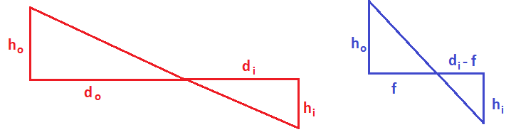
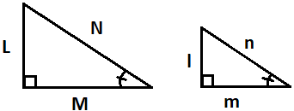
- Recall: If two triangles are similar, that means the sides are related by ratios. This means that $\frac{l}{L}=\frac{m}{M}=\frac{n}{N}$.

Match up the ratios of the corresponding sides of the triangles you drew in #10
⇨ $\frac{h_{i}}{h_{o}}=\frac{d_{i}}{d_{o}}$ $\frac{h_{i}}{h_{o}}=\frac{d_{i}-f}{f}$
- Which term appears in both statements?
⇨ $\frac{h_{i}}{h_{o}}$
- If this term appears in both statements, what does that mean about the relationship between $\frac{d_{i}}{d_{o}}$ and $\frac{d_{i}-f}{f}$?
⇨ $\frac{d_{i}}{d_{o}}=\frac{d_{i}-f}{f}$
- Show how you would prove that $\frac{d_{i}}{d_{o}}$can be rewritten and $\frac{1}{d_{o}}+\frac{1}{d_{i}}=\frac{1}{f}$
⇨ $\left(\frac{1}{d_{i}}\right)∙\frac{d_{i}}{d_{o}}=\frac{d_{i}-f}{f}∙\left(\frac{1}{d_{i}}\right)$
$\frac{1}{d_{o}}=\frac{d_{i}-f}{d_{i}f}=\frac{d_{i}}{d_{i}f}-\frac{f}{d_{i}f}=\frac{1}{f}-\frac{1}{d_{i}}$
$\frac{1}{d_{o}}+\frac{1}{d_{i}}=\frac{1}{f}$

Appendix C for Thin Lens Equation: Student Copy
Gauss’s Thin Lens Equation:
- Trace two light rays starting from the tip of the object arrow:
#1) Parallel to the optical axis. When it hits the center of the lens, draw a new line through the far focal point $\left(f^{'}\right)$. Extend it out further. (We will call this whole line the Parallel Ray).
#2) Through the center of the lens. Extend to other side. (We will call this the Chief Ray).
- Extend both lines until they meet. At this point, draw the image of the arrow.

- Label the following points on the diagram with these letters:
- Top of original arrow
- Center of base of the original arrow (on optical axis)
- Where the Parallel Ray (Ray #1) meets the center of the lens
- Where the Chief Ray (Ray #2) meets the center of the lens (on optical axis)
- Where the Parallel Ray (Ray #1) crosses the optical axis (far focal point)
- Where the Parallel and Chief Rays (Rays #1 and #2) meet
- Center of base of the image (on the optical axis)

- Connect lines $\overline{AB}, \overline{CD},$ and $\overline{FG}$
- Of the points you labeled, how many right triangles can you find? Identify them

- Which of these triangles are similar?

- Identify and label the following line segments:
$d_{o}→$ the distance from the object to the lens ⇨
$d_{i}→$ the distance from the lens to the image ⇨
$f→$ the line segment with focal length $f$ ⇨
$h_{o}→$ the height of the object ⇨
$h_{i}→$ the height of the image ⇨
- Using only $d_{i}$ and $f$, how would you write out a value for $\overline{EG}$?

- What other line segment has a length of $h_{o}$? Label it on the diagram

- Redraw the two sets of similar triangles from #6. Label all the values you found

- Recall: If two triangles are similar, that means the sides are related by ratios. This means that $\frac{l}{L}=\frac{m}{M}=\frac{n}{N}$.

Match up the ratios of corresponding sides of the triangles you drew in #10

- Which term appears in both statements?

- If this term appears in both statements, what does that mean about the relationship between $\frac{d_{i}}{d_{o}}$ and $\frac{d_{i}-f}{f}$ ?

- Show how you would prove that $\frac{d_{i}}{d_{o}}$can be rewritten and $\frac{1}{d_{o}}+\frac{1}{d_{i}}=\frac{1}{f}$

