Using Scratch Holography in the Middle School Science Classroom

Timothy R. Coughlin
Department of Physics, SUNY Buffalo State College, 1300 Elmwood Ave. Buffalo, NY 14222 tcoughlin@lancaster.wnyric.org

Acknowledgment: This manuscript was prepared in partial fulfillment of requirements for PHY690: Masters Project in Physics Education at SUNY- Buffalo State College under the guidance of Dr. Dan MacIsaac.

Abstract
This paper reports how scratch holography was used by a New York State middle school science teacher in his physical science classroom, as well as how scratch holography affords science teachers a unique opportunity to make overarching connections between light and matter by introducing an inquiry-based physical science lesson in their middle school level classroom. Evidence was shown that using scratch holography as an activity aids science teachers in unifying scientific themes and processes in their year-long curricular plan for their students that is consistent with both state and national science standards. William Beaty’s “Draw Holograms by Hand” link (http://amasci.com/amateur/holo1.html) on his Science Hobbyist website was used as the primary source for the design of the presented lesson, as well as for troubleshooting within the lesson.

Introduction
It was my goal to find a classroom activity that would allow students to make connections between scientific topics presented during the course of a school year. In doing so, students could reflect on prior knowledge while engaging in processes of science and gain operational knowledge of that process. For many years, compelling arguments have been made for holography to be taught in formal education classrooms at many levels for the very traits I was looking for in an activity. Latham discussed how holography “can be used to teach many of the principles of wave interference and light production in one unit” (Latham, 1986, 396). Dr. Tung Jeong argues, “holography is not merely a craft – it combines meticulous laboratory techniques with extremely elegant formal theory. Indeed, a single hologram contains all the major theories of physical and geometric optics” (Jeong, 1975). Holography is one area that has become an exciting avenue for educators to use for their students to learn due to recent reductions in cost of lasers, film, and chemicals (Jeong, et al, 2003), and seemed like a perfect opportunity to allow my students to experience the first-hand connection between two topics that are traditionally presented apart from each other in middle school text books, matter and light. To cut down on time and the chemistry in development of film, recent options have also been made available for self-developing “Instant Hologram” film (Chiaverina, 2010).
Despite the lowered costs, my personal school budget did not allow for me to purchase enough material in order to give each student their own hologram. This, however, did not mean that my students could not be afforded the opportunity to experience holography. William Beaty, a research engineer at the University of Washington, began a website in 1995 entitled Science Hobbyist (http://amasci.com) that now boasts nearly 20,000,000 visitors since its inception. While the site links to numerous scientific topics of discussion and science education, I would like to give attention to the link entitled “Draw Holograms by Hand” (http://amasci.com/amateur/holo1.html). Beaty proceeds to describe holograms produced by scratches to a solid surface, or scratch holograms. “Unlike the conventional holography, for making this type of hologram by hand, neither a darkroom with isolation table and expensive laser, nor highly photosensitive film plates are necessary” (Augier & Sanchez, 2010). This was a phenomena Beaty chanced upon while walking through a parking lot and noticing a three-dimensional hand floating in the hood of a car left “by a polishing mitt ‘that had traced out millions of nearly parallel scratches in the black paint’ ”(Jones-Bey, 2003).
A scratch hologram works similarly to a rainbow hologram, like the kind found on licensed clothing apparel or in the corner of a credit card. Both can be viewed under white light illumination, rather than under a monochromatic point source, like a laser. Each scratch acts as what Beaty calls “a curved-line scatter” which “can act as a convex or concave spherical mirror, producing either an astigmatic real or virtual image of the distant point source” (Beaty, 2003). Essentially, a source of light shines upon the scratched surface and reflects off each individual “scatterer” and creates virtual images into the surface from different observable view points. Beaty explains that “human stereopsis lets observers perceive either of the two virtual images” based on their position “by looking through the curved scatterer as if the scatterer behaves as a slit-aperture” (Beaty, 2003). To recreate a hologram of this kind, only a piece of sturdy plastic (e.g. Plexiglass™), a pair of dividers, and a source of light are necessary.
Curricular Rationale
A scratch hologram activity could be used to discuss optics, the nature of light, and the interaction of light and matter, and therefore could fit into the yearlong, holistic plan of a teacher. The National Science Education Standards states that “conceptual and procedural schemes unify science disciplines and provide students with powerful ideas to help them understand the natural world” (NRC, 1996, p.104). Scratch holography itself aids to unify conceptual and procedural scientific themes about the nature of light and its interaction with materials by providing an avenue for students to integrate personal experiences with their understanding of the world around them. Also, the applications of the technique can easily make the lesson interdisciplinary. The geometric translation of an image finds its application in mathematics at a level consistent with middle school classrooms, while the aesthetics of scratch holography can easily be explored in an art classroom. Discussions of careers involving holography or photonics could give real substance to the applications of holography, especially since there is a shortage of skilled workers in these areas (John, 2004). Also, a business or marketing class may discuss scratch holography in advertising, as the original application of it is derived from a patent by inventor Hans Weil to “produce simple pictures that appeared floating in space by scratching a metallic or transparent surface in certain directions” (Abramson, 2000).
The scratch hologram method allows a teacher to demonstrate holography without the cost or worry of lasers and consumable chemicals. According to Arnold Arons, “concrete experience is still an essential factor in cultivating understanding of the phenomena and grasp of the extensive vocabulary that is generated” (Arons, 1997, 234), however, just doing the activity wouldn’t be enough. It was important that the experience was “guided by phenomenological questioning” (Arons, 1997, 234) to ensure students were able to concretely associate the experience with the conceptual goals of my curriculum. This could be achieved through the use of whiteboards to “orchestrate discourse” (NRC, 1996) amongst my students demonstrating how and why the images from the scratch hologram formed.
The activity can be specifically linked to content performance indicators in the New York State Intermediate Science Curriculum. In Standard 4, Performance Indicator 4.4b states: “Light passes through some materials, sometimes refracting in the process. Materials absorb and reflect light, and may transmit light. To see an object, light from that object, emitted by or reflected from it, must enter the eye” (Intermediate Level Science, 2002, p.27). We would be using a material medium that could transmit and reflect sunlight. The reflection would be in a specific geometric pattern such that the emitted light from the plastic sheet could only enter the eye in a specific way to produce an image. Light can easily reflect off and transmit through a transparent plastic sheet, thus making scratch holography a practical example of light and matter interacting.
Activity Preparation
I purchased two 48” x 36” sheets of clear Lexan™ (polycarbonate) from the local hardware store closest to my home (see table 1 for pricing of materials). Other plastic materials may be used, but I chose these as they were the lowest priced plastic sheets that were available at that store for the quantity I required. Lexan™ and other comparable plastic materials can be purchased from most hardware stores, home centers, and retail glass dealers, or is easily found online. Using a table saw, I cut them up into about 6” x 4” pieces. Many hardware stores will do this process for you for a minimal cost, and oftentimes for free if you are unable, or uncomfortable, using a table saw. I borrowed a class set of metal compasses from a math teacher in my building. While compasses with pencils in one end are not ideal for the activity due to the potential sliding of the pencil, they still worked to achieve the desired effect and were cost effective. My students made sure to secure the pencil very tightly using masking tape, which seemed to work in the majority of cases where sliding occurred. They used the pencil end to mark the points on their images, and used the pointed end to make their scratches into the plastic. A set of dividers, or a drafting compass with metal tips on both sides, is more ideal to make the most precise scratches and to avoid the slipping of the inserted pencil, but is also considerably more expensive (See Table 2).
Table 1. Pricing of Materials used by author as reported without sales tax on 11/20/2010
Material | Total Bulk Cost | Relative Cost Per Student | Consumable or Reusable Material | Potential Suppliers  *Indicates Supplier used by author
Lexan™  48 in. x 36 in. Polycarbonate Sheet | ~$63.00/sheet x 2 = $126.00 (125 Students) | ~$1.01  (125 Students) | Consumable | Home Depot*  Lowes  McMaster-Carr
Metal Compass | $44.70 (Class Set of 30 Units) | ~$0.36  (125 Students) | Reusable | Office Max*  Office Depot  MisterArt.com
Table 2. Cost Comparison for Different Dividers as reported without sales tax on 11/20/2010.
Type of Reusable Divider | Cost Per Class Set (30 units) | Cost Per Student (if Individually Purchased) | Cost Per Student (Based on Reusing for 125 Total Students) | Potential Suppliers  *Indicates source of price in table
Metal Compass | ~$44.70 | ~$1.49 | ~$0.36 | Office Max*  Office Depot
Drafting Compass | ~$329.70 | ~$10.99 | ~$2.64 | Office Max*  Office Depot
Carpenter’s Dividers | ~$3359.70 | ~$111.99 | ~$26.88 | ToolKing.com*  Sears  Amazon.com

Activity
My students keep bound notebooks in my science class for lab activities, review questions, and free writing. To save on the cost of using additional materials I decided to use this for the activity rather than passing out more paper or cutting larger pieces of plastic for them to compose their images. I passed out a compass and a piece of Lexan™ to each student and instructed them to tape the corners of the Lexan™ onto a clean page in their notebooks (see Figure 1). Taping down the corners anchored the plastic to the page so it remained stationary throughout the activity.
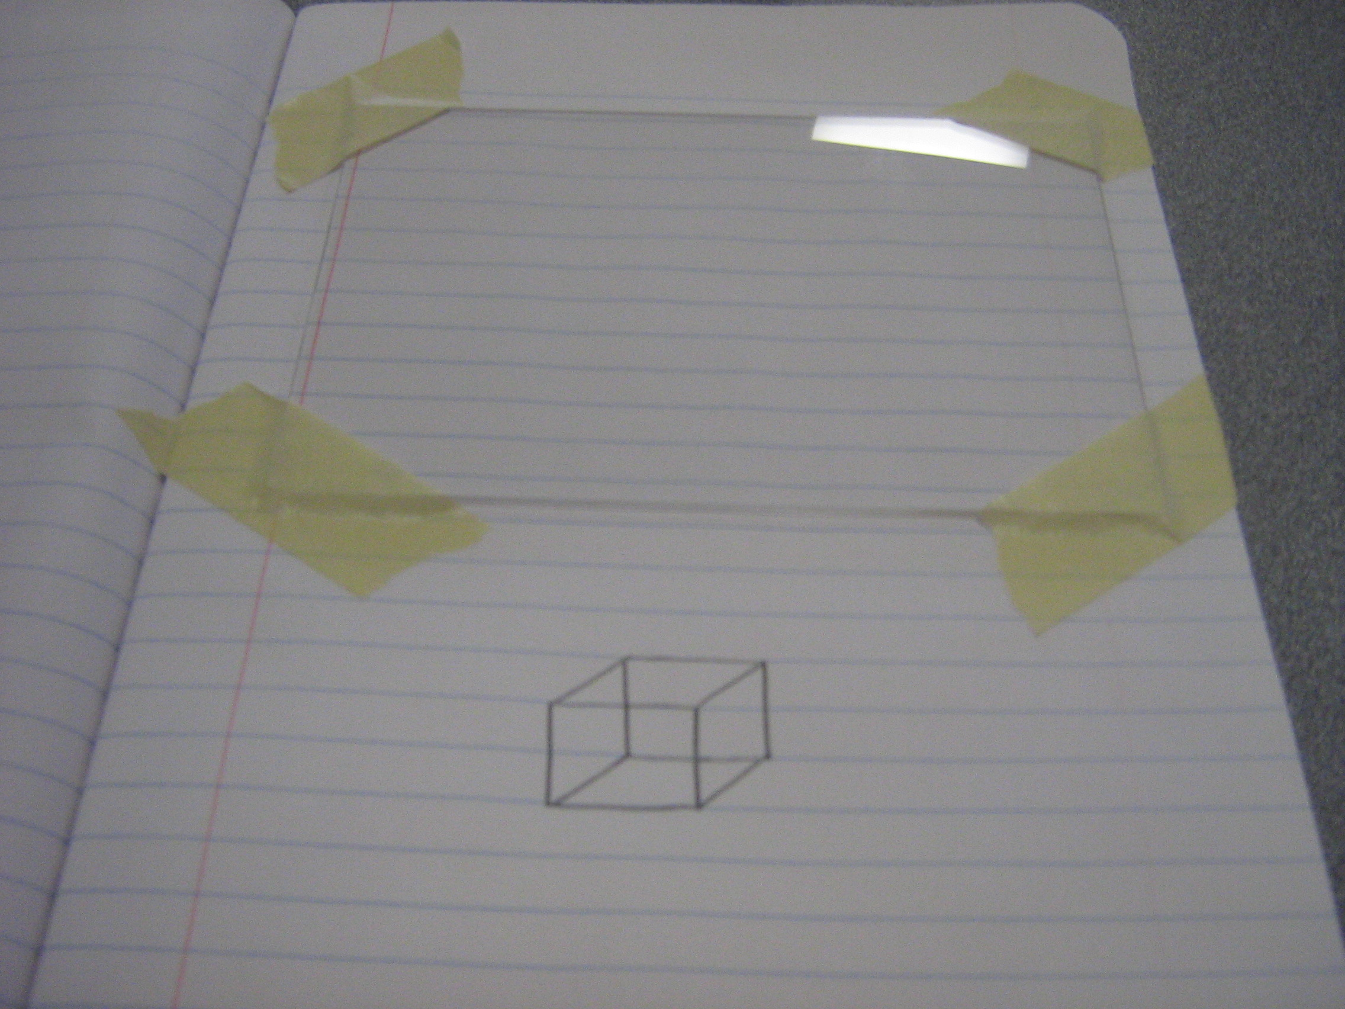
Figure 1. Student notebook setup for scratch hologram
After all students were equipped with the materials, I showed the video of Bill Beaty and his scratch holograms (http://www.youtube.com/watch?v=XUy8lELWhJg) prior to giving any additional instructions. The video is only a few minutes long, but shows a variety of scratch holograms of varying complexity being shown with sunlight. After viewing the video, my students were enthusiastic and eager to make their own.
Below the Lexan™ piece, my students drew the image they wanted to scratch onto the notebook page. Most wanted to try the first initial of their names, while others wanted to try shapes like stars and hearts. The students then proceeded to place the pencil tip of the compass on a single point of their image. Then, holding the pencil in place, I instructed my students to tilt the compass at about a 45 degree angle and make a light scratch across the Lexan™ with the metal tip of the compass (see Figure 2). Beaty states, “It helps to tilt the compass so the point trails across the surface and does not dig in or chatter. The scratch should be easily visible, but not extremely deep. The scratch should be dark and polished, not white and dusty” (http://amasci.com/amateur/holo1.html, para 3).
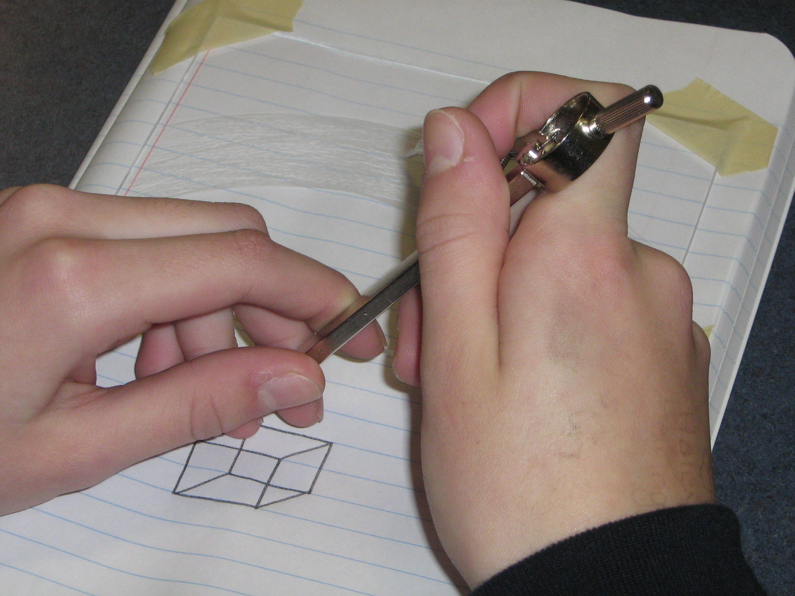
Figure 2. Holding compass at an angle to make scratches.
The students moved around the entire image with their compasses, individual point by point, like pixels in a digital image, and transcribed corresponding scratches into the polycarbonate sheet related to points of their image. We then traveled outside and viewed the holographic images in the sunlight (see Figure 3). Some students laid their holograms on the ground and varied the backgrounds behind the Lexan™ sheets, using dark colored binders and black construction paper in order to get a better quality image. Others held their products in their hands and tilted the Lexan™ until they were able to see their images.
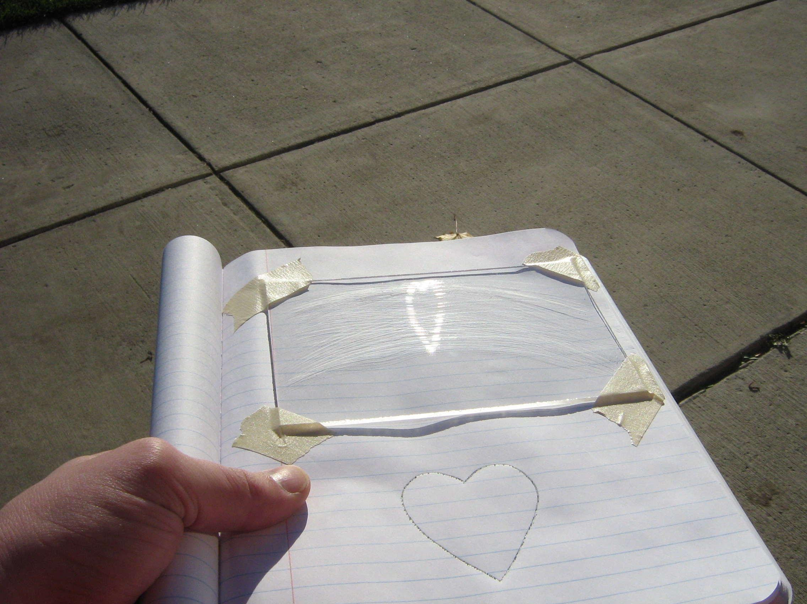
Figure 3. A student-created scratch hologram.
I had made a few simple scratch holograms on my own and each had taken me between 30 and 45 minutes to finish. Since my class periods are only 40 minutes long, I anticipated that a single class period was not enough time for my students to finish properly scratching their image, so I told them we would continue the following day. However, I found that there were a few students in each class that came to my room during study hall periods to continue working, and still others worked to finish their scratch holograms at home to show me the following morning. It was exciting for me to see my students eager about doing science, as well as taking ownership of their personal holograms. We used these completed examples as demonstrations at the start of the following class. Those students that finished helped their classmates or tried making a second scratch hologram with the leftover scraps of Lexan™ I had in the room.
I am fortunate that my room is positioned adjacent to an exit door opening to an athletic field. Throughout the period, we traveled quickly in and out of the room, testing the scratch holograms in the sunlight, making observations and comparing the quality of the images from one to the next. At the end of the period, all students had completed their scratch holograms to varying degrees, and were troubleshooting how to perfect their techniques. Many side discussions ensued amongst students concerning the different types of materials that may work to produce a similar image, as well as suggestions of “painting the plastic black like on the video to see if more light would be attracted to it and make it brighter.”
The next day, I asked my students a simple question: “What happened to make their holograms work?” I wrote this on the board and began the class by having them answer this question independently in their journals for the first few minutes. My students understand very well that free writing in their journals is a risk-free process, so I found that very few students tried to proceed without attempting to write some explanation. I can foresee many more students not attempting to write or even guess if a teacher has not established that routine in their own classroom.
Next, I had them break out into small groups of 3 or 4. I allowed only a few minutes for this to keep pacing of the class period. Students discussed their reasons with each other, sharing what they wrote down. It was interesting to circulate throughout the groups listening to the various evidences and inferences being argued. Some students would only argue what they saw, while others tried to extrapolate based on discussions we had previously had in preceding classes. I did not interfere, or question in any of these groups, but merely made them mindful of the time limit that I had set.
Finally, I told each group to take a whiteboard and dry erase markers and sketch out how they believed the scratch holograms worked. I have found whiteboarding to be a tremendous instructional tool when employed in the classroom as “the whiteboards create an atmosphere in the classroom where ideas are student-generated, leading to students constructing their own evidence-based knowledge” (Henry, et al., 2006, 51). I gave each group a limited time of six minutes to accomplish this task, but ended up giving an additional four minutes as many students were eager to take part in the board’s construction (see Figure 4).
Once they finished, we sat as a class in a large circle, while each group presented their whiteboards. I facilitated the discussion, using a “Socratic” line of questioning in order to differentiate between observations and inferences derived from the phenomena. We highlighted common ideas on each of the boards, and focused on subtle differences that made some boards more descriptive than others. As the discussion ensued, a few students began trying to add additional elements to their boards, which “can be easily modified as students' ideas emerge and are refined through discussion” (Henry, et al., 2006, p.52). The answers varied from group to group, but the ideas of “reflected light,“ “light refracted from the scratches,“ and “light bouncing from the scratches to my eyes” were the most common pervading ideas from group to group and from class to class.
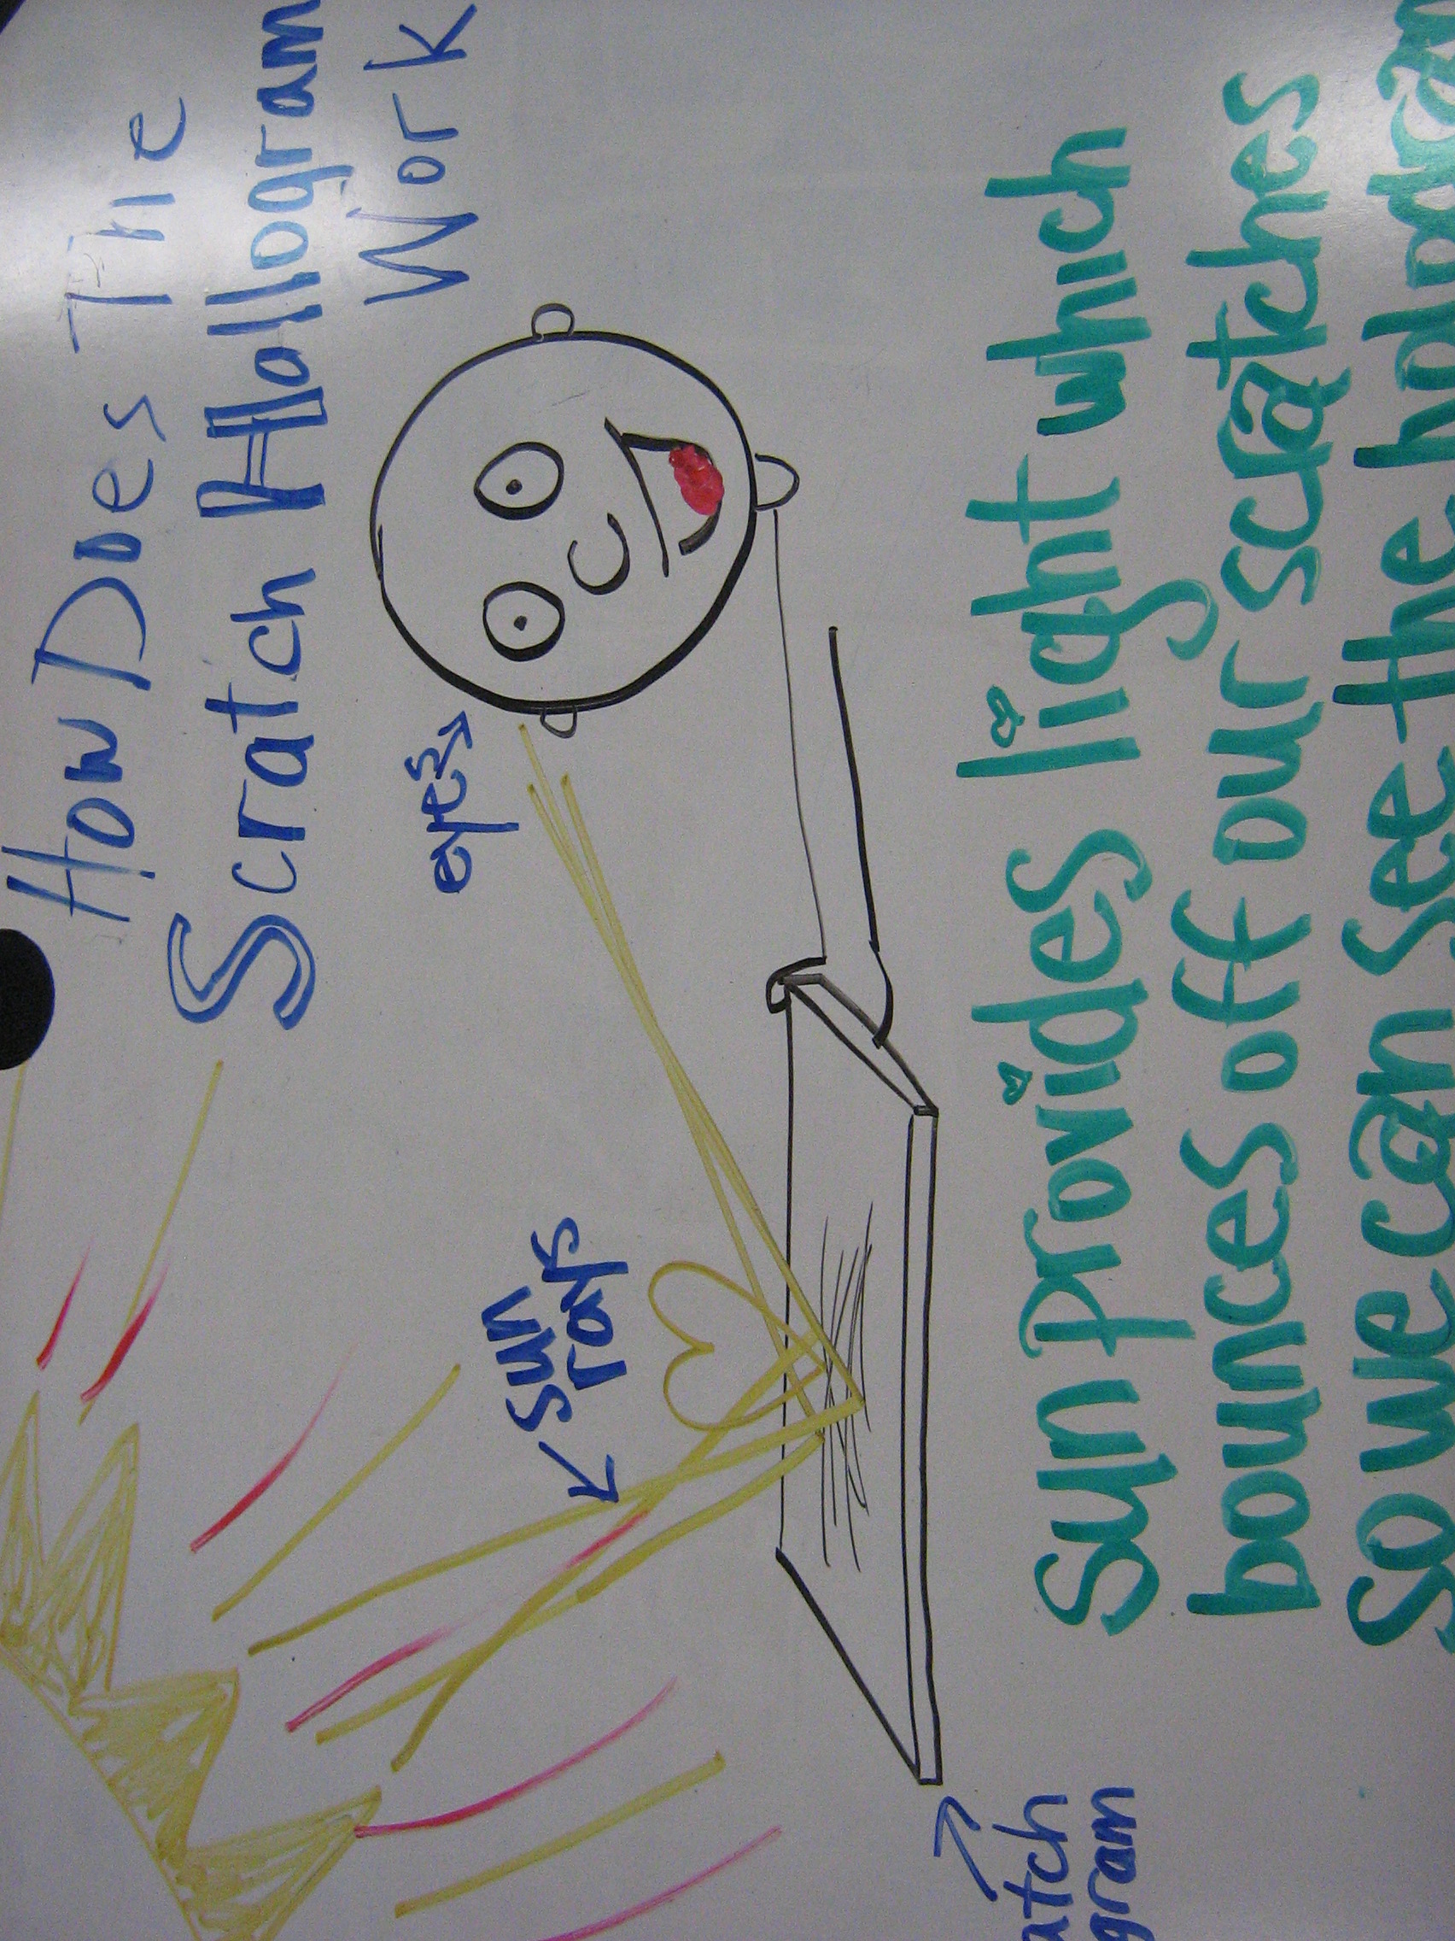
Figure 4. Student whiteboard example reflecting ideas about scratch holograms.
As Arons states, “relatively few students hold a conception of light as a physical effect existing apart from its sources and effects. Light illuminates objects so that they are seen, but the act of seeing is not explicitly associated with the arrival of light at the eye of the observer” (2007, p.263). Therefore, I deemed it important to discern preconceptions that my students had about the nature of light that may or may not affect their inferences about their observations. I facilitated the discussion to have my students make judgments on what inferences had the most support to explain what they observed. Our class discussions seemed to dwell on phenomena that my students observed, specifically the fact that the image seemed to move as they changed their position brought up a lot of discussion, as well as how the image seemed to flip and produce a pseudoscopic image when you oriented the Lexan™ upside down. This was demonstrated on the video (Beaty) and was a point that fascinated my students when they were able to recreate the effect with their own scratch holograms.
Considerations
As with many lessons, while well planned and executed, I would be remiss to say that it went perfectly. Since each student was creating their own individual product, each student could take individual ownership of the finished product. However, this also meant there were a variety of problems that needed to be examined if a student’s scratch hologram did not come out successfully. I found that if students failed to produce a holographic image in their abrasions this was primarily due to two reasons, both of which related to how the scratches were made.
First, students would make too few scratches. Just as in a digital image that is blurry due to lack of pixels, two few scratches resulted in an image without detail that appeared as described by one of my students as “a white smear.” In some cases, students were able to go back and make additional scratches to represent the points on their images and have better results in producing their images. Other times, students made scratches that were too deep. In this case, the light reflecting from the surface would bend at different angles, disrupting the phase relationship of the light waves necessary to produce the image. I found students did this most often if they pointed their compass points directly into the Lexan™, rather than at an angle, or if students did not clearly see a scratch, in which case they would retrace the scratch over and over again (see Figure 5). The holograms that were the most clear and detailed consisted of many fine scratches over the surface of the glass.
Other issues usually stemmed from a failure of the equipment. The success of the image transcription into scratches is dependent on producing scratches that directly relate to specific points on the image being transcribed. If a student did not anchor down the Lexan™ securely to the notebook, the distance between the image and the abrasion could change if the Lexan™ slid, thus causing scratches to be made that did not coordinate with the image and producing the “white smear" effect as was the case when the phase relationship was lost when the scratches were too few or too deep. On the other hand, if the compass was not secure at its pivot point, or the pencil too loose, students often tried to compensate by making deeper scratches, or the over stretched scratches produced a distorted image, elongated similarly to looking at the image as if it were in a funhouse mirror.
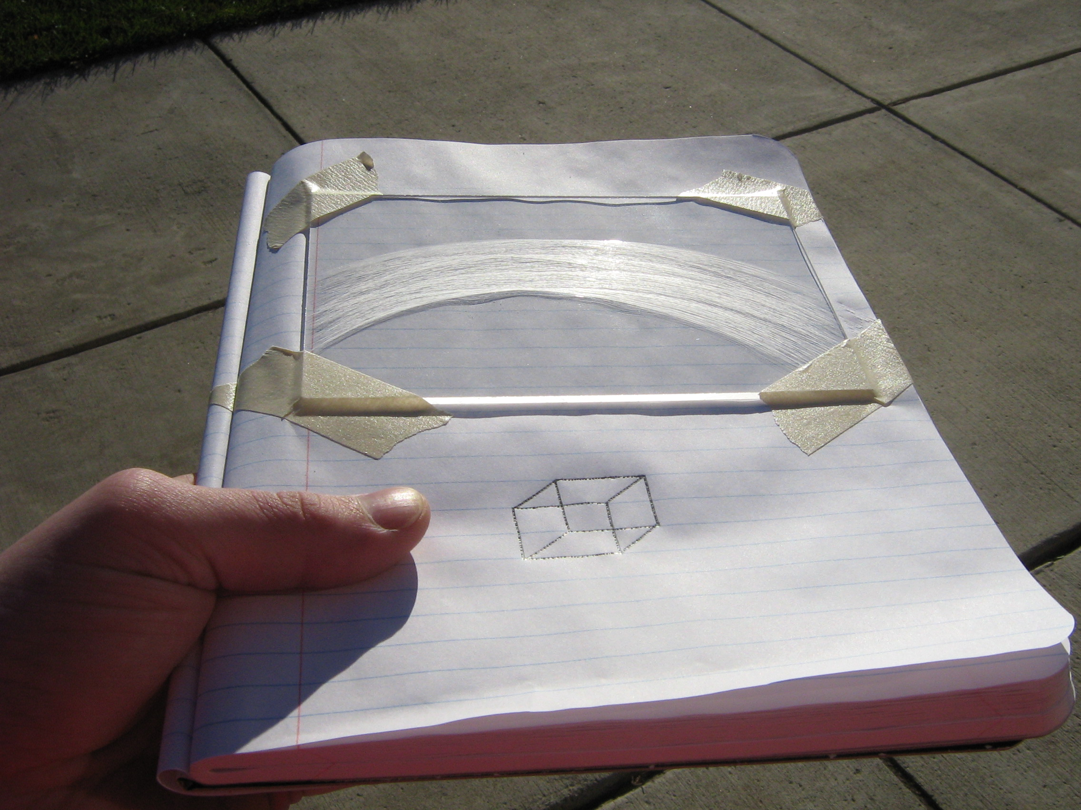
Figure 5. An unclear image due to scratches made too deep in the plastic.
Beaty makes a point of addressing each of the issues we had, as well as different problems that may arise when creating a scratch hologram in the Frequently-Asked Questions link on the site (http://amasci.com/amateur/holohint.html). I found this extremely helpful to read over prior to the lesson, so that I could anticipate errors that students may be making. It was very user-friendly as the page is laid out in a typical FAQ section, with responses to questions he has received concerning scratch holography since first posting his technique on the internet.
While I did not carry out the activity on days that prevented my class from traveling outside, a bleak or cloudy day could hinder the viewing of the hologram. Adverse weather conditions are something to be considered in implementing this activity. I suggest viewing scratch holograms outside in the sunshine. However, they may be viewed with some difficulty in a nearly dark room using a nearly point source of white light. I have been able to view scratch holograms I have made using a strong flashlight or spotlight in a classroom with blackened windows and as minimal interior and exterior sources of light as possible. This may be a preferred option of teachers that do not have simple access to going outside during the school day, but it does pose safety or classroom management concerns considering the logistics of individual classrooms and populations.
I do not suggest directing middle school students to Beaty’s website to carry out the activity on their own. While the site may be school appropriate, it links to public forums that may not be appropriate or may have less controlled content. The step-by-step method of producing a scratch hologram is detailed and accompanied by illustrations, but the specific scientific concepts discussed behind scratch holography are beyond the reading capability of most middle school aged children. I found that the site is better served as a resource for the teacher as an instructional tool. If a teacher was so inclined to have their students research the subject on their own, other online resources are available on the subject, but none as complete as Beaty’s site. However, the instructional video from the Fort Worth Museum of Science and History is very topic-focused and presented at the level of a middle school student (http://www.youtube.com/watch?v=0uko9oixijg).
Conclusion
Scratch holography provides an engaging and enriching opportunity for children of any age to practice science in a very tactile and real way. When used in combination with techniques of whiteboarding and phenomenological questioning, it allows for a broadening of student understanding of the connection of matter and light, consistent with both New York State and National Science Standards. Scratch holography proves effective in producing an economic product in its employment for individual student ownership with broad application so as to be used as an interdisciplinary project. Using Science Hobbyist (http://amasci.com/amateur/holo1.html) as a primary resource, interested teachers can employ such an activity in their own classrooms as a unifying concept between matter and energy, and as a real world application.

References
Abramson, N. (2000). Incoherent holography. Proc. SPIE, 4149, 153-157.
Arons, A. B. (1997). Teaching Introductory Physics. New York: John Wiley & Sons, Inc.
Augier, A., & Sanchez, R. B. (2010). Hologravure as a computer-generated and laser engraved
scratch hologram. Opt. Commun. doi:10.1016/j.optcom.2010.09.008.

Beaty, W.J. (1995). Hand-drawn holograms. Retrieved from
http://amasci.com/amateur/holo1.html.

Beaty, W.J. (2003). Drawing holograms by hand. Proc. SPIE –IS&T Electronic Imaging, 5005,
156-167.

Beaty, W. J. (2008). Hand-drawn holograms. Retrieved from http://www.youtube.com/watch?v=XUy8lELWhJg

Chiaverina, C. (2010). Litiholo holography: apparatus review. The Physics Teacher, 48, 551-
552. doi:10.1119/1.3502513

Henry, D., Henry, J., & Riddoch, S. (2006). Whiteboarding your way to great student
discussions. Science Scope, 29(7), 50-53. Retrieved from Education Research
Complete database.

Jeong, T.H. (1975). A study guide on holography (draft). Test edition. AAAS study guides on
contemporary problems. Retrieved from http://www.eric.ed.gov/ERICWebPortal/search/detailmini.jsp?_nfpb=true&_&ERICExtSearch_SearchValue_0=ED157788&ERICExtSearch_SearchType_0=no&accno=ED157788.

Jeong, T.H., Aumiller, R., Ro, R., Blythe, J. (2003). Teaching holography in classrooms, making holograms with PFG-03M plates with JD-4. Retrieved from
http://www.holokits.com/a-teaching_holography.htm

John, Pearl. (2004). Teaching holography - inspiring an interest in science. Retrieved from http://holographer.org/teaching-holographyinspiring-an-interest-in-science/

Jones-Bey, H. (2003). Making a hologram from scratch. Laser Focus World, 39(3), 24. Retrieved
from Academic Search Complete database.

Latham, R. E. (1986). Holography in the Science Classroom. The Physics Teacher, 24, 395-400.

Lexan™ Pricing. Retrieved from http://www.homedepot.com/h_d1/N-5yc1vZ1xhc/R-
202038065/h_d2/ProductDisplay?langId=-1&storeId=10051&catalogId=10053

Metal Compass and Drafting Compass Pricing. Retrieved from
http://www.officemax.com/catalog/search.jsp?freeText=compass

National Research Council (NRC). (1996). National science education standards. Washington,
DC: National Academy Press.

University of the State of New York State Education Department, The. (2002). Intermediate
Level Science, Core Curriculum, Grades 5-8. Retrieved from http://www.p12.nysed.gov/ciai/mst/pub/intersci.pdf

