Using Science Fiction Examples of Gravity Assists to Teach Regents Level Physics
Brandon DeFilippis
SUNY Buffalo State College
1300 Elmwood Ave
Buffalo, NY 114222
deflipb@gmail.com

Acknowledgements: This paper is submitted in partial fulfillment of the requirements necessary for PHY690: Masters Project at SUNY Buffalo State under the guidance of Dr. Dan MacIsaac. Thanks to Andrea Dunca and Peter Doolittle for editing.

Bio: Brandon DeFilippis is a SUNY Geneseo graduating with a Bachelor’s in Geological Sciences and Adolescent Education. He has been teaching Earth Science and Astronomy for eight years, starting in New York City and now in Nassau county. Currently he is enrolled in the Master’s program at Buffalo State in Physics Education.
Abstract
Over the past few years, fiction and specifically science fiction has become entrenched more and more in popular culture: revivals of old fandoms and books being made into movies and television shows making significant profit in both theaters and on streaming platforms. These are not only entertaining to watch, but also in their own way help fuel discovery (Teskleves 2015) and are an engaging and interesting way to access some higher-level Bloom’s questioning (Shakhman and Barak 2019) on whether the laws of physics are being held to or not. Personally, I get a lot of enjoyment Neil DeGrasse Tyson live tweeting (Watercutter 2013) watching a movie like Gravity (Cuarón 2013). Discussions of contemporary examples of physical phenomena can allow for meaningful access points in curricula for a variety of disciplines including physics even for nonscience majors (Dark, M. 2005). Outer space holds a special place in the hearts and minds of many children and adults, ranging from actual fascination in astronomy and cosmology to UFOs or astrology.
These types of lessons will only become more relevant with the implementation of the Next Generation Science Standards (https://www.nextgenscience.org) and New York State Science Learning Standards (http://www.nysed.gov/curriculum-instruction/science-learning-standards), providing springboards into what the NGSS refer to as “anchor phenomena” (https://www.nextgenscience.org/resources/phenomena).
This article is an exploration of gravitational slingshots as one of these “anchors,” with discussion of how this phenomenon can be linked to a variety of topics for a wide range of physics classes. Additionally, the author wishes to expand upon the discussion (Barlett and Hord, 1985) to attain a “simple understanding” of the gravitational slingshot (also known as a gravity assist). Students will first use simulations to comprehend the basic physics behind the phenomenon, then discuss a fictitious situation in the context of how realistic its portrayal is. The activity will lay the foundation for the integration of the gravity assist phenomenon in curricula using plot points in the television show The Expanse (Shankar et al. 2015-2021) and novel/movie The Martian (Wier 2011/Scott R. 2011), followed up by contextualizing these scenarios with real-world examples.

Introduction
Applications for Gravitational Slingshots in the Next Generation Science Standards and the New York State Science Learning Standards
The move toward Next Generation Science Standards (https://www.nextgenscience.org) in many states will force even veteran teachers to alter their approach. The units require the use of anchor phenomenon that students will explore and complete inquiry-based activities about in order to understand the larger goal of the unit. The NGSS defines these as (https://www.nextgenscience.org/resources/phenomena):
- Natural phenomena are observable events that occur in the universe and that we can use our science knowledge to explain or predict. The goal of building knowledge in science is to develop general ideas, based on evidence, that can explain and predict phenomena.
- Engineering involves designing solutions to problems that arise from phenomena and using explanations of phenomena to design solutions.
- In this way, phenomena are the context for the work of both the scientist and the engineer.
The NYSSLS (http://www.nysed.gov/curriculum-instruction/science-learning-standards) is New York’s localization of the NGSS. There are many pertinent standards outlined by the state that can be applied through gravity assists:
Table 1: Standards as outlined by the NYSSLS:
Middle School Standards  (http://www.nysed.gov/common/nysed/files/programs/curriculum-instruction/ms-science-learning-standards.pdf) | High School Standards  (http://www.nysed.gov/common/nysed/files/programs/curriculum-instruction/hs-science-learning-standards.pdf)
MS-PS2-3. Ask questions about data to determine the factors that affect the strength of electric and magnetic forces. | HS-PS2-1. Analyze data to support the claim that Newton’s Second Law of Motion describes the mathematical relationship among the net force on a macroscopic object, its mass, and its acceleration.
MS-PS2-3. Ask questions about data to determine the factors that affect the strength of electric and magnetic forces.  (This is specific to the use of the magnet activity (outlined later), but draws on analogy to help students understands the effects.) | HS-PS2-2. Use mathematical representations to support the claim that the total momentum of a system of objects is conserved when there is no net force on the system.
MS-PS2-4. Construct and present arguments using evidence to support the claim that gravitational interactions are attractive and depend on the masses of interacting objects and the distance between them. | HS-PS2-4. Use mathematical representations of Newton’s Law of Gravitation and Coulomb’s Law to describe and predict the gravitational and electrostatic forces between objects.
MS-PS2-5. Conduct an investigation and evaluate the experimental design to provide evidence that fields exist between objects exerting forces on each other even though the objects are not in contact. | HS-PS3-5. Develop and use a model of two objects interacting through electric or magnetic fields to illustrate the forces between objects and the changes in energy of the objects due to the interaction.  (Again, specific to the magnetism analogy.)
MS-PS3-1. Construct and interpret graphical displays of data to describe the relationships of kinetic energy to the mass of an object and to the speed of an object. | HS-ESS1-4. Use mathematical or computational representations to predict the motion of orbiting objects in the solar system.
MS-PS3-2. Develop a model to describe that when the arrangement of objects interacting at a distance changes, different amounts of potential energy are stored in the system.
MS-ESS1-2. Develop and use a model to describe the role of gravity in the motions within galaxies and the solar system.

Gravitation as a NGSS Anchor Phenomenon
It is important that these anchor phenomena both demonstrate fundamental aspects of the larger topic at hand and are also engaging and interesting to students on an intellectual level. This helps offset two of the most challenging aspects of inquiry-based learning: it requires a significant amount of dedicated class time and, particularly with lower-achieving student populations, motivation on the students’ part to work through frustration and confusion.
As defined by the NGSS (https://www.nextgenscience.org/resources/phenomena), anchor phenomena should include certain qualities:
- Build upon everyday or family experience:
  - Gravity is one of the most everyday experiences there is. As one of the four fundamental forces in the universe, it is an essential part of any physics curriculum. It is deceptively simple to students as they experience it daily with macroscopic falling objects. This is part of what makes gravity as a topic so powerful: the students come in with an entrenched belief on how it works, giving students a level of personal investment with the content.
- Apply multiple NGSS performance expectations:
  - In this case, we look to the performance standards on momentum and gravity (those others can apply), such as “HS-PS2-2: Use mathematical representations to support the claim that the total momentum of a system of objects is conserved when there is no net force on the system.”
- Too complex to design a solution in a single lesson:
  - Depending on the depth, the concept is flexible and can be built upon over a number of class sessions.
- Observable to students:
  - The simulations and calculations not only provide the ability for students to observe the phenomena but also to calculate and predict outcomes to practice questions.
- Case of wonderment:
  - Space exploration is an excellent hook for a variety of students.
- Audience or stakeholder community who cares about the findings or products:
  - Gravity assists will be an essential part of any space exploration or colonization effort, making all of humanity stakeholders.
Gravity assist as a topic is also malleable, allowing you to introduce, build upon, or review on a variety of other topics in sequence or simultaneously. Some examples of conceptual tie-ins include:
- Reference Frames
  - Frame of reference play a large role in understanding many aspects of physics and Earth science alike, from establishing axes in projectile motion or momentum problems to establishing that not all rivers flow south (believe it or not, huge shock for many ninth graders).
- Vector/Free Body Diagrams
  - Students can practice the use and conventions of these diagrams (for example, size of the arrow correlating to magnitude).
- Kepler’s Laws
  - Kepler’s laws are touched on both in high school Earth Science and Physics, and assuming you have students that take the courses in that order you should be able to draw upon some of the students’ prior knowledge. Students in New York drew ellipses and at least briefly touched on the other two laws, which can be modified to establish the equation used in the activity.
- Newtonian Gravity
  - This is a take on gravity many students will not be familiar with, but a great way of reviewing both F=ma and the inverse square law. Students’ understanding of gravity usually stems from the world around them, this idea of gravity “pulling things down.” Here, students will be forced to use gravity as the attraction to the center.
- Conservation of Energy and Momentum
  - Depending on the reference frame, gravity assists can seem to violate both principles, allowing for inquiry into these points to identify and address misconceptions. Gravitation is also a conservation force. Berg and Brouer (1991) have an in-depth consideration of many of these misconceptions.
- Collisions (inelastic vs. elastic)
  - This can be used to expand upon collisions uniquely as gravity assists are attractive elastic collisions that do not require physical contact.

The Physics of Gravity Assists
“Simple” Definition of a Gravity Assist
Barlett and Hord (1999, pg 53) describe how a gravity assist works. A crucial component of space travel is the ability to alter course mid-flight, and many works of fiction will have you believe this is typically done through propellants shot up with the rocket as fuel. Although the “delta-v” budget of a rocket is important, most large scale course corrections cannot be achieved using launched propellant, as it is prohibitively difficult and expensive to launch spacecrafts with massive amounts of fuel. Since the spacecraft only has whatever amount of propellant it is sent up with, the management of this fuel source is paramount and must be considered at every point in the mission (Doody 2019).
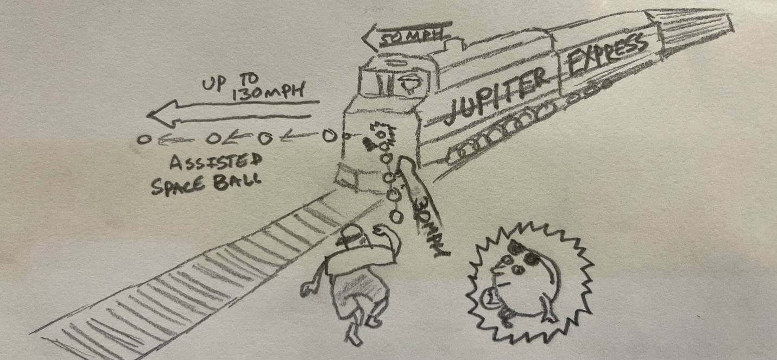
Gravity is essentially free momentum transfer for spacecraft. You can observe this on Earth, things do not need fuel to accelerate downward: the Earth’s gravitational field transfers kinetic energy to objects that are falling (Arons, 1997, pg 81-88). Gravity assists do this on a massive scale by using precise flight, one can transfer the kinetic energy from a planet’s gravitational well to a spacecraft. Gravity assists make solar system space travel possible by giving spacecraft access to momentum exchange that can accelerate spacecraft to speeds able to span the great distances in the solar system in a fraction of the time (and cost!) the spacecraft would have needed otherwise.
Figure 1: Illustration of a gravity assist. A boy throws a ball at an oncoming train in a sun-stationary frame of reference. The ball bounces off of the train with additional momentum in the Sun-stationary frame of reference. Author’s rework of a cartoon conceptualized by Charles Kohlhase, based on artwork by Gary Hovland. (Doody 2019, https://solarsystem.nasa.gov/basics/primer/)
Real World Application
The first paper on gravity assists ever compiled was in 1918, but was not published until 1938 by Ukrainian scientist Yuri Kondratyuk (Wikipedia, https://en.wikipedia.org/wiki/Gravity_assist), In his paper “Тем кто будет читать, чтобы строить, (To those who will be reading [this paper] in order to build [an interplanetary rocket])” he posits that you could use the moons of two planets in order to accelerate a space craft to travel in between them (Mel’kumov 1965). In his 1929 book Conquest of Interplanetary Space, he described one of the first proposals for a lunar orbit rendezvous (Mel’kumov 1962).
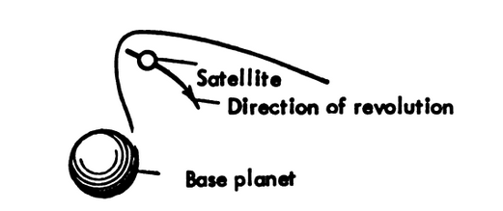
The first documented use of the gravity assist maneuver was on the Soviet Luna 3 mission in 1959. The spacecraft used the moon’s gravity to swing itself around the moon and capture the first ever pictures of the far side of the Moon (Johnson, 1979).
Figure 2: Excerpt from Kondratyuk’s Paper (Mel’kumov 1965), showing a gravity assist path a spacecraft could use to for braking and land on a foreign planet using that planet’s satellite. Public Domain. (https://hdl.handle.net/2027/mdp.39015047366193)

Gravity assists are now commonplace in almost all space exploration missions. One of the challenges of the maneuver is the heavy reliance on the position of the planets at the time of launch. Astrophysicists calculate trajectories based on the known period of the planets’ orbits and the angle that the target planet is from the Earth. This angle is called an “opportunity.” The Hohmann Transfer Orbit (Wei and Zhang, 2019) is an example of this strategy put into practice, where the spacecraft is launched at a particular opportunity to minimize the amount of propellant required to complete its mission, relying on the gravitational pull of the Sun and the target to control its flight. This is the type of assist usually applied to send spacecrafts to Mars (by speeding the spacecraft up, allowing it to climb farther out of the Sun’s gravity well) or Venus (by slowing the spacecraft down, forcing it to fall deeper into the Sun’s gravity well). If propellant is available or planned for, astrophysics can also use the Oberth Effect (Blanco and Mungan 2019). Instead of just using the gravity of the planets to control flight, the planet accelerates as it enters the gravity well until it reaches periapsis. This can provide more kinetic energy to the spacecraft than just the gravity assist alone.
Several of the more famous uses of the gravity assist include the Voyager missions, which were the first to see the outer planets (Bartlett and Hord, 1985), and New Horizons, the first spacecraft to take close pictures of Pluto (NASA 2007, https://www.nasa.gov/mission_pages/newhorizons/news/jupiter_flyby.html). Both these missions are only possible when the planets are aligned in a particular opportunity. Astrophysicists plan space exploration around these opportunities, sometimes decades in advance.
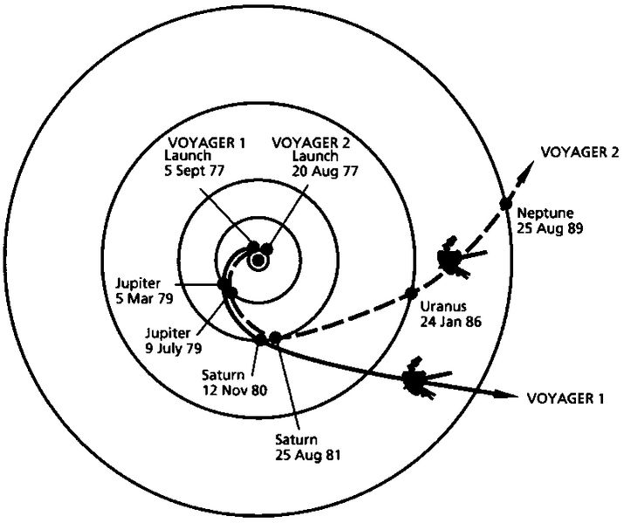
Figure 3: Picture taken from the Public Domain of the “Grand Tour” alignment. This orientation of the inner and outer planets made the Voyager missions possible, and only occurs about once every 175 years, with the next occurring in 2152. (https://upload.wikimedia.org/wikipedia/commons/thumb/5/53/Voyager_Path.svg/1024px-Voyager_Path.svg.png)

Pedagogical Applications of Gravity Assist Simulators
Bridging Analogies
Some teachers currently use spandex or another fabric to model gravity as the slope of spacetime. This is done with large pieces of fabric stretched over a frame which allows the fabric in the middle to be depressed when a mass is placed on it. The depression of the fabric represents the gravity well of the object, and one can observe how the slope of the fabric alters the path of smaller objects (typically marbles or small balls) that are introduced into the system. An example of an activity using this principle can be found in the references, with excellent descriptions of the process and pedagogical pitfalls described in Overduin, J., Perry, J., Huxford, R., Selway, J., 2019, also Kersting, 2019, and Hilborn, 2019.

A first example used to explain the transfer of energy in a gravity assist system is that of a ball bouncing off a moveable wall (Barlett and Hord, 1985 use a ball and a truck). An excellent interactive simulation of this example can be found on the John Hopkins Applied Physics Laboratory website (https://messenger.jhuapl.edu/Learn/interactives/conv_gravity_assist/gravity_assist_menu.html). In the simulation, the green path/line (V₁) refer to the initial velocity of the ball before the collision, where the red path/line (V₂) shows the velocity of the ball after the collision. Figures 4-7 are screenshots are all taken directly from the simulation.
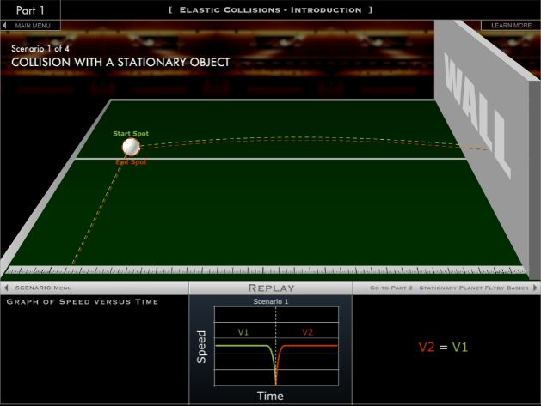
Figure 4: The first example is that of a simple elastic collision: the ball is thrown at the wall and after a perfect elastic collision returns to the same spot it started. As the graph shows the velocity of the ball remains constant until the ball hits the wall, then the ball accelerates back to the same magnitude but in the opposite direction.

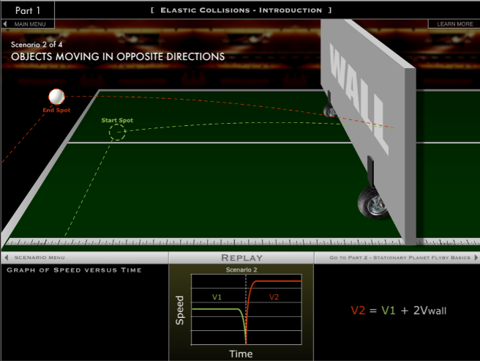

Figure 5: In the second example, the wall is moving toward the ball at some velocity (v_{wall}). The ball travels in the opposite direction (v_{ball}) toward the wall, and after the elastic collision leaves the wall in the direction of v_{wall} with a magnitude v_{wall}+v_{ball}. The additional kinetic energy was transferred from the wall to the ball.
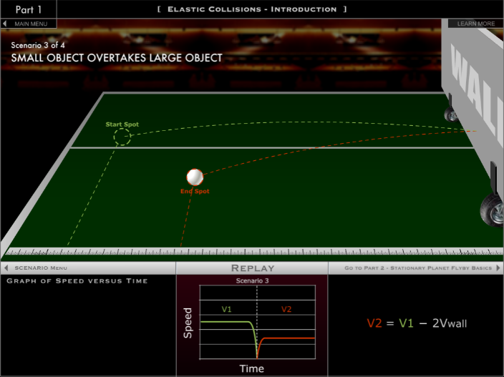
Figure 6: The third example shows the ball and wall both moving in the same direction, though the ball is moving faster than the wall is. Here, the ball transfers some of its kinetic energy to the wall on impact and leaves the wall in the opposite direction at a slower velocity (the ball’s velocity after the collision is v_{ball}-v_{wall}).

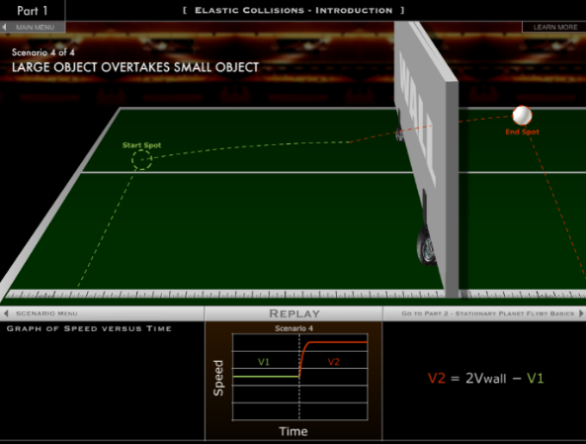

Figure 7: In the fourth example, the wall starts on the left side behind the ball and they both move to the right, where V_{wall} is greater than V₁. When the wall catches up to the ball, the wall transfers kinetic energy to the ball, and the ball moves in the same direction at a higher magnitude.
These examples can all be adapted for gravity assists: the ball is the spacecraft and the wall represents the planet. There are some caveats to the wall analogy:
- As identified by Barlett and Hord, the ball bouncing off the wall is a repulsive force. Gravity is an attractive force, so the “ball” (spacecraft) in the real-world example “bounces” around the planet’s gravitational field.
- The collision in the analogy requires physical contact to transfer the energy. In a real-world gravity assist, the spacecraft interacts with the planet’s gravitational field but (hopefully) never comes into physical contact with the planet.
The first example below is similar to what happens during the assist from the planet’s frame of reference.

Figures 8-10: showing the planet frame of reference for a single spacecraft’s pass of a “fixed” or stationary planet where the spacecraft changes course. The spacecraft (in blue) and planet (orange). Time proceeds from left to right. Based on the gifs by Shortt, 2013. (https://www.planetary.org/articles/20130926-gravity-assist).

As the spacecraft approaches the planet in a straight line, the gravitational force of the planet changes the angle of the spacecraft’s flight. An extremely close pass, resulting in an almost 90 degree turn is shown here, passing at a farther distance would create less change in speed and direction. If you were on the planet, you would see the spacecraft gain kinetic energy as it approached the vertex of the hyperbola, then lose kinetic energy at the same rate as it moved back out of the gravity well. These observations would be right in line with conservation of momentum and general relativity.
This conceptual interpretation is not the whole story. In shifting the frame of reference to holding the sun stationary with both the planet and satellite moving, we can see what makes these maneuvers so useful.
Figures 11-14, showing the Sun frame of reference of the same spacecraft pass with the planet also moving from left to right. The spacecraft (in blue) and planet (orange). Time proceeds from left to right. Note the spacecraft both accelerates and changes course. Based on the gifs from Shortt 2013. (https://www.planetary.org/articles/20130926-gravity-assist)

In Figures 11-14, the spacecraft approaches the planet at an angle and passes behind the planet as it moves to the right. The gravitational pull of the planet alters the spacecraft’s course and causes it to travel in the same direction that the planet is. It doesn’t just change direction, it speeds up significantly to the extent that it actually overtakes the planet. An observer from this frame of reference would be forgiven for thinking that the spacecraft generated its own kinetic energy somehow. In reality, the planet is transferring its kinetic energy to the spacecraft and slowing down ever so slightly, a a prime example of Newton’s third law. However, since the mass of the planet is so much greater than the mass of the spacecraft, a negligible change in the speed of the planet is very significant for the spacecraft.
A similar maneuver can also be utilized to slow the spacecraft down, which is particularly useful if the satellite needs to orbit a planet after it has traveled to it, like the spacecraft Cassini. By passing in front of the planet, the planet’s gravity forces the spacecraft to slow down to the point where it is no longer traveling fast enough to escape the gravitational well, and it enters an elliptical orbit. Another fantastic modeling of this scenario can be found on the Venus Assist Simulator from the John Hopkins site.

Diagrams showing the gravity assist from the Venus Assist Simulator, JHUAPL . The larger dot represents Venus and the smaller dot the MESSANGER probe. Arrows show direction but are not scaled for magnitude. (https://messenger.jhuapl.edu/Learn/interactives/conv_gravity_assist/gravity_assist_p4.html)
Gravity Assists in Science Fiction
Many shows, books, and movies about space explicitly or implicitly employ gravity assists as it may be the only way for the characters to traverse large distances in space, especially if the story occurs in a universe without some type of advanced ion thruster (much more than our current applications of the technology), faster-than-light travel, or artificial wormholes. The Expanse (Shankar, N. et al. 2015-2021) has several explicit mentions of gravity assists, for example:
- “Slingshotting” is an outlawed extreme sport where spacecraft pilot will attempt to chain multiple gravity assists together in succession to compound the accelerating effects.
- Alex (the pilot) is attempting to evade a fleet of Martian battleships and cannot use his main engine or he will be detected. He uses a series of gravity assists around several of Jupiter’s moons to travel and save the other protagonists on Ganymede.
The gravity assist maneuver is also pivotal to the rescue plot of The Martian (both the book (Weir 2011) and movie (Scott 2011)).
- On the return mission to Earth, NASA is trying to work out how to get back to Mars to save Mark Watney. The crew and NASA decide instead of having their ship Hermes decelerate and fall into Low Earth Orbit, instead they have the craft accelerate to conserve velocity and use the Earth’s gravity to swing back toward Mars. They then use another assist around Mars to come back to Earth, the “Rich Purnell Maneuver.”
Accuracy of the Accounts
In the Expanse, several issues come with the portrayal, some identified by the show’s creator. The idea of “slingshotting” through several moons at high speeds does work conceptually like the way the Voyager missions used the planets in our solar system. However these moons are still very great distance from one another, instead of the rapid pace the characters seem to fly through them in the show. The show also depicts the pilot being thrown around the craft, which does not make sense as the pilot and the ship are both being accelerated at the same rate since the moons are the objects providing the acceleration, not the engines of the ship. The pilot and the ship would still have little relative motion compared to one another, similar to traveling at high speeds on an airplane at cruising altitude.
This is a similar issue to Alex’s rescue mission, where the moon Alex started at (Cyllene) over twenty-two and a half million kilometers away from Ganymede, and he transverses this distance through a series of gravity assist maneuvers with no Oberth Effect in a way that takes slightly over an hour. Even with the incredible assumption that Jupiter’s outer moons were all aligned in perfect opportunity for the journey to Ganymede, the distances in between these moons and the slow accretion of acceleration in only using gravity assists simply make this sequence unfeasible.
The Martian on the other hand, fares far better. In her paper, Burke (2015, pg 9) analyzes multiple aspects of the “Rich Purnell Maneuver” and found “both the nominal and both contingency trajectories… consistent with the laws of physics.” She did cite however, that as the trajectory would have taken the Hermes within the orbit of Venus, radiation levels and high temperatures may have been a more dangerous issue than explored in the book.
REFERENCES
Andreadis, A. “The double helix: Why science needs science fiction,” Thought and Action (Summer 2003), http://www.nea.org/assets/img/PubThoughtAndAction/TAA_03_02.pdf
Asimov, I. “Try Science Fiction as a Teaching Aid.” The Physics Teacher 6, 416 (1968); https://doi.org/10.1119/1.2351320
Arons, A. B. (1984). Student patterns of thinking and reasoning. Physics Teacher, 22, 21–26.
Bachman, A. A. (1984). Free fall and weightlessness. Physics Teacher, 22, 482.
Barlett, A. & Hord, C. (1985) The slingshot effect and analogies. The Physics Teacher 23, 466-473; https://doi.org/10.1119/1.2341882
Berg, T., & Brouer, W. (1991). Teacher awareness of student alternate conceptions about motion and gravity. Journal of Research in Science Teaching, 28(1), 3–18.
Blanco, P.R and Mungan, C,E. (2019) Rocket Propulsion, Classical Relativity, and the Oberth Effect. The Physics Teacher 57:7, 439-441.
Burke, L. (2015). An Examination of "The Martian" Trajectory. NASA. Retrieved from https://ntrs.nasa.gov/archive/nasa/casi.ntrs.nasa.gov/20150019662.pdf

Clement, J. (1982). Students' preconceptions in introductory mechanics. American Journal of Physics, 50(1), 66–71.
Cuarón, A. (Director) 2013. Gravity. [Film] Warner Brothers Pictures.
Dark, M. “Using science fiction movies in introductory physics, ”Physics Teacher 43, 463 (Oct. 2005). https://doi.org/10.1119/1.2060648

Doody, D. (2019, January 13). Basics of Spaceflight. Retrieved November 20, 2019, from https://solarsystem.nasa.gov/basics/primer/

Driver, R., Guesne, E. T., & Tiberghien, A. (1985). Children's ideas and learning science. In R. Driver, E. Guesne, & A. Tiberghien (Eds.),Children's ideas in science 1–9. Milton Keynes: Open University Press.
Dubeck et al., “Science fiction aids science teaching,” The Physics Teacher. 28, 316 (May 1990). https://doi.org/10.1119/1.2343039
Dykla, J., Cacioppo, R, and Gangopadhyaya, A. (2004) Gravitational slingshot. American Journal of Physics 72:5, 619-621.
Fowler, M. (2004). Slingshot. Retrieved December 10, 2019, from http://galileoandeinstein.phys.virginia.edu/more_stuff/flashlets/Slingshot.htm
Freedman and Little, “Physics 13: Teaching modern physics through science fiction,” Am. J. Phys. 48, 548–551 (July 1980). https://doi.org/10.1119/1.12060
Galili, I. Interpretation of students' understanding of the concept of weightlessness. Research in Science Education 25, 51–74 (1995). https://doi.org/10.1007/BF02356460
Hilborn, R. (2019) Comment on “Classroom Simulation of Gravitational Waves from Orbiting Binaries” and a challenge. The Physics Teacher 57:4, 211-211.

John Hopkins University Applied Physics Lab. Gravity Assist Simulator. (2003). Retrieved from https://messenger.jhuapl.edu/Learn/interactives/conv_gravity_assist/gravity_assist_menu.html

Johnson, N. L., Handbook of soviet lunar and planetary exploration - volume 47 science and technology series, Amer. Astronau. Soc. Publ., 1979. https://nssdc.gsfc.nasa.gov/nmc/spacecraft/display.action?id=1959-008A

Kersting, M. (2019) Free fall in curved spacetime—how to visualise gravity in general relativity. Physics Education 54:3, 035008.

Mel'kumov, T. M. (Ed.). (1965, November). NASA technical translation. no.9285 1959. Retrieved from https://hdl.handle.net/2027/mdp.39015047366193

Next Generation Science Standards. (2020, April 3). Retrieved from https://www.nextgenscience.org/
Overduin, J., Perry, J., Huxford, R., Selway, J. (2019) Classroom Simulation of Gravitational Waves from Orbiting Binaries. The Physics Teacher 56, 586 (2018); https://doi.org/10.1119/1.5080568
Scott, R. 2011 (Director). The Martian [Film] Scott Free Productions, Kinberg Genre, TSG Entertainment.
Shakhman, L. and Barak. M. 2019 EURASIA Journal of Mathematics, Science and Technology Education, 15(11), em1764 ISSN:1305-8223. https://doi.org/10.29333/ejmste/109266
Shankar, N., Fergus, M., Ostby, H., Daniel, S., Brown, J., Hall, S., Johnson, B., Kosove, A., Lancaster, L., Abraham, D., Franck, T., Nowak, D. (Executive Producers). (2015-2021). The Expanse [TV Series]. Penguin in a Parka; SeanDanielCo; Alcon Entertainment; Just So; Hivemind; Amazon Studios.
Shortt, D. (2013, September 9). Gravity Assist. Retrieved February 22, 2020, from https://www.planetary.org/blogs/guest-blogs/2013/20130926-gravity-assist.html
Tsekleves, Emmanuel. 2015, Science Fiction as Fact: How Desires Drive Discoveries. The Guardian. Retrieved Dec 2020. https://www.theguardian.com/media-network/2015/aug/13/science-fiction-reality-predicts-future-technology
Watercutter, Angela. 2013, Astrophysicist Neil deGrasse Tyson Fact-Checks Gravity on Twitter. WIRED. https://www.wired.com/2013/10/neil-degrasse-tyson-gravity/ Retrieved December 12, 2020.
Watts, D. M. (1982). Gravity-don't take it for granted! Physics Education, 17, 118–121.
Weir, Andy. The Martian. Crown Publishing Group, 2011.

Assignments
The attached assignments are adaptations for high school physics courses using simulators found online and hands-on components.
Appendix A: Activity 1 - JHUAPL Assignment (A1-A9)
- Type of Activity: Computer Simulation
- URL: https://messenger.jhuapl.edu/Learn/interactives/conv_gravity_assist/gravity_assist.html
Appendix B: Activity 2 - Jupiter Slingshot Flashlet Assignment (B1-B2)
- Type of Activity: Computer Simulation
- URL: http://galileoandeinstein.phys.virginia.edu/more_stuff/flashlets/Slingshot.htm
  - Though works best when ran through a Flash Debugger
Appendix C: Activity 3 - Magnetism as an Analogy for Gravity (C1-C6)
- Type of Activity: Hands-On Lab, Qualitative
Appendix D: Activity 4 - JAVALab Simulator (D1-D2)
- Type of Activity: Computer Simulation
- URL: https://javalab.org/en/swingby_1_en/

Part I. Elastic Collisions
Activity 1
Scenario #1: With A Stationary Object
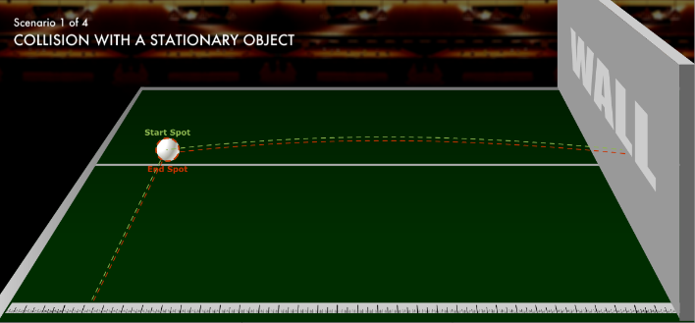
- In one or two sentences, describe what is occurring in this scenario. Include a screenshot or a sketch of the scenario, including defining any relevant physical quantities (mass, velocity, etc.).
_______________________________________________
The ball collides with the at rest wall and bounces back along the same path. The ball’s mass remains the same before and after the bounce. The ball’s velocity goes to zero when it strikes the wall and then back up to the original magnitude as it bounces off, but in the opposite direction.
_______________________________________________
_______________________________________________
_______________________________________________
_______________________________________________
- Sketch or take a screenshot of the graph in the scenario and insert it into the box below. Write a statement that describes the relationship between the variables and link it back to your description of the scenario (don’t forget velocity is a VECTOR).
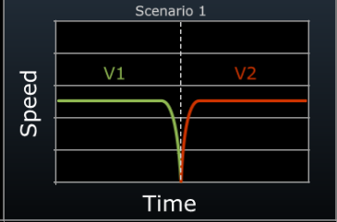
_____________________________________________________
The magnitude of the ball’s velocity before (V₁) and after (V₂) the bounce is equal, but in opposite directions.
The velocity drops to zero momentarily as the ball is bouncing.
_____________________________________________________
_____________________________________________________
_____________________________________________________
_____________________________________________________
_____________________________________________________
- Write the formula for relationship between the velocities in this scenario in the box below.
V₁ = -V₂ or V_{ball initial} = -V_{ball final}

Scenario 1 Reflection:
R1: Describe another situation that would be an elastic collision.
Billiard balls colliding on a pool table.
R2: A .2kg cue ball traveling to the right at 3 m/s collides with the side of the pool table. After they collide, what would the velocity of the ball be, assuming no friction and no movement of the table?
The velocity would still be 3 m/s, but in the other direction: -3 m/s
R3: A .2kg cue ball traveling to the right at 3 m/s collides head on with the 8 ball, which at rest. After they collide, the 8 ball moves to the right at 3 m/s. What is the velocity of the cue ball, assuming no friction?
A1
p₁ = p₂ M₁ = Cue Ball M₂ = 8-ball
M₁V_{1i} + M₂V_{2i} = M₁V_{1f} + M₂V_{2f}
(.2kg)(3 m/s) + (.2kg)(0m/s) = (.2kg)(V_{2f} m/s) + (.2kg)(3 m/s)
Conservation of momentum dictates the ball would have transferred all its momentum to the 8-ball, so the cue balls V_{f} = 3 m/s
Part I. Elastic Collisions
Scenario #2: Objects Moving In Opposite Directions
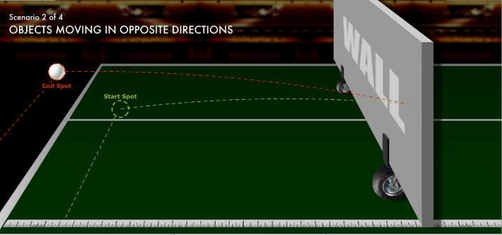
- In one or two sentences, describe what is occurring in this scenario. Include a screenshot or a sketch of the scenario, including defining any relevant physical quantities (mass, velocity, etc.).
The ball collides with the oncoming wall and bounces back along a different path than the one it started. The ball’s mass remains the same before and after the bounce. The ball’s velocity goes to zero when it strikes the wall and then back up to a higher magnitude as it bounces off, but in the opposite direction.
_______________________________________________
_______________________________________________
_______________________________________________
_______________________________________________
_______________________________________________
- Sketch or take a screenshot of the graph in the scenario and insert it into the box below. Write a statement that describes the relationship between the variables and link it back to your description of the scenario (don’t forget velocity is a VECTOR).
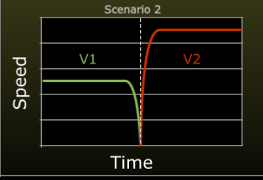
_____________________________________________________
The magnitude of the ball’s velocity before the bounce (V₁) is less than the magnitude after (V₂), and in the opposite direction.
The velocity drops to zero momentarily as the ball is bouncing.

_____________________________________________________
_____________________________________________________
_____________________________________________________
_____________________________________________________
_____________________________________________________
- Write the formula for relationship between the velocities in this scenario in the box below.
V₂ = V₁ + 2V_{wall} or V_{ball after} = -V_{ball before} +2(V_{wall})

Scenario 2 Reflection:
R4: How did this situation differ from Scenario #1? What difference did this have on the outcome of the experiment?
The wall was moving toward the ball in this scenario, as opposed to #1 where it was stationary. The ball’s velocity after the bounce was higher than the ball’s velocity before the bounce.

R5: Would bouncing the ball on the ground affect the outcome of the experiment? Why or why not?
A2
The ball would likely lose some velocity if you bounced it before it hit the wall, but you would still see proportional increase to the velocity of the ball after.

Part I. Elastic Collisions
Scenario #3: Small Object Overtakes Large Object
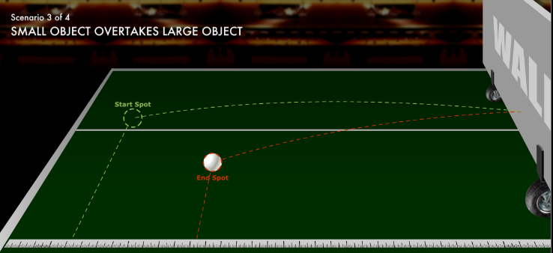
- In one or two sentences, describe what is occurring in this scenario. Include a screenshot or a sketch of the scenario, including defining any relevant physical quantities (mass, velocity, etc.).
The ball collides with the retreating wall and bounces back along a different path than the one it started. The ball’s mass remains the same before and after the bounce. The ball’s velocity goes to zero when it strikes the wall and then back up to a lower magnitude as it bounces off, but in the opposite direction.
_______________________________________________
_______________________________________________
_______________________________________________
_______________________________________________
_______________________________________________
- Sketch or take a screenshot of the graph in the scenario and insert it into the box below. Write a statement that describes the relationship between the variables and link it back to your description of the scenario (don’t forget velocity is a VECTOR).
The magnitude of the ball’s velocity before the bounce (V₁) is more than the magnitude after (V₂), and in the opposite direction.
The velocity drops to zero momentarily as the ball is bouncing.

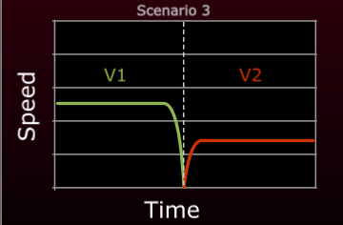
_____________________________________________________
_____________________________________________________
_____________________________________________________
_____________________________________________________
_____________________________________________________
_____________________________________________________
- Write the formula for relationship between the velocities in this scenario in the box below.
V₂ = V₁ - 2V_{wall} or V_{ball after} = -V_{ball before} - 2(-V_{wall})

Scenario 3 Reflection:
R6: How did this situation differ from Scenario #2? What difference did this have on the outcome of the experiment?
The wall and the ball traveled in the same direction. The ball’s velocity after the bounce was lower than the ball’s velocity before the bounce.

R7: Suppose the ball and the wall are both traveling at x (m/s). How would this change the experiment?
Yes, if they were traveling at the same speed, the ball would never be able to catch up to the wall to bounce off of it, so there would be no collision.

R8: Suppose the ball is traveling at an initial velocity of x m/s and the wall is traveling at .25x m/s. Algebraically solve for the speed of the ball after the collision.
A3
V₂ = -x m/s – 2(-.25x)m/s
V₂ = -x m/s + -.5x m/s
V₂ = -.5x m/s

Part I. Elastic Collisions
Scenario #4: Large Object Overtakes Small Object
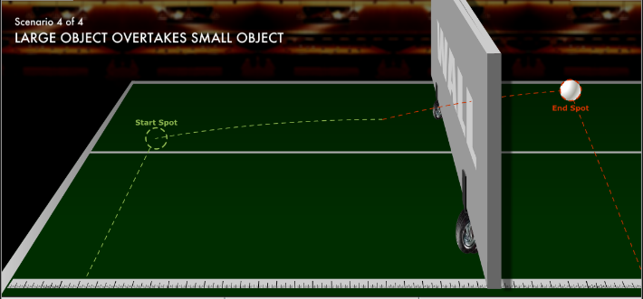
- In one or two sentences, describe what is occurring in this scenario. Include a screenshot or a sketch of the scenario, including defining any relevant physical quantities (mass, velocity, etc.).
The wall advances on and catches up (V_{wall}) to a ball that is already traveling (V_{ball}) in the same direction, at a slower rate (V_{wall} > V_{ball}), which bounces off when struck. The ball’s mass remains the same before and after the bounce. The ball’s velocity increases when struck by the wall and moves in the same direction.
_______________________________________________
_______________________________________________
_______________________________________________
_______________________________________________
_______________________________________________
- Sketch or take a screenshot of the graph in the scenario and insert it into the box below. Write a statement that describes the relationship between the variables and link it back to your description of the scenario (don’t forget velocity is a VECTOR).
The magnitude of the ball’s velocity before the bounce (V₁) is less than the magnitude after (V₂), but in the same direction.
The velocity drops to zero momentarily as the ball is bouncing.

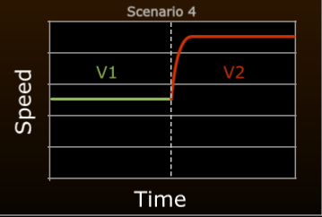
_____________________________________________________
_____________________________________________________
_____________________________________________________
_____________________________________________________
_____________________________________________________
_____________________________________________________
- Write the formula for relationship between the velocities in this scenario in the box below.
V₂ = 2V_{wall} - V₁ or V_{ball after} = 2(V_{wall}) – V_{ball before}

Scenario 4 Reflection:
R9: How did this situation differ from Scenario #3? What difference did this have on the outcome of the experiment?
The wall was traveling faster than the ball. The ball’s velocity after the bounce was higher than the ball’s velocity before the bounce.

R10: Suppose the ball is traveling at an initial velocity of x m/s and the wall is traveling at 4x m/s. Algebraically solve for the speed of the ball after the collision.
V₂ = 2(4x)m/s – x m/s
V₂ = 8x m/s - x m/s
V₂ = 7x m/s

A4
Part II. Stationary Planet Flyby
Use the Learn More Tab to answer the questions.
R11: What frame of reference are we using in this simulation? Do you think this frame of reference adequately describes reality? Explain your thinking.
Planet stationary frame of reference.
Yes – planet would not appear to move to the approaching satellite since there would be nothing close enough to compare its position to
No – planet is moving in orbit around the sun, is not stationary in sun frame of reference, regardless of satellite’s perspective

_____________________________________________________________________________________
_____________________________________________________________________________________
_____________________________________________________________________________________

- Paste a screenshot or sketch the scenario, including defining any relevant physical quantities (mass, velocity, etc.). Additionally, label the segments of the trajectories as Approaching Saturn, Closest Point, and Leaving Saturn. How are the trajectories different from one another?
______________________________________
The trajectories differ in how close they approach to Saturn. The first trajectory makes the closest pass and has the largest change in angle and velocity. The third trajectory makes the farthest pass and has the smallest change in angle and velocity. The second trajectory is between them.
______________________________________
______________________________________

- Fill in the table below describing how the variable changes over the course of the simulation for all trajectories (use the terms increasing, decreasing, remains the same, maximum, or minimum).
Variable | Approaching Saturn | Closest Point | Leaving Saturn
Velocity of Spacecraft | Increasing | At Maximum | Decreasing
Gravitational Force  Between Saturn and Spacecraft | Increasing | At Maximum | Decreasing
Mass of Spacecraft | Constant | Constant | Constant
Kinetic Energy of Spacecraft | Increasing | At Maximum | Decreasing
Gravitational Potential Energy of Spacecraft | Decreasing | At Minimum | Increasing
A5
- Fill in the table below for the first trajectory, using the numbers from the simulation to calculate the values not given to you. Assume the mass of the spacecraft is 100 kg and that Saturn is stationary with a mass of 5.7 x 10²⁶ kg.
Variable | Start of simulation  (50,000 m away) | Closest Point  (10,000 m away) | End of simulation  (50,000 m away)
Velocity of Spacecraft  (m/s) | 14,000 m/s | 22,000 m/s | 14,000 m/s
Gravitational Force  Between Saturn and Spacecraft (N) | 1.522 x 10⁹ N | 3.804 x 10¹⁰ N | 1.522 x 10⁹ N
Kinetic Energy of Spacecraft (J) | 9.8 x 10⁹ J | 2.42 x 10¹⁰ J | 9.8 x 10⁹ J
Momentum of spacecraft (N*s) | 1.4 x 10⁶ N*s | 2.2 x 10⁶ N*s | - x 10⁶ N*s
Kinetic Energy of Saturn in this reference frame (J) | 0 J | 0 J | 0 J
Momentum of Saturn in this reference frame (N*s) | 0 N*s | 0 N*s | 0 N*s

- Does this simulation violate the laws of conservation for energy and/or momentum? Why of why not? How can we correct this?
Yes, the simulation violates both conservation of momentum and energy, as the spacecraft appears to gain momentum and energy from nowhere, since Saturn’s always remains at zero (it is stationary). We can correct this by having Saturn moving so we can calculate the transfer of the momentum/kinetic energy to the spacecraft.

- According to the chart, how much momentum/kinetic energy should Saturn lose to the satellite at the closest approach?
Equal to the amount the spacecraft gained, so about 14.4 billion J of energy, or 800,000 N*s of momentum.

A6
Part III. Jupiter Gravity Assist
- Paste a screenshot or sketch the scenario, including defining any relevant physical quantities (mass, velocity, etc.). How are the trajectories different from one another?
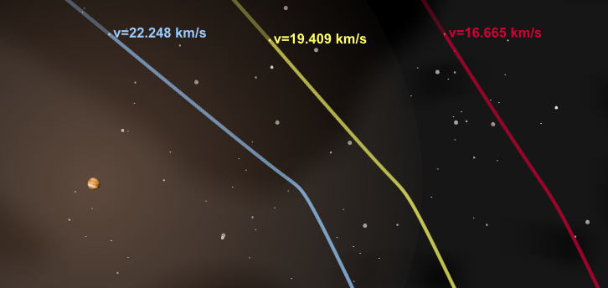
_______________________________
The trajectories differ in how close they approach to Jupiter. The first trajectory makes the closest pass and has the largest change in angle and velocity. The third trajectory makes the farthest pass and has the smallest change in angle and velocity. The second trajectory is between them.
_______________________________
_______________________________
_______________________________

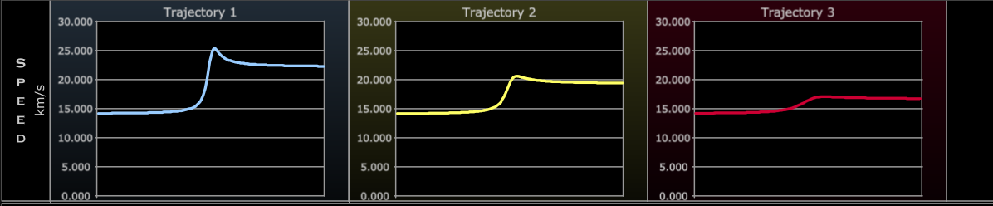
- Paste a screenshot or sketch the velocity graphs below. Describe how the velocities of the trajectories compare to one another and explain why there is a difference between them.
V₁ > V₂ > V₃
Trajectory 1, being the closest approaches, transfers the most gravitational potential energy into kinetic energy, resulting in a larger velocity gain. Trajectory 3, being the farthest, transfers the least gravitational potential energy into kinetic energy, resulting in a smaller velocity gain.

_____________________________________________________________________________________

- Compare this simulation with the previous one involving Saturn. Are the simulations describing different events? Explain your reasoning.
_____________________________________________________________________________________
No, they are describing the same event from two different reference frames. With the Saturn example, it looks like the satellites are gaining velocity as if from nothing, since Saturn has no apparent momentum in the stationary reference frame. But with the Jupiter example, you can tell how Jupiter’s momentum pulls and influences the satellites.
_____________________________________________________________________________________
_____________________________________________________________________________________
R12: Two spacecrafts, A and B, travel passed a planet with the same mass, initial velocity, closest approach distance, and trajectory. If one spacecraft approaches Jupiter and the other approaches Saturn, which planet will have more of an effect on the spacecraft? Why?
Jupiter will have more effect since the planet has a higher mass than Saturn, creating more gravitational attraction. The satellite that passes Jupiter will increase its speed more because of the larger gravitational pull.
_____________________________________________________________________________________
A7
Part IV. Venus Gravity Assist Simulator
- Paste a screenshot or sketch the scenario, including defining any relevant physical quantities (mass, velocity, etc.). How are the trajectories different from one another?
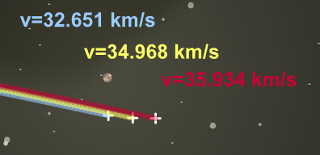
_______________________________
The trajectories differ in how close they approach to Venus. The first trajectory makes the closest pass and has the largest change in angle and velocity. The third trajectory makes the farthest pass and has the smallest change in angle and velocity. The second trajectory is between them.

_______________________________
_______________________________
_______________________________

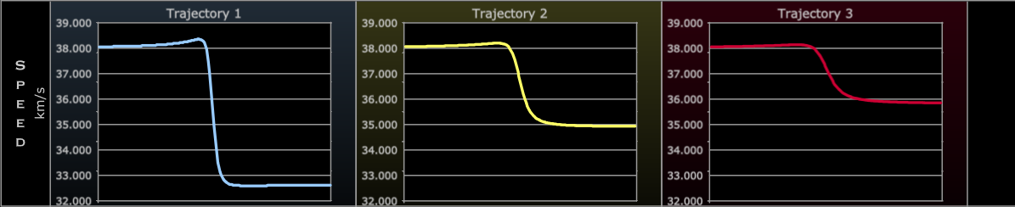
- Paste a screenshot or sketch the velocity graphs below. How are these different from the previous simulations? Why does this difference occur?
This scenario is different in that the satellites pass in front of the planet, rather than behind it. This causes the satellites to slow down as they transfer momentum to the planet.

- Describe how the velocities of the trajectories compare to one another and explain why there is a difference between them.
_____________________________________________________________________________________
V₃ > V₂ > V₁
Trajectory 1, being the closest approaches, transfers the most energy to the planet, resulting in a larger decrease in velocity. Trajectory 3, being the farthest, transfers the least energy, resulting in a smaller drop in velocity.
_____________________________________________________________________________________
_____________________________________________________________________________________
_____________________________________________________________________________________
A8
Conclusion Questions (to be answered on Google Doc, submit one for your group, diagrams are welcome)
C1) Can gravity assists be described as elastic collisions? Highlight the similarities and differences between the scenarios in Part I and Parts II, III, and IV. Make sure you specifically cite examples from the activity.
Yes, gravity assists work as elastic collisions even though there is no physical contact between the satellite and the planet. The Jupiter assist (Part III) was most like the fourth scenario of Part I, where the wall transferred a considerable amount of momentum to the ball after it bounced. The planet does slow down, but a negligible amount compared to the satellite due to the significant mass difference between them. The Venus assist (Part IV) is most like the third scenario of part I, where the ball and the wall are traveling at in the same direction, but the ball is moving faster. Again, the planet’s momentum changes (it speeds up), but a negligible amount compared to the satellite due to the significant mass difference between them.

C2) In some of the simulations, it is obvious that the spacecrafts increase their velocity when they pass by the planets. What does this do for the momentum of the spacecraft? How is this possible without violating the law for conservation of momentum?
Since momentum is p=mv, increasing the velocity of the craft also increases the momentum. This is only possible since the total momentum of the planet-satellite system must be conserved. The sum of the momentums of the planet and satellite before the assist are equal to the sum after the assist.
This implies that the planet also must change velocity during the assists. This change though is so small that it is not noticeable since the mass of the planet is many orders of magnitude larger than the mass of the satellite.

C3) In what ways are gravity assists essential to space exploration?
To travel the vast distances in space, spacecraft must move very quickly to traverse these distances in workable amounts of time. Gravity assists allow for increases and decreases in velocity without the need to launch the spacecraft with additional fuel, assuming the assisting body is in opportunity with the desired direction of travel.

Gravity assists increase the range of satellites by allowing them to travel faster, while also possibly allowing them to slow down enough to enter the target objects orbit.

A9
Michael Fowler Jupiter Slingshot Flashlet
Activity 2
http://galileoandeinstein.phys.virginia.edu/more_stuff/flashlets/Slingshot.htm
*NOTE: This is required to be run in a standalone flash window, like the debugger. You should practice a few times getting the procedure of the simulator down before attempting the activity. Do not move the arrow for the launch.
Radius | 71,500 km
Orbital speed | 13 km/s
Mass | 1.9 x 10²⁷ kg
g at surface | 23ms⁻²
The Data for Jupiter in the simulation is shown here:

- Find a successful set of settings and launch timing that would allow you to increase the speed of the spacecraft as it passes by Jupiter.
  - Record your settings and add a screenshot of the simulation on the next page.
- Find a successful set of settings ad launch timing that would allow you to decrease the speed of the spacecraft as it passes by Jupiter.
  - Record your settings and add a screenshot of the simulation on the next page.
1 hr
Screenshot 1 | Screenshot 2
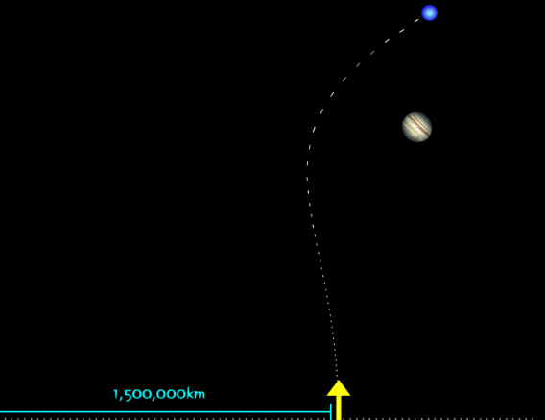 | 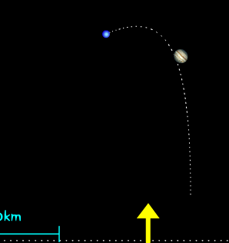
Jupiter’s Path Distance: _________________  9.27 km/s  1251250 km  Initial Velocity of Spacecraft: ______________  10 hr  Launch delay (hours after hitting start) :___ ___  41 km/s  Estimated velocity right after pass: ____________  31 km/s  Velocity 10 hours after pass: ______________ | Jupiter’s Path Distance: _________________  1251250 km  17.88 km/s  Initial Velocity of Spacecraft: ______________  Launch delay (hours after hitting start) :______  23 km/s  Estimated velocity right after pass: ____________  14 km/s  Velocity 10 hours after pass: ______________

- Compare the situations. How does the placement of the path of the spacecraft relative to Jupiter’s path change from screenshot 1 to screenshot 2.
In the first example, the satellite passes behind Jupiter, then curves in the direction of Jupiter’s motion. In the second example, the satellite curves in the opposite direction of Jupiter’s motion after passing in front of the planet.
B1
- Explain why the spacecraft’s velocity increases in one but decreases in the other.
Jupiter’s momentum and gravitational field affect the spacecraft differently depending on whether it passes in front of or behind the planet. When passing behind, Jupiter’s gravitational attraction cause the planet to accelerate to the right. When passing in front, Jupiter’s gravitational attraction causes the planet to accelerate to the left and then down, resulting in a more significant change in direction and a more significant change in velocity.

- In the simulation, it is obvious that the spacecraft increases its velocity when it passes by the planet. How does this affect momentum of the spacecraft? How is this possible without violating the law for conservation of momentum?
Since momentum is p=mv, increasing the velocity of the craft also increases the momentum. This is only possible since the total momentum of the planet-satellite system must be conserved. The sum of the momentums of the planet and satellite before the assist are equal to the sum after the assist.
This implies that the planet also must change velocity during the assists. This change though is so small that it is not noticeable since the mass of the planet is many orders of magnitude larger than the mass of the satellite.

Class Challenge:
- Highest Spacecraft Velocity right after pass
- Lowest Spacecraft Velocity right after pass
- Get Spacecraft to end up back where it started (closest wins, like horseshoes)

Challenge Questions:
Is it possible to have the spacecraft fall into orbit around Jupiter? Why or why not? What would have to be true about the velocity and trajectory of the spacecraft? You can move the launch arrow in this part.
Student challenge results will vary
It is possible to loop the satellite to come back where it started, remember you can alter the arrow. Theoretically it should be possible to have the satellite fall into orbit, though I have not managed to do so in the simulation.

Michael Fowler Jupiter Slingshot Flashlet
http://galileoandeinstein.phys.virginia.edu/more_stuff/flashlets/Slingshot.htm
B2
Materials:
Activity 3
For qualitative results:
- Smooth surface, with as little friction as possible (tile, plexiglass, etc.)
- Magnetic (or at least a metal) ball bearings
- Moderate-sized magnet(s) that can slide on the surface in a relatively straight path
If you are interested in quantitative results, you will also need:
- Device to launch ball bearings at a relatively consistent initial velocity
- LoggerPro or another motion capture type app
- iPad / Cell Phone to record video
- Markings on the floor to measure distance traveled or establish scale for LoggerPro
- Protractor (optional)

Procedure 1:
- Place the magnet in a location on the floor and attempt to send the ball bearing around it.
  - You do not want the ball to contact the magnet.
  - If the magnet is repelling the ball, flip the magnet around/upside down.

It bends toward the magnet
What happens to the path of the ball as it passes the magnet?
It slightly speeds up as it approaches
What happens to the speed of the ball as it passes the magnet?

Experiment until you find the limits of the path:
- What is the closest you can get to the magnet without it connecting?
- What is the distance where the magnet stops having a noticeable effect?

How does the distance of closest approach change the velocity of the ball as it comes out of the turn?
The closer the approach to the magnet, the faster the ball comes out of the turn

C1
Procedure 2:
- Now, have your partner slide the magnet across the floor, while you launch the ball bearing perpendicular to the magnet’s velocity.
- Try to time it so that the ball bearing passes just in front of the magnet.
- Try it until you get five successful trials.

Ball turns to the left
What appears to happen to the path of the ball?
Nothing really, travels from left to right
What appears to happen to the path of the magnet?
Slows down and shifts left
What appears to happen to the velocity of the ball (think both magnitude AND direction)?
Stays constant
What appears to happen to the velocity of the magnet?
Decreases
What appears to happen to the momentum of the ball?
Stays constant
What appears to happen to the momentum of the magnet?
What appears to happen to the momentum of the system?
Decreases
Vary the speed you are moving the magnet at while keeping the ball’s speed the same. How does this affect the path/velocity of the ball?
The faster the magnet is going, the greater the effect on the ball’s velocity and curve

C2
Procedure 3:
- Now, have your partner slide the magnet across the floor, while you launch the ball bearing perpendicular to the magnet’s velocity.
- Try to time it so that the ball bearing passes just in behind of the magnet.
- Try it until you get five successful trials.

Ball turns to the right
What appears to happen to the path of the ball?
Stays constant
What appears to happen to the path of the magnet?
Speeds up and shifts right
What appears to happen to the velocity of the ball (think both magnitude AND direction)?
Stays constant
What appears to happen to the velocity of the magnet?
Increases
What appears to happen to the momentum of the ball?
What appears to happen to the momentum of the magnet?
Stays constant
What appears to happen to the momentum of the system?
Increases
Vary the speed you are moving the magnet at while keeping the ball’s speed the same. How does this affect the path/velocity of the ball?
The faster the magnet is going, the greater the effect on the ball’s velocity and curve

C3
Procedure 4:
Set up a series of magnets spaced out similarly to the way shown below (this will require significant tweaking through trial and error).
- The goal is to tray and use the “gravity” of each of the magnets to increase the speed of the ball in series.
- Try to make the ball pass in between as many of the magnets as you can, gaining speed each time
- Be careful as the ball may move faster than you expect
- Put a target on the wall behind the magnets to try and hit

Questions:
- Look at your results for the first three procedures.
  - What is the best way to increase the velocity of the ball? Be specific about the ball’s initial velocity, the magnet’s initial velocity, how close they should pass, should the ball pass behind or in front, what happens to the direction of the ball, etc.)
To increase the final velocity of the ball, you want both the ball’s initial velocity to be high and the magnet’s initial velocity to be high. The ball should pass as close behind the magnet as possible.
This transfers the most momentum to the ball as it passes, and changes the ball’s path to be closest to parallel with the magnet’s path.

  - What is the best way to decrease the velocity of the ball? Be specific about the ball’s initial velocity, the magnet’s initial velocity, how close they should pass, should the ball pass behind or in front, what happens to the direction of the ball, etc.)
C4
To decrease the final velocity of the ball, you want both the ball’s initial velocity to be low and the magnet’s initial velocity to be low. The ball should pass in front of the magnet, as close as possible.
This transfers the most momentum from the ball to the magnet as it passes and changes the ball’s direction initially opposite to the magnet’s velocity, but curving after to different degrees.
- Procedure 4 is like how we explore space, fuel for treks across the solar system is prohibitively heavy to launch with every satellite. In what ways is the setup we used for procedure 4 like the path of the Voyager spacecraft? In what ways is the set up different?
Yes, it is similar to the Voyager path in that we set the magnets up in opportunity to hit the goal, where the magnet gains speed after every assist.
It is different than Voyager in that the magnets are much closer together than the planets, and they are also stationary, unlike the planets traveling in their orbits. The ball also loses velocity to friction with the floor unlike in space.

Post Activity Reflection Questions:
- What were the most challenging parts of the activity?
Will vary

- In what ways do you think this activity models the gravity assist phenomenon well?
Will vary, examples:
- Gravity and the attractive magnetic force are similar
- Both gravity assists and magnetic assists are momentum transfer without physical contact
- The magnet being so much larger has very little change in momentum similar to the planet

- In what ways do you think this activity models the gravity assist phenomenon poorly?
Will vary, examples:
- Magnetism is also a repulsive force, there is no correlating “gravitational repulsion”
- Friction impacts both the magnet’s and ball’s path, slowing them down and altering the direction
- The distances, forces, accelerations, masses, and velocities are off by many orders of magnitudes
- Planets also rotate, giving angular momentum to the satellites
- Does not consider the durability of the spacecraft, which may break apart at certain speeds
- All matter has gravitational attraction, where magnets only attract magnetic substances

C5
Examples of quantitative extensions:
1) Using a ball launcher with a constant initial velocity, solve for the ball’s final velocity in procedure 2 and 3 using the momentum of the system. Compare this to the final velocity measured just after the pass. Does the calculation work? Why or why not? Use the space below for calculations.
Will vary

Looking mostly for the M_{ball}V_{ball initial} + M_{magnet}V_{magnet initial} = M_{ball}V_{ball final} + M_{magnet}V_{magnet final} setup

Students will either:
- Not have any appreciable drop in V_{magnet final}, so V_{ball final} would be the same as V_{ball initial}. This should conflict with their data on the ball just after the pass which should be a larger velocity in procedure 3 and a smaller velocity in procedure 2.
- Have too much of a drop in V_{magnet final}, due to the friction slowing the magnet down and not the ball, getting too high of a value for V_{ball final}

C6
Start by changing the speed of the moon to be 0.0 times that of the Spacecraft.
Activity 4
- Click run on the simulation. What do you notice about the relationship between the red dots and the speed of the spacecraft?
The red dots are farther spaced apart the faster the spacecraft moves.

- Change the speed of the moon to 1 times the speed of the spacecraft. How did this affect the spacecraft’s flight?
The red dots are farther spaced apart the faster the spacecraft moves.

- Select some other values for the speed of the Moon. What relationship do you find between the speed of the moon and the motion of the spacecraft? Be specific in discussing how it alters the spacecraft’s velocity.
The faster the moon is moving, the faster the spacecraft moves after it passes.

- How does the force exerted by the Moon on the spacecraft at a given point compare to the force exerted by the spacecraft on the Moon?
Newton’s third law states that the forces are equal and opposite.

- How does the acceleration exerted by the Moon on the spacecraft compare to the acceleration exerted by the spacecraft on the Moon? Explain why this must be mathematically.
Newton’s third law states that the forces are equal and opposite, and Newton’s second law defines F=ma. Since the moon’s mass is many times larger than the spacecrafts, the moon’s acceleration due to the force must be much smaller than the spacecraft’s.

- Set the Speed of the Moon to be two times that of the spacecraft. Run the simulation and take a screenshot or sketch the path taken by the spacecraft. Draw arrows showing the direction of the spacecraft’s acceleration and label the following points/segments for the spacecraft on your diagram:
  - Fastest velocity e. Increasing gravitational force
  - Slowest velocity f. Decreasing gravitational force
  - Increasing velocity g. Highest gravitational force
  - Decreasing velocity h. Lowest gravitational force
D1
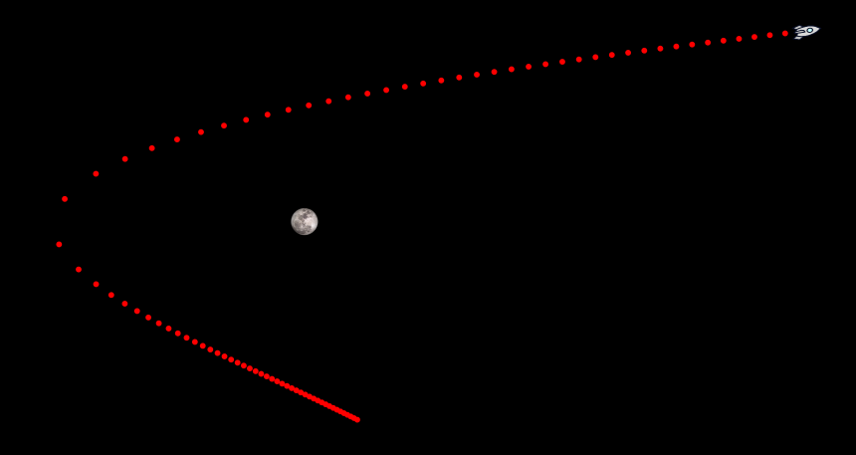
h
d + f
b
c + e
a + g
- Fastest velocity e. Increasing gravitational force
D2
- Slowest velocity f. Decreasing gravitational force
- Increasing velocity g. Highest gravitational force
- Decreasing velocity h. Lowest gravitational force
D2

