Phyction: Using the Physics In Fiction in the Classroom
Brandon DeFilippis
SUNY Buffalo State College
1300 Elmwood Ave
Buffalo, NY 114222
deflipb@gmail.com

Acknowledgements: This paper is submitted in partial fulfillment of the requirements necessary for PHY690: Masters Project at SUNY Buffalo State under the guidance of Dr. Dan MacIsaac. Also special thanks to Andrea Dunca for editing.

Bio: Brandon DeFilippis is a SUNY Geneseo graduating with a Bachelor’s in Geological Sciences and Adolescent Education. He has been teaching Earth Science and Astronomy for eight years, starting in New York City and now in Nassau county. Currently he is enrolled in the Master’s program at Buffalo State in Physics Education.

ABSTRACT
As science fiction continues to entrench itself in popular culture, discussions of contemporary examples of physical phenomena can allow for relevant access points in curricula for a variety of disciplines, topics, and subtopics. Outer space particularly holds a special place in the hearts and minds of many children and adults, ranging from actual fascination in astronomy and cosmology to the blief that UFOs These types of lessons will only become more relevant with the implementation of the Next Generation Science Standards, providing springboards into what the NGSS refer to as “anchor phenomena.” This article is an exploration of gravitational slingshots as one of these “anchors,” with discussion of how this phenomenon can be linked to a variety of topics, and modified through the complexities of the assumptions for a wide range of physics classes. Additionally, the author wishes to expand upon the discussion embarked on by Barlett and Hord to attain a “simple understanding” of the gravitational slingshot (aka gravity assist) effect. This expansion will be achieved by modeling the dissection of a fictitious situation by physical parameters; this dissection will lay the foundation for the integration of the gravity assist phenomenon in curricula using plot points in television shows The Expanse and novel/movie The Martian.

INTRODUCTION
Next Generation Science Standards
The move toward Next Generation Science Standards in many states will force even veteran teachers to alter their approach. The units require the use of anchor phenomenon that students will explore and complete inquiry-based activities about in order to understand the larger goal of the unit. The NGSS defines these as:
- Natural phenomena are observable events that occur in the universe and that we can use our science knowledge to explain or predict. The goal of building knowledge in science is to develop general ideas, based on evidence, that can explain and predict phenomena.
- Engineering involves designing solutions to problems that arise from phenomena and using explanations of phenomena to design solutions.
- In this way, phenomena are the context for the work of both the scientist and the engineer.
Why Gravity Assists?
It is important that these anchor phenomena both demonstrate fundamental aspects of the larger topic at hand and are also engaging and interesting to students on an intellectual level. This helps offset two of the most challenging aspects of inquiry-based learning: it requires a significant amount of dedicated class time and, particularly with lower-achieving student populations, motivation on the students’ part to work through frustration and confusion. This will be especially true in the beginning years of NGSS, where students will not yet be trained to consider problems in this way.
As defined by the NGSS, anchor phenomena should include certain qualities:
- Build Upon Everyday or Family Experiences:
  - Gravity is one of the most everyday experiences there is. As one of the four fundamental forces in the universe, it is an essential part of any physics curriculum. It is deceptively simple to students as they experience it daily with macroscopic falling objects. This is part of what makes gravity as a topic so powerful: the students come in with an entrenched belief on how it works, giving students a level of personal investment with the content.
- Apply Multiple NGSS Performance Expectations:
  - In this case, we look to the performance standards on momentum and gravity (those others can apply), such as “HS-PS2-2: Use mathematical representations to support the claim that the total momentum of a system of objects is conserved when there is no net force on the system.”
- Too complex to design a solution in a single lesson:
  - Depending on the depth, the concept is flexible and can be built upon over a number of class sessions.
- Observable to students:
  - The simulations and calculations not only provide the ability for students to observe the phenomena but also to calculate and predict outcomes to practice questions.
- Case of wonderment:
  - Space exploration is an excellent hook for a variety of students.
- Audience or stakeholder community who cares about the findings or products:
  - Gravity assists will be an essential part of any space exploration or colonization effort, making all of humanity stakeholders.
Gravity assist as a topic is also malleable, allowing you to introduce or review on a variety of other topics in sequence or simultaneously. Some examples of conceptual tie-ins include:
- Reference Frames
Frame of reference play a large role in understanding many aspects of physics and Earth science alike, from establishing axes in projectile motion or momentum problems to establishing that not all rivers flow south (believe it or not, huge shock for many ninth graders).
- Vector/Free Body Diagrams
Students can practice the use and conventions of these diagrams (for example, size of the arrow correlating to magnitude).
- Kepler’s Laws
Kepler’s laws are touched on both in high school Earth Science and Physics, and assuming you have students that take the courses in that order you should be able to draw upon some of the students’ prior knowledge. Students in New York drew ellipses and at least briefly touched on the other two laws, which can be modified to establish the equation used in the activity.
- Newtonian Gravity
This is a take on gravity many students will not be familiar with, but a great way of reviewing both F=ma and the inverse square law. Students’ understanding of gravity usually stems from the world around them, this idea of gravity “pulling things down.” Here, students will be forced to use gravity as the attraction to the center.
- Conservation of Energy and Momentum
Depending on the reference frame, gravity assists can seem to violate both principles, allowing for inquiry into these points to identify and address misconceptions. Gravitation is also a conservation force. Berg and Brouer have an in-depth consideration of many of these misconceptions.
- Collisions (inelastic vs. elastic)
This can be used to expand upon collisions uniquely as gravity assists are attractive elastic collisions that do not require physical contact.

THE PHYSICS
“Simple” Definition of a Gravity Assist
Barlett and Hord have a fantastic breakdown of how the gravity assist works, the physics of which we will get into later. A crucial component of space travel is the ability to alter course mid-flight, and many works of fiction will have you believe this is typically done through propellants shot up with the rocket as fuel. Although the “delta-v” budget of a rocket is important, most large scale course corrections cannot be achieved using launched propellant, as it is prohibitively difficult and expensive to launch spacecrafts with massive amounts of fuel. Since the spacecraft only has whatever amount of propellant it is sent up with, the management of this fuel source is paramount and must be considered at every point in the mission (Doody 2019).
Gravity is essentially free fuel for spacecrafts. You can observe this on Earth, things do not need fuel to accelerate downward: the gravitational field transfers kinetic energy to objects that are falling. Gravity assists do this on a massive scale, by using precise flight, one can transfer the kinetic energy from a planet’s (or star’s, moon’s, asteroid’s, etc.) gravitational well to a spacecraft. Gravity assists make solar system space travel possible by giving the spacecrafts access to “fuel” that can accelerate them to speeds able to span the great distances in the solar system in a fraction of the time (and cost!) they would have needed otherwise.
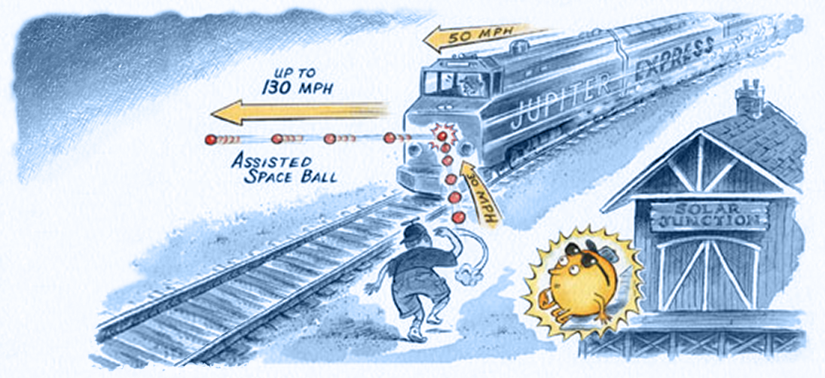
Illustration of a gravity assist. Concept by Charles Kohlhase, based on artwork by Gary Hovland. (Doody 2019)
Real World Application
The first paper on gravity assists ever compiled was in 1918, but was not published until 1938 by the Russian scientist Yuri Kondratyuk, a man who life absolutely needs to be made into a movie (seriously, that’s a stolen identity and he managed to publish all this during the rise of the Soviet Union). In his paper Тем кто будет читать, чтобы строить, (To those who will be reading [this paper] in order to build [an interplanetary rocket]) he posits that you could use the moons of two planets in order to accelerate a space craft to travel in between them (Mel’kumov 1965). Later on in his 1929 book Conquest of Interplanetary Space, he described one of the first proposals for a lunar orbit rendezvous (Mel’kumov 1962).
The first documented use of the gravity assist maneuver was on the Luna 3 mission in 1959. The spacecraft used used the moon’s gravity to swing itself around the moon and capture the first ever pictures of the far side of the Moon (Johnson 1979).
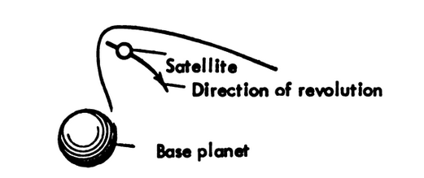

Excerpt from Kondratyuk’s Paper (Mel’kumov 1965)

Gravity assists are now commonplace in almost all space exploration missions. One of the challenges of relying on the maneuver is that viability is heavily reliant on the position of the planets at the time of launch. Astrophysicists calculate trajectories based on the known period of the planets’ orbits and the angle that the target planet is from the Earth. This angle is called an “opportunity” The Hohmann Transfer is an example of this strategy put into practice, where the spacecraft is launched at a particular opportunity to minimize the amount of propellant required to complete its mission, instead relying on the gravitational pull of the Sun and the target to control its flight. This is the type of assist usually applied to send spacecrafts to Mars (by speeding the spacecraft up, allowing it to push farther out of the Sun’s gravity well) or Venus (by slowing the spacecraft down, forcing it to fall farther into the Sun’s gravity well). If propellant is available or planned for, astrophysics can also use the Oberth Effect (Blanco and Mungan 2019). Instead of just using the gravity of the planets to control flight, the planet accelerates as it enters the gravity well until it reaches periapsis. This can provide more kinetic energy to the spacecraft than just the gravity assist alone.
Several of the more famous uses of the gravity assist include the launch of the Voyager missions, which were the first to see the outer planets, and New Horizons, the first to take close pictures of Pluto. Both these missions are only possible when the planets are aligned in a particular opportunity. Astrophysicists plan space exploration around these opportunities, sometimes decades in advance.
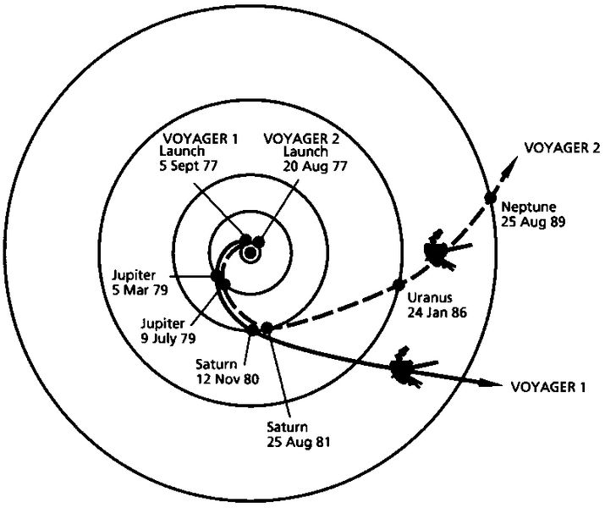
Picture taken from Bartlett and Hord, of the “Gran Tour” alignment. This orientation of the inner and outer planets made the Voyager missions possible, and only occurs about once every 175 years, with the next occurring in 2152.

THE PEDAGOGY
Bridging Analogies
A common example used to explain the transfer of energy in the system is that of a ball bouncing off a moveable wall (Barlett and Hord use a ball and a truck). An excellent interactive simulation of this example can be found on the John Hopkins Applied Physics Laboratory website (https://messenger.jhuapl.edu/Learn/interactives/conv_gravity_assist/gravity_assist_menu.html
). On the simulation, the green path/line (V1) refer to the initial velocity of the ball before the collision, where the red path/line (V2) shows the velocity of the ball after the collision.
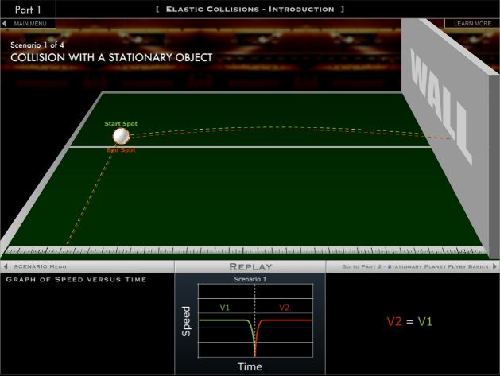
The first example is that of a simple elastic collision: the ball is thrown at the wall and after a perfect elastic collision returns to the same spot it started. As the graph shows the velocity of the ball remains constant until it hits the wall, then it accelerates back to the same magnitude but in the opposite direction.
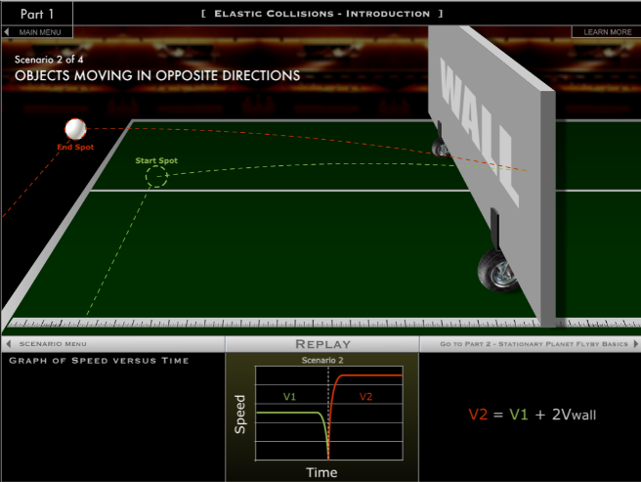

In the second example, the wall is moving toward the ball at some velocity (v_{wall}). The ball travels in the opposite direction (v_{ball}) toward the wall, and after the elastic collision leaves the wall in the direction of v_{wall} with a magnitude v_{wall}+v_{ball}. The additional kinetic energy was transferred from the wall to the ball.
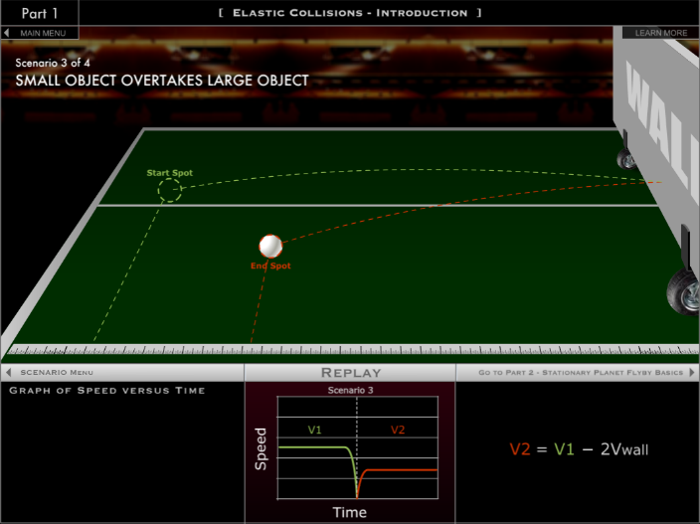
The third example shows the ball and wall both moving in the same direction, though the ball is moving faster than the wall is. Here, the ball transfers some of its kinetic energy to the wall on impact and leaves the wall in the opposite direction at a slower velocity (the ball’s velocity after the collision is vball-vwall).
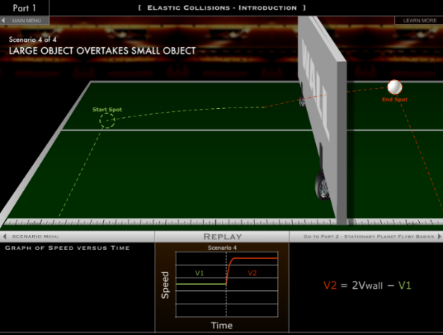
In the fourth example, the wall starts on the left side behind the ball and they both move to the right, where V_{wall} is greater than V1. When the wall catches up to the ball, the wall transfers kinetic energy to the ball, and the ball moves in the same direction at a higher magnitude.
These examples can all be adapted for gravity assists: the ball is the spacecraft and the wall represents the planet. There are some caveats to the analogy:
- As identified by Barlett and Hord, the ball bouncing off the wall is a repulsive force. Gravity is an attractive force.
- The collision in the analogy requires physical contact to transfer the energy. In a gravity assist, the spacecraft interacts with the planet’s gravitational field but (hopefully) never comes into physical contact with the planet.
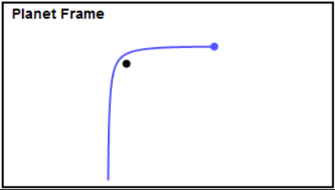
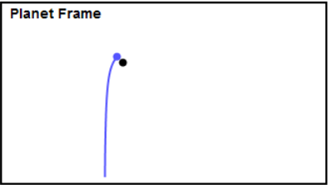
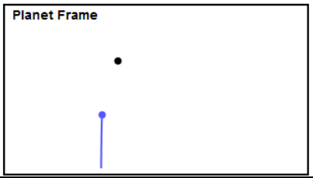
The first example is similar to what happens during the assist from the planet’s frame of reference. These gifs were created by David Shortt, which I have taken frames from.

Figures showing the planet frame of reference. The spacecraft (in blue) and planet (black). From Shortt 2013.

As the spacecraft approaches the planet in a straight line, the gravitational force of the planet changes the angle of the spacecraft’s flight. An extremely close pass, resulting in an almost 90 degree turn is shown here, passing at a farther distance would create less change in speed and direction. If you were on the planet, you would see the spacecraft gain kinetic energy as it approached the vertex of the hyperbola, then lose kinetic energy at the same rate as it moved back out of the gravity well. These observations would be right in line with conservation of momentum.
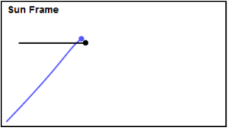
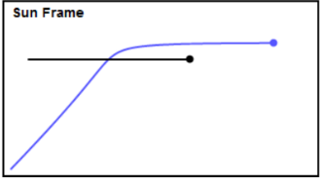
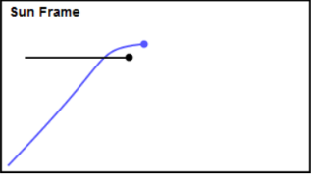
This interpretation is not the whole story. In shifting the frame of reference to holding the sun stationary, we can see what makes these maneuvers so useful.
Figures showing the Sun frame of reference. The spacecraft (in blue) and planet (black). From Shortt 2013.

Here the spacecraft approaches the planet at an angle and passes behind the planet as it moves to the right. The gravitational pull of the planet alters the spacecraft’s course and causes it to travel in the same direction that the planet is. It doesn’t just change direction, it speeds up significantly to the extent that it actually overtakes the planet. An observer from this frame of reference would be forgiven for thinking that the spacecraft generated its own kinetic energy somehow. In reality, the planet is transferring its kinetic energy to the spacecraft and slowing down ever so slightly, a a prime example of Newton’s third law. However, since the mass of the planet is so much greater than the mass of the spacecraft, a negligible change in the speed of the planet is very significant for the spacecraft.
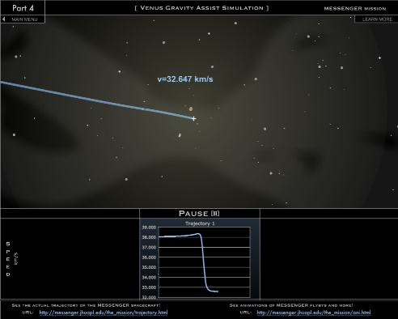
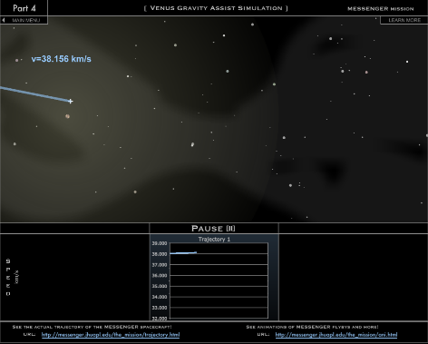
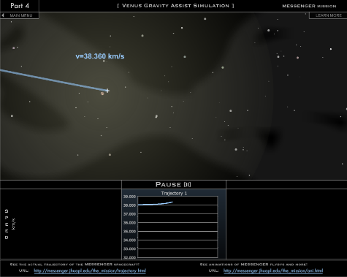
A similar maneuver can also be utilized to slow the spacecraft down, which is particularly useful if the satellite needs to orbit a planet after it has traveled to it, like the spacecraft Cassini. By passing in front of the planet, the planet’s gravity forces the spacecraft to slow down to the point where it is no longer traveling fast enough to escape the gravitational well, and it enters an elliptical orbit. Another fantastic modeling of this scenario can be found on the Venus Assist Simulator from the John Hopkins site.
THE “PHYCTION”
Gravity Assists in Fiction
Many shows, books, and movies about space explicitly or implicitly employ gravity assists as it may be the only way for the characters to traverse large distances in space, especially if the story occurs in a universe without some type of advanced ion thruster (like Deep Space 1 or Dawn), faster-than-light travel, or artificial wormholes. The Expanse (both books and TV series) have several explicit mentions of gravity assists, for example:
- “Slingshotting” is an outlawed extreme sport where a pilot will attempt to chain multiple gravity assists together in succession in order to compound the accelerating effects.
- Alex (the pilot) is attempting to evade a fleet of Martian battleships and can not use his main engine or he will be detected. He uses a series of gravity assists around several of Jupiter’s moons to travel and save the other protagonists on Ganymede.
The gravity assist maneuver is also pivotal to the rescue plot of the Martian (both the book and movie).
- On the return mission to Earth, NASA is trying to work out how to get back to Mars to save Mark Watney. The crew and NASA decide instead of having the ship decelerate and fall into Low Earth Orbit, instead they have it accelerate in order to conserve velocity and use the Earth’s gravity to swing back toward Mars. They then use another assist around Mars to come back to Earth.
Accuracy of the Accounts
In the Expanse, several issues come with the portrayal, some identified by the show’s creator. The idea of “slingshotting” through several moons at high speeds does work conceptually, however these moons are still very distance from one another, instead of the rapid pace the characters seem to fly through them in the show. This is a similar issue to Alex’s rescue mission, where not only is the moon Alex started at (Cyllene) almost 14 million miles away from Ganymede, he transverse this distance through a series of gravity assist maneuvers with no Oberth Effect that takes slightly over an hour.
The Martian on the other hand, fares far better. In her paper, Laura Burke analyzes multiple aspects of the “Rich Purnell Maneuver” and finds it to be “consistent with the laws of physics.” She did cite however, that as the trajectory would have taken the Hermes within the orbit of Venus, radiation levels and high temperatures may have been a more dangerous issue than explored in the book.

Assignment
The attached assignment is an example of short calculations the students can use with Kepler’s laws to determine simplified Hohmann orbits in between particular planets.

WORKS CITED
Arons, A. B. (1984). Student patterns of thinking and reasoning. Physics Teacher, 22, 21–26.
Bachman, A. A. (1984). Free fall and weightlessness. Physics Teacher, 22, 482.
Barlett, A. & Hord, C. (1985) The slingshot effect and analogies. The Physics Teacher 23, 466-473; https://doi.org/10.1119/1.2341882
Berg, T., & Brouer, W. (1991). Teacher awareness of student alternate conceptions about motion and gravity.Journal of Research in Science Teaching, 28(1), 3–18.
Blanco, P.R and Mungan, C,E. (2019) Rocket Propulsion, Classical Relativity, and the Oberth Effect. The Physics Teacher 57:7, 439-441.
Burke, L. (2015). An Examination of "The Martian" Trajectory. NASA. Retrieved from https://ntrs.nasa.gov/archive/nasa/casi.ntrs.nasa.gov/20150019662.pdf

Clement, J. (1982). Students' preconceptions in introductory mechanics.American Journal of Physics, 50(1), 66–71.
Doody, D. (2019, January 13). Basics of Spaceflight. Retrieved November 20, 2019, from https://solarsystem.nasa.gov/basics/primer/

Driver, R., Guesne, E. T., & Tiberghien, A. (1985). Children's ideas and learning science. In R. Driver, E. Guesne, & A. Tiberghien (Eds.),Children's ideas in science 1–9. Milton Keynes: Open University Press.
Dykla, J., Cacioppo, R, and Gangopadhyaya, A. (2004) Gravitational slingshot. American Journal of Physics 72:5, 619-621.
Galili, I. Interpretation of students' understanding of the concept of weightlessness. Research in Science Education 25, 51–74 (1995). https://doi.org/10.1007/BF02356460
John Hopkins University Applied Physics Lab. Gravity Assist Simulator. (2003). Retrieved from https://messenger.jhuapl.edu/Learn/interactives/conv_gravity_assist/gravity_assist_menu.html

Johnson, N. L., Handbook of soviet lunar and planetary exploration - volume 47 science and technology series, Amer. Astronau. Soc. Publ., 1979. https://nssdc.gsfc.nasa.gov/nmc/spacecraft/display.action?id=1959-008A

Mel'kumov, T. M. (Ed.). (1965, November). NASA technical translation. no.9285 1959. Retrieved from https://hdl.handle.net/2027/mdp.39015047366193

Next Generation Science Standards. (2020, April 3). Retrieved from https://www.nextgenscience.org/

Shortt, D. (2013, September 9). Gravity Assist. Retrieved February 22, 2020, from https://www.planetary.org/blogs/guest-blogs/2013/20130926-gravity-assist.html
Watts, D. M. (1982). Gravity-don't take it for granted! Physics Education, 17, 118–121.
Weir, Andy. The Martian. Crown Publishing Group, 2011.

