Roller Derby as an Instructional Tool to Engage
NYS Regents Physics Students

by
Amanda L. Dolan

Submitted in Partial Fulfillment
of the Requirements for the Degree

Masters of Physics Education

Supervised by
Dan MacIsaac

Department of Physics

State College at Buffalo
Buffalo, New York

2014

Abstract

Drawing connections between the classroom topic and activities in our students’ lives is a powerful tool for gaining and maintaining student motivation. Using sports to illustrate different physics principles is a helpful tool to increase student engagement. Typically, most sports mentioned in physics practice questions and explanations are traditionally male sports. Roller derby is the perfect sport to help physics teachers break out of this mold. Using personal experience as well as new data, I will show how various concepts from the Regents physics curriculum can be explored through the sport of roller derby.

Need to include findings and data… soooo… sample physics problems?
Table of Contents

Abstract
Background
Experimental Equipment
The Physics of Roller Skating
Falling and Stopping
Conclusion

Appendices
A - Acknowledgements
B - Author’s biography
C - Introduction to Roller Derby
D - Sample Questions
E - References
Background

Angell, Guttersrud and Henriksen (2004) found that students, especially female students, consider physics to be one of the most difficult subjects. The study also proclaims that physics students find developing a sound understanding of physics concepts to be both essential and difficult. The perceived complexity of physics topics by students is a good reason for physics educators to strive to showcase physics principles in new and interesting situations that can increase engagement for all students.

Modern Roller derby is a relatively new sport that reentered the public sports scene in 2001. As a result there are very few papers written on the topic. Therefore I must look to sports that share similarities with roller derby. In Physics on Rollerblades (1998) Eugenia Etkina used rollerblades to introduce basic kinematics to her students and then used that foundation to expand their knowledge into the more complicated areas of curvilinear and circular motion, inertia and centripetal force. Student interviews allowed her to record the positive effects the rollerblading activity had on her students. After Etkina's rollerblading unit her students were able to "see physics everywhere."

Sports are an excellent way to teach physics principles. In a study by Hatch and Smith (2004), physics and sports were merged and students showed very positive responses. The sports most commonly used for instruction are traditionally male, and could leave female students feeling overlooked. Enter, roller derby: the up and coming, fast paced, hard hitting, all women sport. Roller derby is often touted as being one of the fastest growing sports in America. It is new, fresh and exciting; and it's full of physics!

Experimental Equipment

Attempting to write sample physics problems for roller derby caused me to wonder things like, “How fast do we skate?” The lack of public knowledge concerning typical measurements for derby phenomena forced me to conduct some experiments of my own.

A basic method to calculate the speed of a skater was to time her laps and measure the distance of the path she followed. Then, using that information I was able to do some quick calculations to find her speed.

The Hot Wheels Radar Gun, which retails for $69.99, is a more technologically advanced ways I used to find the speed of a skater. For more information regarding this tool see: http://service.mattel.com/instruction_sheets/j2358-0920.pdf. I positioned myself at several different places around the track to try and get a good reading of the skaters as they skated past. I found I got the best readings at the end of the straight-aways. It also worked best when I pointed the radar gun at the skater's chest. Using the radar gun when only one skater was passing at a time allowed me to be certain about which skater's speed the radar gun was displaying.

Kinematics of Roller Skating - Roller Derby Style

Toxin Dioxin skating in a low derby stance

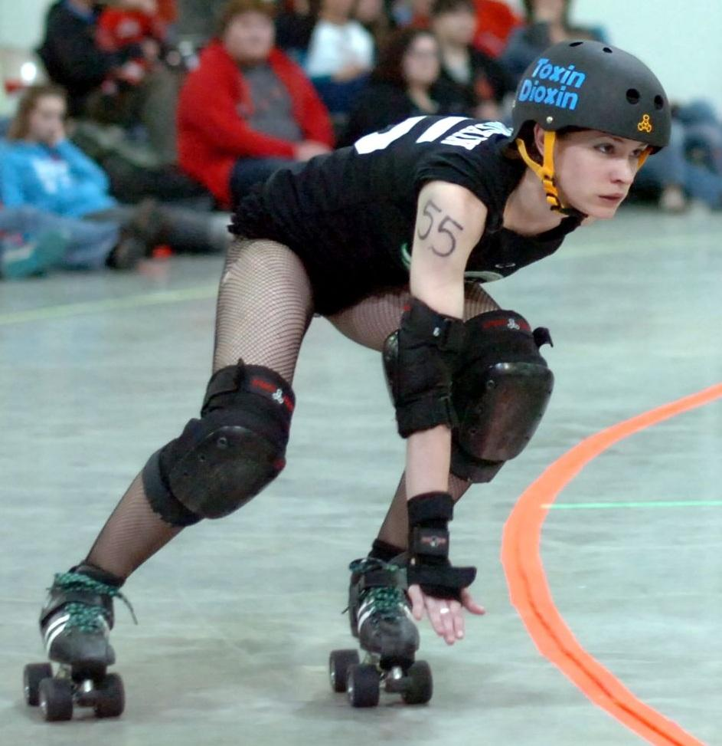
Figure 1: This picture shows a typical derby stance, low and centered, as the skater uses crossovers to speed around the track (photo credit: Robert Krzaczek)

In roller derby, skaters are always accelerating or decelerating. Skaters generally accelerate by pushing off of the floor with their skates. Skaters use a combination of crossovers and sculling to gain and maintain speed. Crossovers are when the skater picks up her outside foot to step over the inside foot to push herself toward the center of the track. Sculling is when the skater keeps all eight wheels on the track and uses a sideways pushing motion to propel herself forward.

Crossovers  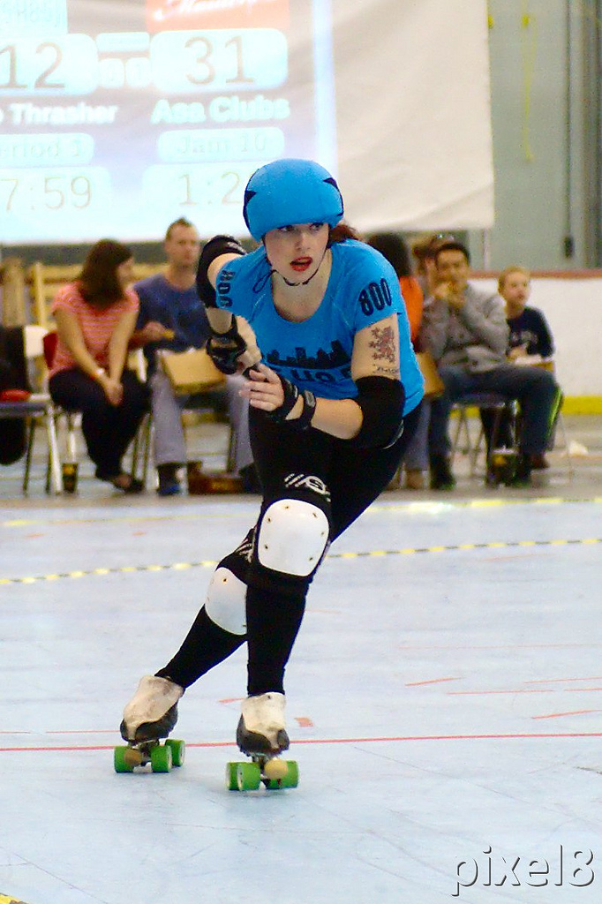  Figure 2: Skater, JoJo Thrasher, using crossovers to skate around the track. (Photo credit: Robert Krzaczek) | Sculling  Figure 3: Skater, Karmalized, sculling to propel herself around the track. (Photo credit: Robert Krzaczek)

Using both the stopwatch and the radar gun I was able to find the speed while sculling and crossing over.

Lap Times Recorded with Stopwatch
 | crossovers | sculling
 | Δt | Δt
lap 1 | 13 seconds | 12 seconds
lap 2 | 10 seconds | 12 seconds
lap 3 | 9 seconds | 10 seconds
average | 10.6 seconds | 11.3 seconds
Table 1: The following chart shows the data I collected with my stopwatch while RCRD skater, TaTa Pain, raced around the track. When using crossovers, TaTa followed a circular path and when she was sculling she followed the inside line of the track.

The data lets us compare the two styles of skating. At first glance, the similarity in the times for each lap could lead one to believe that there is little difference between the two skating styles. However, TaTa followed two different paths when using these two different skating styles. In the first trial, using constant crossovers, she was following a circular path as she skated on the inside line at the turns and toward the outside line on the straight-aways. In the second trial, TaTa was hugging the inside line as she sculled around the track.

Regulation track for Women’s Flat Track Roller Derby Association
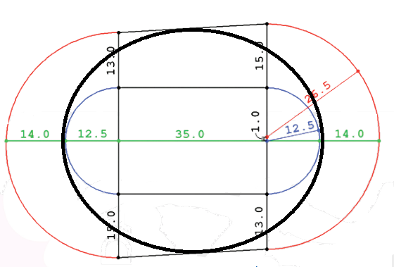
Figure 4: This image shows the dimensions of the WFDTA regulation track. I drew the thick black line to show the path followed by TaTa as she skated with crossovers. The inside line of the track is shown in blue on the turns and black on the straight-aways shows the path she skated when sculling. (Image credit: WFTDA)

According to WFTDA, the circumference of the inside line measures 148.5 On the other hand, the circular crossover path is 178 ft. Since the crossover path is longer, students might expect it to take more time to traverse in comparison with sculling along the shorter path on the inside line. Knowing the difference between the two paths TaTa skated and the difference between the two methods employed will help students to compare the similarities in the times recorded for each lap. Asking a student to develop a robust explanation as to why the times are so similar is a great opportunity for students to demonstrate a firm understanding of the relationship between time, distance and speed.

To clarify the relationship between speed, distance and time using the two skating styles, students can calculate the speed of the skater and compare the following data.

Average Speed of a Skater
 | Stopwatch |  | Hot Wheels Radar Gun
 | crossovers | sculling | Crossovers | Sculling
Average Speed | 5.1 m/s | 4 m/s | 5.4 m/s | 4.4 m/s
Table 2: When following the shorter path and sculling, Tata’s average speed was slower than when she was using crossovers and following a longer path. The radar gun shows a similar comparison between sculling and crossovers.

Unintentional Deceleration and Intentional Deceleration
Or
Falling and Stopping

Falling and the trajectory of objects in circular motion

Falling is something a spectator will see a great deal of at a derby bout and those observations provide a perfect opportunity to demonstrate the difference between angular acceleration and angular velocity. A fallen skater is no longer accelerating towards the center of the track she will slide to the edge, or perhaps even off the track. This is because her angular acceleration is now zero so she will no longer have any force pushing her towards the center of the track. Since the direction of angular velocity is tangential to the circular path the skater is traveling on, students can predict which spectator will get a flying derby girl in their lap after a fall and slide into the crowd.

Falling and sliding to a stop

Skater Falling After a Heavy Hit
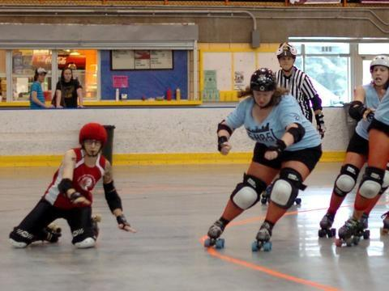
Figure 5: This photo shows a fallen skater sliding off the track. (photo credit: Robert Krzaczek)

The skater in red is at the mercy of her own inertia as she slides away from the track. However, the skater in blue, Wolf Blitzkreig, is still on her skates and can shift her center of mass to maintain enough angular acceleration to keep her position on the track. This is very similar to the traditional demonstration of whipping a string with a ball at the end around your head and cutting the string to watch the ball fly off away from your hand. In the roller derby example the ball is the red skater and the vector of centripetal acceleration caused by skating can represent the string. Once a skater is no longer up and skating she flies off in the direction of her velocity just prior to her fall.

This could be a good place to ask to compare the trajectories of the skater's slide after a fall when she falls on the curved portion of the track versus the straight portion of the track.

Studying falls and stops in roller derby provides a good example of friction bringing an object in motion to a halt. By recording the stopping time and stopping distance we can compare the magnitude of deceleration for various falls and also intentional stops.

Another one of my teammates from Roc City Roller Derby, Shockin’ Audrey, demonstrated two controlled falls while I recorded her stopping distance and time. I used a stopwatch to record the time it took her to come to a complete stop after she hit the floor. The skate floor was constructed of one by one foot plastic tiles. I counted these tiles to find an approximate stopping distance once Shockin’ had come to a complete stop.

The One-Knee Fall  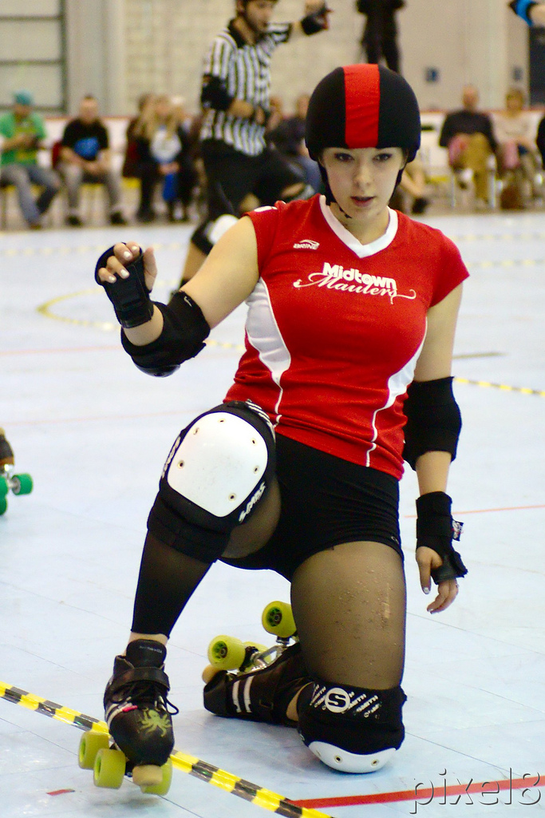  Figure 6: Skater, Susan B. Agony, performing a one-knee fall (photo credit: Robert Krzaczek) | Two-Knee Fall - “Rock Star”  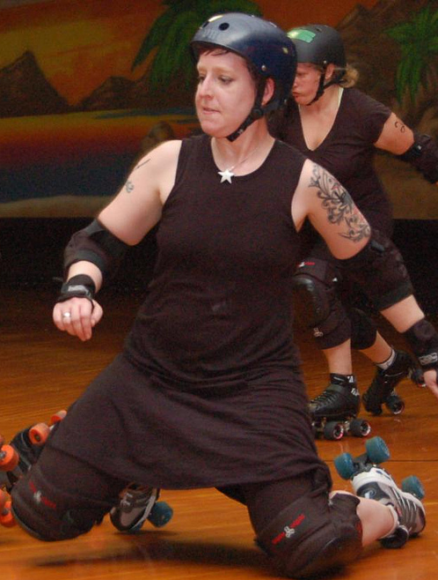  Figure 7: Skater, Scarlett Bloodletter, performing a two-knee fall (Photo credit: Amanda Dolan)

Comparing Two Methods of Falling
 | Time (seconds) |  | Distance (meters)
 | One-Knee Fall | Two-Knee Fall | One-Knee Fall | Two-Knee Fall
Trial 1 | 2.72 | 7.2 | 1.67 | 4.3
Trial 2 | 2.52 | 7.3 | 1.53 | 4
Trial 3 | 2.79 | 8.7 | 1.46 | 4.3
Average | 2.6 | 7.7 | 1.6 | 4.2
Table 3: This table displays data for how long it takes for a skater to come to a complete stop while performing a one-knee and a two-knee fall as well as how far that skater slides after making contact with the floor.

The data in the above chart provides teachers with appropriate values to formulate physics examples related to roller derby. Finding the initial velocity the skater was moving at just before she began her deceleration due to the fall is one example of a physics problem to solve. Sample problems can be found in the appendix.

Stopping Intentionally

Skaters have numerous methods for stopping at their disposal. I recorded the stopping times and distance for several of these methods. Shockin’ Audrey performed four different types of stops. I, Farrah Daze Rage, also demonstrated a stop. I recorded our stopping distances and times just as I did with the one-knee and two-knee falls.

Comparing Four Methods of Stopping
 | Time (seconds) |  |  |  |  | Distance (meters)
 | Toe Stop | T-Stop | Plow Stop  Audrey | Plow Stop  Rage | Tomahawk | Toe Stop | T-Stop | Plow Stop  Audrey | Plow Stop  Rage | Tomahawk
Trial 1 | 3.63 | 2.51 | 3.07 | 1.46 | 0.97 | 9.45 | 5.49 | 8.23 | 4.27 | 2.74
Trial 2 | 3.70 | 2.41 | 2.79 | 1.81 | 1.32 | 9.45 | 6.71 | 7.92 | 5.03 | 3.35
Trial 3 | 3.98 | 2.51 | 2.76 | 1.60 | 1.18 | 9.75 | 5.49 | 6.71 | 4.57 | 2.74
Average | 3.77 | 2.48 | 2.87 | 1.62 | 1.16 | 9.65 | 5.89 | 7.62 | 4.62 | 2.95
Table 5: This table displays data for how long it takes for a skater to come to a complete stop as well as how far that skater slides after initiating stop.

The Toe Stop
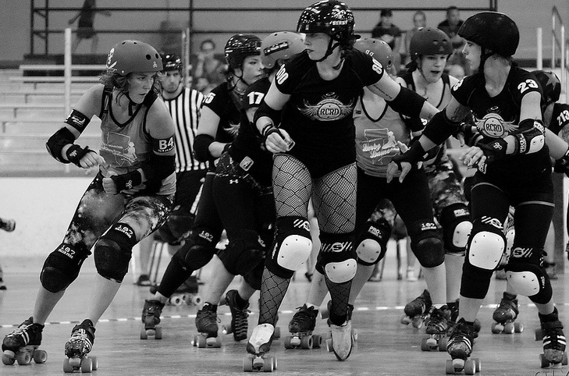
Figure 8: Skater, JoJo Thrasher (#800, middle) drags her toe-stop, changing her speed to dodge an incoming blocker. (Photo credit: Robert Krzaczek)

The science of the toe stop could be a paper all on its own. The variables that could be included in an extensive study of toe stops are many. Toe stops are made from many different materials, and in different shapes. Sin City Skates, a popular site for buying roller derby equipment, sells fourteen different types of toe stops. The length of the toe stop can be short and close to the skate, or long and near the floor. The toe stop rubs away every time it is used; this wear and tear changes the toe stop and also affects stopping ability. Finally, the skater's technique also influences the effectiveness of stopping.

The basic method of stopping using a toe stop is to extend one skate behind the other, dragging the toe stop on the ground. The harder the skater pushes the toe stop into the ground, the quicker she will slow down.

The T-Stop
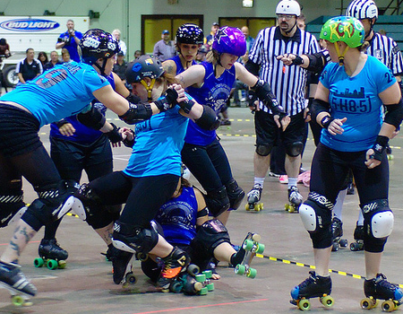
Figure 9: Skater, Camraderay (#24 on the right side of the photo), performing a t-stop. (Photo credit: Robert Krzaczek)

The t-stop is common method for stopping in crowded areas since it allows the skater to keep her legs close together. To execute this stop, the skater must place one of her skates perpendicular to the rolling skate. The stopping power from the t-stop comes from the skater pushing the wheels of the perpendicular skate down on the ground.

The T-stop brings the skater to a stop about one second faster and in almost half the distance when compared to using the toe-stop. Since roller derby is a game where speeding up and slowing down happens constantly, having an effective method of stopping quickly is crucial for serious skaters.

As with the toe stop, there is an interesting materials aspect to the T-stop that can have a significant impact on the skater's ability to stop. A quick glance back at Sin City Skates’ website shows more than forty different types of wheels available for sale. If one were to peruse other skate-shop sites they would discover even more types of wheels. Here too, the condition of the wheels is important to note.

The Plow Stop
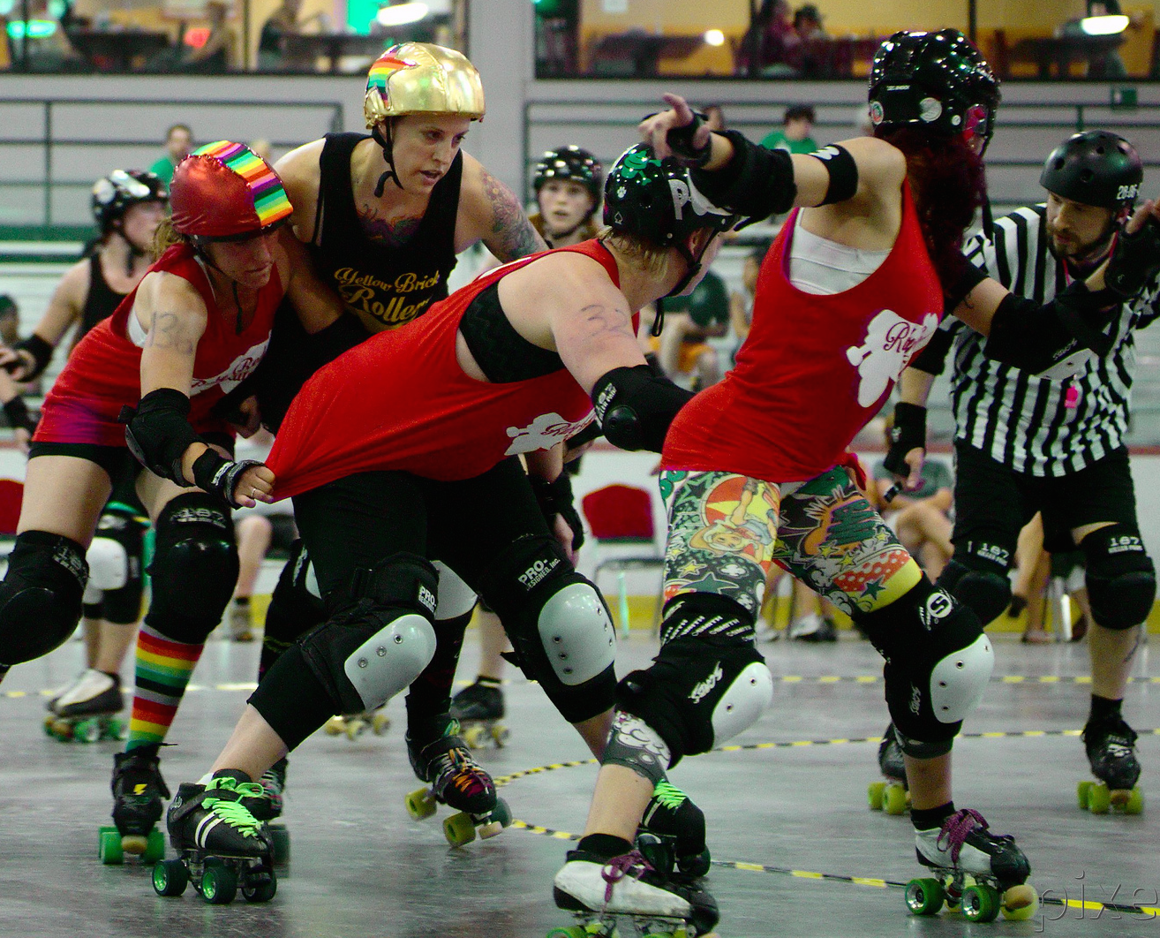
Figure 10: Skaters Jacky Spades (#8, far right) and Poplockndropya (#32, center) are performing plow stops to slow opposing jammer, GWAR (gold helmet cover), as Beric Dondarrion (#136) comes in for a hit. (Photo credit: Robert Krzaczek)

The plow stop is more than just a method of stopping. It is also a method for positionally blocking other skaters. To execute a plow stop the skater must skate with a wide, low stance, bending at her knees. She pushes the innermost wheels of each skate into the floor while turning her toes in. This causes her to slow down quickly and, depending on her stance, can also act as a barrier on the track, impeding skaters who hope to glide past her.

I chose to collect data on two skaters to display the differences in using the stop with varying levels of success. The difference in effective use of the plow stop can be seen in the differences between Audrey and Rage’s average stopping time and distance. Each skater has her preferred stopping method, and it is usually the one she is most proficient at.

The Tomahawk
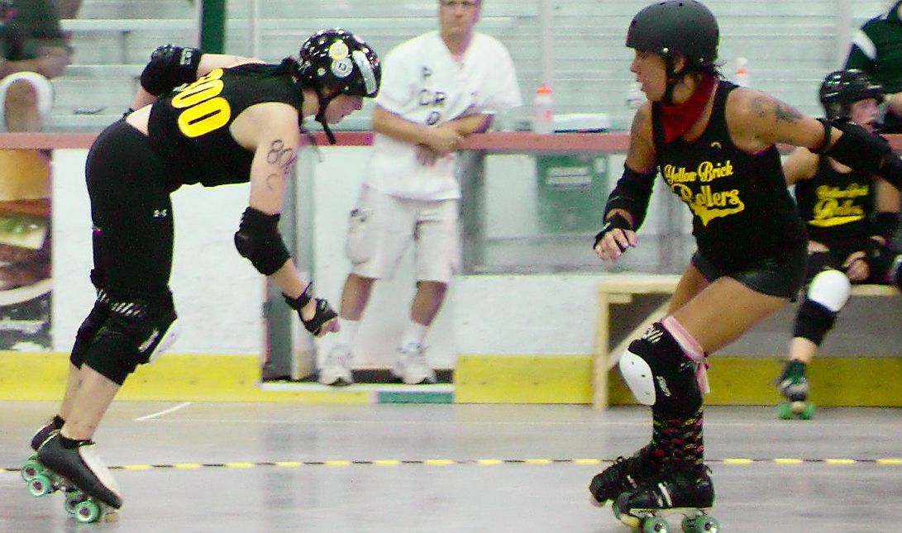
Figure 11: Skater JoJo Thrasher (#800, far left) performing a tomahawk stop. Both skaters’ direction of motion is to the left. (Photo Credit: Robert Krzaczek)

The tomahawk is one of the most immediate ways to come to a controlled stop while on skates. In contrast to the plow stop, the tomahawk does not require the skater to spread out on the track, so this stop can be executed in tight packs without fear of tripping other skaters. The tomahawk is also one of the most difficult stops for a skater to learn.

To do a tomahawk stop the skater must first transition from skating forward to skating backwards. The skater will lean forward, in the direction opposite to her direction of motion, with her weight on her toes. Then she lifts up off her heels and rear wheels to her toe stops. Without any wheels rolling and only two toe stops dragging under her, the skater skids to a stop very quickly.

The tomahawk is the fastest way to stop when compared to the other methods discussed in this paper. Once a student has been exposed to roller derby they can use physics to explore the differences between the numerous ways derby skaters stop on the track.

Graph 1: This graph compares the average stopping distance and time for all falls and stops studied in this paper.

Conclusion

Using practical examples such as sports to help teach physics helps students to better grasp the new and complex concepts that are part of the Regents physics curriculum. Including roller derby scenarios with today’s commonly used sports scenarios to teach physics can add something new and unique and also engage more female students due to female dominance in the sport of roller derby.

My goal with this paper was to introduce roller derby to the physics teaching community and provide ideas for physics questions and a basis for numerical values to use in those questions to keep the scenarios valid. I also hope I was able to show that there is more the roller derby than just kinematics; materials science is one of many other areas that could also be explored if students showed interest.

Engaging students is important, and helping students develop an authentic understanding of the physical world should be our goal. With more scenarios for practice questions we increase the chance that more students will see physics everywhere.

Appendix A – Acknowledgements

I would like to express my appreciation and thanks to my advisor Dr. Daniel MacIsaac for never giving up on me throughout this long process. I would also like to thank Roc City Roller Derby and all its members for helping me and participating in my research.

Appendix B - Biography

Amanda Dolan, born and raised in Rochester, NY, graduated from The University at Buffalo with a B.A. in Physics in 2003. In 2004 Amanda began studying for her Masters in Physics Education at Buffalo State College under the guidance of Dr. Dan MacIsaac. In 2009 Amanda joined Roc City Roller Derby and donned the pseudonym Farrah Daze Rage. Thinking about physics as she skated came so naturally she decided to focus on roller derby as her thesis. Amanda currently runs a daycare out of her home while she works with a colleague to start a new public school in Rochester, NY.

Farrah Daze Rage #49, Lead Jammer
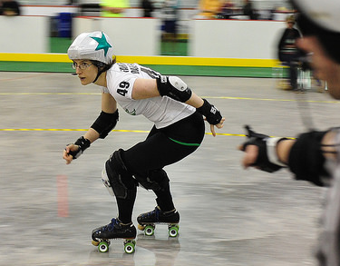
Figure 12: Here I am, doing what I love. (Photo Credit: Robert Krzaczek)
Appendix C - A Brief Introduction to Roller Derby

"It's like Wayne Gretzky said: "Skate to where the puck is headed, not to where it's been"...except of course, in our case the "puck" is the opposing jammer, or a blocker we're trying to control...and it has a mind of its own. Roller derby is so much better than hockey."
Resident Eva (Roc City Roller Derby)

I often speak with people who are unaware of the recent resurgence of roller derby, yet many people remember roller derby’s initial incarnation. With banked tracks, high speeds, minimal safety equipment and skaters with strong personae it is difficult to forget the roller derby created and promoted by Leo Seltzer in the 1930s. Barbee and Cohen’s book, Down and Derby (2010) delves into roller derby’s roots and how the 1970s the gas crisis and the increased theatrical nature of the roller derby caused the sport's popularity to wane. Fortunately, in 2001 a group of people in Texas gathered to begin roller derby’s meteoric comeback. Joulwan, founder of the Texas Rollergirls, chronicled the resurgence of roller derby in her book, Roller Girl (2007.)

These days the most common form of roller derby is played on a flat track and is regulated by the Women’s Flat Track Derby Association (WFTDA.) Rules for the sport can be found at wftda.com/rules. Two thirty-minute halves are divided into an indeterminate number of “jams” which can last up to two minutes each. At the start of each jam eight blockers, four from each team, line up together forming “the pack.” One jammer from each team starts behind the pack and earn one point for each opposing skater they pass legally and inbounds. Throughout the jam. the blockers are positioning themselves to help their jammer and stop the opposing team’s jammer with a variety of hits, blocks and assists. After the jam ends, the skaters leave the track and each team has 30 seconds to get a fresh lineup of skaters out for the next jam.

Brenda "Skater Bater" Delano wrote a short and concise article for American Fitness (2010) explaining the basics of roller derby. A first time fan will most likely find roller derby very confusing, but with Delano's breakdown of the sport, any fan can get up to speed in just a few minutes. Delano describes the basic rules and game-play of the sport, as well as the intense effort skaters must put forth in training.

Appendix D - Sample questions

1. While coasting to rest in a two knee fall, it took Shockin’ Audrey 1.6 seconds to travel 4.2 meters. What was her velocity just before she before she fell?

Using the kinematics equation below is a good way to answer this problem:
$$d=\frac{v_{i} + v_{f}}{2}t$$

Known:
$$v_{f}=0$$
$$t=1.6 s$$
$$d= 4.2 m$$

yields:
$$v_{i}=5.3 m/s$$

2. To add a numerical value to the conceptual explanation of this stopping method, the student would need to find the rate of deceleration and the skater’s initial velocity.

Known:
$$v_{f}=0 m/s$$
$$d=9.65 m$$
$$t=3.77 s$$

Equations:
$$d=\frac{v_{i} + v_{f}}{2}t$$
$$d=v_{i}t+\frac{1}{2}at^{2}$$

Yields:
$$v_{i}=5.1 m/s$$
$$a =1.53 m/s^{2}$$
Appendix E - References and Further Reading

Angell, C & Guttersrud, O & Henriksen, E. (2004, September). Physics: Frightful, but Fun. Pupils' and Teachers' Views of Physics and Physics Teaching. Science Education, 88, 683-706.

Barbee, J & Cohen, A. (2010). Down and Derby. (1st ed.). Berkeley, CA: Soft Skull Press

Delano, B. (2010 September/October). Roller Derby. American Fitness, 28, 45-45

Etkina, E. (1998, January). Physics on Rollerblades. The Physics Teacher. 26, 32-35.

Hatch, G. & Smith, D. (2004, January). Integrating Physical Education, Math, and Physics. Journal of Physical Education, Recreation and Dance, 75, 42-50.

Joulwan, M. (2007). Roller Girl (1st ed.). New York, NY: Touchstone.

Rules Central-Woman's Flat Track Derby Association. (2009-2012). Retrieved December, 12, 2011 from Women's Flat Track Derby Association Web site: http://wftda.com/rules

Appendix B: WFTDA Track Design and Specifications. (2005). Retrieved December 12, 2011 from Women's Flat Track Derby Association Web site: http://wftda.com/rules/wftda-rules-appendix-b-track-design.pdf

