Student Difficulties with Images and Vision for the NYS Physics Teacher
Chelsea M.B. Fink
SUNY Buffalo State College Department of Physics

Abstract
Geometrical Optics has made a reappearance in the New York State Science Learning Standards (NYSSLS) adopted in 2017 in high school physical science. Students are expected to analyze the relationships between size and location of objects and their images depending on focal lengths of lenses and mirrors. The literature shows that simple everyday experiences with light have a strong impact on students’ frameworks for understanding optical phenomena. This paper will focus on the student difficulties with the nature of vision and image formation as found in Physics Education Research (PER). Strategies will be suggested for how to assist students in acquiring scientifically accepted models of these select topics, based on PER literature.

Biography
Chelsea Fink is an M.S.Ed. Candidate in Physics Education at SUNY Buffalo State Physics Education Department. Fink graduated from SUNY Geneseo in May 2012 with a B.S. in Chemistry and Adolescent Education, with initial certification in Chemistry, Physics, and General Science. She taught chemistry for five years and Advanced Placement Chemistry for the last three of those years at Aquinas Institute in Rochester, NY. She is currently staying at home to care for her daughter while tutoring students in chemistry. She intends to expand her business to include tutoring physics students.

Acknowledgements
This paper is submitted in partial fulfillment of the requirements necessary for PHY690: Masters Project at SUNY – Buffalo State College under the guidance of Dr. Dan MacIsaac.
Background
Many students can accurately use the lens equation and ray diagrams to determine the object location, image location, size of the image, etc. given necessary variables, so long as the question is comparable to the experiences supplied by their teacher (Knight, 2004). However, studies conducted by Galili, Goldberg, and Bendall (1991), Goldberg and McDermott (1986, 1987), Wosilait, Heron, Shaffer, and McDermott (1998), and others, found that at least half of post-instruction students could not appropriately describe changes in image size, location, brightness, focus, and orientation in physical scenarios with plane mirrors, convex lenses, and concave mirrors. This should be concerning to educators because this means that their students do not develop working conceptual models in optics.
Prior to formal teaching on light and optics, students develop robust and coherent (yet scientifically inaccurate) models of light because light and vision are such an integral part of students’ everyday experiences (Kaltakci-Gurel & Eryilmaz, 2013). Students interpret these experiences in ways that seem to support their models, and thus have difficulty resolving conflicts between “predictions made based on their interpretations of experience and predictions based on application of the laws of geometrical optics” (Goldberg & McDermott, 1986). This is perhaps why traditional sequences in optics fail to provide students with functioning models of light (Goldberg & McDermott, 1987; Sokoloff, 2016). Students traditionally have their seemingly accurate models rejected outright with little time to explore why their models were incomplete. Instead, students need the opportunity to work within their frameworks and refine them to arrive at scientifically accepted models. It takes carefully constructed and intentionally targeted classroom activities and instruction in order for students to re-interpret their experiences with a scientific mind (Galili, Goldberg, & Bendall 1991).
New York State Assessment on the Nature of Light and Geometrical Optics
In New York State Regents Physics exams prior to 2002, there was an optional section of the exam on geometrical optics (NYSED, 1995; NYSED, 2002). This section was comprised of questions requiring mathematical calculations of focal length and image size, mathematically locating objects and images, and qualitatively assessing the changes in image size as dependent on object location with plane, convex, and concave mirrors as well as converging and diverging lenses (NYSED, 1997; NYSED, 2000). Optics questions in other parts of the exam included applications of Snell’s law and the law of reflection, and general questions on light wave properties such as speed, frequency, wavelength, and interference. Starting in the June 2002 exam, properties of lenses and mirrors were no longer part of the Regents exam. Questions on the behavior of light at an interface and wave properties remained on the exam to the present day (NYSED, 2002; NYSED, 2018).
Physics teachers may be concerned with changes to the format and content of the state exam based on the New York State Science Learning Standards (NYSSLS) for Physical Science, and when those changes will take effect. Physics teachers can expect their students to be tested based on NYSSLS for Physical Science beginning in 2024 (NYSED Curriculum and Instruction Office, 2019).
NYSSLS and NGSS for the Nature of Vision and Geometrical Optics
The Next Generation Science Standards for Physical Science has learning standard PS4 which concerns Waves, Electromagnetic Radiation, and Information Technologies (NGSS Lead States, 2013). NGSS and NYSSLS both have a storyline for developing a model of vision in first and fourth grade that is supported by physics education research and is discussed later in this paper. NGSS and NYSSLS each have nearly identical storylines for investigating how light interacts with objects (NGSS Lead States, 2013; NYSED, 2016). Both standards start with first grade students where they investigate how light interacts with transparent, translucent, and opaque materials and mirrors. Middle school students investigate light that is reflected, absorbed, or transmitted; for NYSSLS this is in the context of lenses and mirrors and includes using ray diagrams to qualitatively model the light behavior (NGSS does not make this specification).
NYSSLS’s storyline concludes in high school with analysis of image formation with lenses and mirrors both mathematically and with ray diagrams. Students are expected to analyze ray diagrams and mathematically model the relationships between image size and location, object size and location, and focal length of the optical device (such as a lens or mirror) (NYSED, 2016). NGSS does not include image analysis in the high school standards. See Chart 1 for the vertical alignment of the NYSSLS performance expectations relevant to the nature of light and vision and geometrical optics. Table 1 summarizes the concepts students must acquire (labeled as “disciplinary core ideas” in the NYSSLS document), which correspond to the relevant performance expectations in Chart 1 (NYSED, 2016).
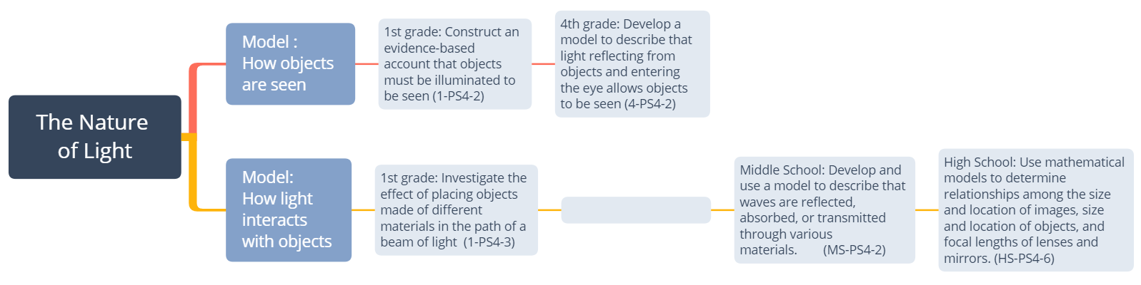
Chart 1. NYSSLS Performance Expectations by grade level pertaining to the Nature of Vision, and Geometrical Optics. (NYSED, 2016)
Table 1 Summary of Light Behavior and Geometrical Optics concepts from first grade through high school based on disciplinary core ideas listed in the NYSSLS (NYSED, 2016).
Grade Level | Concept | Clarifications and Examples
1st grade | Objects can only be seen when illuminated | Examples: Completely dark room, pinhole box, shadows on a wall
 | Certain materials allow all light to pass through, some light to pass through, or no light to pass through. | Examples: Windows, wax paper, color filters, shadows
 | Mirrors redirect a light beam | Examples: Plane mirrors
4th grade | Light reflects off of objects and enters the eye in order to be seen. | Clarification: The particular function of the retina and perception of color are not included in this level.
Middle School | When light encounters an object, light waves are reflected, absorbed, or transmitted depending on the object and the frequency of light (qualitative applications only) | Clarification: Ray diagrams to model behavior of light waves  Examples: objects include plane, convex, and concave mirrors, and biconvex and biconcave lenses.
 | Real and virtual images can be formed by mirrors and lenses, depending on the type of optical device and the location of the object.
High School | The location and size of an image is related to the location and size of the object, as well as the focal length of the optical device. | Clarification: Mathematical models with emphasis on analysis of ray diagrams.  Clarification: This does not appear to include multiple lens systems

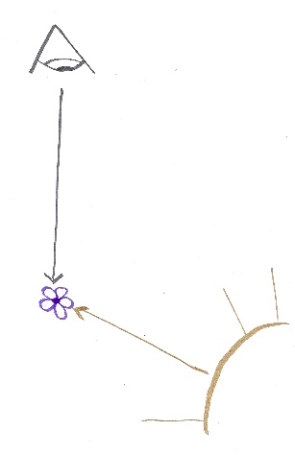
Student Ideas and Corresponding Standards on Vision
Student frameworks of light have been found to mimic early scientists’ theories of light, in that vision and light are not well differentiated (Galili & Hazan, 2000). Students’ ideas can be described by mostly coherent models called schemes. The facets of each scheme outlined by Galili and Hazan (2000) correlate well to students’ responses on diagnostic tests, as studied by Kaltakci-Gurel, Eryilmaz, and McDermott (2017). One student scheme of light is called Spontaneous Vision where the separation of light and vision is not distinct (Galili & Hazan, 2000). Students hold the belief that seeing happens naturally just because of the presence of the eye. This scheme holds that light must illuminate an object in order for it to be seen, but there is no connection made to that light then traveling into the eye (Fig 1). This is the level of scientific understanding expected of first graders in the NYSSLS (NYSED, 2016), yet some high school students and pre-service teachers demonstrated this level of understanding (Galili & Hazan, 2000). When students are limited to this model of vision, it contributes to the student difficulties reported on image formation and perception of those images with mirrors and lenses, as discussed in later sections of this paper.
Figure 1: Spontaneous vision. Light must illuminate the object, and it is seen because the eye is open and directed at the object.
Galili (2000) found that little is done to change students’ conceptualization of vision in the course of typical optics instruction. This is attributed to the neglect of the role of the observer in depictions and discussions of image formation. Many textbooks gloss over or avoid an investigation into the function of the eye and brain in image perception, and as a result so do the teachers who rely on the textbooks (Kaltakci-Gurel & Eryilmaz, 2013). Until recently, New York State standards also neglected the role of the observer and the function of the eye in either physics or living environment standards (NYSED, 1996). In the NYSSLS, fourth graders are expected to develop a model of vision which includes light reflecting off an object and entering the eye in order for the object to be seen (NYSED, 2016). This is included in the life sciences storyline “Structure, Function, and Information Processing”, implying that the structure and function of the eye, such as the iris and lens, are key components to the students’ model of light and vision. The function of the retina and perception of color are specifically excluded from this expectation (ibid).
After fourth grade, however, there is no attempt to include the importance of the observer or the function of the eye in image formation (NYSED, 2016). Teachers should be aware of the importance of vision and the role of the observer in students’ understanding of optical phenomena in middle and high school.
Students’ Ideas of the Nature of Light
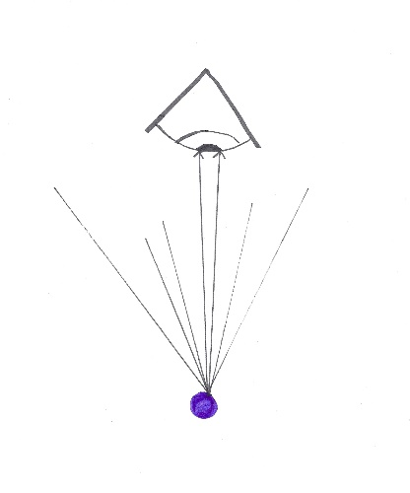
Galili and Hazan (2000) found that some students held the belief that light is a static entity which fills a space and stays there and that rays are literal fundamental pieces of light. Hubber (2006) found this idea as well. Students’ mental models involved the idea of a linear “ray” but some of the students’ use of the term would be better described as a cylindrical light beam or a stream of light particles. While the use of a “light ray” in physics classrooms is meant to model the direction of propagation of light waves, these students fail to make that connection and instead think that light is truly composed of “lines” of light. In these cases, students take on a model of light and believe it to be a picture of reality. This is part of a larger problem for students learning science – the model is assumed as literal truth rather than a human construct used to interpret reality (Grosslight, Unger, Jay, & Smith, 1991).
It is important to note that in studies of college students conducted by Goldberg and McDermott (1986, 1987) and experiences of teachers such as Layman (1979) and Arons (1997) show that even post-instruction students lack the understanding that light must diverge from a point and that those diverging rays must enter the eye in order for that point to be observed. It must be understood that this is necessary whether it is a real image, virtual image, or an illuminated object. It can be helpful to middle and high school teachers to intentionally address this model of light in order to improve students’ models of vision and image formation. Arons (1997) suggests initially using a spherically divergent bundle of rays emerging from a single point to emphasize this concept with students (Fig 2).
Figure 2. Illustrating Divergent light from a single point on an illuminated object entering the eye in order for that point to be seen.
Student Ideas of Image Formation
Gallili and Hazan (2000) report separate schemes for image formation as either an Image Holistic scheme, or Image Projection Scheme. Image Holistic is where an image is a “corporeal replication of an object that might move, remain stationary, or turn as a whole.” Students that exhibit facets of this scheme do not typically have an explanation for image formation or how the image gets to where it is. Students believe the image is transferred as a whole unit, and light helps an observer see the image but the image is still there regardless of the amount of light (ibid). This scheme can cause students to draw ray diagrams where only parallel rays from the object encounter the optical device, thus preserving the shape of the image as it encounters the optical device. These diagrams in turn result in reinforcing several incorrect student predictions about changes to optical apparatuses (Goldberg & McDermott, 1987).
Students gradually shift from an Image Holistic scheme towards the Image Projection Scheme during the course of instruction. In this scheme, “each image point is related to its correspondent object point by a single light ray which transfers it”, which is in contrast to the scientifically accepted model that light leaves in all directions from every point on an object (Galili & Hazan, 2000). This scheme was more commonly demonstrated by students after instruction, so exposure to scientific models of image formation contribute to these student ideas (ibid). Galili and Hazan (2000) suggest that without including concepts of flux and illumination in the curriculum, this scheme is not likely to mature into a scientifically accepted model of image formation.
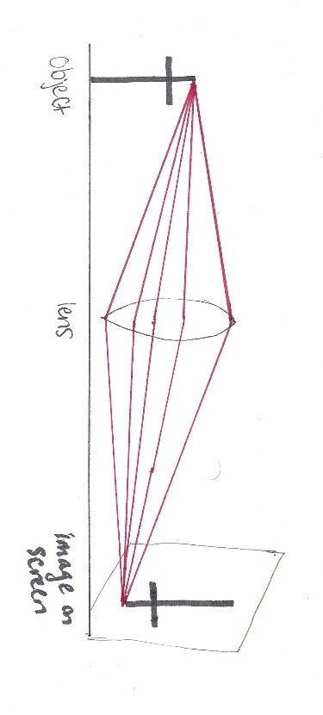
Both image schemes account for findings on students’ struggles with predicting changes to an image as a result of altering an optical apparatus (Goldberg &McDermott, 1987; Goldberg & McDermott, 1986; Layman, 1979). The students’ use of ray diagrams indicated they did not realize that principal rays are merely convenient rays to determine the location of the image and not in fact the only ones by which an image can be formed. For example, if part of a thin lens is blocked, few students correctly predicted that the brightness of the image would decrease. Instead, many predicted some part of the image would disappear, as if the image was cut where the lens was blocked (Goldberg & McDermott, 1987). If students had the experience of drawing multiple rays as in Figure 3, they may understand more fully that light from any point on the object passes through all sections of the lens (Grayson, 1995). With this understanding, blocking part of the lens does not stop the formation of the image but only diminishes the amount of light contributing to its formation.
Figure 3.Illustrating that light diverging from one point on the object enters every part of the lens, thus the image cannot be "cut" by something blocking part of the lens.
Students’ semantic difficulties with images
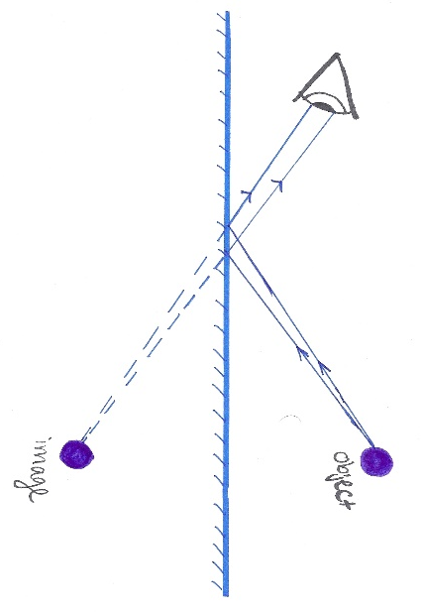
The very term “image” is not a well-defined idea in physics texts, and students are left to assemble their own definition of an image through context (Galili and Goldberg, 1993). Frustratingly, the term “image” is used to describe three different optical phenomena: a pinhole “image” or light pattern, a virtual image, and a real image. The language of “real image” and “virtual image” is unfortunate because of the everyday meanings of the words “real” and “virtual”. “Real” can mean that it is known to exist through the senses. If an image can be seen, then it is “real” in this sense of the word. “Virtual” can allude to virtual reality and holograms as depicted in science-fiction movies. If something is virtual then it can be seen, but is not physically there so it cannot be touched or felt. This idea can describe both real and virtual images, and thus lead to distracting and confusing sense-making for students. In the spirit of building on students’ existing frameworks of light and vision, it would likely benefit students to begin image exploration by using familiar terms which are typically used outside of the classroom.
The instructor and students can use the term “reflection” during the initial concept-building and ray diagramming of how the virtual image forms. Because the location of the reflection is the result of rays apparently diverging from that location, the instructor can lead students to describe this as a virtual location. “Virtual” because it appears to be located there but is in fact not found that many meters on the other side of the mirror. The instructor can then suggest using dotted lines to represent the “virtual” path of photons in their ray diagrams (Fig 4). In this way the term “virtual image” can replace the term “reflection” with a lot less confusion for students.
Figure 4. Using dotted lines to represent the virtual path of photons. (Author image after Galili, Goldberg, and Bendall, 1991).
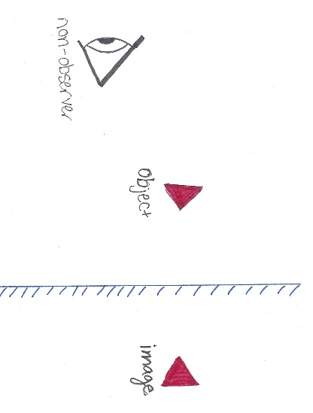
The instructor can lead students down a similar thought process with the real image discussion. Students might use the term “hologram” for an aerial image or “projection” for a real image viewed on a screen in the initial concept building and ray diagramming. The rays in their diagrams are representing actual, real photons coming from the image to the observer’s eye. The hologram or projection must be called something different than “virtual”- a “real” image. In this way a distinction between real and virtual images can more clearly be drawn by students.
Student’s Ideas about the Role of the Observer with Virtual Images
The emphasis on the observer is so weak in most texts that this translates to a poor understanding that “perception and formation of the virtual image occur simultaneously” (Kaltakci-Gurel, 2013). This allows for the student scheme of images as holistic reproductions of objects, as discussed in an earlier section of this paper. Within this scheme, students believe that an observer’s position (and presence) is important in observing an image, but not in the image formation (Galili & Hazan, 2000; Goldberg & McDermott, 1986). This accounts for why some students state that an image is formed in the mirror regardless if someone is looking at it as in Figure 5 (Goldberg & McDermott, 1986).
Figure 5. Student concept that an image is formed regardless of an observer.
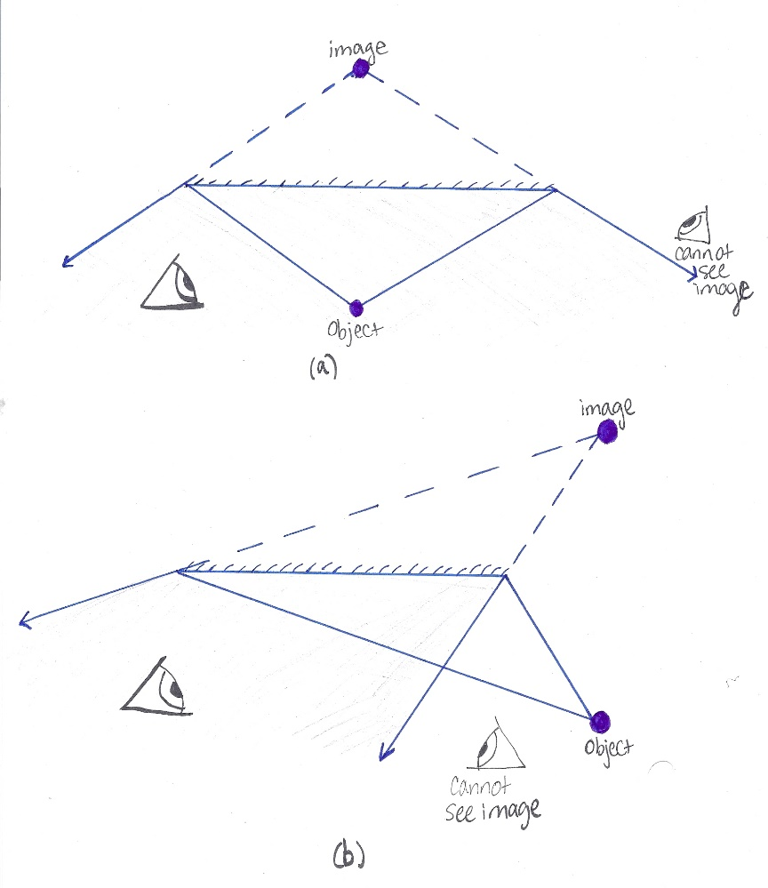
Figure 6. Ray diagrams determining the region where an observer can view the image in a plane mirror. In both scenarios the observer must be within the regions defined by the reflected rays. (Author image after Goldberg & McDermott, 1986).
Interestingly, when asked to predict the location of an image or whether the image can be seen for an observer other than themselves, students demonstrated the belief that the location of a virtual image depends on the position and line-of-sight of that observer (Goldberg & McDermott, 1986). Students can be instructed to draw rays from the object to the extreme edges of the plane mirror and extend those rays by the law of reflection in order to determine the region in which an observer can see the image, as in Figure 6. This application can be extended to the scenario where students are asked how much of their bodies they can see in a small mirror, and if there is anything they can do to see more of themselves in it. Few students could construct appropriate diagrams to help answer these questions, and instead predicted they could see more of themselves by moving further away. Drawing diagrams using the limiting rays helps students to realize the position of the observer does not change the size of the image; the size of the mirror in relation to the observer is what determines how much can be seen in the mirror (Goldberg & McDermott, 1986).
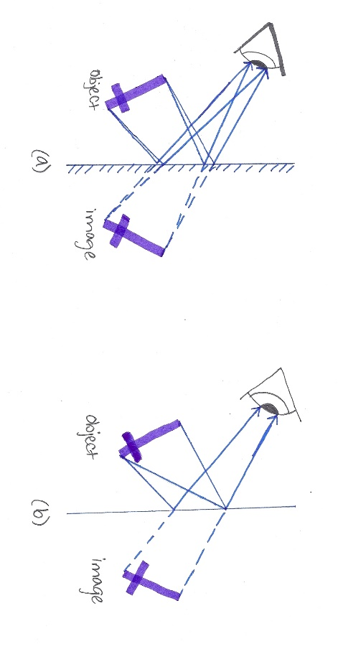
Some texts use the observer, however it is often incorrectly (Kaltakci-Gurel & Eryilmaz, 2013). Often an eye is depicted as intercepting only one light ray reflected from the mirror (either because only one ray is drawn, or because the eye is too small to intercept more rays). This implies that an image can be seen by just one ray, instead of something more like a conical bundle of rays. In diagrams of an observer perceiving an image, there should be multiple sets of diverging rays entering the eye, such as in Figure 7. By requiring a students’ diagram to include the observer, there are more opportunities for students to conceptualize that light diverges from a point in order for that point to be seen, and that the divergent light must enter the eye in order to be seen.
Figure 7. (a) A more complete representation of an observer perceiving a virtual image by two sets of diverging rays. (b) an incomplete representation of image formation, showing only one ray from each point on the object entering the eye (Author image after Kaltakci-Gurel & Eyrilmaz, 2013)

Students’ Ideas about the Role of the Observer with Real Images
In the formation of a real image by lens or curved mirror, students typically failed to realize that the presence of the screen or eye was irrelevant to the formation of a real image (Goldberg & McDermott, 1987). As a result, these students were surprised to find that they could see an image when directed where to stand. Even students who said an image could be viewed without the screen were not able to say where the eye should be positioned in order to see it. Because of the repetition of using screens to view real images, and the rarity of extending rays past the image point, students did not realize that “the eye must be placed beyond the point of its formation so that light diverging from it can enter the eye” (Goldberg & McDermott, 1987, p.118).
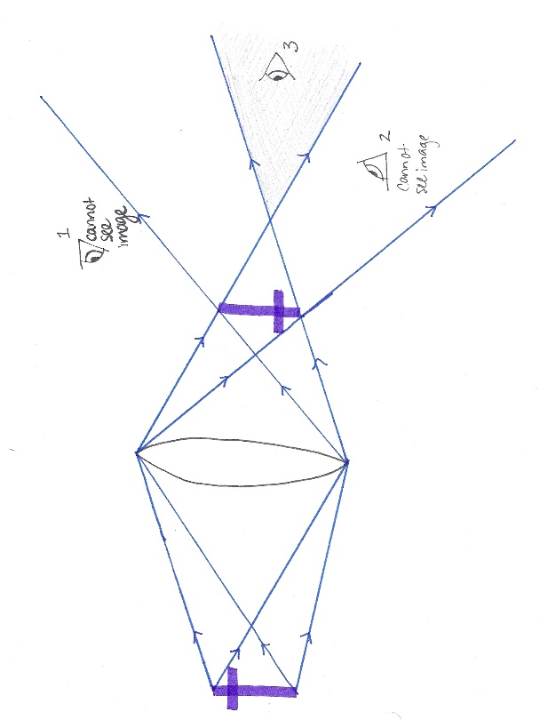
In Wyrembeck and Elmer’s (2006) “Investigation of an Aerial Image First”, students were asked to explore an aerial real image apparatus with a coffee can lid to operate as a translucent screen. When they found an image, they were directed to remain in place but pull the screen away to reveal that the image exists independent of the screen. Then students were directed to close one eye at a time to realize only one of their eyes has perceived the image. If a student steps away from the focal axis, they can no longer see the image. Students can be asked to construct ray diagrams (perhaps on large whiteboards) in an attempt to explain why only one eye perceived the image, and why only certain locations allowed for it to be seen. This investigation can reinforce the idea that when diverging light rays enter the eye, this allows for an object or image to be seen by the observer.
Kaltakci-Gurel and Eryilmaz (2013) note that none of the textbooks analyzed in their study include complete representations of real image formation; meaning that the role of the observer in aerial and screen image formation is not clearly shown. Students should be instructed (once the image location has been determined using principal rays) to draw rays from the top of the object to the extreme ends of the lens, where they refract to the top of the image and extend beyond the point of convergence. The same should be done for the bottom of the image. As a result, the smaller region framed by the rays diverging from the ends of the image defines the region where an observer can view an aerial real image. This is illustrated in figure 8.
Figure 8. Rays diverge past the image so that observer 3 can see the aerial image. Observers 1 and 2 cannot without an opaque screen. (Author image after Goldberg et al, 1991)
Students’ Ideas about the Location of Virtual Images
The study by Goldberg and McDermott (1986) outlines four tasks asked of students through an interview about image formation with a plane mirror. A vertical dowel rod is placed on a table between the student and the mirror, so that the student is slightly to the right of the rod and the interviewer is to the left of it. The student was asked whether he or she saw an image of the rod (all said yes), and then to place his or her finger on top of where the image is located. About one third of the pre-instruction students did not understand the meaning to the question, and placed their finger on the mirror surface with little confidence. Students may do this because they can’t go through the mirror into “the world inside”. If instead students were asked where they would place their finger to show where the image appears to be, it is possible the question would yield a different result for this group of students. Post-instruction students showed no difficulty in understanding that the image is located behind the mirror the same distance the object is in front of the mirror (Goldberg & McDermott, 1986).
Students demonstrated a lack of understanding that the position of the virtual image is independent of the observer’s position and instead solely dependent on the position of the object (Goldberg & McDermott, 1986). Some students indicated that the parallax of the image against its background (as the observer changes position) led them to make the prediction that the image location would change (Goldberg & McDermott, 1986). Students who drew ray diagrams to support this idea did not draw correct ones, even though they referenced the law of reflection in their explanations.
Layman (1979) describes a demonstration that seeks to address this issue with students. Students are presented with a ring stand in front of a plane mirror (which is shorter than the ring stand) in the middle of a table. Multiple students are given strings attached to the mirror at different points along the top of the mirror. Students are asked to move their end of string so that the end attached to the mirror appears to align with the virtual image of the ring stand. This first set of strings are analogous to the reflected rays in a ray diagram. Students on the other side of the mirror have pieces of string attached at the same positions on the top of the mirror and are asked to align theirs so as to extend the lines made by the first strings. This second set of strings is analogous to the virtual rays in a ray diagram. All the strings “behind” the mirror converge to a single point, where a second ring stand is placed. When the strings are dropped, students by the apparatus can see that no matter how they change their position, the virtual image aligns with the top of the second ring stand.
Students’ Ideas about the Location of Real Images
While students typically are capable of using ray diagrams and corresponding equations to predict the location of real images, many fail to accurately predict changes in an optical system once it is altered in some way, regardless of whether the optical device is a concave mirror or converging lens (Goldberg & McDermott, 1987). Students can fail to understand that a real image has a unique position depending solely on the focal length of the optical device and the position of the object (Goldberg &McDermott, 1987). This can be observed when students are asked about an optical system consisting of an object, lens or concave mirror, and a screen where the screen is then removed. Some students do not realize they can view the real image without a screen, and when they do view the image students do not realize it is located at the original position of the screen (Goldberg & McDermott, 1987). Even when viewing the parallax of the image, these students failed to realize this meant that the image was not on the surface of the lens. In the case of the concave mirror, students were more likely to state the aerial real image was located at the original position of the screen. This is possibly because students had the object as a point of reference, whereas with the lens they did not have a physical object’s position with which to compare (Goldberg & McDermott, 1987).
Student Difficulties with Understanding the Function of a Thin Lens and Concave Mirror
In a study conducted by Goldberg and McDermott (1987), students were presented with an optical apparatus consisting of an unfrosted or frosted light bulb, thin lens or concave mirror, and screen. Students were asked what would happen to the image if the lens were removed or the mirror were replaced with a plane mirror. Few were able to recognize that the image would not appear on the screen at all- most said the image would reinvert to be upright. This indicated that students saw the lens and concave mirror as a means of inverting the object’s image rather than focusing the light diverging from the object. In a separate task of the study, a student commented “the image… comes down into the lens, is turned upside down, and then comes out” (Goldberg & McDermott, 1987, p 112). This is the result of the student possessing the Image Holistic scheme which thus influences the students’ incomplete understanding of the function of the lens.
Student Difficulties with Understanding the Function of a Screen
In the scenario where a screen is brought closer to a thin lens or concave mirror, students demonstrated that they lacked the understanding that the screen functions simply as a diffuse reflector enabling observers in various positions to see the image (Goldberg & McDermott, 1987). Wyrembeck and Elmer (2006) proposed changing the optics curriculum to investigate an aerial image first- in other words, do not begin by locating an image on a screen. If instead students start with an investigation of a real image in free space, students first experience looking along the axis of the lens to see an image. If the students then use a screen to locate an image, they learn the screen functions as a tool to make the image visible without needing to look along the focal axis.
Conclusion
Multiple studies have confirmed that while science students may be able to produce correct responses in mathematical (“traditional”) problems, most fail to apply the underlying scientific concepts to phenomena not specifically covered in their course (Arons, 1997; Gallili, Goldberg, & Bendall, 1991). In the studies conducted by Goldberg & McDermott (1986, 1987), it was repeatedly demonstrated that students with incorrect predictions about optical systems relied on what they perceived to be their experiences. When asked to draw a ray diagram, some seemed to force their diagrams to support what they already predicted, violating laws of reflection without recognizing they had done so. Even with correct ray diagrams, students struggled to reconcile the two and would typically fall back on their experience rather than the diagram to make their predictions (ibid).
In order to address these issues, a thorough and productive curriculum should be designed to be inquiry-driven into the nature of light and the role of the observer before any formal work with optical devices is conducted (Knight, 2004; Goldberg, Bendall, & Galili 1991). Students should initially investigate the nature of light and shadow through the use of pinholes with light sources and pinhole cameras in order to help build the foundation for the ray model (Wosilait et al, 1998; Galili & Hazan, 2000; Knight, 2004; Andersson & Bach, 2003). The illumination patterns formed from pinholes are typically given little to no attention due to the apparent simplicity of the topic, yet students’ scientifically incorrect schemes on the nature of light could be confronted in this context. In studying light’s behavior with pinholes, students may more concretely develop their understanding of light traveling in straight lines, the model of light flux, and the necessity of divergent light in modeling vision. With this foundation, subsequent investigations in optics such as formation of images, and the role of a lens and of a screen can be more readily understood.
The student-generated ray model of light should subsequently be modified and refined based on qualitative investigations with mirrors and lenses (Maley, Stoll, & Demir, 2013). Once the conceptual model is sufficiently established, new experiences can direct students to call for more sophisticated means of predicting and explaining optical phenomena. This is where mathematical models can be developed and refined by students, as opposed to traditional optics curricula which presents the math as a pre-established construct to be learned rather than derived.
There are legitimate arguments for more than one sequence that leads to genuine learning in optics. Andersson and Bach (2004) suggest that so long as the teacher incorporates key components of content-specific instruction, they will support the development of scientific modes of thinking in optics. If a teacher or curriculum designer remains focused on assisting students with the knowledge-building process rather than finding the ideal sequence and scope in high school optics, then the ultimate goal of scientific literacy building can be achieved (Andersson and Bach, 2004).
Teachers may be interested in finding ready-to-use activities, tutorials, and homework that take into account the findings described in this paper. Teachers should familiarize themselves with various PER curricula available to them (Beichner 2009; PER central). Of special note is Tutorials in Introductory Physics by McDermott, Shaffer, and the Physics Education research group at the university of Washington. McDermott authored several of the articles referenced in this paper. The text and accompanying homework book include a section on Geometrical optics with tutorials in light and shadow, plane mirrors, curved mirrors and multiple reflections, interpreting ray diagrams, convex lenses, and magnification.

References
Andersson, B., & Bach, F. (2003). Att undervisa i geometrisk optik—kunskapsbas och undervisningsförslag. (Ämnesdidaktik i praktiken nr 6.) Mölndal: Göteborgs Universitet, Inst. för Pedagogik och Didaktik.
Andersson, B., & Bach, F. (2004, November). Teaching sequences taking geometrical optics as an example. Wiley InterScience. DOI 10.1002/sce.20044
Arons, A.B. (1997) Waves and light. In S. Johnson (Ed.), Teaching introductory physics. (pp. 257-264). New York: John Wiley & Sons, Inc.
Beichner, R. (2009, January). An introduction to physics education research. American Association of Physics Teachers, 16.
PER Central. (2019). Retrieved from https://www.compadre.org/per/search/...Curriculum
Galili, I., Goldberg, F., and Bendall, S. (1991, October) Some reflections on plane mirrors and images. The Physics Teacher 29, 471; doi: 10.1119/1.2343391
Galili, I. & Hazan, A. (2000) Learners' knowledge in optics: interpretation, structure and analysis. International Journal of Science Education, 22(1), 57-88. DOI: 10.1080/095006900290000
Goldberg, F., Bendall, S., and Galili, I. (1991, April) Lenses, pinholes, screens, and the eye. The Physics Teacher 29, 221 doi: 10.1119/1.2343285
Goldberg, F. and McDermott, L. (1986, November) Student difficulties in understanding image formation by a plane mirror. The Physics Teacher 24, 472. DOI: 10.1119/1.2342096
Goldberg, F. M., & McDermott, L. C. (1987). An investigation of student understanding of the real image, formed by a converging lens or concave mirror. American Journal of Physics, 55(2), 108– 119. DOI: 10.1119/1.15254
Grosslight, L., Unger, C., Jay, E., & Smith, C. (1991). Understanding models and their use in science: Conceptions of middle and high school students and experts. Journal of Research in Science Teaching, 28(9), 799–822.
Hubber, P. (2006, December) Year 12 students’ mental models of the nature of light. Research in Science Education 36, 419–439. DOI 10.1007/s11165-006-9013-x
Kaltakci-Gurel, D. & Eryilmaz, A. (2013). A content analysis of physics textbooks as a probable source of misconceptions in geometric optics. Haceteppe University Journal of Education 28(2), 234-245.
Kaltakci-Gurel, D. , Eryilmaz, A., & McDermott, L.C. (2017) Development and application of a four-tier test to assess pre-service physics teachers’ misconceptions about geometrical optics. Research in Science & Technological Education, 35(2), 238-260. DOI: 10.1080/02635143.2017.1310094
Knight, R.D. (2004) Geometrical optics. A. Black (Ed.), Five easy lessons (pp. 275-287) San Francisco: Addison Wesley.
Layman, J.W. (1979, April) That can’t be: a virtual comment. The physics teacher, 17, 253-254. doi: 10.1119/1.2340203
Maley, T. , Stoll, W., and Demir, K. (2013, September) Seeing an old lab in a new light: Transforming a traditional optics lab into full guided inquiry. The Physics Teacher 51, 368-371. doi: 10.1119/1.4818379
McDermott, L.C., Shaffer, P.S., and the Physics Education Group at the University of Washington. (1998) Tutorials in introductory physics, preliminary edition. Prentice Hall, Upper Saddle River, NJ.
New York State Education Department. (2016) New York State P-12 Science Learning Standards. Retrieved at http://www.nysed.gov/common/nysed/files/programs/curriculum-instruction/p-12-science-learning-standards.pdf
New York State Education Department Office of Curriculum and Instruction. (2019). Science timeline update. Retrieved at http://www.nysed.gov/common/nysed/files/programs/curriculum-instruction/science-timeline.pdf
NGSS Lead States. 2013. Next Generation Science Standards: For States, By States. Washington, DC: The National Academies Press.
Wosilait, K. , Heron, P.R.L., Shaffer, P.S., McDermott, L.C. (1998) Development and assessment of a research-based tutorial on light and shadow. American Journal of Physics, 66(10), 906-913. DOI: 10.1119/1.18988.
Wyrembeck, E.P. (2006, November) Modeling the behavior of light with a light cone. The Physics Teacher, 44, 549.
Wyrembeck, E. P., Elmer, J.S. (2006, February) Investigating an aerial image first. The science teacher: NSTA, 51-55.

