A Hands-on Investigation of Electric Circuits using a Light Bulb

Daniel Graf, Department of Physics, State University of New York – Buffalo State College, 1300 Elmwood Ave, Buffalo, NY 14222 <dtgraf@yahoo.com>

Acknowledgements: This paper is submitted in partial fulfillment of the requirements for PHY690: Master’s Project at Buffalo State College under the guidance of Dr. Dan MacIsaac.

**Abstract:** This article describes an activity to introduce students to the scientific process using a novel curriculum examining a household item: a 3-way incandescent light bulb. We build upon standard introductory exercises involving simple DC circuits with batteries and miniature light bulbs. Standard activities have merit in exposing students to ideas of a closed circuit, current flow and resistance, but they often fail to fully invoke the scientific process. Using 3-way bulbs, we can extend these experiments to draw testable hypotheses from our students. Allowing our students to explore 3-way bulbs turns our students into scientists doing inquiry.

**Biography:** Dan Graf lives in Amherst, New York. He received a B.S. in Mechanical Engineering from University at Buffalo in 2003. He has worked as both a middle school science and high school physics teacher for 7 years. He is currently a full time physics teacher at Clarence High School, from which he graduated in 1999.

**Introduction:**

The study of electricity can be very challenging to students. Many students initially possess ideas about the flow of electric current in simple DC battery and bulb circuits that are highly inconsistent with a physicist’s views (Henry & Jabot 2007; McDermott & Shaffer 1992; Borges, Tecnico, & Gilbert, 1999). Other studies have been conducted specific to students’ ideas of potential difference (Liegeois, Chasseigne, Papin & Mullet 2003) and resistance (Liegeois, Mullet, & Mullet, 2002). It is a common mistake in instruction to assume students have some basic knowledge of simple electric circuits (Arons, 1997). A study by McDermott and Shaffer (1992) revealed many students have no observational or experiential base that they can use as a foundation for constructing the formal concepts of introductory electricity. Their survey of a large calculus-based physics class found 60% of students lacked precious experience with simple DC circuits. In fact, only about 15% indicated that they had some familiarity with batteries and bulbs. This lack of hands on experience leads to several deficiencies including an inability to apply formal concepts to an electric circuit, an inability to use and interpret formal representations of an electric circuit, and an inability to reason qualitatively about the behavior of an electric circuit.

The literature shows traditional lecture style teaching often has little impact on students’ preconceived ideas (Prakash 2010; McDermott & Shaffer, 1992). As teachers, we know all too well how many of our students enter our classroom with little knowledge of topics “covered” in a previous class. Our students may be passing exams without truly understanding the material by memorizing content with little context to its proper application (Lujan & DiCarlo, 2006). Many students succumb to memorization when studying electricity, often because the opportunity to experiment is not sufficiently granted during instruction.

The activity described in this paper expands on standard battery and bulb activities described thoroughly by Evans (1978), McDermott & Shaffer (1992), Arons (1997) and others. The 3-way bulb investigation offers hands-on time for students to see and think about circuits in real life applications. The activity is designed to be conducted with all levels of high school or even middle school students, ranging from a recommended minimum of 80 minutes to 120 minutes or more, depending on the ability of the students and the depth of study desired. It is best run all in one day if possible.

|  |
| --- |
| **Table 1:**  **Electricity and Scientific Inquiry Skills from the NYS Physics Core Curriculum** |
| **Standard 1: Analysis, Inquiry, and Design** |
| *Key Idea 1:* The central purpose of scientific inquiry is to develop explanations of natural phenomenain a continuing, creative process. |
| *Key Idea 2:* Beyond the use of reasoning and consensus, scientific inquiry involves the testing ofproposed explanations involving the use of conventional techniques and proceduresand usually requiring considerable ingenuity. |
| *Key Idea 3:* The observations made while testing proposed explanations, when analyzed using conventionaland invented methods, provide new insights into phenomena. |
| **Standard 7: Interdisciplinary Problem Solving** |
| *Key Idea 1:* The knowledge and skills of mathematics, science, and technology are used together to make informed decisions and solve problems, especially those relating to issues of science/technology/society, consumer decision making, design, and inquiry into phenomena. |
| **STANDARD 4: The Physical Setting** |
| 4.1n A circuit is a closed path in which a current* can exist.  (*use conventional current) |

**Traditional Teaching:**

“Public understanding of science is appalling. The major contributor to society’s stunning ignorance of science has been our own educational system” (Volpe, 1984, p.433). Three decades ago, Volpe was sounding the alarm – a wake-up call to educators to get our students to “actively know,” not just “passively believe.” Traditional teaching often involves a “sage on the stage” lecture-oriented classroom. The teacher tells students what he or she knows and the students are left to memorize as much as possible. Even lucid lectures from experienced and knowledgeable teachers often fail to develop within students the critical thinking, problem solving, and communication skills we strive to instill. Lectures expose students to content, but exposure is not sufficient for learning. Research indicates that students forget much of the factual information they memorize. Furthermore, after a short time, students who received high grades know no more that students who received low grades (DiCarlo, 2009). Passive reception of information is very limited and short lived. We must allow our students to actively process new information (Lujan & DiCarlo, 2005).

**Active Learning:**

In recent years, numerous studies have reported on the merits of active learning over so called traditional teaching. How can teachers create an environment where students are more active in their own learning? Michael, (2006, p. 160) offers this definition from the *Greenwood Dictionary of Education:*

“Active Learning: …The process of keeping students mentally, and often physically, active in their learning through activities that involve them in gathering information, thinking, and problem solving.”

An active learning environment in the classroom lifts our students above the role of passive “regurgitator” and turns them into scientists who must gather information, think and solve problems – in short, construct working models based on observations they make and data they collect. C*onstructivism* (Freedman, 1998 cited in İpek and Çalık 2008) forces students to link new learning to prior knowledge, often confronting misconceptions head on (Michael, 2006, p. 160).

Why should we bring active learning into our classrooms? Where is the evidence that active learning works better than traditional teaching methods? Using, the Force Concept Inventory (FCI), a valuable assessment tool for the classroom teacher, Richard Hake performed a comparison of learning outcomes from 14 traditional courses (2084 students) and 48 courses using “interactive-engagement” (active learning) techniques (4458 students). The results showed students in the interactive-engagement courses outperformed students in the traditional courses on the FCI assessment by 2 standard deviations (Michael, 2006, p. 162).

In another side by side comparison, Burrowes compared learning outcomes in two sections of the same course taught by the same teacher. One section was taught in the traditional teacher-centered manner, whereas the other section was taught in a manner that was based on constructivist ideas. The results of this experiment were striking: the mean exam scores of the experimental group were significantly higher than those of the control group, and students in the experimental group did better on questions that specifically tested their ability to think like a scientist (Burrowes, 2003).

**Applying Active Learning: Lighting the Way**

If we expect our students to use knowledge to solve problems, we must provide them with opportunities to practice problem solving and receive feedback about their performance (Michael, 2006, p. 161). This is best accomplished by restructuring our class-time to provide more opportunities for students to be engaged in actively doing science. Certainly, some topics lend themselves more readily to an active learning approach. Direct current electricity is a subject rich in the opportunity for reasoning, for the development of models and theories, for the design of crucial experiments, and for free exploration. “If the students are to realize the benefits of this opportunity, they must be left to their own devices much of the time” (Evans, 1978, p. 16). We must be mindful that most students require guidance in their investigations to arrive at desired learning outcomes. Arons (1997 p.199) suggests initial suggestions and leading questions, not “cookbook instructions” that destroy all the inquiry.

**Electric Circuits – An Introductory Activity:**

Evans (1978) outlines detailed activities involving various arrangements of batteries, bulbs and wire. “As elementary as these tasks may seem, they are essential. Most of the students have no idea about way the various wires inside a light bulb are connected. Lacking this understanding, how secure can they be in their understanding of ‘circuit’?” (Evans, 1978, p. 17). My students include general and Regents level physics classes consisting of a mix of 11th and 12th graders. They typically have very limited exposure to electricity in previous classes. Some have had brief and seemingly unconnected hands on experience with batteries and bulbs in 4th grade while others have not. Those that have previous experience typically fair little or no better than those that have none. I conduct the following activity in a 40 minute class period to give my students a better picture of what a complete circuit entails and how a light bulb is wired inside.

1. Give the students a worksheet with 10 hypothetical setups involving a battery, bulb, and 1 or 2 wires (see appendix A). I ask students to predict which of the 10 setups will light the bulb and which will not. They are to circle Y or N next to ‘prediction.’ Allow 2-3 minutes for this task.
2. Towards the end of the 2-3 minutes, ask them to count the total number of ‘yeses’ and write that number in the upper right corner of the sheet. As I wander around the room, I can quickly see that most papers have the wrong number in the upper corner. Typically only one or two (if any) out of the entire class correctly predict that only 2 of the setups will work.
3. Allow the students a few minutes to discuss their choices with a partner and check for agreement on predictions. If both partners agree on a yes or no, they may move on. If they disagree, they should explain their reasoning to their partner and try to convince the other person to change their mind. Listen carefully to their conversations to get an idea of where they are starting out. Ultimately, they may agree to disagree and keep their differing predictions.
4. Next, give the students a battery, bulb, and 2 wires of 6-8” in length. It is best to use relatively new alkaline batteries. Some of the 10 setups are short circuits and will get warm to the touch (I warn them as I pass out materials that some setups might get warm). This is important for students to make note of for later discussion. I allow about 10 minutes of experimentation, and instruct students to circle Y or N next to ‘observation’ for the setups that actually work. This allows me to wander around the room and verify each group is correct in their findings.
5. I then ask students to write a sentence or two outlining what conditions are necessary for the bulb to light. Most students indicate something to the effect of both sides of the battery must be touched and the side and bottom of the bulb must be touched.
6. Next, ask students what the inside of the bulb must look like behind the threads. Have them predict and draw their ideas on the blank light bulb picture (see appendix B - Top). I then give them a minute or two to discuss with their partner while I pass around clear household (120V) bulbs that have been specially prepared so as to be able to clearly see inside by grinding away some of the metal threaded area (see figure I). The goal is for students to see one wire connects to the side of the bulb (threads) and one wire connects to the tip (base). I close the first day having students draw a complete circuit including a battery, wires, and bulb (see Appendix B – bottom). If time permits, I ask the class if it matters whether the current enters the side and exits the bottom of the bulb or vice versa. I lead them to realize that either way works fine (the filament doesn’t care which way the current flows) however it is safer for current to enter the bottom and exit the side. At 120 V (household voltage), the hot wire is turned on or off by the switch and contacts the bulb on the bottom, while the threaded side of the bulb connects to the neutral. At this stage I don’t discriminate between alternating and direct current.

**Inquiry with a 3-Way Bulb:**

At this point, students should understand a complete circuit is required for electric current to flow. The activity described here offers students the challenge of applying basic circuit concepts to a novel, real world application; a 3-way incandescent bulb. Students must formulate a theory about the inner workings of a 3-way bulb and provide supporting evidence based on their observations and experiments. Doing so, students must use prior knowledge and reason qualitatively about the behavior of electric circuits by examining evidence to construct a working theory. There is a heavy emphasis on active learning techniques.

1. Introduction – How do 3-way bulbs work? (8-10 minutes)
   1. Pass out 3-way bulb activity worksheet (appendix C) and experiment log (appendix D).
   2. Begin lesson with a 3-way lamp in the front of the room. Demonstrate the 4 possibilities: off, low, medium, high.
   3. Challenge students to form a hypothesis about how the 3-way bulb is wired inside without making any more observations. Encourage testable hypothesis. Allow 3-5 minutes for students to form a hypothesis on their own. They should record a written hypothesis in the box provided on the top of their experiment log. Encourage drawings or diagrams.
2. Rules of the challenge (5 minutes)
   1. Similar to real life, they will be on a budget. Each group of two to three students will receive a fictional grant of $5000. They will use this grant to pay for various experiments with the 3-way bulb.
   2. Students must design experiments (within their budget) that serve to support or disprove elements of their hypothesis and document these experiments in their experiment log (appendix D).
   3. The one experiment that students cannot afford is to break open a 3-way bulb. I tell them that in the “real world,” some experiments are either too expensive to conduct within budget or simply not possible with current technology. Breaking open the bulb fits into this category.
   4. Students must NOT look up information specific to 3-way bulbs in print or on the internet.
   5. Students can earn more grant money by writing their experimental observations down and submitting to *Electrician’s Digest*, a fictional scholarly journal within the classroom for sharing of information amongst the groups. These submissions are shared publicly within the classroom on either a lab table or bulletin board.
3. Ask the students what experiments they could perform to test their hypothesis.
   1. At this stage, I emphasize to students that science is a creative endeavor, and that constructing models and explanations about phenomena in nature requires human creativity and imagination ("Learning About Learning:," 2007, p. 55). These models can then be tested and evaluated based on experimental evidence.
   2. Students should design specific experiments to test various elements of their hypothesis. Example experiments that I have thought of are listed in appendix F, along with their associated “cost.”
4. Students perform experiments to test hypothesis. This is the core of the activity, lasting anywhere from 40 to 80 minutes.
   1. When students have designed an experiment and are ready to perform it, deduct an appropriate amount from their budget.
   2. Example “costs” are listed in appendix F. I usually tell them they have 5 minutes for each experiment. I let them police themselves on time.
   3. If students desire to do experiments outside the realm of experiments discussed in the table, use your judgment accordingly. My rule of thumb is that experiments based on observation are cheaper than experiments that require action or energy.
   4. Students must complete an experiment log for each experiment they perform. Students accept or reject their current hypothesis based on experimental evidence or research through Electricians Digest. I usually require a minimum of 3 experiment logs filled out per group.
5. Ultimately, the lesson culminates in a white-board session (MacIsaac) lasting 20-30 minutes or more where students share their findings with the class. During presentations, others can comment with similar findings, concerns, or divergent ideas. My goal is always to encourage student discourse and play the role of facilitator.

**How a 3-way Bulb Works:**

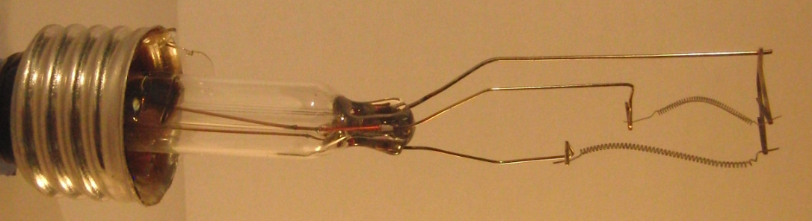An incandescent 3-way bulb provides 3 levels of brightness by the use of two filaments within the bulb (see figure 1). A low power setting is achieved by lighting a high resistance (low current) filament. Medium power is achieved by lighting a lower resistance (more current) filament. High power is achieved by lighting both filaments simultaneously.

Figure 2 shows the bottom of the bulb contains two metal connections, one leading to each filament. The threaded side of the bulb connects to the neutral wire. Figure 3 shows a regular socket (left) vs. a 3-way socket (right). Both sockets have a brass flap that contacts the center of the bottom of the bulb. The 3-way socket contains an extra connector that touches the extra metal ring on the bottom of the 3-way bulb.

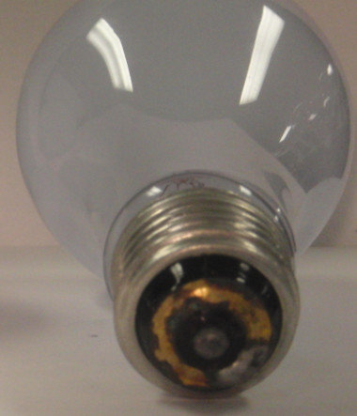

Figure 1

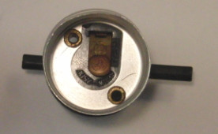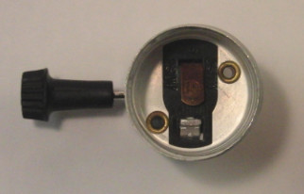

Figure 2

Figure 3

The switch inside a 3-way socket (figure 4) contains a rotating disc that is ¾ metal and ¼ plastic insulator. Each click of switch rotates the center disc 90o. When the plastic fourth contacts the incoming “hot” wire from the socket, the bulb is off. The first click rotates the plastic quadrant to the low resistance filament, leaving it off and connecting the hot wire to the high resistance filament. The second click rotates the plastic quadrant to the high resistance filament, turning it off and the low resistance filament on. The third click rotates the plastic piece out of the way, so that the three metal quadrants connect the hot wire to both filaments.

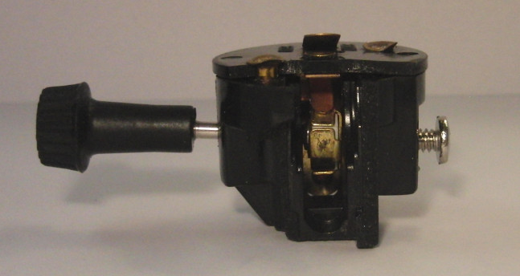

Figure 4

**3-Way Bulb Activity: Discussion, Modifications and Extensions**

At the onset, many interesting and plausible hypothesis emerge amongst the class. The most common initial hypothesis is that there are 3 filaments contained within the bulb. I always ask students to clearly indicate how 3 filaments offer 3 distinct levels of brightness; for within the “3 filament” theory there are two distinct variations. Some students believe the first click of the switch lights one filament, the second click lights an additional filament, and the third click lights three filaments at once. A similar theory is that the first click lights one filament, the second click lights a second, brighter filament, and the third click lights a third, brightest filament in a one-at-a-time fashion. Both of these theories have merit and can only be changed by careful investigation of the bottom of the 3-way bulb and the 3-way lamp socket (only 2 inputs to the bulb). Another common initial theory is that there are 3 different resistors in the 3-way lamp socket that allow 3 different amounts of current into the bulb. This theory suggests an ordinary light bulb would work in a three way lamp. While plausible, this theory is quickly debunked by investigation of the 3-way bulb or socket, or testing of a regular bulb in a 3-way lamp.

Some students quickly deplete their budget on several experiments and fail to note significant features of a 3-way bulb or socket. These students often stand by an incorrect theory. Out of money and still not sure how the bulb works inside, these students often congregate around the electricians digest, waiting for information from other groups experiments. I encourage them to read as much information from others as possible to try to support or disprove their hypothesis.

Some students reach wrong conclusions from observations during various experiments. I have seen some students think that the two connections on the bottom of the 3-way bulb and the treaded side of the bulb provide three ways for electricity to get in, “proving” a three-filament model. These mistakes usually come out during whiteboarding session through rich dialog between students. Two or more groups may observe the same thing and infer different meaning from the same observation. Usually, the class reaches a correct conclusion during the resulting discourse.

In some instances, I have provided a mix of 30/70/100 W bulbs (figure 5) and 50/100/150 W bulbs (figure 6). Some clever students pick up on the fact that the maximum wattage of the 3-way bulb is the sum of the first two. Students only look at one bulb experimentally but often read through the Electrician’s Digest that others have observed different wattages on the bulb. Instructors may choose to use all the same bulb or intentionally mix in some of each. 50/100/150 W bulbs seem to offer less of a hint along this line of reasoning.

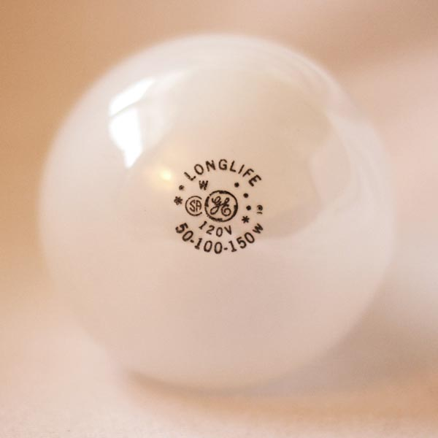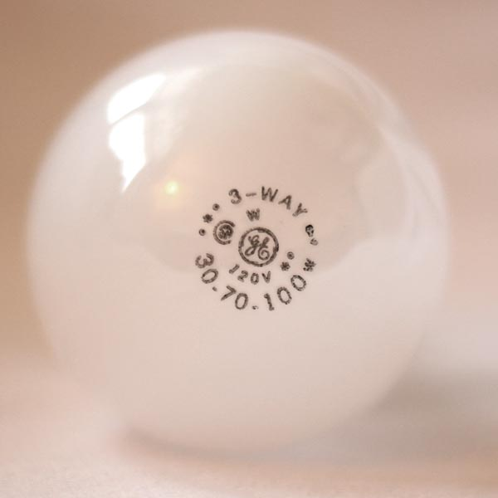

Figure 6

Figure 5

I recommend using bulbs that are heavily frosted to prevent seeing inside. Some students attempt to hold the bulbs up to the lights or windows to see inside. I quickly protest such behavior and insist they examine the exterior of the bulb only.

The 3-way bulb activity can be extended to include discussion of the resistance of each filament and the current through each filament, the electrical energy and power consumed by each filament, and the parallel configuration of the two filaments.

The intricate detail of the 3-way switch is fascinating to some students and beyond the grasp of others. I typically direct the more advanced students in the class who may finish early to figure out the details of the switch.

**Conclusion:**

The 3-way bulb activity offers teachers a unique opportunity to observe their students as they assume the role of scientist. I find many of my ‘difficult to engage’ students open up and participate much more than usual. Having students work together in a small group encourages discourse associated with planning what experiments to perform and the conclusions drawn from those experiments. I find many of students enjoy the puzzle associated with the activity and learn a lot about the scientific process, as well as simple circuits.

**Appendix A: Batteries and Bulbs Student Worksheet**

|  |  |  |  |  |
| --- | --- | --- | --- | --- |
| 1 (No wires)  **+**  Prediction: Y or N  Observation: Y or N | 2 (One wire)  **+**  Prediction: Y or N  Observation: Y or N | 3 (One wire)  **+**  Prediction: Y or N  Observation: Y or N | 4 (One wire)  **+**  Prediction: Y or N  Observation: Y or N | 5 (One wire)  **+**  Prediction: Y or N  Observation: Y or N |
| 6 (Two wires)  **+**  Prediction: Y or N  Observation: Y or N | 7 (One wire)  **+**  Prediction: Y or N  Observation: Y or N | 8 (Two wires)  **+**  Prediction: Y or N  Observation: Y or N | 9 (Two wires)  **+**  Prediction: Y or N  Observation: Y or N | 10 (Two wires)  **+**  Prediction: Y or N  Observation: Y or N |

**Appendix B – Batteries and Bulbs Student Worksheet p.2**

Label all of the parts of a light bulb. Also write if the part is an insulator or a conductor.

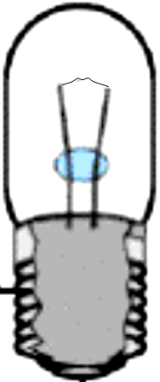

In the following diagram use a colored pencil, crayon, or marker to carefully follow the path of conductors from one side of the battery to the other:

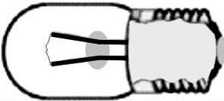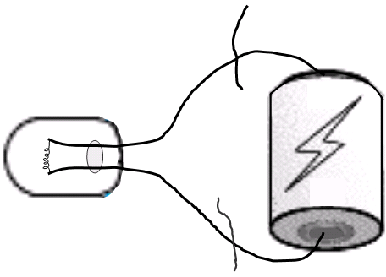

**Appendix C: 3-Way Bulb Activity Sheet p.1**

Name _________________________ Date ________________ Period ______

**Purpose:** You must develop and test a hypothesis about how a 3-way bulb works. Your goal is to develop a theory backed by evidence about the inner wiring of the bulb.

**Introduction:** Design and then perform experiments as necessary to test your hypothesis. You must pay to perform each desired experiment. Simpler “oberservational” experiments are cheaper while more complex experiments are more expensive. To further your abilities of scientific deduction, **you may NOT break open a 3-way bulb for any reason.** The internet or reference books are also strictly prohibited. In this spirit of conducting “real” science where the “right answer” is not yet known, do NOT cheat!

**Requirements:**

* Develop a hypothesis about how a 3-way bulb operates. Record your initial hypothesis in the box provided.
* Design experiments are necessary to test your hypothesis. (Most likely experiments will be observational in nature.) Describe your experiment in the box provided on the experiment log provided.
* Describe in as much detail as possible your observations and conclusions from each experiment performed.
* In the final box, indicate whether the evidence supports your current hypothesis or suggests formulating a new and different hypothesis.
* Electricians Digest: You may submit your findings to the Electrician’s Digest journal. The journal is a collection of experimental results that will be spread out on a lab table for all to see. Quality submissions will be rewarded with a $500 payment.
* **Fictional operating Budget = $5,000**
* You will work in groups of two.

**Getting Started:** For example, your first experiment could be to look at a 3-way bulb. Explain the experiment on your “Experimental Log” sheet and then get a price quote and permission from your teacher. The amount of time you have to perform the experiment may be limited, so work fast and record observations on paper to be analyzed after the experiment. Think of any experiment you would like to perform. Some may not be possible due to cost or equipment considerations, but this is very true in the real world as well.

**Appendix D: Experiment Log that students complete for each experiment done.**

Experiment Log Names:

|  |  |
| --- | --- |
| Current Hypothesis |  |
| Experiment Description |  |
| Observations / Drawings |  |
| Conclusion |  |
| Supports current hypothesis or suggests a new hypothesis? |  |

**Appendix E: Submission form for Electrician’s Digest**

Names:

|  |  |  |
| --- | --- | --- |
| **Experiment Description** | **Observations / Drawings** | **Conclusions** |
|  |  |  |

**Appendix F: Recommended experimental “costs”**

Hypothetical Operating Budget = $5,000

|  |  |
| --- | --- |
| **Experiments** | **Cost** |
| Look at a regular bulb | 1000 |
| Look at a 3 way bulb | 1500 |
| Look in a regular lamp with bulb removed | 1000 |
| Look in a 3-way lamp with bulb removed | 1500 |
| Plug in and test a regular bulb | 1000 |
| Plug in and test a 3-way bulb  (keep the shade on, otherwise filaments are visible) | 2000 |
| Look at a 3 way switch  (Attempted cut-away of inside the switch. Pieces were removed in an attempt to see inside the switch mechanism.) | 2000 |
| Using a multi-meter in conjunction with any other experiment. (appropriate for more advanced classes) | 500 |
| Plug in and test a 3-way lamp with a regular bulb installed (shade on) | 2500 |
| Plug in and test a regular lamp with a 3-way bulb installed (shade on) | 2500 |
|  |  |
| Payment for journal submissions | 500 |

References

Arons, A. B. (1997). *Teaching Introductory Physics*. New York: John Wiley & Sons, Inc.

Borges, A. T., Tecnico, C., & Gilbert, J. (1999). Mental models of electricity. *International Journal of Science Education, 21*(1), 96-99.

Burrowes, P. A. (2003). Lord's Constructivist Model Put to a Test. *American Biology Teacher*, 491-502.

Burrowes, P. A. (2003). A Student-Centered Approach to Teaching General Biology That Really Works: Lord's Constructivist Model Put to a Test. *The American Biology Teacher, 65*(7), 491-502.

DiCarlo, S. E. (2009). Too much content, not enough thinking, and too little FUN! *Advances in Physiology Education, 33*, 257-264.

Driver, R., Asojo, R., Leach, J., Mortimer, E., & Scott, P. (1994). Constructing scientific knowledge in the classroom. *Educational Researcher, 23*, 5-12.

Evans, J. (1978, January). Teaching electricity with batteries and bulbs. *The Physics Teacher*, 15-22.

Jabot, M., & Henry, D. (2007). Mental Models of Electricity and Middle School Students in Analyzing Simple Battery and Bulb Circuits. *School Science and Mathematics, 107*(1), 371-381.

Learning about learning: Activity 4 hw reading. (2007). In *Physics and Everyday Thinking* (pp. 55-56). Retrieved from http://petpset.its-about-time.com/pettg/c4/a4hw/targetideas.html

Liegeois, L., Chasseigne, G., Papin, S., & Mullet, E. (2003). Improving high school students' understanding of potential difference in simple electric circuits. *International Journal of Science Education, 25*(9), 1129-1145.

Liegeois, L., Mullet, M., & Mullet, E. (2002). High school students' understanding of resistance in simple series electric circuits. *International Journal of Science Education, 24*(6), 551-563.

Lujan, H. L., & DiCarlo, S. E. (2006). Too much teaching, not enough learning: what is the solution? *Advances in Physiology Education, 30*, 17-22.

MacIsaac, D. (n.d.). *Whiteboarding in the Classroom*. Retrieved from http://physicsed.buffalostate.edu/AZTEC/BP_WB/index.html

McDermott, L. C., & Shaffer, P. S. (1992). Research as a guide for curriculum development: An example from introductory electricity. Part I: Investigation of student understanding. *American Journal of Physics, 60*(11), 994-1002.

Michael, J. (2006). Where's the evidence that active learning works? *Advances in Physiology Education, 30*, 159-167. doi:10.1152/advan.00053.2006

Prakash, E. S. (2010). Explicit constructivism: a missing link in effective lectures? *Advances in Physiology Education, 34*, 93-96.

Shaffer, P. S., & McDermott, L. C. (1992). Research as a guide for curriculum development: An example from introductory electricity. Part II: Design of instructional strategies. *American Journal of Physics, 60*(11), 1003-1013.

Volpe, E. P. (1984). The Shame of Science Education. *Americal Zoologist, 24*(2), 433-441.