Physics of Discus, Hammer Throw and Shot Put

by
Stephen W. Hassard

Submitted in Partial Fulfillment
of the Requirements for the Degree of

Masters of Physics Education

Department of Physics

State University of New York College at Buffalo
Buffalo, New York

Acknowledgements: This paper is submitted in partial fulfillment of the requirements necessary for PHY690: Masters Project at SUNY – Buffalo State College under the guidance of Dr. Dan MacIsaac.

Abstract
The importance of physics in the sport of track and field is paramount. Individual success in throwing events, such as discus, hammer throw, and shot put, are strongly influenced by the angle of release, exit velocity, and height of release. This paper focuses on how utilizing these variables will in turn improve the athlete’s performance. Questions and materials such as lab activities and worksheets will align with the New York State Physics Regents and NYSSLS. These materials can be developed using a variety of athletic activities as central ideas and examples of phenomena. Students can be inspired by topics including momentum, forces, and circular motion as they become more knowledgeable about how science and physics specifically control the basic movements in their sports. Student athletes can also be led to calculate and understand many different sports.

Stephen Hassard is a physics teacher in Nassau County, New York. He earned his bachelor's degree in Earth and Atmospheric science from the University of Albany and is currently finishing his M.S.Ed (Physics) degree at SUNY Buffalo State. While completing his undergraduate degree, Stephen competed for the track and field team and followed this passion as a coach at the high school and division one level. Stephen’s goal is to bring athletics to the classroom through an exploration of the science behind physical movement.

Introduction
In the last 50 years track and field has evolved due to the development of video analysis and observations in biomechanics. Athletes have increased their individual distances and achievements through the science of biomechanics. Throwing events, in particular, have seen substantial improvements due to the increased understanding in aerodynamics and biomechanics. In all throwing events, the distance is determined by the angle of release, exit velocity and height of release (Frohlich, 2006) and physics can be used to examine one or all of these three variables (Raafat, 2012). In sports it is critical for athletes to know that the longer time a force can be applied, the greater the final acceleration. There is a limit to this concept when it comes to throwing events that correlate with a specific number of turns spun by the athlete (Atwaa, 2019). The ideal release angle is under the commonly accepted 45º because of the effects of air resistance and wind (Ecker, 2015). Finally, height plays an important role in all of the throwing events and it can be clearly identified that the tallest throwers have an advantage. This paper will attempt to explore how each of these variables impact throwing (Dai, Leigh, Li, Mercer, & Yu, 2012) as well as how sports can be utilized in the classroom as a teaching tool (Frohlich, 2006).
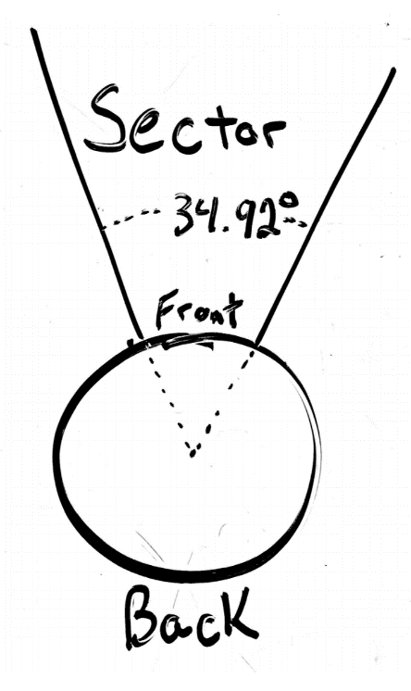
The New York State Education Department Regents Physical / Physics core curriculum demands students that students collect, analyze, represent and interpret data collected relating to the study of motion (http://www.nysed.gov/common/nysed/files/programs/curriculum-instruction/p-12-science-learning-standards.pdf). Athletics provide endless data in the field of mechanics and aerodynamics although collecting this data can be difficult. The use of video capture technology is used to measure variables such as velocity, acceleration and distance. Students can explore the forces of measured quantities. Students can also use video capture of throwing events to develop valuable visual and mathematical models. The future of the state assessments indicate that models will be more heavily weighted in the grading of said assessments.
Figure 1: Throwing circle with sector

Discus, shotput and hammer throw are all similar to each other in that they all require hurling a mass as far as possible. Athletes are allotted a limited space (referred to as the circle) to accelerate and throw their implement. The implement must then land within an assigned sector to be considered a legal throw. The sector is 34.92º wide and the circle is 2 meters in diameter. An athlete must not step foot outside the circle during the throwing motion and if an athlete throws outside the sector, it is a foul and the throw will not be counted. All athletes get a minimum of three throws with the potential of three more throws in finals (Ecker, 2015).
2 m

The implements and basic throwing strategy.
- Discus: the discus is a metallic circular implement that has a mass of 1kg for women and 2kg for men. An athlete starts at the back of the circle and spins around until they reach the front of the circle where they release the discus. (Ecker, 2015).

- Shotput: the shot has mass of 7.26 kg (16pounds) for men and 4 kg for women. Shotput is similar to discus as athletes must stay within the designated circle and release the shot. Unlike discus, there are two competing throwing techniques known as the glide and the spin. (Ecker, 2015).
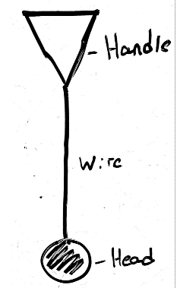
Figure 2: Components of a hammer
- Hammer throw: The Hammer is made up of three parts: the hammer, the wire and the handle. The masses for the hammer are the same as the shotput. In the hammer throw athletes spin 3 or 4 times to reach the front of the circle where they will release. (Ecker, 2015).

Throwing vocabulary.
- Power position – The most important stage of any throw. The Power position is the final position in discus and shot put before the implement leaves the athlete’s hand. This is where a large portion of the overall momentum is developed.
- Back of the circle – The area of the circle farthest from the sector. This is where the throw begins.
- Single support – When only one leg is in contact with the ground.
- Double Support – When both feet are in contact with the ground.
- Standing throw - When discus throwers warm-up they often perform multiple standing throws which has the athlete focus mostly on the power position portion of their throw.

Discus
Discus release angle and release velocity.
Figure 3: Launch angle and exit velocity Photo by Stephen Hassard
Asking a high school physics student for advice on how to increase the distance produced by a discus throw would develop predictable answers. The student would likely suggest increasing the release velocity and throw at an angle of release 45º. These suggestions neglect to consider air resistance and lift. In real-world applications, aerodynamics are an important area of study for athletics.
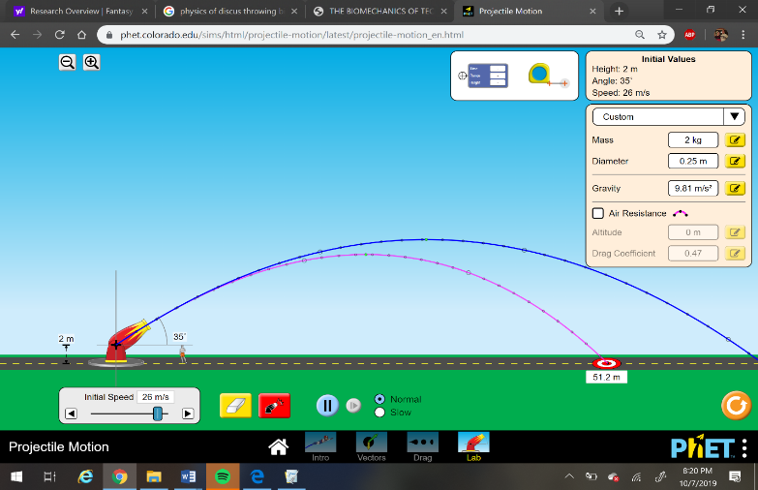
Using Logger Pro 3.8, I was able to analyze a video of myself and find approximations for both release angle and velocity in figure 3. For velocity I found a rough estimate to be 26 m/s just before the disc is released. A simulation was performed to check the values obtained. (https://phet.colorado.edu/en/simulation/projectile-motion). The simulation returned a distance very similar to when I was throwing at the time of the video. I was also able to measure my launch angle, which was approximately 36º. The suggested ideal release angle for a discus is between 35º and 40º depending how far the athlete throws as air resistance is proportional to the velocity squared. This explains why high-level throwers, like Olympians, bring their angle down closer to 35º to optimize distance.
Figure 4: https://phet.colorado.edu/en/simulation/projectile-motion

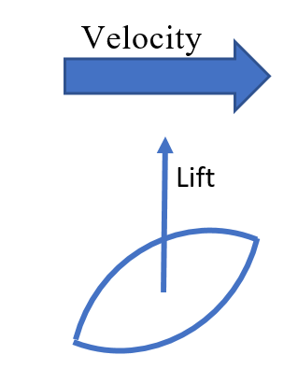
Role of Air Resistance in Discus?
Unlike most sports, a tail wind is disadvantageous and in fact pushes the wing shaped discus downward, lowering the height, and leading to a shorter flight time and horizontal distance. Discus throwers prefer a head-on wind to increase relative speeds. This concept can be seen when aircraft carriers turn into the wind when launching planes. The effects of relative velocities can be calculated below v_{relative} = v_{discus} – v_{wind}
wind aiding v_{wind}= 12m/s
v_{relative} = v_{discus} – v_{wind}
v_{relative} = 26m/s– -12m/s
v_{relative} = 38 m/s
No wind aiding
v _{discus} = 26m/s

F_{g}

Figure 5: Side view of discus in flight.
$$Lift= \frac{C_{L}ρAv^{2}}{2}$$
$$Lift= \frac{\left(0.41\right)\left(\frac{1.225kg}{m^{2}}\right)3.8x{10}^{-2}m^{2}{(38m/s)}^{2}}{2}$$
$$Lift= 13.78 N$$

$$Lift= \frac{C_{L}ρAv^{2}}{2}$$
$$Lift= \frac{\left(0.41\right)\left(\frac{1.225kg}{m^{2}}\right)3.8x{10}^{-2}m^{2}{(26m/s)}^{2}}{2}$$
$$Lift= 6.45 N$$

Figure 6: Calculations of lift for discus with and without wind

Given an increase of 72% in the discs’ relative velocity, there is an increase of 113% in lift, in effect giving the discus a higher height and longer range. Theoretically, there must be an asymptotic relationship between effective lift and head-on wind speed. Eventually, the wind resistance will be too great to be helpful (Maheras, 2016). Discus throwers dread tail winds for the exact opposite reason they desire head winds, as the discus will be pushed downward.

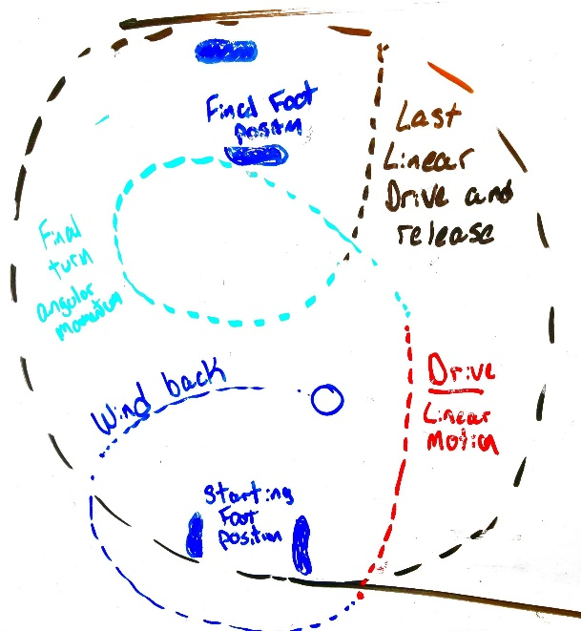
Path of the discus and transfer of momentum
A discus circle is only 2.5 meters in diameter but when the discus is thrown correctly it will travel a distance in the circle of almost 10 meters during its rotational path. In figure 7, the red and black portion of the path shows a mostly linear path. The black portion of figure 7 is the most vital part of throwing. This is where all linear and angular momentum must be transferred to the discus. During a standing throw, an athlete can throw approximately 70 % the distance of a normal full throw. This should mean that they can only achieve 70% of the release velocity and final momentum. A rocket launch is analogous to a discus throw. The initial booster rockets initiate movement similar to the turn (blue, red and green portion of figure 7). In the discus throw, the main engines would be the power position (black section of figure 7). The main purpose of the booster stage is to make the job of the main engines easier. Similarly, the main purpose of the spin is to make the power position easier for an athlete. Below are equations to demonstrate how much momentum is gained in the last moments of throwing in the power position.
Momentum at release
$$p= mv$$
$$p=(2kg)(26m/s)$$
$$p= 52\frac{kgm}{s}$$
$$s$$
Angular momentum
$$L= Iω$$
$$L=(11m/s)(1.6kgm^{2})$$
$$L= 17.6\frac{kgm}{s}$$
$$s$$

Impulse from final position
$$J= ∆p$$
$$J=\frac{52kgm}{s}-\frac{17kgm}{s}$$
$$J= 34.4\frac{kgm}{s}$$

Figure 7: Discus path

Figure 8: Calculations of momentum throughout a discus throw.

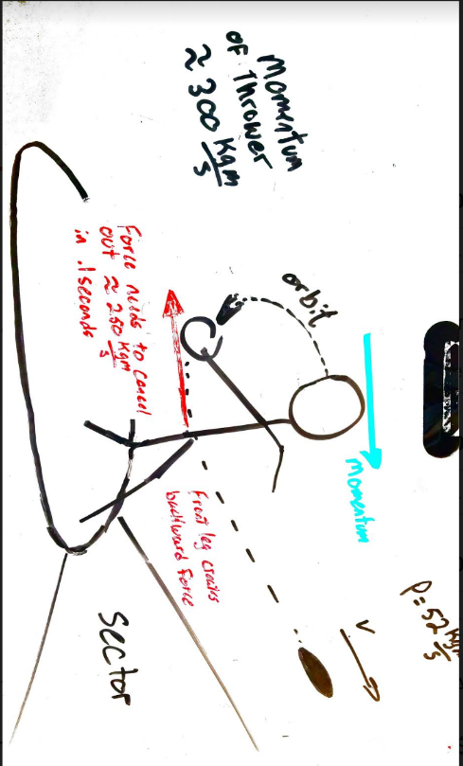
The goal of a discus throw is to generate momentum and attempt to transfer as much as possible to the discus. Discus throwers often come to a nearly complete stop; a discus thrower can generate upwards of 300kgm/s far too much to be canceled out by the 52 kgm/s given to the discus. Throwers must create an impulse backwards to eliminate the excess momentum. If they are unable to do so, they will foot foul out at the front of the circle. After the release of the discus throwers can lose the excess momentum by continuing to turn, known as a “reverse”. A thrower can only generate force when their feet are in contact with the ground. This takes up only 40% of the total throw time (Ecker, 2015). To prevent a thrower from fouling out of the front of the circle, they must also provide a large backward force.
Figure 9: Momentum in final position

Number of turns in discus
The 1.5 rotational turns equates to approximately 540 degrees. The idea of increasing the number of turns should cause some hesitation. There is currently a balance of angular and linear momentum. With an addition of another 180 degrees, athletes will increase the angular distance that the discus will travel in the circle and be able to provide a longer force. One study explored the benefits of what hammer throwers call a toe-turn addition and how it would affect the distance of the throw for a decathlete (Atwaa, 2019). A toe-turn allows a thrower to do a full 360 degree rotation without moving linearly through the circle. Dr. Atwaa found that a 66% increase in rotational path length led to an overall increase of 6% in throwing distance. This modified technique changed the release angle from 41º to a much lower 30º while also significantly increasing the exit velocity. As of 2019, no elite discus throwers have adapted the 2.5 turn technique, although some are experimenting with other modified turns.

Height advantages
Shotput
The shotput and discus share many similarities including the idea that the most important part of the throw is the power position and everything prior serves only to create a better, more efficient power position (Raafat, 2012. The launch angle is below 45º for a variety of reasons. Air resistance does not play as big of a role in shotput, but the release height is an issue. Considering the difference in release height and landing height is a much bigger percentage of max height, the angle must be reduced to 40º - 42º. Unlike the discus, where there is one agreed upon way of throwing which requires a spin, the shotput has two competing approaches. The one consistent goal for both techniques is to get into the power position. Both the glide and the spin technique offer different benefits to different types of throwers.

Glide Technique
$$m=7.26 kg$$
$$time= 0.13 sec$$
$$∆v=\frac{9m}{s} \\ F=ma$$
$$F=\frac{m∆v}{t}$$
$$F=\frac{7.26kg (9m/s)}{0.13s}$$
$$F=503N$$

Figure 10: Calculation of average force applied to shot
The glide technique is found to be more useful for two types of throwers who can be defined as novice throwers and tall throwers. The glide is generally the easier of the two techniques to learn so it is often the first way athletes are exposed to the shotput. The glide is easier because it forces athletes to end up in the power position and has less room for error. Unlike the spin technique, the glide has a lot more development of linear momentum. The thrower no longer must worry about converting angular momentum to linear momentum and can focus on moving as fast as possible through the circle, rotating the hips 180º and releasing. David Storl (World champion shot putter from Germany) can move across a 2-meter circle in 0.4 seconds giving him and the shotput a velocity of
5 m/s. When the shot exits his hand, it’s moving approximately 14m/s. In the final 0.13 seconds the shot’s velocity increases by
9 m/s, so a quick force calculation proves that professional shot putters can produce forces of 500 Newtons in the final moments of a throw.

Spin Technique for Shot Put
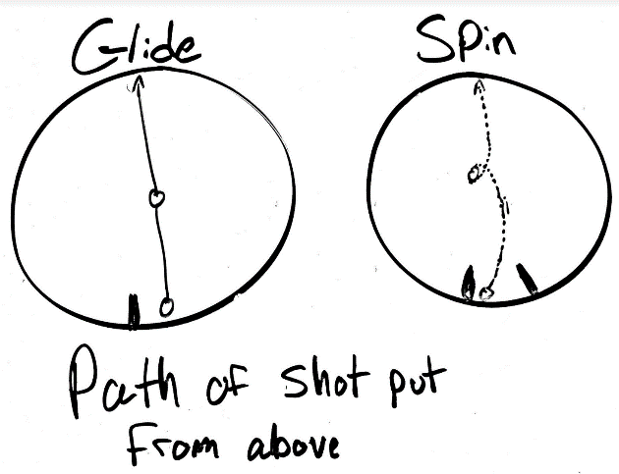
Most American shot putters adopted the spin technique in the 1970s. Marks began to quickly increase, and explanations began to develop about these advances. The original belief was that like the discus, the spin forced the implement to travel a greater distance. The idea that the shot was traveling a greater distance and therefore could be accelerated for a longer time was proven false shortly after. When viewed from above the shot’s path seemed to be extremely similar therefore it was not the source of the improvement (Ecker, 2015). In the spin, the shot putter’s center of mass changes because of the mass of the shot and it appears as if the athlete’s body rotates around the shot. This ability to rotate gives the athlete the ability to use different muscle groups of the body, specifically in the chest. Shot putters quickly started to adjust preparation to include a focus on the chest.
Figure 11: Path difference between glide and spin

Conclusion between glide and spin
(Ecker, 2015) suggests that the limit of the spin technique might not have yet been reached, but that the glide has plateaued in the last couple of decades. While the spin offers an advantage in generating momentum and eventually velocity, it also creates more opportunities for error, while the glide is far more consistent. It is common for a spin technique shot-putter to foul half of their throws, while a glider might be able to have all six of their throws measured. Because of the reliance of natural human levers for the glide, taller athletes should fare better in the glide than the spin. For everyone else, the spin technique allows individuals to make up for the lack of long levers by keeping a lower center of mass through most of the transitional phase and building as the shot it thrown (Luhtanen, 2009).

The Hammer Throw
The hammer throw requires that an athlete rotate three or four times in the attempt to accelerate a 7.26kg steel ball before releasing. The forces involved in the hammer throw are enormous, making it the most dangerous of the three weighted throw events. Aerodynamics play a smaller part in the hammer throw because of its low drag coefficient. Olympic hammer throwers can throw upward of 80 meters because of this. The height of the thrower does not affect the release angle as in the shot put; the release angle is much closer to 45º usually, somewhere between 42º and 44º (Ecker, 2015). The most important objective in the hammer throw is similar to most throwing events; one must achieve the highest release velocity possible. Often these velocities reach 30 m/s. This larger velocity comes with an extremely large force as seen in calculation below. An Olympic class hammer thrower can experience forces over 3200 Newtons (approx. 730lbs) in their hands alone. Hammer throwers wear gloves to protect themselves from extreme forces. Without these gloves, their hands would most certainly be damaged after every throw.

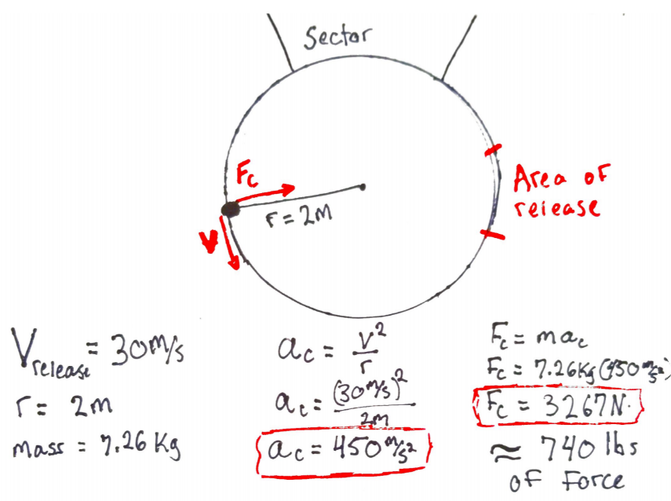
Three Turns vs. Four Turns
Figure 12: Calculations for Centripetal forces for hammer throw
As the hammer throw evolves, athletes have been finding more effective ways of generating force. In the shotput most Olympic class throws have switched to the spin over the antiquated glide technique. Similarly, in the hammer throw, athletes have moved towards adding another turn to the original three-turn technique. Instead of covering the 2-meter distance across the circle in three turns, athletes have reduced the distance of each turn from 65 cm to about 50 cm allowing them enough room for an additional turn. This additional turn comes with some clear advantages and some hidden disadvantages. The most blatant advantage is the reduction of average force over the entire throw; athletes achieve approximately the same release velocity but have more angular distance to accelerate. This, in effect, reduces the average angular acceleration, which will in turn reduce the required force. A study in Japan was conducted using seven four-turn throwers in the final of the 2009 world championship. The average period of revolution for a four-turn world-class athlete is 2.04 seconds. That is 24% greater than a three turn throwers average period of 1.65 seconds (Hirose, 2019). The hammer would have a moment of inertia value of approximately 29 kgm². Illustrated below, the average torque required for a three-turn thrower was significantly higher than a four-turn thrower. In the hammer throw, one foot remains in contact with the ground for the entire length of the throw while the other leaves and makes contact each turn. This explains why the four-turn technique might have the advantage. Only when both feet are on the ground is there an ability to generate more angular momentum. Therefore, with an additional turn, there is greater overall momentum in the hammer-thrower system.

Number of turns | Degrees of revolution | Time elapsed (sec) | Rotational acceleration | Average Torque
3 | 1080 | 1.65 | 9.1 rad/s² | 264 Nm
4 | 1440 | 2.04 | 7.4 rad/s² | 206 Nm
Table 1: Comparing 3-turns and 4-turns using values obtained from video analysis software for the hammer throw. Video by Stephen Hassard.

Portion of cage closed for right-handed thrower

Figure 13: Closed section of hammer cage

Technique Issue – Fouls and Numbers of Attempts
Due to the high velocities and larger forces associated with the hammer throw, cages are modified to reduce the danger to bystanders. Cages have two gates in the front a left side and a right side, for right handed throwers the left gate is shut as to not allow significant sector fouls. This limits the throwers opportunity to throw with in the sector slightly. There is only an available arch for release of 36º for hammer throwers with the cage closed, and with the ball moving at 30m/s. In figure 13 the red circle represents the actual orbit of the hammer with the athlete is in their fourth turn, the blue arrow represents the latest the thrower can release, and the green arrow is the earliest thrower can release to have a legal throw.
Figure 14: Common throwing circle

Limitations and future of the sport
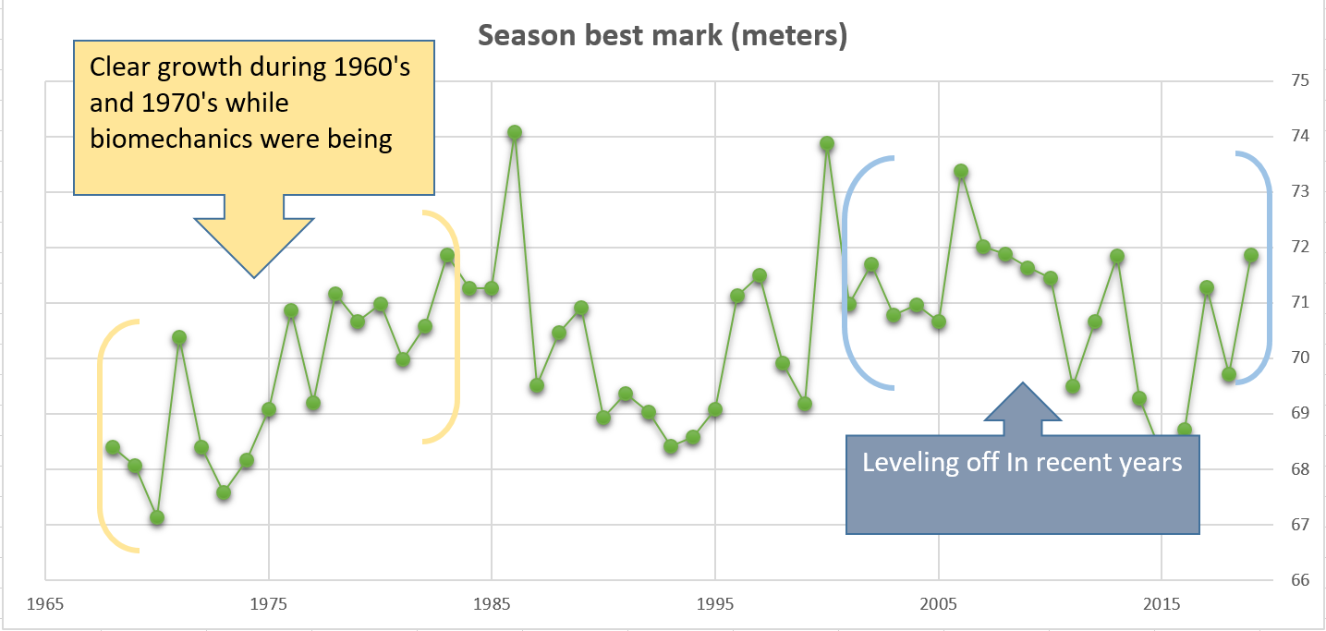
The men’s world records for discus, shot put and hammer were all set at the height of the scientific revolution for sports (Berthelot, et al., 2010). This revolution took place while performance-enhancing drugs were relatively difficult to test for athletes. Some experts in the weighted throws believe that these records may never be broken for a variety of reasons such as the body's physical limit and plateauing in biomechanics.
Figure 15: Seasons best discus throw for men from 1967-2019 data taken from https://en.wikipedia.org/wiki/Discus_throw#Men_4

Figure 14 illustrates the best throws of the year for the last 50 years in the discus. What is seen in discus has also happened in the hammer throw and less drastically in the shotput. A study done on a variety of individual sports found that the most recent and possibly final peak performances for track and field took place in 1988.

Conclusions
The increased understanding and application of biomechanics and physics in sports has led to major improvements in individual performances. A greater number of athletes can be seen throwing with consistency rather than a more sporadic world record throw. It seems fair to conclude, in the case of discus throwers, althetes have reached a pinnacle of performance. Although a peak may have been found in distance it is possible to see more and more throwers going over the coveted 70-meter mark because of this better understanding of the sport. As for the four-turn technique in the hammer throw and spin technique in shotput, it appears that these newly invented methods have provided throwers with a beneficial variation. The variation can be used by a large population of throwers. The increased understanding of aerodynamics has also led to the bettering of the sport; it is evident that the discus has been most affected by these revelations. Shots and hammers being spherical has made the aerodynamic lift much less severe than that of the discus. For discus and shot, sub-45º angles are optimal but for completely different reasons, discus being for aerodynamics and shotput because of how different initial height and final height trajectories work.
As an athlete in college competing I was unable to rely on some of the natural advantages such as height so I found myself resorting my advantages such as my understanding of forces, aerodynamics and motion. I was lucky enough to have a coach in college that taught physics so we were able to explore ideas that would have been difficult alone. I am glad to have had the opportunity to compete at such a high level and experiment with different techniques that pushed the limits of the body. Track and field has also provided me with countless examples and analogies for the physics classroom. With the NYSSLS, an increase of phenomenon-based learning and modeling is going to be required of high school students. I have developed worksheet and various examples using throwing events as the subject of questions. Students have positivity responded to these activities and ideas as they can clearly see my own excitement when teaching with these materials and they respond with their own enthusiasm. Student-athletes respond particularly well, as they try to take their own sports and come up with ways to quantify and analyze their movements and performance. I have had students try to calculate the difference in force between a tackle in football and a tackle in rugby with video analysis. Seeing students try to create their own real-world physics problems with the goal to solve them, has been an incredible rewarding benefit.

Appendix A
Using Discus, shotput and hammer throw in high school physics as real world phenomenon
Throwing events can act as real world phenomena, it can be used to help emphasizes acceleration, projectiles, forces, circle motion, torque and more.
Questions developed for high school physics using the hammer throw
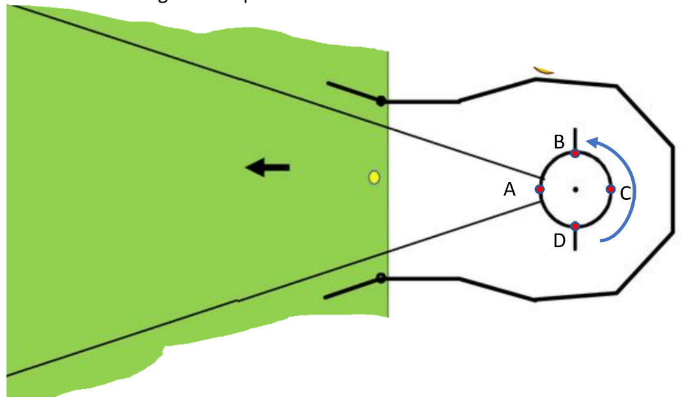
- At which point should the hammer be released so that it lands within the sector?

SECTOR

- A
- B
- C
- D

- A hammer thrower turns a 7.26 kg ball in a circular path with radius 2 meters with a tangential velocity is 22 m/s
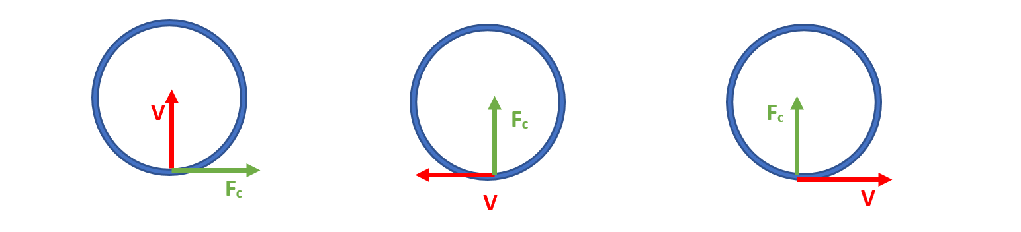
  - Which diagram best represents F_{c} and v for the situation above at position d?

  - Calculate the centripetal acceleration of the hammer $$a_{c}= \frac{v^{2}}{r}$$
$$a_{c}= \frac{{(22m/s)}^{2}}{2m}$$
$$a_{c}=\frac{242 m}{s^{2}}$$
  - Calculate the centripetal force of the hammer$$F_{c}= {ma}_{c}$$
$F_{c}=(7.26kg)(\frac{242 m}{s^{2}}$)
$$F_{c}= 1757N$$

Bibliography
- Berthelot, G., Tafflet, M., El Helou, N., Len, S., Escolano, S., Guillaume, & Hermine, O. (2010). Athlete atypicity on the edge of human achievement: performances stagnate after the last peak, in 1988. PloS one, 5(1).

- El Monsef, R. A., Salem, M., El Shaeer, O., El Baky, A. A., Abd, M., Hameed, E., ... & Ghazy, T. Biomechanical Analysis of Top Discus Throwers Performance in Egypt.

- Atwaa, M. (2019, January 2). A Better Way To Throw The Discus? Track & Field.

- Ecker, T. (2015). Basic track & field biomechanics. Tafnews.

- Dai, B., Leigh, S., Li, H., Mercer, V. S., & Yu, B. (2013). The relationships between technique variability and performance in discus throwing. Journal of sports sciences, 31(2), 219-228..

- Frohlich, C. (Ed.). (2006). Physics of sports: selected reprints. American Association of Physics Teachers..

- Luhtanen, P., Blomqvist, M., & Vänttinen, T. (1998). A preliminary study of rotational shot put technique. In ISBS-Conference Proceedings Archive.

- Hirose, K., Byun, K. O., & Maeda, K. (2016, November). The Relationship Between The Duration Time of Turn and the Throwing Record in Men’s Hammer Throw. In ISBS-Conference Proceedings Archive.

- NGSS Lead States. (2013). Next Generation Science Standards: For states, by states. Washington, DC: The National Academies Press

- Maheras, A. (2016). Long Distance: Basic Aerodynamics and Flight Characteristics in Discus Throwing. Techniques for Track & Field and Cross Country, 9, 8-20.

