Enhancing Student learning using Computer Simulations with Modeling Instruction when Teaching High School Physics

Mark Niedziela

State University College of New York at Buffalo

Acknowledgments
This manuscript was completed for PHY 690 Masters Project at Buffalo State College Department of Physics Education under the guidance of Dr. Dan MacIsaac.

Abstract
This paper reviews existing literature which supports the use of student-centered, conceptual model based, inquisitive instruction and the use of computer simulations in teaching high school physics. Conclusions are drawn regarding the use of computers simulations as an initial exposure to conceptual models before more traditional instruction and laboratory experiments and presented. Examples of computers simulations used in this context are given from high school physics instruction.

Introduction
Research has shown student-centered, inquiry based instruction which promotes conceptual models is beneficial in the classroom (Hake, 1988; Gomez, 2008; Jackson & Ash, 2012; Thornton & Cummings, 1999; Brna, 1987; Hake, 1997; Stratford, 1997; Pardo, 2010; Jimoyiannis & Komis, 2001; Sarabando, Cravino & Soares, 2014). Modeling Instruction is a particular method of instruction which incorporates these ideals.
Additional research has shown how computer simulations can be used to replace or supplement science classroom laboratory experiments (Jimoyiannis et al., 2001; Jackson, 2008; Brna, 1987; Bryan, 2002; Jimoyiannis & Komis, 2000; Holec, Spodniakova, Pfefferova & Ragonova, 2004; Finkelstein, 2005; Pardo, 2011; Sari, Hassan, Guven & Sen, 2017). Because Modeling Instruction traditionally introduces a concept with a demonstration or laboratory to help the student construct the best conceptual model, using computer simulations for this purpose was investigated (AMTA, 2014; Megowan, 2007).
Current literature was reviewed in the field of student centered, conceptual, inquiry led instruction and the use of computer simulations in science instruction. This literature review, in conjunction with my own experiences teaching New York State Regents physics, honors physics, AP Physics 1 and previously AP Physics B in a private, Catholic, all male high school was used to draw conclusions, determine practical application in theory, show examples, and recommend suggestions.

Pedagogy
Traditional, teacher-centered lecture methods of instruction are not most effective (Mestre, 1991; Mestre, 2001; Arons, 1997; Gomez, 2008; Wells, Hestenes & Swackhamer, 1995). Even students who perform well on standardized textbook type assessments do not necessarily have an adequate conceptual understanding of science topics (Arons, 1997). This is due in part to gaps in background education making the proper formation of new concepts difficult (ibid, P.1). This leads to various student misconceptions (ibid, 1997). Arons also states students have many preconceptions about physics concepts that are deeply rooted and highly resistant to change (ibid, p.56). These incorrect preconceptions make our teaching much less effective (Viennot, 1979). Furthermore, students may not truly understand that which they have been told through traditional lecture methods, because the idea has not been made part of the students' concrete experience (Arons, 1997, p. 3). It has been determined only 10 to 15 percent of students who learn from traditional lecture methods change their conceptual understanding (Hake, 1998).
Carey (2014) argues to mentally struggle through a problem, especially one that is meaningful to the learner not only increases retention in the short run but also improves future problem-solving because the experience allows learners to recognize the meaningful parts that hint at solution. In a study involving chess players, it was shown those who were ranked as grandmaster did not think more moves in advance, nor did they have a memory better than lower ranked players. The study concluded better players were able to recognize positions on the board and link them to plausible solutions; "...extracting the most meaningful set of clues". This comes from experience, making mistakes, and building intuition (Carey, 2014, P.177-178).
“Teaching by telling”, teacher-centered instruction, is not sufficient even by motivated, and dedicated teachers. Likewise, algorithmic solutions such as “plug-and-chug practices” of inserting numbers into formulas does not promote problem solving skills. Students need to construct their own understandings (Wells et al., 1995). Rather, students need opportunities to explore the relationships between ideas (Minstrell & Kraus, 2005).
In general, instruction to formulate new and better conceptual understanding should include interactive engagement of students with hands-on activities allowing for immediate feedback through discussion with peers and/or instructors (Hake, 1998). It has been shown research based, interactive instruction leads to greater conceptual understanding (Thornton et al., 1999). Likewise, many experts agree conceptual models can correct student misconceptions (Brna, 1987; Hake, 1997, Stratford, 1997; Pardo 2010; Jimoyiannis et al., 2001; Sarabando et al., 2014). Students do need a moderate level of structure. It has been observed that students should have an intermediate level of instruction with enough structure to keep them on task as well as the freedom to investigate as needed (Gonzalez-Cruz, 2003). Students should struggle to discover their own conclusions with the help of a guiding instructor (Sari et al., 2017).
Part of the reasoning for “conceptual instruction” is supported by Kolb (1984) who argues learning is a process of stages with feed into each other. These stages include Active Experiment, Concrete Experience, Reflective Observation, and Abstract Conceptualization.

Figure 1: Show the relationship between the Kolb Learning Strategies

According to Kolb, although the cycle can be entered at any stage, all four processes must be present. The similarity with the scientific method which is based on constructing, testing, and revising a hypothesis through experimentation can be seen.
Richard Hake conducted a study that supports the idea of student centered learning by showing interactive engagement methods of teaching produced superior results to traditional teacher centered lecture (Hake, 1988). Likewise, a study performed by Malcolm Wells (1987) showed students who received student-centered, conceptual, inquiry driven instruction outperformed students who received other more traditional types of instruction. Student-centered, inquisitive instruction of a conceptual nature is preferred over traditional instruction because it promotes higher order thinking and not only yields greater results but also leads to greater student retention (Wilson, 2010).

Modeling Instruction
The Modeling Instruction in High School Physics Project originated at Arizona State University was originally supported by the National Science Foundation from 1994 to 2000 and continues to be refined through workshops, publications, and online resources (AMTA, 2014). Model building has been defined as a process where students engage in scientific inquiry to construct models treated as subsets of larger more comprehensive systems (Campbell, Zhang & Neilson, 2011). Modeling instruction, therefore is organized into phases of development, evaluation and application initiated with a demonstration and class discussion followed by students planning and defending their conclusions (AMTA, 2018). In Modeling Instruction, the instructor focuses on helping students construct appropriate mental models of phenomena; students then present and justify their models (Jackson et al., 2007). Modeling Instruction develops a conceptual understanding before moving on to algebraic treatment of problem solving (ibid, 2007).
In addition to the benefits of conceptual instruction, Modeling Instruction has been shown to exceed NSES and other teaching standards and helps students by encouraging cooperation and discourse about complicated ideas in a supportive environment (Jackson et al., 2015).
Similar to the The Scientific Method and the Kolb Cycle, Modeling Instruction focuses on having students develop a hypothesis, evaluate the success of their model, and ultimately use the model in application. “Students have to account for everything they do in solving a problem, ultimately appealing to models developed on the basis of experiments done in class.” (Jackson et al., 2007, P. 14).
A nationwide sample of 7500 high school physics students from 1995 to 1998 showed an increase of 10 percent in post-test results for novice modeling teachers and a significant increase of 56 percent greater for expert modeling teachers (Jackson et al., 2007). Other research is mixed with some showing little or no significant results over less interactive, more traditional methods (Campbell et al., 2011, Ogan-Bekiroglu & Arslan-Buyruk, 2018).

Whiteboarding
Whiteboarding is pedagogical approach where students use whiteboards and dry erase markers in pairs or small groups to work out and solve problems and subsequently share, present, support and defend their ideas and reasoning by presenting to the class (McKagan & McPadden, 2017, Jackson et al., 2007). In theory, whiteboarding is an instrument for improving student discourse (Wells, et al., 1995).
Whiteboarding in useful in Modeling Instruction for many reasons. Whiteboarding gives students a chance to reinforce their understanding of concepts (Jackson et al., 2007). Whiteboarding is student-centered instruction because it naturally shifts the classroom focus from teacher-centered as students “take the floor” and present their ideas (Megowan, 2007). This is supported by Gomez (2008) who states instruction should be student-centered so students can develop and refine their ideas and understandings through discussions and debates. Arons (1997) supports this reasoning stating students who are forced to support their reasoning verbally are forced to think about the meaning behind their calculations rather than simply manipulating a formula. Often, students don’t have a firm understanding of their own reasoning until they are forced to express their ideas verbally (Jackson et al., 2007).
In addition to giving students a chance to verbalize and refine their ideas, students have increased motivation to understand their reasoning as they are forced to present to their peers (Jacken et al., 2007). Also, whiteboarding allows teachers to review student progress and guide them with Socratic questioning (Jackson et al., 2007; McKagan et al., 2017). This teacher review with feedback is important. Thornton (1977) states successful teachers need to give frequent feedback to assess the effectiveness of instruction and so students can assess their own understanding. This can be accomplished by teachers frequently asking questions, students asking each other questions, and having open-ended questions as part of whiteboarding activities (Committee on Undergraduate Science Education, 1997). With frequent feedback opportunities and other opportunities to reflect upon their understanding, students will realize when they do not fully or adequately understand a topic can then seek additional information or instruction (Brown, 2016).
Thoron continues stating the importance of following up a demonstration with questions to further check understanding. In Modeling Instruction, every lab activity is concluded by each lab team preparing, on a whiteboard, a detailed post-lab analysis of the activity and reasoning that leads to the proposed models (Jackson et al., 2007).
Dewey (1910) argued it was necessary for students to reflect on their experiences, pull out what was meaningful to them, and utilize that knowledge in future problems. He noted this was especially true when we are struggling through a problem.
McTighe (1988) concluded one reason whiteboarding and similar think-pair-share activities are superior over standard teacher questioning is because wait time, which is the time a student has to think about a problem before answering, is stretched from a few seconds to several minutes resulting in longer more elaborate answers supported with evidence.
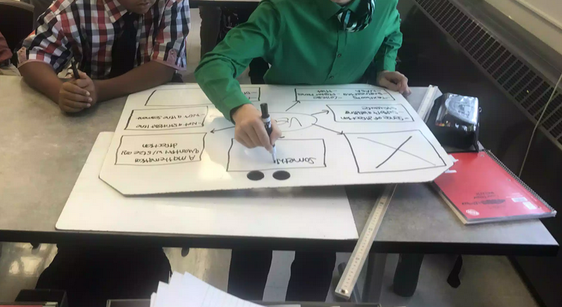
Figure 2: High school physics students whiteboarding during the kinematics unit at St. Francis High School, Hamburg, NY. September, 2017.

Inquiry Based Instruction
The National Science Education Standards (NSES) defines inquiry based instruction as a pedagogical method that models scientific practices and encourages students to gain content knowledge. NSES (1994, P. 19) also states inquiry based instruction allows learners to develop explanations from evidence to address scientific questions and evaluate their explanations while communicating them. In conjunction with the methods of Modeling Instruction, inquiry based instruction is a pedagogical method where students make discoveries before being explicitly told the desired outcomes (Pritchard, 2016).
. There is broad agreement that students should investigate phenomena scientifically, and scientific inquiry is an effective way to learn core science concepts (Shemwell, Chase & Schwartz, 2014). The Next Generation Science Standards puts great emphasis put on inquiry and student centered instruction. Carey (2015) gives numerous examples of greater retention when we struggle through a problem.
Inquiry leads to a higher level of thinking on Bloom's Taxonomy and a greater conceptual understanding. Higher order thinking and forming conceptual models not only yields greater results but also leads to greater student retention (Wilson, 2010).
In two studies of college students, inquiry based instruction was shown to “produce greater student success at discovering the deep structure of the phenomenon” (Shemwell et al., 2014, P. 22).
Studies have shown that students who learn through an inquiry-based strategies model have greater achievement gains on standardized tests than those students who were taught using traditional teacher-centered methods (Jackson et al., 2012; Wilson, Taylor, Kowalski & Carlson, 2010; Shemwell et al., 2014). Some concerns with respect to open inquiry include: (1) teachers’ difficult controlling student inquiry, (2) time concerns, and (3) lack of research evidence for improved student performance (Settleage, 2007; Campbell, 2011).

Computer Simulations
Many educators consider interactive computer simulations adequate tools for teaching science (Rutten, van Joolingen & Van der Veen, 2012; Sari et al., 2017). Computer simulations can be used to direction confront misconceptions (Jimoyiannis et al., 2001; Brna, 1987). Computer simulations can be especially useful in observing natural events too big, too small, too complex, or too dangerous for a high school science classroom (Sari et al., 2017; Bryan, 2006). With traditional experiments and demonstrations, reproducing a phenomenon being studied can be challenging, but computer simulations are a way to present abstract concepts easily (Pardo, 2011). Computer simulations can allow the manipulation of variables and highlight the results (Sari et al., 2017; Bryan, 2006). In addition to making the results clearer, computer simulation can likewise “clean-up” real world experiments that give inconsistent or unwanted results (Bryan, 2002). Through the power of animation, simulations can communicate information more accurately than a diagram or textbook. They can speed up or slow down time to help students visualize various phenomena. Simulations can provide additional information in the form of calculations or graphs in real-time, not requiring students to crunch data or manually plot points. Computer models are easily set up, paused, and changed allowing students’ deeper investigation (Rutten et al., 2012). An additional advantage to using computer simulations is the increase in student interest in motivation (Holec et al., 2004).
Malcolm Wells was one of the first to use computers in high school. He then adopted a method of teaching physics using modeling instruction which was developed at Arizona State University (Jackson, 2008). Computer simulations contribute to student-centered learning (Bryan, 2006) thereby supporting inquiry practices including formulating questions, hypothesis development, data collection, and theory revision (Rutten et al., 2012).
Research has shown overwhelming evidence that using computer simulations produces higher student understanding and achievement (Pardo, 2011). In the article When learning about the real world is better done virtually: A study of substituting computer simulations for laboratory equipment by Finkelstein, Adams, Keller, Kohl, Perkins, Podolefsky and Reid (2005) show how microcomputer simulations are used and compare to more traditional hands-on students’ physics experiments. One group used computer simulations, another group used traditional physics laboratories, and a third control group used neither. The authors concluded students who used computer simulations used time more efficiently and performed better than those students who used traditional physics laboratory activities. Jimoyiannis and Komis (2001) conducted a study of high school physics instruction related to kinematics and concluded those who received instruction with computer simulations alongside traditional instruction had greater achievement. Additionally, a study testing a teaching model in conjunction with interactive computer simulations with high school physics classes showed significant increase in performance on post-test results with computer simulations (Sari et al., 2017).

Application
Laboratory experiments and demonstrations are used in Modeling Instruction to introduce the concept before traditional definitions and notes are given to the students (AMTA, 2014). Bryan (2006) concludes the best way to successfully implement and use technology in the classroom is to have “learner-centered” instruction. Student-centered instruction is at the heart of modeling, making computer simulations a good fit for modeling instruction.
Within the Modeling Instruction framework, computer simulations can be used to introduce a concept. Within such an assignment, students can be required to answer various conceptual questions forcing them to predict and test various outcomes as they would in a traditional hands-on laboratory, but in a fast, convenient, repeatable way which highlights the exact concepts we are trying to teach.
Additionally, as the introduction to a new concept, computer simulations can be used to address common student misconceptions directly and immediately. It is not uncommon for students to experience a demonstration or laboratory experiment which shows a physics concept correctly yet some students still hold on to their original beliefs (Arons, 1997). Jimoyiannis and Kornis (2000) noticed current research indicates conventional instruction is ineffective in dealing with misconceptions and conducted a study showing the success of computer simulations to disprove misconceptions in high school physics.
Not all students contribute equally in traditional science laboratory experiments. Some students are ultimately working harder, contributing more, and experiencing more than others. Even when all students in a group may be contributing, students are typically leaving the higher order thinking to the ones they perceive as the smarter classmates (Cohen, 1992). Computer simulations assigned with one-to-one devices, in a computer lab, or as a homework assignment are more likely to have students working independently and therefore more engaged in the activity.
Once a student has experimented with the computer simulation but have not had the traditional laboratory yet, they can be guided by the teacher as they collaborate in pairs or small groups, revising and refining their ideas through various whiteboarding activities. Students can then present and defend their models before the class. This is the modeling development stage of the Modeling Cycle which loosely follows the Kolb Learning Strategies (1984) of reflective observation and abstract conceptualization.
Sokoloff & Thornton (1977) examined the importance of students making predictions before performing an experiment. They go on to say it challenges the students and forces them to be open minded thinkers. The open-ended, inquiry laboratory experiment can be introduced at any point during the instruction cycle because it is after the initial computer simulation. Because the laboratory experiment is not first, students have already been introduced to the concept through one or more initial computer simulation and possibly other class demonstrations and hands-on activities they have already formed their predictions and are ready to apply and test their models.
Arons (1997) states that operational definitions students arrive at should reflect the whole “story” of how students identified the concept. Arons goes on to discuss how the “idea first and name afterward” method should be used to examine the phenomena of acceleration. Inquiry can be directed towards devising how velocity changes with respect to time (ibid, p. 33), rather than giving the definition at the start of the unit. Following this reasoning, formal definitions are introduced after experimentation.

Recommendations
My own coverage of Kinematics is introduced with students using one or more computer simulations. Students are asked to make predictions and answer questions to start them thinking about key relationships. This is followed by worksheets and textbook problems usually completed in class along with group whiteboarding activities, various demonstrations, hands-on classroom activities, and hands-on, open-ended, inquiry laboratory experiments. Through these processes, students are defending and revising their models. These procedures repeat with every major topic.
I have observed, when students are conducting a hands-on experiment, when undesirable, real-world problems occur such as friction skewing the desired result of the experiment, with the foundation of the concept already formed for the students through computer simulations and opinions defended though whiteboarding activities, these real-world problems were more easily identified, classified, and dismissed from altering the correct conceptual model.

Displacement
The unit on kinematics introduced the concepts of distance and displacement with a simulation from Phet Interactive Simulations, entitled Vector Addition. Students have experience with this simulation from a previous unit which covered math review, trigonometry, SI Units, and vectors. Students investigated the vector representation of X,Y positions. Students were questioned about possible distances traveled to reach a position compared to referencing a two-dimensional position in space back to the origin. This simulation is very versatile. The program allowed students to grab vector arrows, position them on the screen, reposition and resize them. The simulation also allowed the user to see the components in a variety of ways. Students were encouraged to form their own conclusions about distance, position, displacement and vector components. Students were questioned to reflect upon these points and the significance of the components of two-dimensional position.
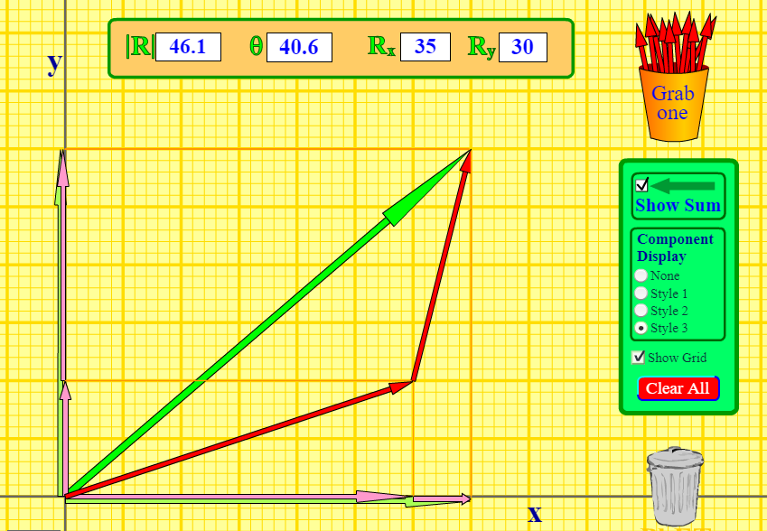
Figure 3: Screen capture of the vector addition computer simulation from University of Colorado Boulder, Phet Interactive Simulations: Vector Addition, URL: https://phet.colorado.edu/en/simulation/vector-addition

The computer simulation I used to teach the topic of displacement is by CK-12 Exploration Series, entitled Position and Displacement. Students used this simulation and investigated the relationship between distance traveled and displacement. This simulation guided students to choose distances and angles and find certain locations on the map. Students were challenged to investigate distance, displacement, negative displacement, and displacement directions.

Velocity and Acceleration
Velocity and Acceleration are introduced to the students with the Moving Man computer simulation from Phet Interactive Simulations. This simulation introduces students to position versus time, velocity versus time, and acceleration versus time graphs. An online assignment which accompanies the simulation has students asking questions about reference frame, position, trajectory, relative motion, scalars and vectors. The key concept is a change in position per change in time.
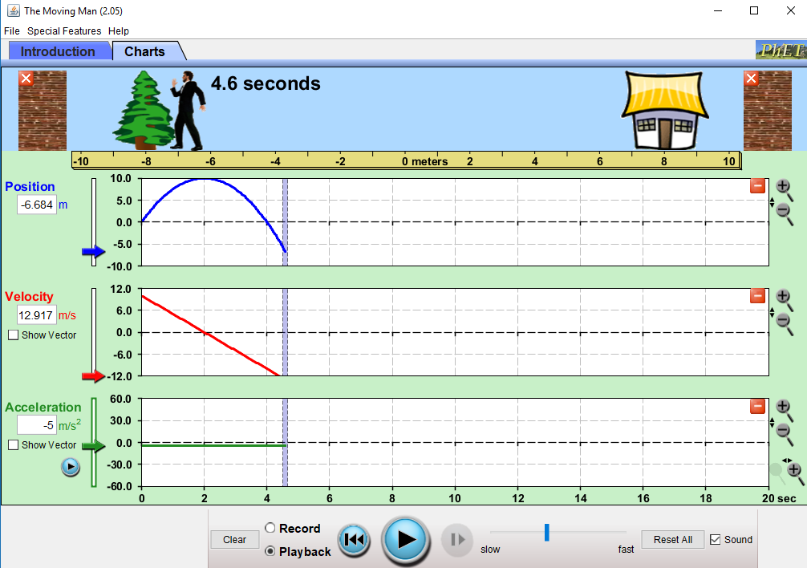
Figure 4: Screen capture of the kinematics graphing computer simulation from University of Colorado Boulder, Phet Interactive Simulations: The Moving Man, URL: https://phet.colorado.edu/en/simulation/legacy/moving-man

The Moving Man simulation can easily manipulate the variables of initial position, initial velocity, and acceleration. The simulation can be paused and stepped forwards and backward. The simulation can be repeated multiple times, quickly and easily with different parameters allowing the student to not only see the movements of the man at the top of the screen but also see the graphical representations of his motion. Leaving acceleration at zero initially, students investigate how position and constant velocity are related.
A hands-on activity involves a motion sensor pointing at students while they are asked to run forwards, walk backward, stand still, and perform other actions while Logger Pro software graphs out their motion.

Free Fall
The topic of Free Fall starts with the simulations by Open Source Physics entitled Free Fall Model and Free Fall with Air Resistance Model. These simulations show the motion diagram as well as position versus time, velocity versus time, and acceleration versus time graphs. The simulation can be paused, stepped forwards, and restarted. Variables include the initial height, the initial velocity, acceleration due to gravity, and the air resistance factor. A simulation runs in slow motion with about two seconds of simulation time taking about 15 seconds of real-time. A similar simulation from North Carolina State University also shows distance and velocity graphs of free fall, but shows simulation time about equal to real-time. This version allows the user to change the initial height as well as the select the acceleration due to gravity to represent Earth, Moon, Mars, or Jupiter. This version is especially useful in showing the initial height of free fall affects the total time but does not affect the acceleration due to gravity.
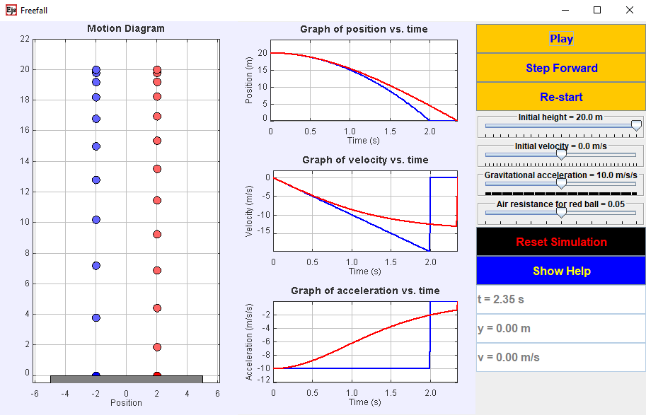
Figure 5: Screen capture of a free fall simulation from Open Source Physics: Free Fall with Wind Resistance Model, URL https://www.compadre.org/osp/items/detail.cfm?ID=10002

Computer simulations such as Moving Man mentioned earlier, along with other technology such as motion sensors and high speed video analysis can help students see the concepts associated with the kinematics while looking at graphical representations of the data and avoid a simple “plug and chug”, low level, algorithm type problem solving often associated with the kinematics formulas.

Projectile Motion
Projectile motion computer simulations are common and easily found online. Two I have used include the Phet Projectile Motion simulation and another by German physics teacher Walter Fendt. Both of these simulations allow students to change all variables associated with projectile motion: height, angle, initial speed, and mass. The Phet simulation also allows for a simple representation of wind resistance.

Online Assignments
Deveans & Jackson (2009) showed the online assessment website, WebAssign.com, used with mathematics classes allowed students to make accurate self-assessments of their strengths and weaknesses, helped students take more responsibility for their learning, had a significant effect on overall grades, and improved student confidence.
I have used the WebAssign website for the past several years in conjunction with online computer simulations. The website allows me to custom assign any of the problems contained in my standard textbook. The website randomizes the numerical givens for each student and grades the problems in real-time. As the instructor, I can look and see the average time it took other high school students to answer the same question, plus a gauge of problem difficulty based on student opinions. The randomizing of question details for each student makes it impossible for students to share answers. I can set up the problems so students can try a sample problem before answer a question. I can change settings so students are allowed multiple attempts to correctly answer a question. WebAssign makes is easy for me to see who is doing their homework, who isn’t, who is struggling, and what topics need more attention.

Conclusion
Modeling Instruction and whiteboarding can be further enhanced by using computer simulations in addition to teacher demonstrations, hands-on activities, and laboratory experiments. The maximum benefit comes not from replacing traditional hands-on activities and experiments but rather to supplement them.
I have found this works best when the computer simulation comes first in the sequence of activities. In accordance with the Modeling Instruction, the starting activity allows the student to form the basis of their conceptual model. Computer simulations have several advantages over traditional laboratory experiments in this regard. Students can use the simulation independently rather than being a passive member of a group. Students can pause, rewind, replay, reverse, slow down, and change a host of variables in real-time and immediately see the results. With simulations, key concepts and misconceptions can be highlighted.

References

Arons, A. (1997) Teaching Introductory Physics (Compilation of 3 previously published works). New York, NY. Wiley.
Brown, P. Concannon, J. (2016). Students’ Perceptions of Vocabulary Knowledge and Learning in a Middle School Science Classroom. International Journal of Science Education. 38(3), 191-408.
Brna, P. (1987). Confronting Dynamics Misconceptions. Instructional Science. 16, 351-379.
Bryan, J. (2006). Technology for Physics Instruction, Contemporary Issues in Technology and Teacher Education. CITE Journal. 6(2), 230-245.
Campbell, T., Zhang, D., Neilson, D., (2011). Model Based Inquiry in the High School Physics Classroom: An Exploratory Study of Implementation and Outcomes. Journal of Science Education and Technology. 20(3), 258-269.
Carey, B. (2015). How We Learn: The Surprising Truth About When, Where, and Why It Happens. New York, NY. Random House.
Cohen, E. (1994). Restructuring the Classroom, Conditions for Productive Small Groups. Review of Educational Research, 64(1), 1-35.
Committee on Undergraduate Science Education. (1997). Science Teaching Reconsidered: A Handbook. Washington, DC. National Academy Press.
Deveans, T., Jackson, H. (2009). An Exploration Assessing WebAssign Using Student Instructor Feedback. (Master’s Thesis) United States Military Academy, West Point, NY.
Dewey, J. (1910). How we think. Boston, MA: D.C. Heath.
Finkelstein N., Adams, W., Keller, C., Kohl, P., Perkins, K., Podolefsky, N., Reid, S. (2005). When Learning About the Real World is Better Done Virtually: A Study of Substituting Computer Simulations for Laboratory Equipment. Physical Review Special Topics Physics Educational Research. 1(1).
Gonzalez-Cruz, J., Rodriguez-Sotres, R., Rodriguez-Penagos, M. (2003). On the convenience of using a computer simulation to teach enzyme kinetics to undergraduate students with biological chemistry-related curricula. Biochemistry and Molecular Biology Education, 31(2), 93–101.
Gomez, K., Zywica, J. (2008). Annotating to Support Learning in the Content Areas: Teaching and Learning Science. Journal of Adolescent & Adult Literacy. 52(2), 155-164.
Hake, R. (1998). Interactive-Engagement Versus traditional Methods: A Six-Thousand-Student Survey of Mechanics Test Data for Introductory Physics Courses. American Journal of Physics. 66(1).
Holec, S., Spodniakova Pfefferova, M., Raganova, J. (2004). Computer Simulations in Mechanics at the Secondary School. Informatics in Education. 3(2), 229-238.
ISTE (International Society for Technology in Education). (2009). Essential Conditions: Necessary Conditions to Effectively Leverage Technology for Learning. www.iste.org.
Jackson, Jane & Dukerich, Larry & Hestenes, David. (2007). Modeling Instruction: An Effective Model for Science Education. Sci Educ. 17.
Jackson, J. (2008). Malcom Wells: a Highly Effective Teacher. Arizona State University Modeling Instruction & MNS Degree Programs. Retrieved from http://modeling.asu.edu/modeling/MalcolmWells_MasterTeacher.htm.
Jackson, J., Ash, G. (2012). Science achievement for all: Improving science performance and closing achievement gaps. Journal of Science Teacher Education, 23(7), 723–744.
Jimoyiannis, A., Komis, V. (2000). Computer Simulations in Physics Teaching and Learning: A Case Study on Students’ Understanding of Trajectory Motion. Computers & Education. 36, 183-204.
Koehler, M., Mishra, P. (2005). What happens when teachers design educational technology? The development of Technological Pedagogical Content Knowledge. Journal of Educational Computing Research. 32(2), 131-152.
Kolb, D. A. (1984). Experiential learning: Experience as the source of learning and development. Englewood Cliffs, NJ. Prentice-Hall.
McKagan, S., McPadden, D. (2017). Best Practices for Whiteboarding in the Physics Classroom. PhysPort. AAPT. Retrieved from URL: https://www.physport.org/recommendations/Entry.cfm.
McTighe, J., Lyman, F. (1988). Cueing Thinking in the Classroom: The Promise of Theory-Embedded Tools”. Educational Leadership. 45(7), 8.
Megowan, M. (2007). Framing Discourse for Optimal Learning in Science and Mathematics, (Ph.D. Dissertation). Arizona State University.
Mestre, J. (1991). Learning and Instruction in Pre-College Physical Science. Physics Today. 44(9), 56-58.
Minstrell, J., & Kraus, P. (2005). Guided inquiry in the science classroom. In M.S. Donovan & J.D. Bransford (Eds.), How Students Learn: History, Mathematics, and Science in the Classroom (pp. 475-513). Washington D.C.: The National Academic Press.classroom.
Mishra, P., Koehler, M. (2006). Technological pedagogical content knowledge: A Framework for Teacher Knowledge. Teachers College Record. 108(6), 1017–1054.
Ogan-Bekiroglu, Feral & ARSLAN-BUYRUK, Arzu. (2018). Comparison of Pre-Service Physics Teachers’ Conceptual Understanding of Dynamics in Model-Based Scientific Inquiry and Scientific Inquiry Environments. 10.21891/jeseh.389737.
Pardo, P. (2010). Comparative Study of the Effectiveness of Three Learning Environments: Hyper-Realistic Virtual Simulations, Traditional Schematic Simulations and Traditional Laboratory. Physics Review Special Topics Physics Educational Research. 7(1)
Pfefferova, M., (2014). Computer Simulations and Their Influence on Students’ Understanding of Oscillatory Motion. Informatics in Education. 14(2), 279-289.
Rutten, N., van Joolingen, W.R. & van der Veen, J.T. (2012). The Learning Effects of Computer Simulations in Science Education. Computers & Education, 58(1), 136-153.
Sarabando, C., Cravino, J., Soares, A. (2014) Contribution of a Computer Simulation to Students’ Learning of the Physics Concepts of Weight and Mass. Research Conference on Virtual Worlds – Learning with Simulations. Procedia Technology, 13, 112-121.
Sari, U., Hassan, A., Guvan, K., Sen, O. (2017). Effects of the 5E Teaching Model Using Interactive Simulations on Achievement and Attitude in Physics Education. International Journal of Innovation in Science and Mathematics Education. 25(3), 20-35.
Schwarz, C. (2002). Using Model-Centered Science Instruction to Foster students’ Epistemologies in Learning with Models. American Educational Research Association, New Orleans, LA.
Shemwell, J. T., Chase, C. C. and Schwartz, D. L. (2015), Seeking the general explanation: A test of inductive activities for learning and transfer. J Res Sci Teach, 52: 58-83.
Sokoloff, D., Thornton, R. (1977). Using Interactive Lecture Demonstrations to Create an Active Learning Environment. The Physics Teacher. 35(6), 340-347.
Stratford, S. (1997). A review of Computer-Based Model Research in Precollege Science Classrooms. Journal of Computers in Mathematics and Science Teaching, 16(1), 3-23.
Thornton, R. (2004). Uncommon Knowledge: Student Behavior Correlated to Conceptual Learning.
Trowbridge, L., Bybee, R., Powell, J. (2008). Teaching Secondary School Science: Strategies for Developing Scientific Literacy (9th ed,). Upper Saddle River, NJ. Pearson.
Viennot, L. (1979). Spontaneous Reasoning in Elementary Dynamics. European Journal of Science Education. 1(2), 205-221.
Wells, M. (1987). Modeling Instruction in High School Physics (Doctoral dissertation).
Wells, M. Hestenes, D, Swackhamer, G. (1995). A modeling Method for High School Physics Instruction. American Journal of Physics, July 1995.
American Modeling Teachers Association. (2014). What is Modeling Instruction. Arizona State University. Retrieved from URL http://modeling.asu.edu/modeling/WhatModlInstructionIs-2014.htm.
Wilson, C. D., Taylor, J. A., Kowalski, S. M., & Carlson, J. (2010). The relative effects and equity of inquiry-based and commonplace science teaching on students’ knowledge, reasoning, and argumentation. Journal of Research in Science Teaching, 47(3), 276–301.

