A Table of Specifications for Physics Pedagogical Content Knowledge

http://physicsed.buffalostate.edu/pubs/PHY690/Pauli2015PhyPCKTOS/

Alyssa Pauli
PHY 690

ABSTRACT
This Table of Specifications (TOS) is intended to be a tool used to create an instrument to assess the physics Pedagogical Content Knowledge (PCK) of high school teachers. This instrument will inform physics teacher candidate preparation and physics teacher professional development. Building upon Eugenia Etkina’s five aspects of PCK and their relationships to teaching physics, the physics PCK TOS combines knowledge that a physics teacher who effectively creates an environment conducive to learning is presumed to have (2010).
Etkina, E. (2010). Pedagogical content knowledge and preparation of high school physics teachers. Phys. Rev. ST Phys. Educ. Res. 6, 020110, 1-26. DOI: 10.1103/PhysRevSTPER.6.020110

This master’s project was made possible by the PHY 690 course of SUNY Buffalo State College’s Physics Education master’s program and Dr. Dan MacIsaac.

Alyssa Pauli, formerly known as Alyssa Cederman, earned her bachelor’s of science at Buffalo State college with a major of physics education and a minor in mathematics in 2013. She is expected to earn her master’s of science at Buffalo State College with a major in physics education in 2015. She holds a NYS teaching certificate in physics education 7-12.
She has been employed under titles physics education undergraduate researcher in 2009, calculus teaching assistant in 2010, computational mathematics undergraduate researcher in 2011, English language arts tutor in 2012, physics learning assistant in 2012, physics undergraduate student teaching assistant in 2012-2013, and physics graduate student teaching assistant in 2013-2014, at Buffalo State College. She taught physics, geometry, and money skills at WNY Maritime Charter School in 2014-2015. She is currently available for a full-time physics teacher position.

INTRODUCTION
In a country where only 40% of physics teachers have a degree in physics or physics education and only 56% would describe themselves as physics specialists, many districts would benefit from being able to assess and improve upon their physics teachers’ pedagogical content knowledge (PCK) in physics (White & Tyler 2014, Shulman 1986). The Table of Specifications (TOS) accompanying this article will guide design of such an instrument.

Table of Specifications
A Table of Specifications (TOS) is a two-way chart or grid which ensures a connection between content knowledge goals and pedagogical goals (Notar 2004). The column of the chart lists the objectives or "levels of skills" to be addressed; the rows list the key concepts or content the test is to measure. A TOS helps teachers align objectives, instruction, and assessment (Fives & DiDonato-Barnes 2013). Each level of skill is the equivalent to each level of the cognitive domain of Bloom's Taxonomy (1956). Teachers can be assured that they are writing better objective tests by measuring students' content learning as well as the student’s level of skill or order thinking (Cerbin 2009). “The use of a TOS may ensure that teachers include test items that tap different levels of cognitive complexity when measuring students' achievement” (Alade & Omoruyi 2014).

Pedagogical Content Knowledge
Imagine an English teacher who has never studied physics beyond their exposure at the high school age. This English teacher may understand how to teach, yet may struggle to teach physics due to a lack of physics content knowledge. Imagine a prominent physicist who has never studied pedagogy. The physicist might be an expert in physics, but struggle as a teacher without pedagogical knowledge.
Content knowledge is knowledge in a given field that allows students to learn maximally accurate concepts. This content knowledge is an expected quality of physicists and physics teachers alike. Pedagogical knowledge, or the knowledge of how people learn, remember, behave, and mentally develop, is an expected quality shared among teachers in every content area.
Now imagine a teacher who double majored in history education and physics. This person has a good understanding of how to teach students, and a good understanding of physics. Yet this history certified teacher may struggle to lead the students to conceptual understandings more than a person who studied physics education in particular. This history teacher is lacking physics pedagogical content knowledge (PCK), the unique knowledge specific to those who spend time thinking of ways to encourage concept construction for a given field of study (Shulman 1986).
PCK is the mixture of pedagogical knowledge and content knowledge in a specific field. The PCK required is different for every content area. Subsequently, physics PCK is professional knowledge unique to those who teach physics.
PCK has been defined by Shulman as “the special amalgam of content and pedagogy that is uniquely the providence of teachers, their own special form of professional understanding” (1986). Such an understanding as PCK is vital to building a classroom that maximizes student learning in physics.
Students may not efficiently acquire physics content knowledge by solely reading about the physics content and listening to lecture, but learning is effectively increased with increasing engagement (Hake 1998). Physics PCK is thought to have a similar learning efficiency function, due to overlap in physics content (Etkina 2010).
Figure 1 is from Etkina’s “Pedagogical content knowledge and preparation of high school physics teachers” (2010). The diagram shows that the importance of the PCK is that it combines content knowledge with pedagogical knowledge. The table describes five aspects of physics PCK.
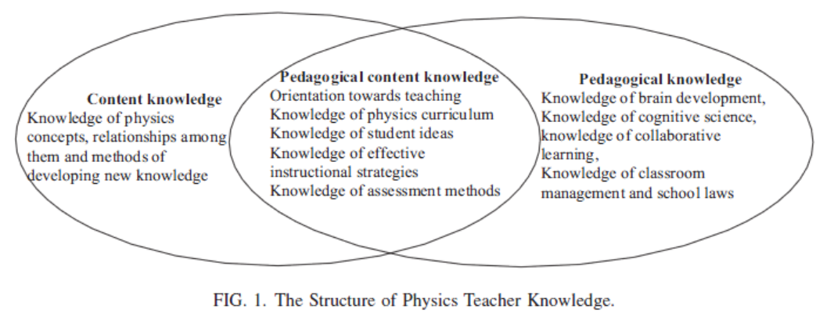

ASPECTS OF PHYSICS PCK
The physics PCK aspects included in the TOS are modified from Etkina’s “Pedagogical content knowledge and preparation of High School Physics Teachers” (2009). The five main aspects are:
- Orientation to science teaching,
- Knowledge of physics curriculum,
- Knowledge of and respect for common difficulties with key concepts and practices,
- Knowledge of teacher strategies to scaffold student learning of key concepts and practices, and
- Knowledge of widely accepted conceptual assessments, assessment strategies, and facilitation of metacognition.
Each aspect is applied to physics content and described below (Etkina 2009). Figure 2 organizes the five aspects of physics PCK, as well as sub-topics.
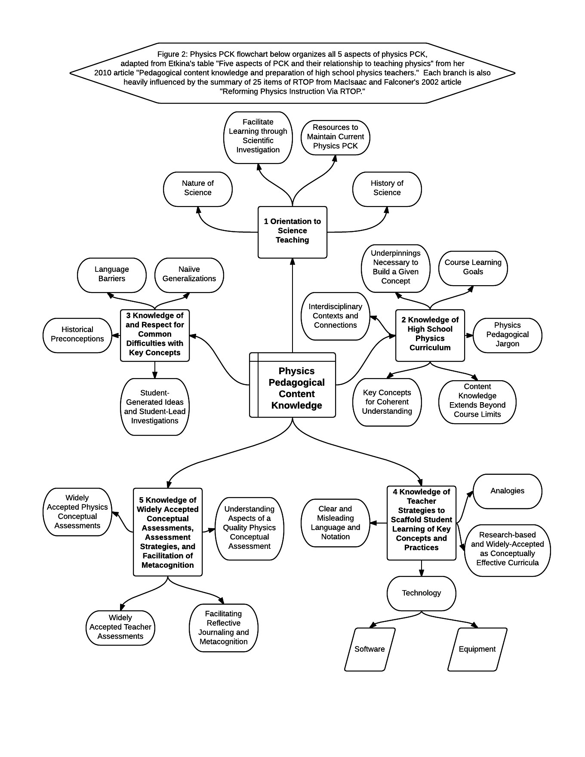
The physics PCK TOS is included in table 1.
Orientation to science teaching is related to the teacher’s beliefs about science teaching. Throughout the physics education field, scientific investigation is regarded as an effective way to facilitate learning in the subject while simultaneously engaging the student in an activity which reveals the nature of science (MacIsaac & Falconer 2002). Also, due to the nature of science as well as the growing field of physics education, there must be at least one facet for the teacher to access up-to-date information on their field.
Knowledge of the physics curriculum is essential to guide students to an understanding in physics. The teacher must know the learning goals of the course they teach, which are usually defined by state standards. Knowing which concepts in the curriculum are essential over-arching themes that connect topics helps teachers plan to know what is most essential for students to spend time analyzing. The teacher must have a content knowledge base that extends beyond the normal range in the classroom to help students pursue answers to unexpected questions, take advantage of teachable moments, and to pursue interests of students to keep student morale high. For the same reasons, having interdisciplinary knowledge is useful. It is also useful to use to connect an abstract concept to a more “concrete” situation in which the student may bridge their understanding (Bransford 2000). Given a physics concept, a physics teacher should be able to determine what underpinnings are necessary for their students to have in order to reach the goal understanding. The teacher must also be familiar with physics pedagogical jargon to communicate with colleagues and understand professional articles.
Knowledge of and respect for common difficulties with key concepts and practices allows students to see why there are good reasons to believe inaccurate theories until they are proven inaccurate, and accept the nature of science. Common difficulties rise from naive generalizations, or general rules extended to a situation in which that generalization does not apply. Language barriers offer a huge obstacle for many students, as was extensively addressed by Arons (1990). In addition, knowledge of the history of science may help a teacher learn about what their students may believe.
Knowledge of teaching strategies to scaffold student learning of key concepts and practices is a knowledge of techniques in teaching specific or general physics content. Widely accepted physics curricula, such as the physics tutorials, the physics of everyday thinking, and the physics modeling curriculum offer strategies and activities that may increase student learning. Poorly chosen words can ruin students’ chances of sense-making, while other carefully chosen words may clarify and facilitate rapid cognitive growth. Analogies are useful tools in bridging gaps between what students understand and a new concept. Technology may be a huge help with student understanding. For example, RealTime physics motion lab is used widespread because it graphs student motion almost instantly to help students correlate graph shape with a kinesthetic motion. Simulations and videos can raise morale and allow students to think more deeply about something abstract.
Knowledge of widely accepted conceptual assessments, assessment strategies, and facilitation of metacognition is crucial to gauge activity effectiveness and student understanding. There are many widely accepted conceptual physics assessments that students may take, such as the FCI, FMCE, TUG-K, CTSR, BEMA, CSEM, DIRECT, STEBI-B, and MCTP. In addition, physics teaching strategies can be evaluated with widely accepted teaching assessments, such as RTOP. Since teachers often create their own assessments, teachers should have a basic understanding of the difference between a mathematically involved problem solving assessment and a quality physics concept assessment. Teachers should also know how to encourage and facilitate metacognition. One way to do this is through reflective journaling.

PHYSICS PCK ASSESSMENT
The PCK aspects outlined above are mostly knowledge-based. Yet knowledge does not create an effective teacher. The teacher must be able to use higher levels of thinking from Bloom’s Taxonomy to be able to use this knowledge to the students’ advantage (1956). Figure 3 displays several ways in whichteachers must be able to apply physics PCK to create effective lessons.
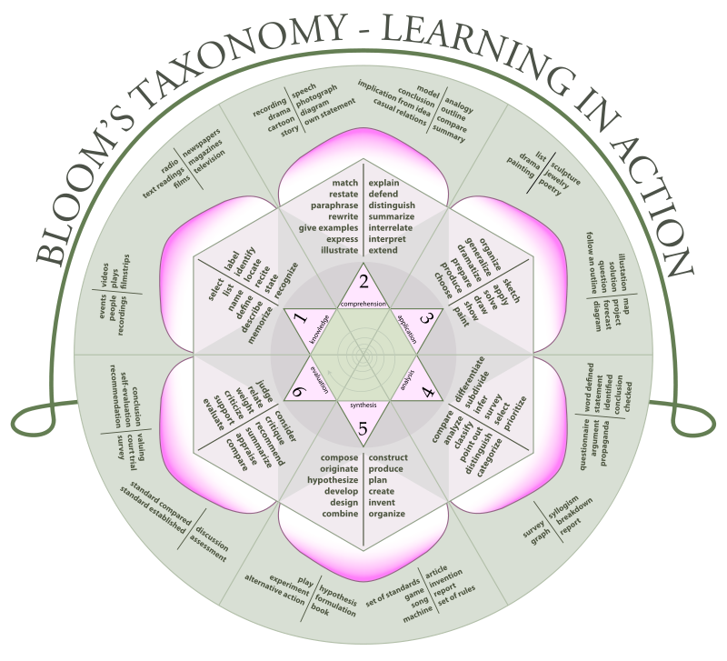
Figure 3: Bloom’s Taxonomy lists several verbs which a physics teacher should be able to do with physics PCK (1956).
Performance-based assessments are used to measure the amount of inquiry-based or constructivist methods being used in the classroom via RTOP (MacIsaac & Falconer 2002, 479). The edTPA Secondary Science assessment is also performance-based with a video component and a written task accompanying several student samples, lesson plans, and worksheets. The edTPA assesses teacher candidates in this manner to measure teacher readiness and to allow the candidates to “demonstrate their understanding of teaching and student learning” (SCALE 2015, 1).
Understanding of physics PCK should be evaluated through a performance-based assessment for the same purposes. Physics teachers should be given an opportunity to demonstrate their understanding of PCK through planning, instruction, and assessment, as well as an explanation accompanying each task, as displayed in figure 4 from the edTPA assessment handbook (SCALE 2015, 2).
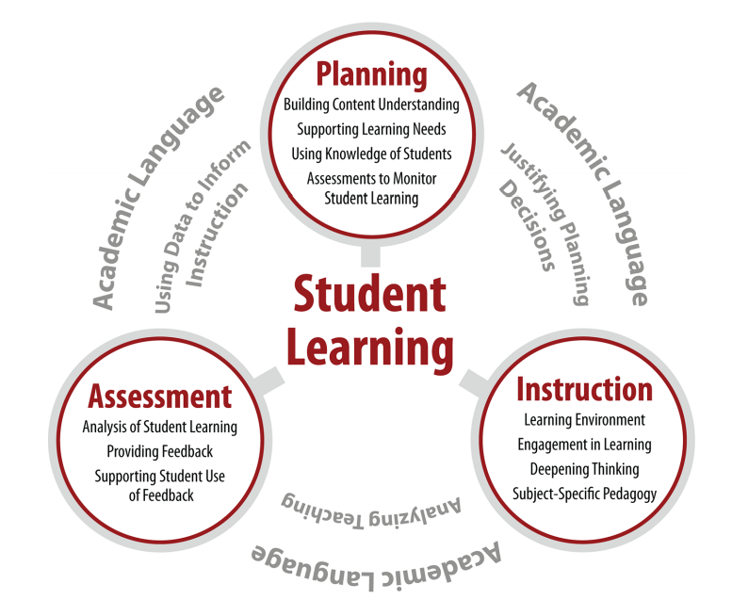
Figure 4: The edTPA tasks and cycle of effective teaching (SCALE 2015, 2).
Table 2 shows every aspect and subtopic of physics PCK, as well as resources to find quantifiable items of each subtopic.

CONCLUSION
This table was a compilation and organization of several great minds in the physics education field. Therefore, it has a slight advantage over other tables in assisting in the creation of an assessment tool to detect physics PCK in a teacher.

REFERENCES
American Association of Physics Teachers (AAPT). (2004). Powerful Ideas in Physical Science. Available from <http://www.aapt.org/ >.
Alade, O., & Omoruyi, I. (2014). Table of specification and its relevance in educational development assessment. European Journal of Educational and Development Psychology, 2, 1-17. Available from <http://www.eajournals.org/>.
Arons, A. (1990). A guide to introductory physics teaching. Wiley. New York.
Bloom, B. S.; Engelhart, M. D.; Furst, E. J.; Hill, W. H.; Krathwohl, D. R. (1956). Taxonomy of educational objectives: The classification of educational goals. Handbook I: Cognitive domain. David McKay Company. New York.
Bransford, J., Brown, A., & Cocking, R. (2000). How people learn: Brain, mind, experience, and school: Expanded edition. National Academies Press, Washington D. C.
Camp, C., Clement, J. (1994). Preconceptions in mechanics : Lessons dealing with students’ conceptual difficulties. Kend All/Hunt. Iowa.
Cerbin, B. (2009). Writing better objective tests. Center for Advancing Teaching & Learning of Univ. Wisconsin La Crosse. Available from <http://www.uwlax.edu/ >.
Darling-Hammond, L. (2000). How teacher education matters. J. of Teacher Ed., 51, 166-173.
Etkina, E. (2007). Pedagogical content knowledge. Rutgers University ppt.
Etkina, E. (2010). Pedagogical content knowledge and preparation of high school physics teachers. Phys. Rev. ST Phys. Educ. Res. 6, 020110, 1-26. DOI: 10.1103/PhysRevSTPER.6.020110
Etkina, E. et al. (2010). Design and reflection help students develop scientific abilities: Learning in introductory physics laboratories. The J. of the Learning Sci., 19, 54-98. DOI: 10.1080/10508400903452876
Fives, H. & DiDonato-Barnes, N. (2013). Classroom test construction: The power of a table of specifications. Practical Assessment and Research Eval.18(1). Available from <http://pareonline.net/ >.
Goldberg, F (2000). Constructing physics understanding (CPU) project.. Available from <http://cpucips.sdsu.edu/web/CPU/default.html>.
Henry, D., Henry, J., Riddoch, S. (2006). Whiteboarding your way to great student discussions. Sci. Scope. April/M., 51.
Hestenes, D. (1993). Modeling Instruction in High School Physics (NSF Grant ESI 9353423), Information about the workshops can be obtained by visiting the Project’s web site at <http://modeling.asu.edu/ >.
Hake, R. (1998). Interactive engagement versus traditional methods: a six-thousand-students survey of mechanics test data for introductory physics courses. Am. J. Phys. 66(1), 64-74.
Loughran, J., Berry, A., and Mulhall, P. (2006). Understanding and Developing Science Teacher Pedagogical Content Knowledge. Sense Publishers, Rotterdam, Taipei.
MacIsaac, D.L. & Falconer, K.A. (2002, November). Reforming physics education via RTOP. The Physics Teacher 40(8), 479-485. Available from
< http://physicsed.buffalostate.edu/pubs/TPT/TPTNov02RTOP/ >, describes physics-specific RTOP use.
Notar, C., Wilson, J., Yunker, B., & Zuelke, D. (2004). The table of specifications: Insuring accountability in teacher made tests. J. of Instruc. Psych. 31(2), 115. Available from <http://go.galegroup.com/ >.
Neiss, M. (2005). Preparing teachers to teach science and mathematics with technology: Developing a technology pedagogical content knowledge. Teaching and Teacher Ed., 21, 509-523. doi:10.1016/j.tate.2005.03.006
Piburn, M., Sawada, D., Falconer, K., Turley, J. Benford, R., Bloom, I. (2000). Reformed Teaching Observation Protocol (RTOP). ACEPT IN-003. The RTOP rubric form, training manual and reference manual containing statistical analyses, are all available from
< http://PhysicsEd.BuffaloState.Edu/AZTEC/rtop/RTOP_full/PDF />. IN-001 contains the RTOP rubric alone, IN-002 contains rubric and training manual, IN-003 adds the statistical analyses
Schmidt, D. et al. (2009). Technological pedagogical content knowledge (TPACK): The development and validation of an assessment instrument for preservice teachers. J. of Research on Tech. Ed., 42, 2, 123-149. DOI: 10.1080/15391523.2009.10782544
Shulman, L. (1986). Those who understand: Knowledge growth in teaching. Educational Researcher, 15, 4-14.
Stanford Center for Assessment, Learning and Equity (SCALE). (2015). edTPA secondary science assessment handbook. Board of Trustees of the Leland Stanford Junior University.
White S., & Tyler J. (2014). Focus on: Who teaches physics? AIP Statistical Research Center. Available from < https://www.aip.org/>.

