A Table of Specifications for Physics Pedagogical Content Knowledge

http://physicsed.buffalostate.edu/pubs/PHY690/Pauli2015PhyPCKTOS/

Alyssa Pauli
PHY 690

ABSTRACT
This Table of Specifications (TOS) is designed to be a tool used to create an instrument to assess the Pedagogical Content Knowledge (PCK) of high school teachers. This instrument might inform physics teacher candidate preparation or physics teacher professional development. For example, most introductory HS physics content includes significant mechanics, kinematics, some electrostatics, circuits, waves, sound and optics, so new teachers should know something about common student conceptual difficulties associated with these topics (like Aristotelian physics, confuting position, velocity and acceleration; graph reading, centripetal acceleration direction) as well as touchstone pedagogical measurements and activities (FCI and FMCE; developing kinematics equations from the motion of battery operated toys) and something of research-based introductory curricula.

INTRODUCTION
In a country where many physics teachers are not certified in the field, many districts would benefit from being able to assess and improve upon their physics teachers’ pedagogical content knowledge (PCK) in physics. The Table of Specifications (TOS) accompanying this article is meant to provide the underpinnings from which one may eventually design such an instrument.

Table of Specifications
A Table of Specifications (TOS) consists of a two-way chart or grid relating instructional objectives to the instructional content. The column of the chart lists the objectives or "levels of skills" to be addressed; the rows list the key concepts or content the test is to measure. A TOS helps teachers align objectives, instruction, and assessment. It identifies not only the content areas covered in class, it identifies the performance objectives at each level of the cognitive domain of Bloom's Taxonomy. Teachers can be assured that they are measuring students' learning across a wide range of content and readings as well as cognitive processes requiring higher order thinking. The use of a TOS ensures that teachers include test items that tap different levels of cognitive complexity when measuring students' achievement.

Pedagogical Content Knowledge
Imagine an English teacher who has never studied physics beyond the high school level. This English teacher may understand how to teach, yet may struggle to teach physics due to a lack of physics content knowledge. Imagine a prominent physicist who has never studied pedagogy. The physicist might be an expert in physics, but struggle as a teacher without pedagogical knowledge.
Content knowledge is knowledge in a given field that allows students to learn maximally accurate concepts. This content knowledge is required by physicists and physics teachers alike. Pedagogical knowledge, or the knowledge of how people learn, remember, and mentally develop, is a requirement shared among teachers in every content area.
Now imagine a teacher who double majored in history education and physics. This person has a good understanding of how to teach students, and a good understanding of physics. Yet this history certified teacher may struggle to lead the students to conceptual understandings more than a person who studied physics education in particular. This history teacher is lacking physics pedagogical content knowledge (PCK), the special knowledge specific to most effectively teaching physics.
PCK is the mixture of pedagogical knowledge and content knowledge in a specific field. The PCK required is different for every content area. Subsequently, physics PCK is professional knowledge unique to those who teach physics.
PCK has been defined by Shulman as “the special amalgam of content and pedagogy that is uniquely the providence of teachers, their own special form of professional understanding.” Such an understanding as PCK is vital to building a classroom that maximizes student learning in physics.
Students do not efficiently acquire physics content knowledge by solely reading about the physics content and listening to lecture, but efficiency is increased with increasing engagement. Physics PCK is thought to have a similar learning efficiency function, due to overlap in physics content.
The diagram and the table below are from Etkina’s “Pedagogical content knowledge and preparation of high school physics teachers.” The diagram shows that the importance of the PCK is that it combines content knowledge with pedagogical knowledge. The table describes five aspects of physics PCK.
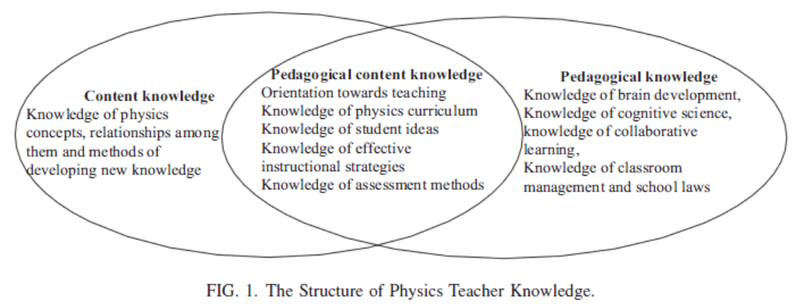

ASPECTS OF PCK
The physics PCK aspects included in the TOS are modified from Etkina’s “Pedagogical content knowledge and preparation of High School Physics Teachers” (2009). The five main aspects are [1] orientation to science teaching, [2] knowledge of physics curriculum, [3] knowledge of and respect for common difficulties with key concepts and practices, [4] knowledge of teacher strategies to scaffold student learning of key concepts and practices, and [5] knowledge of widely accepted conceptual assessments, assessment strategies, and facilitation of metacognition. Each aspect is expanded upon specifically for the physics content.
[1] Orientation to Science Teaching is related to the teacher’s beliefs about science teaching. Throughout the physics education field, scientific investigation is regarded as an effective way to facilitate learning in the subject while simultaneously engaging the student in an activity which reveals the nature of science (MacIsaac & Kathleen 2002). Also, due to the nature of science as well as the growing field of physics education, there must be at least one facet for the teacher to access up-to-date information on their field.
[2]Knowledge of the physics curriculum is essential to guide students to an understanding in physics. The teacher must know the learning goals of the course they teach, which are usually defined by state standards. Knowing which concepts in the curriculum are essential over-arching themes that connect topics helps teachers plan to know what is most essential for students to spend time analyzing. The teacher must have a content knowledge base that extends beyond the normal range in the classroom to answer unexpected questions, take advantage of teachable moments, and to pursue interests of students to keep student enthusiasm high. For the same reasons, having interdisciplinary knowledge is useful. It is also useful to use to connect an abstract concept to a more “concrete” situation in which the student may bridge their understanding (Bransford 2000). Given a physics concept, a physics teacher should be able to determine what underpinnings are necessary for their students to have in order to reach the goal understanding. The teacher must also be familiar with physics pedagogical jargon to communicate with colleagues and understand professional articles.
[3] Knowledge of and respect for common difficulties with key concepts and practices allows students to be wrong and accept the nature of science. Common difficulties rise from naive generalizations, or general rules extended to a situation in which that generalization does not apply. Language barriers offer a huge obstacle fo many students, as was extensively addressed by Arons (). In addition, knowledge of the history of science may help a teacher learn about what their students may believe.
[4] Knowledge of teaching strategies to scaffold student learning of key concepts and practices is a knowledge of techniques in teaching specific or general physics content. Widely accepted physics curricula, such as the physics tutorials, the physics of everyday thinking, and the physics modeling curriculum. Poorly chosen words can ruin students’ chances of sense-making, while other carefully chosen words may clarify and facilitate rapid cognitive growth. Analogies are useful tools in bridging gaps between what students understand and a new concept. Technology may be a huge help with student understanding. For example, realTime physics motion lab is used widespread because it graphs student motion almost instantly to help students correlate graph shape with a kinesthetic motion. Simulations and videos can raise morale and allow students to think more deeply about something abstract.
[5] Knowledge of widely accepted conceptual assessments, assessment strategies, and facilitation of metacognition is crucial to gauge activity effectiveness and student understanding. There are many widely accepted conceptual physics assessments that students may take, such as the FCI, FMCE, TUG-K, CTSR, BEMA, CSEM, DIRECT, STEBI-B, and MCTP. In addition, physics teaching strategies can be evaluated with widely accepted teaching assessments, such as RTOP. Since teachers often create their own assessments, teachers should have a basic understanding of a quality physics concept assessment. Teachers should also know how to encourage and facilitate metacognition. One way to do this is through reflective journaling.

CONCLUSION

