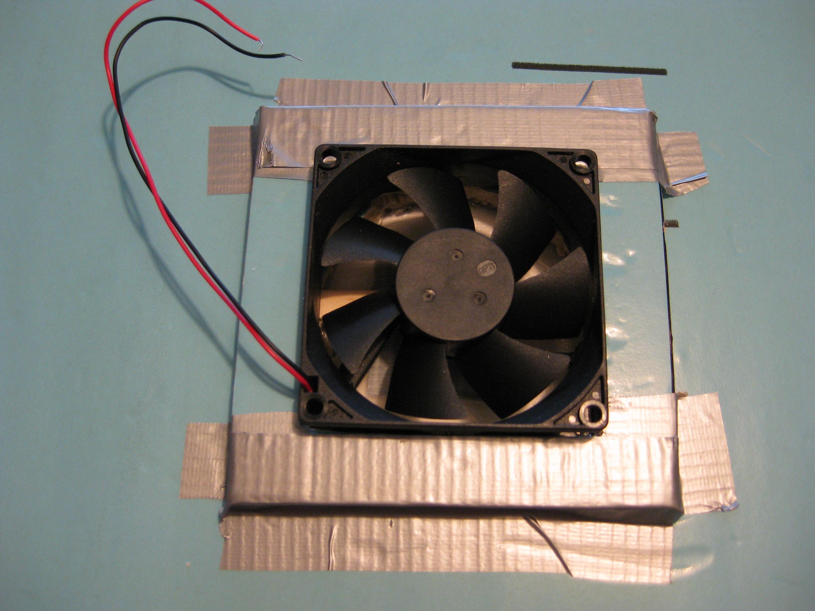
FIG: 13 Fan and mounting block secured to the hovercraft body

