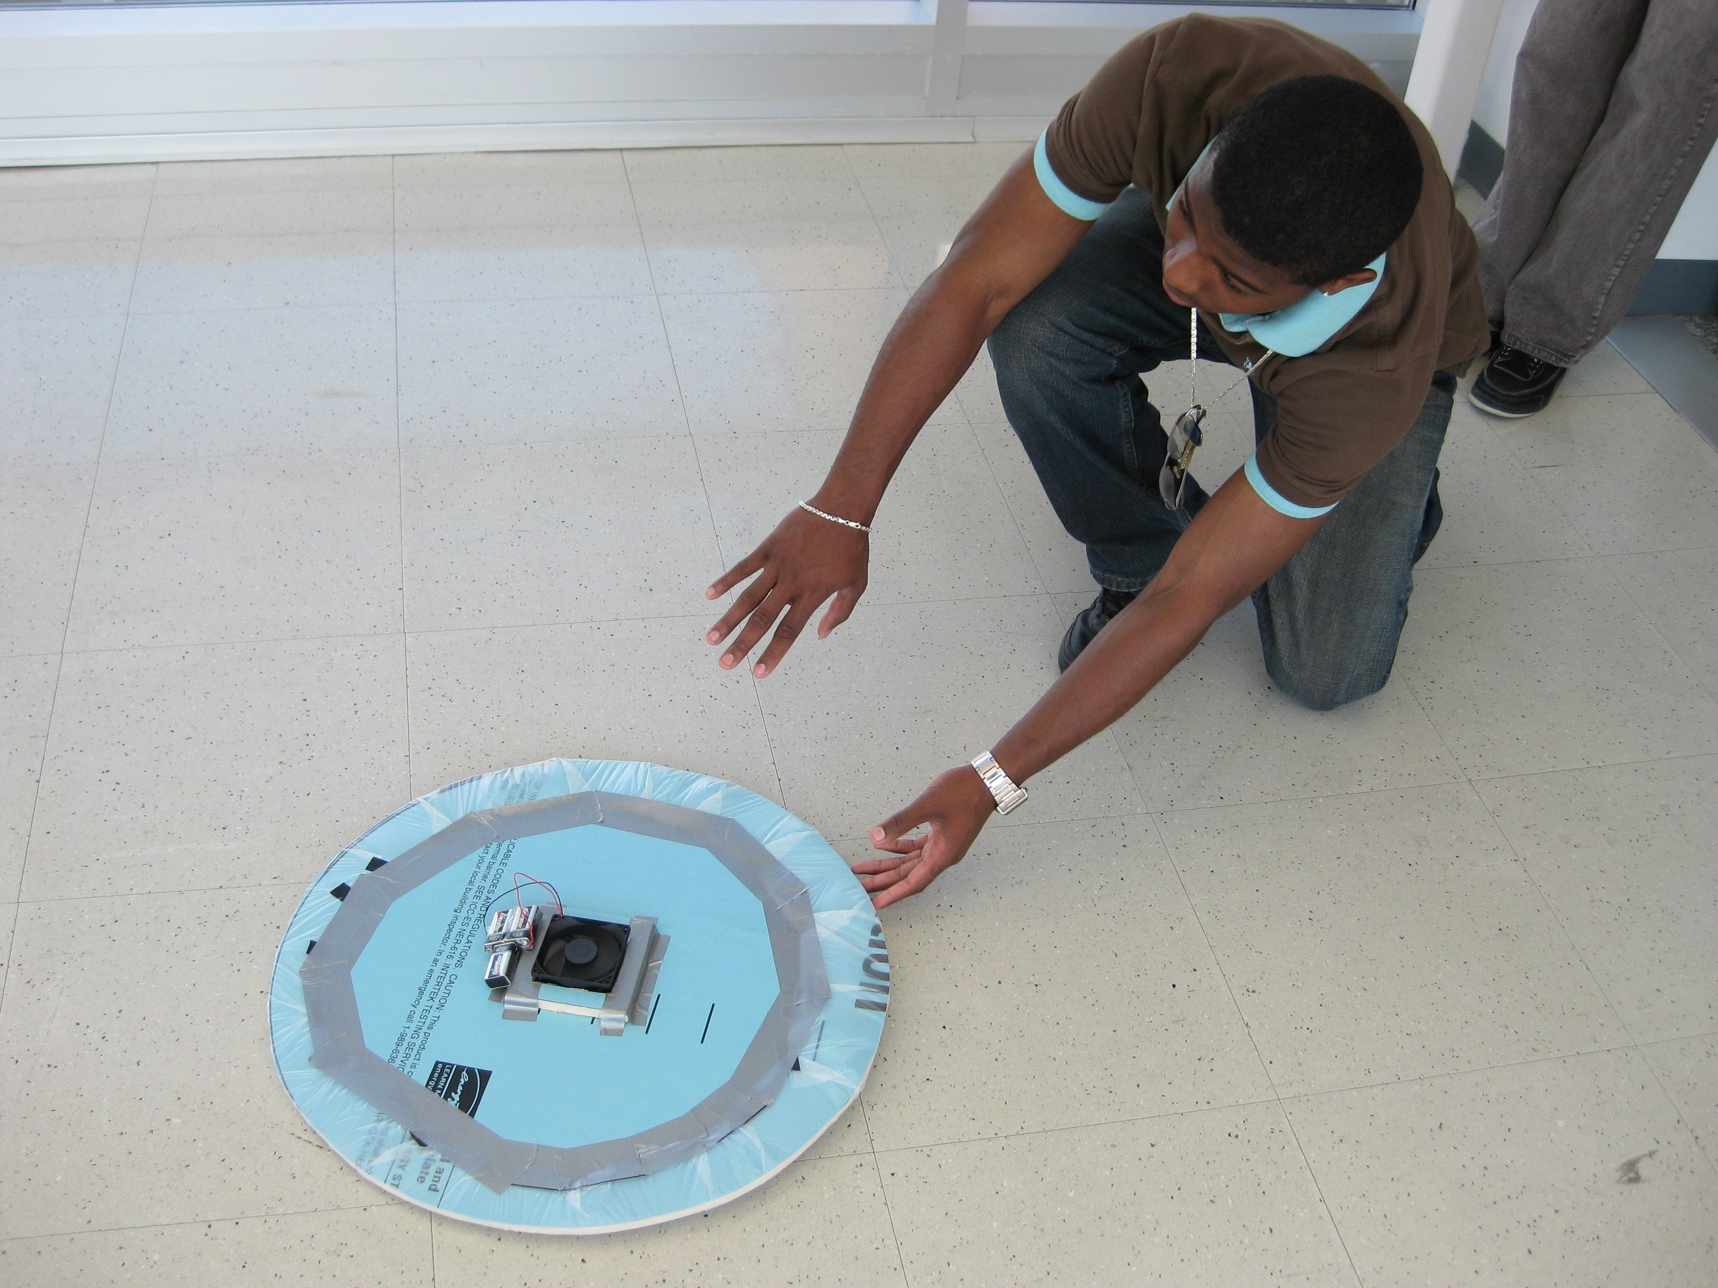
FIG 2: Student pushing hovercraft

