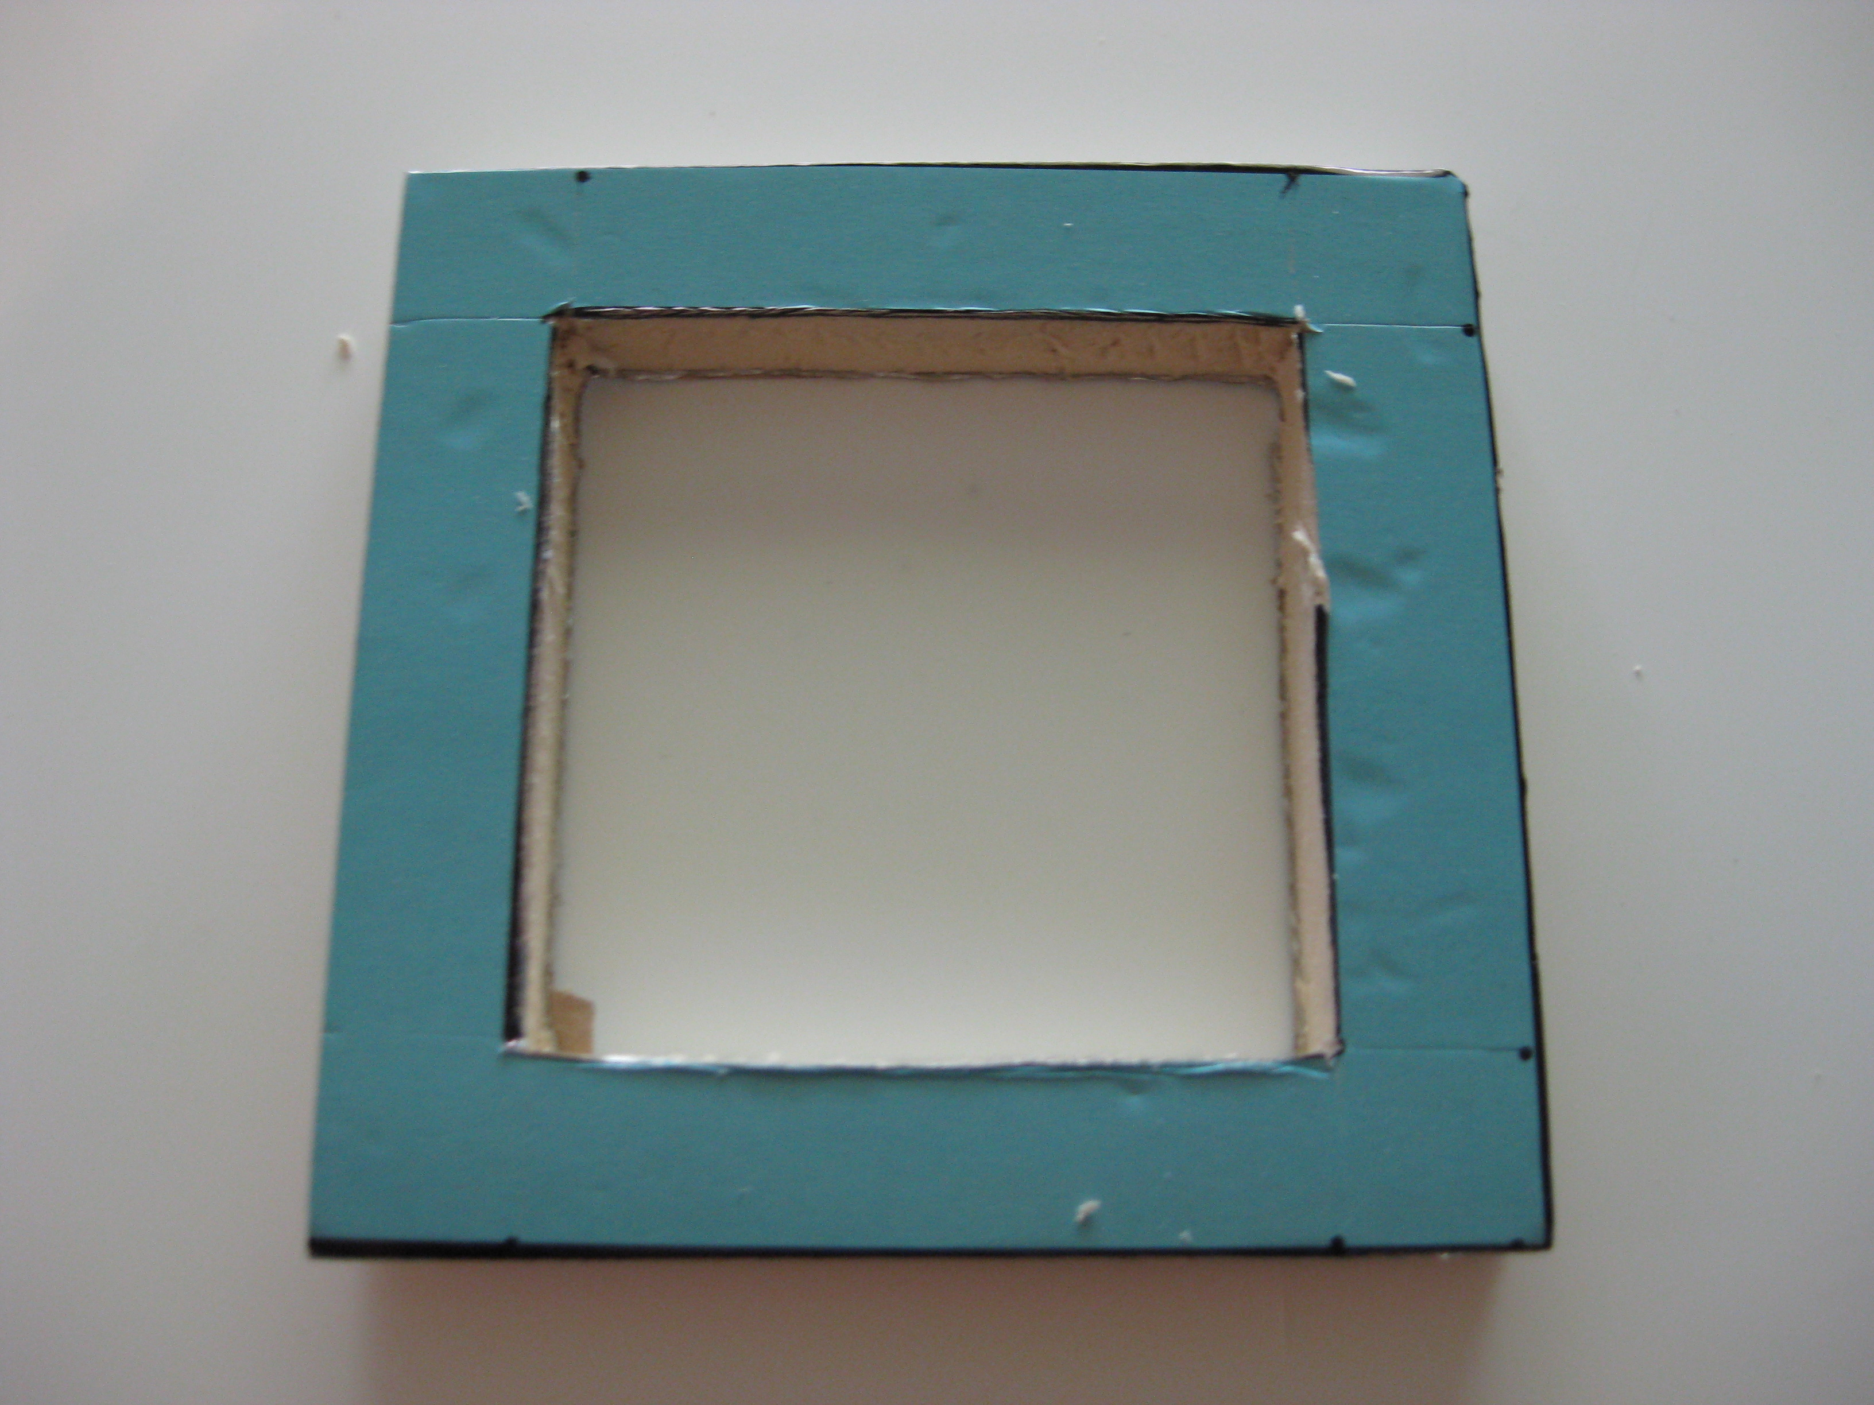
FIG: 7 Cut out of fan mounting block

