Developing an Intuitive Grasp of Exponential Functions from Real World Examples
David M. Rheam
Department Of Physics, SUNY-Buffalo State College, 1300 Elmwood Avenue,
Buffalo, NY 14222, teamrheam@gmail.com

This manuscript was completed as a requirement for PHY 690: Masters Project at SUNY-Buffalo State College Department of Physics, under the supervision of Dr. Dan MacIsaac. Dr. David Abbott also contributed comments and insights.

Abstract
Albert A. Bartlett (1976) stated “The greatest shortcoming of the human race is our inability to understand the exponential function” (p.394). It is unsurprising that many of our high school students have difficulty grasping concepts involving exponentials (Weber, 2002). One main reason for this is that students enter our classrooms with their own ideas about the way things grow and decay from what they have seen in their own life experience. Unfortunately, most of what they see is not exponential. It is extremely difficult to change deep-seated student beliefs. Students cannot simply be taught a formula or shown a graph dealing with exponential growth and decay and be expected to understand how it works. Rather, students need to build their own understanding of new concepts (Alagic and Palenz, 2006). Real life experiences in our classrooms in which students can explore exponential functions, select representations and make connections can make their learning more meaningful (Greeno & Hall, 1997). Not only are exponential functions essential to mathematics they are also embedded in the sciences and provide a model for representing growth and decay in real world phenomena (Strom, 2006). Here I describe several possible classroom experiences that can help students discover exponential functions and then connect them to some important topics in the realm of physics. I also take an in-depth look at compound interest as a physical example of e; which is the essential link to move from understanding discrete exponential functions in our classroom examples to grasping the continuous exponential functions that are explored in physics.
Developing an Intuitive Grasp of Exponential Functions from Real World Examples
Introduction
Albert A. Bartlett (1976) stated “The greatest shortcoming of the human race is our inability to understand the exponential function” (p.394). It is unsurprising that many high school students have serious difficulty grasping concepts involving exponentials (Weber, 2002). One main reason for this is that students enter the classroom with their own extensive naïve observations and ideas about the way things grow and decay from their own life experiences. Students see the way they themselves develop, or plants and animals around them grow, or watch the way a candle shrinks as it burns and they formulate ideas about how growth and decay happen. Unfortunately, most of what students see is not exponential but linear growth and decay instead. The concept of linear growth is then reinforced at school as students study linear relationships as a central theme in algebra. Students have many real life and classroom experiences with linear growth and, because of this, many students still revert back to linear representations when they first start to deal with exponential growth (Alagic & Palenz, 2006).
It is extremely difficult to change deep-seated student beliefs. Students cannot simply be taught a formula or shown a graph dealing with exponential growth and decay and be expected to understand how it works. Rather, students need to build their own understanding of new concepts (Alagic and Palenz, 2006). Conventional lessons on functions use a correspondence approach that begins by establishing a rule that connects x-values and y-values, usually in the form an equation. However, research shows it is often more powerful to use a covariational approach, where students first work to fill in the table of x-values and y-values by an operation they create using the context of a real life problem (Confrey and Smith, 1994). These real life experiences in classrooms in which our students can explore exponential functions, select representations and make connections, can make their learning more meaningful (Greeno & Hall, 1997). The Nation Council of Teachers of Mathematics Principles and Standards has recognized and emphasized the importance of function development using real world examples as well (NCTM, 2000). Not only are exponential functions essential to mathematics, they are also embedded in the sciences and provide a model for representing growth and decay in real world phenomena (Strom, 2006). Here I describe several possible classroom experiences that can help students discover exponential functions and then connect them to some important topics in the realm of physics. I also take an in-depth look at compound interest as a physical example of e; which is the essential link to move from understanding discrete exponential functions in our classroom examples to grasping the continuous exponential functions that are explored in physics.
Classroom Examples of Exponential Growth: Chessboards and Rice, Paper Folding
When introducing the topic of exponential growth a simple approach is best, by restricting arithmetic to the familiar: multiplication, division, addition, and subtraction (Goldberg & Shuman, 1984, p.344). With this in mind, one of this simplest ways to think of exponential growth is something that has a constant doubling period. A good introduction to the idea of a doubling period and the power of exponentials is a lesson on the famous story of “The King’s Chessboard” (Birch, 1988). Here a man requests, as a reward, to have one grain of rice for the first square and then asks the king to double it for each of the squares on the chessboard. A short version of this story can be found online at http://www.cs.berkeley.edu/~vazirani/algorithms/chap8.pdf (paragraph 4).
Have students think independently about the strange request and whiteboard predictions about how much rice they think it would be. Ask students whether they think the man would be better off taking 10,000 grains of rice per day, or some other linear relationship instead (Alagic & Palenz, 2006, p.644). Then have students start to act out the man’s request in groups of three or four having one student in each group record the data in a spreadsheet (figure 1). The spreadsheet allows students to explore the data quickly and to see a graphical representation of the grains of rice (figure 2) (Alagic & Palenz, 2006, p.643). It is essential that students think hard about finding an equation that relates the number of grains of rice to the number of the square and the spreadsheet allows students to compare their equations to their results (Doerr, 2000). The repeated action of doubling creates the basis for students to discover this equation (Confrey & Smith, 1995). Making a four by four grid of the chessboard is helpful since it is impossible to complete this task (figure 3). For more details on this example see Lesson Plan 1 – Exponential Growth (http://physicsed.buffalostate.edu/pubs/PHY690/RheamExponential2008/).

Square | # Grains | Exponents | Total Rice
1 | 1 | 2^0 | 1
2 | 2 | 2^1 | 3
3 | 4 | 2^2 | 7
4 | 8 | 2^3 | 15

Figure 1; Spreadsheet Figure 2; Graph of rice on a chessboard
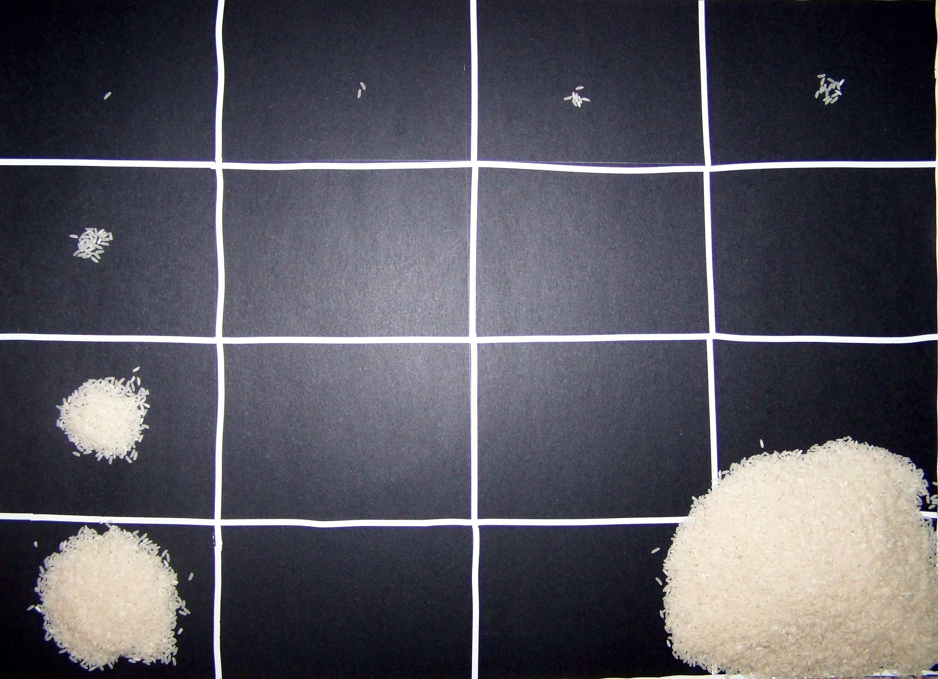
Figure 3; Four by four grid
Once the students have finished the task it is beneficial to have them reflect back on what they have just done by finally responding to key questions such as: Compare the number of grains of rice on the 16th square to how much rice had been used on the previous 15 squares? When did you know you were going to run out of rice? What do you think would happen if your graph continued? How much rice would be used on the 32nd square? How about the last square? How many squares do you have to move to quadruple the number of rice grains? How many squares do you have to move to have ten times as much rice?
Using this one activity, students have gained knowledge about exponential growth through multiple representations. They counted the rice grains and put them on the grid, wrote the numbers on the spreadsheet, discovered the equation that links the grains of rice to the square that they are on, and visualized it in a graphical representation. This also provides a concrete example that students can relate back to when they experience exponential growth in other areas.
Another example of where students can see the power of multiplying by two can be from simply folding a piece of paper in half (Bartlett, 1976, p.394). As students enter the classroom hand each of them a sheet of paper and have them predict how many times they could fold it in half. Once the students have made their predictions have them carry out the task. Most students will be able to fold a standard sheet of paper 6 times (see figure 4). It is important to help the students conclude that the thickness of the paper will experience six doublings.

Figure 4; Folded Paper
There are several important facets of exponential growth that can be brought out from this activity. One is the suddenness of exponential growth. “After the first two or three folds, everything seemed to be going fine. Then, suddenly, when we went from fold five to fold six, the game was suddenly up” (http://jzimba.blogspot.com/2007/05/understanding-exponential-growth.html, para. 15). This is an amazing aspect of exponential growth that is never seen in linear growth. Recall the question from the grains of rice activity that was important to ask “When did you notice you were going to run out of rice?” Most students don’t realize this until they’re on the last or next to last square. Albert Bartlett discusses a few interesting examples of this apparently sudden explosive growth dealing with bacteria in a bottle and algae on a lake in his famous talk on exponential growth which can be seen on www.youtube.com by searching “The Most Important Video You Will Ever See” or at http://dandelionsalad.wordpress.com/2007/12/23/the-most-important-video-youll-ever-see-videos-parts-1-4/ and http://dandelionsalad.wordpress.com/2007/12/23/the-most-important-video-you%E2%80%99ll-ever-see-videos-parts-5-8/. The second aspect is how astronomical the thickness of the paper would get if you were able to keep on folding the paper, which can be seen in detail at http://raju.varghese.org/articles/powers2.html. The area of the paper after each fold can also be used to demonstrate exponential decay.
Classroom Examples of Exponential Decay: Basketball and Dice
When moving on to the topic of exponential decay it is important to approach it similarly to the way we taught exponential growth. Just as exponential growth is something that has a constant doubling period, exponential decay is something that has a constant halving period. One way to illustrate this is to look at a bracket for the NCAA basketball tournament and show students that in each round half of the teams are eliminated; this means that each round could be analogous to a half-life (figure 5). Once the idea that the time it takes for something to be cut in half is a half-life, which most students grasp fairly quickly, there are several activities that you can do to help students experience this. One example of exponential decay is to drop a basketball and record the height, which decreases exponentially with each bounce (Sriraman & Strzelecki, 2004, p.30).

Round 1 Round 2 Round 3 Round 4

Figure 5; NCAA Bracket

Another experience in the classroom that can lead smoothly into the topic of radioactive decay or the discharging of a capacitor is to do a simple activity with dice. Have students break up into groups of about three or four and give each group 64 dice (this number can obviously vary) and a container with a lid to shake the dice (that is big enough for all the dice to be spread out). Have the students shake the container and then take out all of the dice that have odd numbers and count the dice that are left. In this example, each time students open the container and count the dice left, it should be one half-life. Have students repeat this process until all the dice have decayed or until they have repeated the process 10 times. Then have students graph their results using a spreadsheet (the number of rolls should be on the x-axis and the dice left should be on the y-axis). You can also demonstrate this curve for your class afterwards with two strips of paper (figure 6) (Palcic, 2006).
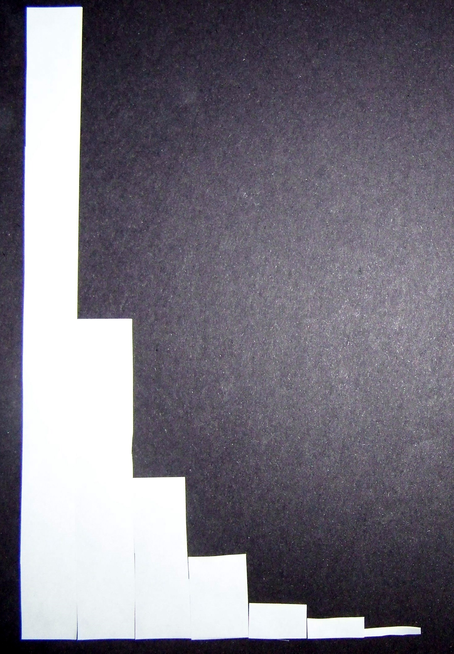
Figure 6; Paper curve
There are several variations of this activity using coins or M&M’s, although M&M’s tend to get eaten, which can be unsanitary. One advantage of using dice is that after the students have gone through this activity with having the odd numbers decay you can change the activity and have different groups use different rates of decay. For instance, one group may have only threes decay or another group may have fives and sixes decay. You can also use 20 sided dice for even slower decays. This can makes things more challenging for the students because now each time they open the container, it doesn’t necessarily correlate to one half-life. Since students will be getting different results it can also lead into a discussion at the end of the period where each group shares what they have learned. One concept that is critical to bring out in this type of discussion is the fact that the number of dice that decay is proportional to the number of dice that were in the sample (just like the number of rice depended on how many rice were on the previous square). In other words, as the number of total dice decreased so did the number of dice that decayed. For more details on this example see Lesson Plan 2 – Exponential Decay (http://physicsed.buffalostate.edu/pubs/PHY690/RheamExponential2008/).
A popular example of exponential decay is radioactive decay. The dice activity is a great way to lead into this discussion. Not only does it give the students a good background of what a half-life is, but it also allows them to see that radioactive decay really deals with the probability that any given atom will decay. A great way to continue to study radioactive decay involves activities from Vernier where students use the computer to collect data from real radioactive sources and actually see the curve form in front of them (Palcic, 2006).
Another area of physics that deals with exponential decay is the discharging of capacitors in dealing with circuits. Let’s consider specifically the discharging of a capacitor that has been charged up to nine volts and connected to a one ohm resistor. Many students imagine that a capacitor would charge and discharge at a constant rate. However, the current goes down as the voltage goes down. “This means it discharges at a progressively slower rate over time. When the capacitor voltage reaches six volts, there will only be six amps; when it’s three volts, the current is three amps” (http://www.coilgun.info/theory/capacitorcharging.htm, para. 6). Consequently, the capacitor is discharging exponentially.
Explanation Of e: Compound Interest
An essential component to understanding exponential growth and decay is the constant e. However, to simply say that e is a constant that is approximately 2.718 used in exponential growth and decay would be sidestepping one of the cornerstones of exponential functions. For instance, many students that enter the math classroom know that pi is a number that is approximately 3.14 and even know the formulas for circumference and area of a circle, but when they are questioned as to what pi means or what the formulas mean, they have no intuitive grasp of how pi relates to circles. Although e is a bit more mysterious than pi, I believe that it needs to be approached in a similar manner. We can’t sidestep it because it can be confusing, we have to address it in a way that will help students gain an intuitive grasp of what e is and what it means.
Many of the classroom examples that have been discussed, such as rice on a chessboard, rolling dice, and folding paper have discrete time variables; however, the physics examples such as radioactive decay and capacitor discharge have continuous time intervals. The essential link to get students from understanding these discrete exponential functions to grasping continuous exponential functions is giving them insight into what e is.
Since personal finance is an important issue for most students, especially as they move on to college and being in charge of their own finances, one of the easiest places to start examining e is by looking at money and how it grows (Faux & Hearn, 2004, p.488).
Let’s say that we put one dollar into an amazing bank account that doubles our money each year. Similarly to what we discovered with the rice on the squares of a chessboard, after one year our dollar would turn into two, then our two dollars would grow into four and so on (figure 7). Writing this in a formula we could say that our total money=2^{n}, where n is the number of growth periods. So the bank takes our money and adds another dollar or 100 percent to it giving us a new formula; total money=(1 + 100%)^{n} (http://betterexplained.com/articles/an-intuitive-guide-to-exponential-functions-e/).

1
1
1
1
1
1
1

Amount
of Money

0 1 2
Time (in years)

1
1
1
.50
1
.50
.25
1
1
1
1
.50

Amount
of Money

0 6 12
Time (in months)

Figure 7; One year intervals Figure 8; Six month intervals

In the real world, however, the bank is actually giving us interest throughout the year not instantly on the last day of the year. This means we could break it up further, into two six month intervals, where we would gain 50 cents in each of the two time periods. But, because the bank gave us interest after the first six months, the 50 cents would also gain another quarter in interest for the second six months (figure 8). This “interest on interest” is called compound interest. Our formula would now be growth=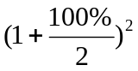 because there are two half-periods each with 50 percent growth. This would give us $2.25 which is actually more than doubling our money (http://betterexplained.com/articles/an-intuitive-guide-to-exponential-functions-e/).

1
1
1

.33
1
1

.04
.33

.11

.66

Amount
of Money

0 4 8 12
Time (in months)

Figure 9; Four month intervals
Still, we said that in real life that bank is giving us money all throughout the year, not just every six months. Figure 9 shows us what would happen if it was broken into three interest periods. Our new formula would be total money=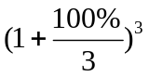 because there are three one-third-periods each with 33% percent growth and we would have a total of $2.37. So in general we could say that total money=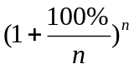, where n is the number of splitting periods (http://betterexplained.com/articles/an-intuitive-guide-to-exponential-functions-e/). If we continued to increase the number of splitting periods here is what would happen:
# of Splitting Periods | Total Money
1 | 2
2 | 2.25
3 | 2.37
5 | 2.488
10 | 2.5947
100 | 2.7048
1,000 | 2.7169
10,000 | 2.71814
100,000 | 2.718268
1,000,000 | 2.7182804

Figure 10; Graph of 100 splitting periods Figure 11; Chart of a million splitting periods
Notice the graph has 100 splitting periods and the chart has 1,000,000 splitting periods yet both converge around the same number 2.718 otherwise known as e. So e is irrational as n goes to infinity; e=lim(1+1/n)^{n}. This means if we invested one dollar and it was compounded continuously at 100 percent for one year we would have $2.72, which is our starting amount of money times e (http://betterexplained.com/articles/an-intuitive-guide-to-exponential-functions-e/). If we had a different percentage, in general, we could say that our Total money = Initial x e^{rate x time}. This formula does not just apply to financial growth; it can be applied to any continuous exponential growth or decay (where the rate would be negative). This principal allows us to take our concrete examples of rice, rolling dice, and folding paper and move into our physics examples of radioactive decay and capacitor discharge.
Conclusion
Understanding exponential functions is crucial for comprehending several key topics in physics, and students cannot gain this knowledge through formulas and graphs alone. In order for students to have an intuitive grasp of exponential functions they need explore it for themselves and be encouraged to use multiple representations to portray what they have learned. The most effective way to provide this experience is through real life examples like those discussed in this manuscript. Once students have been introduced to these concrete examples that have discrete time periods, learners should be presented with a physical example of e, like that of compound interest. This intuitive knowledge of e provides students with the essential link to get from understanding discrete exponential functions in our classroom examples to grasping the continuous exponential functions that are explored in physics.
References

Alagic, M. & Palenz, D. (2006). Teachers explore linear and exponential growth: Spreadsheets as cognitive tools. Journal of Technology and Teacher Education, 14(3), p.633-649
Birch, D. (1988). The King’s Chessboard. New York, NY: Dial Books for Young Readers.
Bartlett, Albert A. (1976). The exponential function – part I. The Physics Teacher, 14, 393-401.
Confrey, J., & Smith, E. (1994). Exponential functions, rates of change, and the multiplicative unit. Educational Studies in Mathematics, 26, 135-164.
Confrey, J., & Smith, E. (1995). Splitting, covariation, and their role in the development of exponential functions. Educational Studies in Mathematics, 26, 66-86.
Doerr, H. M. (2000). Using students’ ways of thinking to re-cast the tasks of teaching about functions. The Journal of Mathematical Behavior, 18(4), 431-454.
Faux, D. A. & Hearn, S. (2004). Using the stock market to teach physics. The Physics Teacher, 42, 488-492.
Goldberg, F. & Shuman, J. (1984). Understanding exponential growth: As simple as a drop in a bucket. The Physics Teacher, 22, 444-445.
Greeno, J.G., & Hall, R.P. (1997). Practicing representation: Learning with and about representational forms. Phi Delta Kappan, 78(5), 361-367.
National Council of Teachers of Mathematics. (2000). Principles and standards for school mathematics. Reston, VA.
Palcic, Z. (2006). Teaching radioactivity in high school. SUNY-Buffalo State College PHY690 Project.
Romer, R. H. (1991). The mathematics of exponential growth – keep it simple. The Physics Teacher, 29, 344-345.
Sriraman, B. & Strzelecki, P. Playing with powers. International Journal for Technology in Mathematics Education, 11(1), 29-33.
Strom, A (2006). The rolve of covariational reasoning in learning and understanding exponential functions. Conference Papers -- Psychology of Mathematics & Education of North America. Annual Meeting, 1.
Weber, Keith (2002). Students’ understanding of exponential and logarithmic functions. (ERIC Document Reproduction Service No. ED477690)

