A physical model using a Lycra® sheet for teaching
gravitational and electric fields in introductory physics
Justin L. Snook
A project submitted in partial fulfillment of the requirements of the degree of
Master’s in Science Education
State University of New York College at Buffalo

Abstract: Newton’s law of universal gravitation is typically presented with an emphasis on its mathematical formalism through the inverse-square relationship between two objects’ spatial separation, r, and the gravitational force they exert on one another, namely
$\left|\vec{F}\right|= \frac{GMm}{r^{2}}$. Often the derivation is given to students with little experimentation to determine the relationship between the variables, i.e. M, m, and r. However, a Lycra® sheet can provide a physical model for gravitation and a means to demonstrate the nature of gravity, visually representing the distortion of the field around a mass. In this paper, I discuss several of the activities and lessons to develop the Lycra® Sheet Field Model for the gravitational force and then extend the model to demonstrate gravitational field and potential. Finally, I extend the lessons to the analogous nature of the electric field.

Introduction
This paper applies model-centered instruction and lecture demonstrations in teaching field force concepts. I introduce the Lycra® Sheet Field Model as a physical model for gravitational fields. The model is patterned after the space-time fabric in Einstein’s theory of general relativity. The Lycra® sheet provides a visual representation describing the effect of an object on the space around it. Once the model has been fully developed for gravitation, it then becomes an analogous model for the electric field. This paper describes how the Lycra® sheet might be implemented in the curriculum for an introductory physics class.

Background
Student Beliefs | Traditional Instruction | LSFM Instruction
Boundary Model - The effects of gravity diminish rapidly or disappear completely, no gravity in space (Williamson & Willoughby, 2012).  Gravity is the result of other forces (i.e. magnetism, rotation, or atmospheric pressure) (Watts, 1982).  The force of gravity acts through a medium (Watts,1982; Williamson & Willoughby, 2012 ).  The gravitational force is selective in how/when it is applied (Watts, 1982).  Inconsistent in the way they apply their beliefs about gravity (Palmer, 2001). | The traditional approach “does not take into account the students’ initial conceptions, which are often incompatible with scientific knowledge” (Baldy, 2007).  Historical approach starting with Kepler’s Laws and then proceeds to discuss Newton’s use of these laws, which are based on observation, to derive $\left|\vec{F}\right|= \frac{GMm}{r^{2}}$ whereas the conceptual relationships are generally stated.  Textbooks seldom devote a whole chapter to gravitation. Gravitation is often with the chapter on uniform circular motion.  Students memorize the formula, remembering and reciting it, but lack conceptual understanding of the physical phenomenon. | The Lycra® Sheet Field Model agrees with modern, relativistic theory.  The use of a physical model to represent the gravitational field enables the student to make personal prediction and observations about the nature of the field.  Demonstrations show that the field is not a localized phenomenon, Students determine that gravitational force has infinite range.  Demonstrations show the interactions of gravitational fields causing objects to attract to one another.  Objects orbiting a massive object can be demonstrated using the Lycra® Sheet Field Model.
Abstract electrostatic concepts are difficult for students to assimilate and understand (Arons, 1997).  Students have little conceptual experience with electrostatic phenomena.  Students’ experience of static electricity comes from observations of static cling, static electric shock, charging a rubber balloon by rubbing it against their hair, etc.  Young children are told by their parents that “opposites attract” without being given any explanations.  Students learning about electrostatic phenomenon are able to use terms such as “electric charge,” “like charges,” “unlike charges,” “electric current,” “potential difference,” etc., but cannot give concrete meanings to describe the words as they use them.  Students will often attribute the electric force interactions to another force, like gravitational or magnetic. | Often taught after mechanics topics and most students do not see a connection between the topics.  Demonstrations of charging processes and the interaction between charged objects.  The relationship between charged objects is generally given to the students and, like gravitation, many times does not include a physical model demonstrating the reasons for the interaction.  The Coulomb’s Law equation is generally stated, followed by the analogy to Newton’s law of gravitation and comparing the relative strength of the respective forces. | The gravitational – electric force/field analogy develops naturally.  Each concept has already been introduced in terms of the gravitational field, and the difficulties the students generally have with the nature of the electric field dissipates.  The abstract and foreign concepts that students typically struggle with do not affect student learning.  Instruction with the Lycra® Sheet Field Model to teach electrical concepts becomes a spiraling activity and an opportunity to review concepts.  Students observe that the interaction between objects that are charged does not require physical contact in order for the force to be applied.  Students are able to independently recognize the similarity to gravitational attraction. They should notice that the closer the charged objects are, the greater the electric force is acting between the charged objects. This observation may remind them of the gravitational field relationship. At this point, students can return to the Lycra® Sheet to review the gravitational field concepts.

The Lycra® Sheet Field Model
The Lycra® Sheet Field Model is introduced as a physical model of gravity that is patterned after Einstein’s theory of the space-time fabric. The Lycra® sheet can be purchased at any fabric store. It is recommended that the fabric contain about 20% spandex, which gives it a considerable amount of stretchiness. The sheet should be large enough to be easily manipulated and visible to the whole class; a 4.5’ x 4.5’ sheet is a good size to meet these requirements. The sheet will be slightly stretched, adding a slight tension to the sheet to make it a flat, horizontal surface. Some teachers have constructed a circular frame to attach the sheet for support, where students line up around the frame to hold it and to observe the demonstrations. Other teachers have just used the students to hold on to the sheet and stretch it manually. This allows the students to feel the pull on the sheet during the demonstrations.
------------------------------------< Insert Fig. 1 >-------------------------------------------------------------

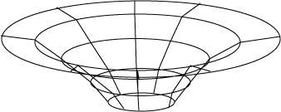
When an object, like a small medicine ball, is placed on the fabric, the mass causes the fabric to stretch as it moves closer to the ground. However, due to the nature of the spandex in the sheet, the slope of the sheet is not constant. In fact, the shape of the sheet and the graph of the gravitational field strength versus the distance from the object have a similar shape. Therefore, the sheet provides a sufficient model of the gravitational and electric field. The changing of the shape of the sheet by the mass of the object represents the distortion of the space-time fabric. The Lycra® Sheet Field Model, therefore, is a model that agrees with modern, relativistic theory.
The use of a physical model to represent the gravitational field, and later the electric field, enables the student to make personal prediction and observations about the nature of the field. Through their observations and discussions, students can reject the common misconceptions discussed previously. Students may observe that the field is not a localized phenomenon. Rather than having a boundary, students should determine that gravity reaches to infinity. By demonstrations applying the Lycra® Sheet Field Model, students can see that it is the interactions of these fields that cause objects to be attracted toward one another. If the curriculum requires instruction on Kepler’s Laws (like in the AP Physics C course), the teacher could use the motion of orbiting objects around a massive object using the Lycra® Sheet Field Model. However, in this case, it should be noted that the Lycra® Sheet fails to show exactly the continuous motion of the orbiting object due to the friction of the sheet on the object. The teacher should make sure to point out the limit of the model in this application.
The Lycra® Sheet Field Model is introduced briefly at first, perhaps by showing the gravitational field and stating that the slope of the sheet represents the field. Spiraling back to the sheet at specific points in the curriculum is important to developing conceptual knowledge of fields. Each time the sheet is used, a review of the parts of the model should be done, followed by new components of the model. By the end of the gravitation unit, the student should know all the characteristics of a field from the Lycra® Sheet Field Model.
Using activities and demonstrations to show the interaction between electrically charged objects is important for students. Students need to be able to observe that the interaction does not require physical contact. Without the teacher telling them, students should be able to recognize the similarity to gravitational attraction. They should notice that the closer the charged objects are, the greater the electric force is acting between the charged objects. This observation may remind them of the gravitational field relationship. At this point, students can return to the Lycra® Sheet to review the gravitational field concepts. Ideas like the deformation of the sheet, the relative strength of the field, represented by the slope of the sheet, at different locations on the sheet, and the shape of the field lines should be among the concepts reviewed. This action renews the context for the students and focuses their thinking on applying the model to a new situation.

Using the Lycra® Sheet Field Model
Gravitational | Electric
Field
Introduction of the Model  The Lycra® Sheet Field Model is introduced after the students have defined the gravitational field strength. (For a detailed description of activities, see the Curriculum guide, Appendix A) The sheet represents the field, a property of the space. When there is no object within that region of space, that field is undisturbed. The teacher asks for predictions about what would happen if an object, like two pound medicine ball, would be placed in the sheet. The object will deform the sheet, pulling in down closer to the ground.  -------------< Insert Figs. 2 and 3 >---------------  After performing the demonstration, the teacher should remove the object and ask for another prediction about an object with greater mass in the same place on the sheet. Following the demonstration of the more massive object, ask students to make observation and comparisons of the two objects. Students should make the following observations:  - The object with more mass deformed the sheet more than the less massive object.  - The sheet has the same general shape regardless of how much mass the object has.  - In either case, the sheet has a slope, even if it is very small.  - The slope of the sheet decreases rapidly as you move away from the object.  These observations should lead to a greater discussion later when spiraling back when discussing Newton’s Law of Universal Gravitation. However, a simple statement of these observations is sufficient at this point.  In the Lycra® Sheet Field Model, the field strength is represented by the slope of the sheet. An object with mass deforms space around it and create a gravitational field. Near the object, the field is greatest, causing the sheet to have the greatest slope near the object. If you examine the slopes at different distances away from the object, the sheet has different slopes, decreasing with greater distances. The teacher should ask the students if the sheet ever remains horizontal, or with a zero slope. The students should recognize that the there is a non-zero slope everywhere on the sheet, even if it were extended to infinity. This line of reasoning should be applied to the misconceptions that gravity has a boundary, does not exist in space, or only exists on the earth.  The slope of the sheet at the same distance from the object always has the same magnitude. This observation is necessary in relating the demonstration back to the investigation of weight versus mass of objects. Since all the measurements were taken at virtually the same distance from the object (the earth), the field would be the same value, approximately 10 N/kg. Students can then model the weight of an object from the graph they generated,$\vec{ F}=\vec{g}m$, where $\vec{g}$ is the slope of the line that they found. Students could then determine the weight of an object with a known mass if they knew the value of the field strength. | Standard demonstrations showing the interaction between electrically charged objects reinforces the field concepts and prompts students to recognize the similarity to gravitational attraction. This action renews the context for the students and focuses their thinking on applying the model to a new situation.  After spiraling the conversation for  review, the students should begin applying the model to the electric force / field. Beginning with a flat sheet, a “charged” object is placed in the field. The students should understand that we are using gravity to model the electric field around the charge. A simple statement of why we can do this can be made. Through the demonstrations at the beginning of the unit on electrostatics, students should have observed that there is an inverse relationship between the force between the charges and the separation of the charge, i.e. the farther away the charged objects are from the other, the smaller the effect on each other. A charged object interacts with other charged objects similar to the way an object with mass interacts with other objects with mass. It does not, however, interact with its own field.  Students also need to see the differences between the gravitational field from an object’s mass and the electric field produced by a charged object. An object’s mass has only a positive the value. As such, the force is always attractive, always drawing two masses together. However, a charged object can either have a positive or negative charge, determined by if the object has lost or gained electrons. Therefore, while all gravitational deformations of the field produces wells in the field, electric fields can produce a well or an “anti-well”, or “witches hat”, that goes upward. This is easily demonstrated on the Lycra® sheet. If a charged object creates a well, the opposite charge can be positioned on the bottom of the sheet and pushed upward and held there by the teacher or student. It obviously will not be able to stay there by itself due to gravity. This limitation to the model should be pointed out. A second important difference between the gravitational force and the electric force the students should know is the difference in magnitude of the forces is due to the experimentally measured constants, G and k$\left(\frac{1}{4πε_{0}}\right)$. Also, Coulomb’s Law can only be applied to stationary, or very slow moving, charged objects. When the charges have motion, other physics, for example special relativity and electromagnetism, dominates and overtakes the Coulombic relationship.  The conceptual formation of the electric field follows the procedure for creating the gravitational field line. It can be repeated using “charged” objects on the sheet and test “charges” at different points. In addition to “point charges, students should observe the distribution of other charged objects. Two similarly charged objects can cause a two-well deformation on the sheet. Using a test charge can reveal the shape of the field line at a position in the field. Students are encouraged to draw the force on the test charge on the sheet from one charged object and then the second. The resultant of these forces produce the direction of the field line at that position. The electric field around two similarly charged objects is significantly different that an electric field around a single charged object. This demonstration can allow students to infer information about the electric field around two objects with different charges.  Students should also compare their drawn field lines with the slope of the sheet. The electric field is represented by the sheet’s slope. Generally, the slope is greatest near the “point” charges and decreases as you move away from both charges. Starting with two equally charged objects, the teacher asks the students to locate a point on the sheet where the electric field has a zero value. By examining the sheet, students may observe that the sheet has a slope at every point in the field. This may lead the students to the conclusion that there is an electric field at all points in space around two similarly charged objects. On the other hand, a field created by two oppositely charges particles would have an electric field of zero somewhere between the charges, which is observed as a horizontal (zero slope) part of the sheet at that point. If students were to be given a problem asking to locate a zero electric field, they could model it with the sheet to confirm their solution.
Universal Gravitation and Field lines

Teaching gravitation using the Lycra® Sheet Field Model begins with an object placed on the sheet to create a gravitational field. A second object of equal mass is shown to the class and predictions from students are solicited about the effects of placing it on the sheet at a different location on the sheet and released. Following the students’ statement of their predictions, perform the demonstration and ask for observations. If done properly, the masses should move towards one another. Remove the second mass and repeat the demonstration two additional times with a smaller second mass each time. Ask the students to compare the three trials: how they are similar and the effect of the mass on the attraction of the objects.
The second demonstration leads to the development of the field lines in a more traditional sense. Using a flat, horizontal sheet with no object in the field, the students are asked to decide how they can determine if a gravitational field is present. Using what they observed from the first demonstration, they should relate that an object placed in the field would feel an attraction, a force that causes it to move toward a second object.

--------------------< Insert Fig. 4 >----------------

The students should discuss the characteristics of the “test” mass in relation to field from an object, specifically it should be very small so it does not distort the field it is in. A mass is placed in the sheet to create a gravitational field, and students can draw on the sheet (with chalk) the direction of the forces at various locations in the field and at different distances from the source of the field. Students should also see that the force is greater near the object and decreases as you move away. When this is done at all points in the field, the standard map of the gravitational field is generated on the sheet. This demonstration is typically done in traditional instruction. However, using the sheet provides the student the experience of generating the field map. This leads to greater understanding of the concept of gravitation. Students should observe that the field lines extend radially, indicating that the field weakens as you move away from the field source. Student understanding of this relationship will be useful when progressing on electric fields. In addition a conceptual introduction to Gauss’ Law and flux can also be discussed.

------------------< Insert Fig. 5 >------------------
Students have now developed a conceptual understanding of the interaction of objects based on their mass. At this point they can do an investigation to determine the mathematical relationship between the masses and the separation of the objects. For example, the “Modeling Universal Gravitation Activity” has students use a simulation at the PhET website (http://phet.colorado.edu/en/contributions/view/3805). In this two part investigation, students manipulate: 1) the values of two masses and 2) the separation of the objects. Students take data for each part and generate a graph, linearizing if necessary, define the relationship and a mathematical model for the data, and calculate the slope of the linearized equation. This activity generates Newton’s Universal Gravitation formula and derive the Gravitational constant, G. After the students perform the investigation, they should write their results and conclusions on a whiteboard and share with their classmates. At this point, students should be led to define the general expression for $\left|\vec{g}\right|$using the relationships they have just discovered,$\left|\vec{g}\right|= G\frac{M}{r^{2}}$.
Potential
The third activity in this unit is an advanced topic that is usually included in a college level or AP physics curriculum. However, certain concepts should be introduced at this point even in a standard physics course so that they can be used to introduce potential of electric fields. To begin, students should review gravitational potential energy that they have learned in the energy unit. This can be done by using a whiteboard to summarize potential energy concepts. The students should remember that the position of the object relative to the earth determines how much energy is stored in the gravitational field. Using stairs whiteboards, pairs of students stand at different steps. Each student is asked to estimate their mass (1 pound is about 0.5 kg), and potential energy. To find their height, students can measure the height of one step and then count how many steps they are above the ground. Next, students determine their gravitational potential by dividing their potential energy by their mass. Students should discover two important concepts: 1) even though they have different masses, students that are on the same step have the same gravitational potential and 2) the potential increases by the same factor for each step they go up. When students move along the level of the step, they do not change gravitational potential and no work is required for them to move along the potential. However, if the students move to a lower step, they now have a lower potential because of the work done by the field. Similarly, work is needed against the field to move them to a higher potential.  Although rarely taught in the standard physics classroom, gravitational potential is an important concept to include in the curriculum. In addition to providing a conceptual anchor to spiral back to when teaching electric potential, the gravitational potential provides the reasoning for equipotential lines that are found on contour maps. Students will use the analogy of contour lines again when they are looking at electrical equipotential surfaces around a charge (Andereck, 1990). The gravitational potential was named “liftage” by Saeli and MacIsaac (2007) to highlight the analogy to the electric potential term voltage. Liftage and liftage difference are defined similar to voltage and voltage difference. In general, gravitational potential is the potential energy per unit mass$\left(L=\frac{GPE}{m}\right)$. This simplifies to  $L= -\vec{g}∙\vec{r}$ for the field around a circular object, and in general the potential is the product of the field and the position of the object.  In the Lycra® Sheet Field Model demonstration of liftage, the sheet is again held and an object is placed in the sheet to create a gravitational field. Students will again draw the gravitational field lines on the sheet. The teacher chooses a point on the sheet, marking it with chalk. The chalk should be passed to students around the sheet and they should mark on the sheet some point that has an equal potential as the teacher-made mark. For a circular object, the marks should make a circle around the object. If there are any points that are not expected, a discussion by the students should occur to verify the validity of those points. A second point at a different distance from the object can be selected and the students should recognize that the equipotential lines should, again, circle the object. Repeating the activity for multiple lines creates the contour map that students may have seen in a previous class. It should be pointed out that the "height" of the sheet, the vertical distance the sheet has moved from the horizontal, flat sheet, at a point represents the liftage at that point. In comparison, the slope of the sheet at the point represents the magnitude of the gravitational field at that point in space. Therefore, liftage, like the field, is a property of the space. The space is gravitationally deformed by the presence of an object within that region of space. | The concepts for the electric potential were developed in the gravitation demonstration of gravitational potential, or liftage. Returning to the concepts in context with the electric potential is a review activity. In the gravitational demonstration, the potential was determined to be the ratio of the potential energy to the mass, a property of the object. In terms of the electric potential, the object’s property being examined is the charge it has. The electric potential, therefore is the potential energy per unit charge,$\left(V=\frac{EPE}{q}\right)$. It is conventionally named voltage, thus the prior analogous term liftage. Just like liftage is  $L= \vec{g}∙\vec{r}$, that is the product of the field strength and the distance from the object with mass that creates the field, voltage simplifies to $V= \vec{E}∙\vec{d}$, the product of the field at a distance from the charged object. On the sheet, the vertical displacement of the sheet at the point represents the electrical potential. The difference in potential causes the test charge by setting up the electric field. Without a potential difference, there would be no electric field, the sheet would have a slope of zero and the test charge would remain stationary. The sheet is displaced by the charged object, creating a well, or anti-well, in the sheet and the test charge will respond according to the charge creating the well.  A uniform field between oppositely charged parallel plates can be modeled using two 50 cm sticks. One 50 cm stick is placed on the top of the sheet and one is held on the bottom.  ---------------< Insert Fig. 6 >----------  When the plates are “not charged”, the rulers are at the same level. Once the plates are “charged”, the plate on the top of the sheet is pushed down, becoming the “negative” plate, and the plate under the sheet is pushed upward, becoming the “positive” side. Students are asked to describe the field between and outside the plates. They should notice that the slope of the sheet between the plates is constant, indicating that the electric field is uniform between the plates. They may also notice that the field looks differently near the edges of the plates than in the center of the plates. If they were to use the test charge on the field, they could determine that the charge would go directly toward the negative plate when placed between the plates, and would run away from the edge of the upward, positive and the curving toward the negative plate.  The students should also repeat drawing the potential lines around the point charge that they did for the gravitational unit. The students will see that the potential will be the same value at the same distance from the charge, creating concentric circles of equal voltage around the charge. In order to move a charge to a different step of potential, work needs to be done, either on the charge by the field in moving it to a lower potential or on the charge by a second object that moves it to a higher potential. The wells and anti-wells can be viewed experimentally by mapping the potential field.

Using the sheet to show the electrical potential removes much of the conceptual confusion that students have about the nature of the potential. For example, many students will express that an electric field is necessary to have an electrical potential, that the potential is zero if the electric field is zero. This comes from the misapplication of the definition of the electric potential,
$V= \vec{E}∙\vec{d}$. However, in the modeling demonstrations, students can observe the electric potential can have a nonzero value even if the net electric field is zero. For example, with the ring of charge situation, the electric field is definitely zero inside the ring because the sheet is flat in that region. However, the sheet has been displaced by the ring upward, representing the potential is not zero, although it does have a constant value. In another example, four identically charged point charges are arranged at the four corners of a square. When the sheet is used to construct this arrangement of charges, the center of the square will have zero slope, indicating zero electric field. However, the center will be moved upward from the plane it is on without the charges, indicating a nonzero value for the electric potential.
Other important charge distributions can be observed and discussed using the Lycra® Sheet Field Model. For example, determining and analyzing the field for a charged ring is generally conceptually challenging, and is typically done mathematically using Gauss’ Law. However, student can use the top of a cup to model the ring of charge. Pushing the cup up from beneath the sheet shows the electric field for the ring of charge. In the center of the ring, the sheet remains flat, its slope is zero. If a test charge is placed in the center of the ring, the charge will not move because the slope of the sheet is zero. Outside the ring appears to be similar to the point charge, and so the field will decrease as inverse-square of the distance, which Gauss’ Law calculations agree. Teachers could demonstrate many similar charge distribution, including a rod of uniform charge distribution with a nearby point charge, etc.

Conclusions
The Lycra® Sheet Field Model provides a physical model for both the gravitational and electric field. Research has shown that model-centered instruction provides engaging, student-centered activities that increase student conceptual understanding. Through lecture demonstrations, probing questions, and the predict–observe–explain learning cycle, students are actively involved in the development of the Lycra® Sheet Field Model at specific points in the curriculum. The model is progressively broken and modified to include new understandings of the gravitational field, including universal gravitation, gravitational potential energy, and gravitational potential. Students can use the lessons learned through the demonstrations as a working model that they can apply to conceptually solve problems.
Following the full development of the Lycra® Sheet Field Model to explain gravitational concepts, the model is then extended to provide an analogous model for the electric field. Since the model is fully deployed when learning about gravitation, a topic students are familiar with and whose concepts can be contrasted by experience, the application of the model during lessons on electric fields becomes a spiraled lesson instead of new content. Even advanced topics, like Gauss’ Law, could be introduced as a conceptual tool when discussing universal gravitation so that the concept becomes familiar to students and removes some of the mathematical sophistication that is inherent when learning about electric potential and charge distribution.
Further research is needed to determine student reception of the model, willingness to use and apply the model, and performance when applying the model in solving problems. However, since the model is designed on research-based principles of modeling-centered instruction and lecture demonstrations, it has the potential to provide a concrete, working model for students to use when learning about the abstract concepts of fields. The students’ role in unpacking the components of the model is most essential to its usefulness as such. When the students are engaged in discovering the model, they will see its usefulness may be more inclined to apply it, even when not required to do so.

References
Andereck, B. (1990). Using contour maps to teach electric field and potential. The Physics Teacher, 28, 7.
Arons, A. B. (1997). Teaching introductory physics. New York: Wiley.
Baldy, E., (2007). A new educational perspective for teaching gravity. International Journal of Science Education, 29, 14, 1767-1788.
Palmer, D. (2001). Students' alternative conceptions and scientifically acceptable conceptions about gravity. International Journal of Science Education, 23, 7, 691-706
Watts, D. M. (1982). Gravity – Don’t take it for granted!. International Journal of Science Education, 17, 4, 116 – 121.
Williamson, K., & Willoughby, S. (2012). Student understanding of gravity in introductory college astronomy. Astronomy Education Review, 11, 1, 10105.

Biography
Justin Snook was born in Sabetha, KS. He received his B.A. in physics from The State University of New York at Buffalo in 2005 and completed his Master's degree (M.S.Ed. physics) in 2013 at SUNY Buffalo State College. He has taught introductory physics at the secondary level in Raleigh, North Carolina and Buffalo, New York since 2006. Justin can be reached at jstnsnook@gmail.com.

Appendix
Figures and Tables
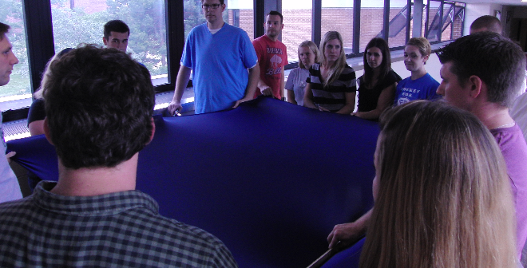
Figure 1: Students supporting Lycra® Sheet during demonstration.

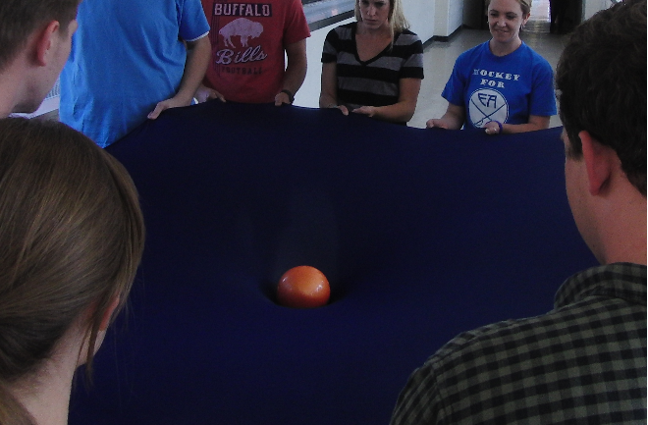
Figure 2: Top view of a ball placed on sheet to create a gravitational field in the sheet.

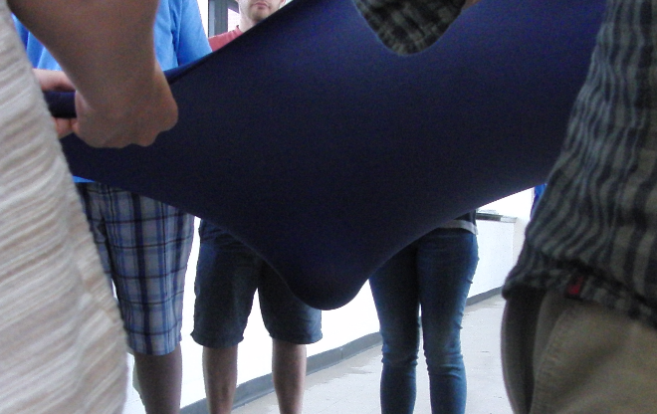
Figure 3: Bottom view of a ball placed on sheet to create a gravitational field in the sheet.

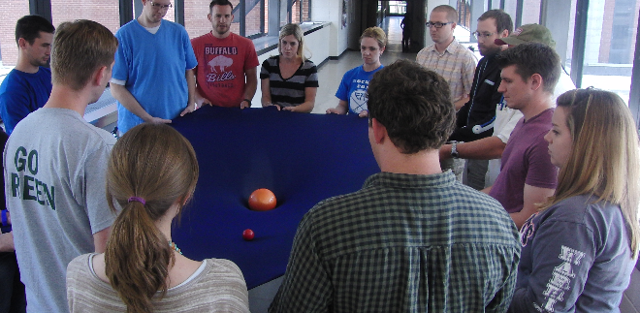
Figure 4: Small test mass is placed on the sheet to test indicate the direction of the gravitational force from the ball

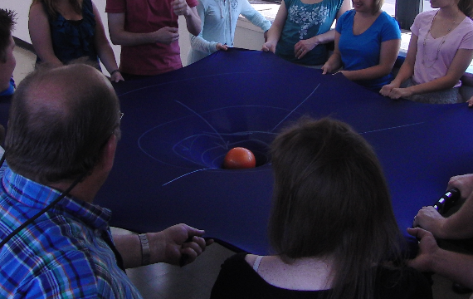
Figure 5: Sheet with student-drawn gravitational field lines.

Figure 6: Two charged parallel plates modeled by 50 cm rulers

Gravitation
Student Beliefs
Boundary Model - The effects of gravity diminish rapidly or disappear completely, no gravity in space (Williamson & Willoughby, 2012).

Gravity is the result of other forces (i.e. magnetism, rotation, or atmospheric pressure) (Watts, 1982).

The force of gravity acts through a medium (Watts,1982; Williamson & Willoughby, 2012 ).

The gravitational force is selective in how/when it is applied (Watts, 1982).

Inconsistent in the way they apply their beliefs about gravity (Palmer, 2001).

Traditional Instruction | LSFM Instruction
The traditional approach “does not take into account the students’ initial conceptions, which are often incompatible with scientific knowledge” (Baldy, 2007).  Historical approach starting with Kepler’s Laws and then proceeds to discuss Newton’s use of these laws, which are based on observation, to derive $\left|\vec{F}\right|= \frac{GMm}{r^{2}}$ whereas the conceptual relationships are generally stated.  Textbooks seldom devote a whole chapter to gravitation. Gravitation is often with the chapter on uniform circular motion.  Students memorize the formula, remembering and reciting it, but lack conceptual understanding of the physical phenomenon. | The Lycra® Sheet Field Model agrees with modern, relativistic theory.  The use of a physical model to represent the gravitational field enables the student to make personal prediction and observations about the nature of the field.  Demonstrations show that the field is not a localized phenomenon, Students determine that gravitational force has infinite range.  Demonstrations show the interactions of gravitational fields causing objects to attract to one another.  Objects orbiting a massive object can be demonstrated using the Lycra® Sheet Field Model.

Electric
Student Beliefs
Abstract electrostatic concepts are difficult for students to assimilate and understand (Arons, 1997).

Students have little conceptual experience with electrostatic phenomena.

Students’ experience of static electricity comes from observations of static cling, static electric shock, charging a rubber balloon by rubbing it against their hair, etc.

Young children are told by their parents that “opposites attract” without being given any explanations.

Students learning about electrostatic phenomenon are able to use terms such as “electric charge,” “like charges,” “unlike charges,” “electric current,” “potential difference,” etc., but cannot give concrete meanings to describe the words as they use them.

Students will often attribute the electric force interactions to another force, like gravitational or magnetic
Traditional Instruction | LSFM Instruction
Often taught after mechanics topics and most students do not see a connection between the topics.  Demonstrations of charging processes and the interaction between charged objects.  The relationship between charged objects is generally given to the students and, like gravitation, many times does not include a physical model demonstrating the reasons for the interaction.  The Coulomb’s Law equation is generally stated, followed by the analogy to Newton’s law of gravitation and comparing the relative strength of the respective forces. | The gravitational – electric force/field analogy develops naturally.  Each concept has already been introduced in terms of the gravitational field, and the difficulties the students generally have with the nature of the electric field dissipates.  The abstract and foreign concepts that students typically struggle with do not affect student learning.  Instruction with the Lycra® Sheet Field Model to teach electrical concepts becomes a spiraling activity and an opportunity to review concepts.  Students observe that the interaction between objects that are charged does not require physical contact in order for the force to be applied.  Students are able to independently recognize the similarity to gravitational attraction. They should notice that the closer the charged objects are, the greater the electric force is acting between the charged objects. This observation may remind them of the gravitational field relationship. At this point, students can return to the Lycra® Sheet to review the gravitational field concepts.

