Building a model of diffraction and interference for high school physics students using multiple inquiry-based experiments.

Quinn Thomson, SUNY - Buffalo State College, 1300 Elmwood Ave, Buffalo, NY, 14222 <qbraxo@gmail.com>

Acknowledgements: This paper is submitted in partial fulfillment of the requirements necessary for PHY690: Masters Project at SUNY – Buffalo State College under the guidance of Dr. Dan MacIsaac.
Abstract
With the recent implementation of the Next Generation Science Standards (NGSS, 2013) and the New York State Science Learning Standards (NYSSLS, 2016), a focus has been placed on inquiry-based science education. Here we present a series of experiments to have high school regents physics students investigate diffraction and interference. Using the experimental guides (Appendices A and C) students make observations and collect data to answer questions that help them describe the physical relationships of diffraction and interference and challenge possible misconceptions. Students will also be asked to create and complete their own experiments as a method to assess their understanding of the topic (Appendices B and D). Something about my results, hopeful: After completing these experiments students have shown improvement with understanding how diffraction patterns are created and how they relate to the object that is creating them.

Introduction
Our goal is to make a series of student experiments that use the standards listed in the NYSSLS to have students gain an understanding of diffraction and interference. These labs will be a mixture of guided inquiry experiments and fully student led experiments. In our guided inquiry experiments, students are given a simple procedure and asked questions based on what they observe and analyze. These student led experiments are when we give students a goal but offer no procedure, requiring students to use their own understanding of the subject to complete the goal.
Scientific inquiry is characterized by the NYSSLS by
“a common set of values that include: logical thinking, precision, open-mindedness, objectivity, skepticism, replicability of results, and honest and ethical reporting of findings.” Page 64
Our guided inquiry experiment follows these values and has students record their observations and work through tougher questions, using these observations to help them. By using multiple labs, we allow students to replicate their observation and results in a variety of different ways.
Across the NYSSLS students are asked to demonstrate that they understand how to “Plan and conduct investigations” across multiple subjects.
Students, during these experiments, will be asked to formulate their own experiments and correct their own initial misconceptions, using the evidence gathered through their experiments. The questions for later experiments will guide students into making logical conclusions based on their observations.
The NYSSLS (HS-PS4-3) states:
“Evaluate the claims, evidence, and reasoning behind the idea that electromagnetic radiation can be described either by a wave model or a particle model (quantum theory), and that for some situations one model is more useful than the other.
[Clarification Statement: Emphasis is on how the experimental evidence supports the claim and how a theory is generally modified in light of new evidence. Examples of a phenomenon could include resonance, interference, diffraction, and photoelectric effect.]” Page 62
These experiments are designed to give students a closer look at interference and diffraction through experimental evidence. They will be asked to describe and reason through the cause of these phenomena using the wave model of light.

Scientific Background
Wavelet
Wavelet Source
New wave-front
Original wave-front
Figure 4
Diffraction is the bending of waves around the edges of a barrier. The most common examples of diffraction are the bending of sound waves around an open-door, as in figure 1, or the bending of ocean waves around a barrier, as shown in figure 2.
Figure 2
Figure 1

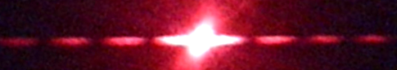
Figure 5

Interference is when two waves are at the same place at the same time. Unlike matter, waves have nothing preventing them from being superimposed. There are two types of interference: constructive and destructive. These are distinct based on what we observe when they are on top of one another. Constructive interference is when two or more waves form an apparent wave with a higher amplitude than either of the original waves, while destructive interference creates a wave with a smaller amplitude as seen in figure 3.
a)
b)
Figure 6: hair results
a) shows results expected for the “shadow” misconception of hair blocking light
b) shows the actual results
Constructive
Destructive
Figure 3
The key factor that creates the effect of diffraction is Huygens’ principle. Huygens’ principle states that every point on a wavefront is a source of new waves (often referred to as wavelets) (Knight 2013). These new waves will normally end up interfering and canceling each other out, so it acts as just a single wavefront as seen in figure 4. However, when a wavefront comes across a thin barrier, slit, or multiple slits, the waves no longer cancel out their interference and a new pattern emerges that we refer to as diffraction.
In the first experiment, we are using the effects of Huygens’ principle in action with human hair. As the light rays strike the hair it prevents some of the wavelets from passing while on the sides of the hair, and they begin to diffract (Messer 2018). The waves formed on each side of the hair begin to interfere causing a pattern of constructive and destructive interference seen in figure 5. Looking at this “interference pattern” is the main point of the lab, as it gives us information about the object or opening that created it. This is also where the first major misconception for this lab is introduced. Many students will assume the pattern created is the “shadow” of the hair on the board as shown in figure 6. The early experiments are made to show that this is not what is happening.
The double pencil experiment offers a different look at diffraction by changing out a barrier with an opening. Using Huygens’ principle, we can see why these two seemly different scenarios, a barrier and opening, result in the same pattern. As the wave front reaches the opening, wavelets are able to spread out, as some of the wave is blocked, resulting in the same pattern as the hair as seen in figure 7 (Knight 2013).
Figure 7
Figure 9
Mesh
Pattern
As the mesh gets finer the pattern gets larger and more spaced.
The gap between the pencils is what is acting as the opening in this experiment, which is key because it allows students to adjust the size of the slit. One of the key factors in these series of labs is how the pattern gives us information on the slit or barrier that created it. With these pencils, students can adjust the size of the slit, thus changing the pattern. The relationship they should see is that as the gap between the pencils gets smaller, the pattern becomes more spread out, as shown in figure 8 (Teng, Teng, Hennekens 2018). For students, this is most likely an unexpected relationship as they will often believe the bigger gap leads to a bigger pattern (McDermott 2000). By using at the Huygens’ principle, we can see why this inverse relationship occurs (Knight 2013). Remember: if a wavefront does not come across anything, it remains a wavefront as the wavelets interfere with themselves resulting in a wave that is not changed. When the gap is larger, more of the waves pass through unaffected, leaving the pattern smaller. Conversely, when the gap is smaller the wave spreads out more making a more obvious pattern.
a)
b)
c)
Figure 8
a) Large starting gap
b) gap slight closed
c) gap pitched nearly closed
The wire mesh works off a similar principle as the previous experiments. In this experiment the meshes are two-dimensional, unlike the hair and pencil opening which act one dimensionally. This leads to a two-dimensional pattern on the screen. As seen in figure 9, as the mesh gets finer the pattern gets larger, similar to the pencil opening. There is an interesting secondary pattern that emerges on the screen where the dots of the main pattern fade in and out. This is due to the thickness of the wires, while the main pattern forms based on the size of the gaps. This secondary pattern is not important within the goals of the lab, but students might notice it, so it is worthwhile to be able to answer any questions regarding this.
The next half of experiments starts to focus more on double slit and diffraction grating interference and their associated formula. This equation comes from Young and his experiment with two slits (Knight 2013). Figure 10 has the basic form of a double slit experiment where a laser interacts with two slits separated by distance $d$ and projects an interference pattern on a nearby screen.
Equation 1
$$d*Sin\left(θ\right)=m*λ$$
$d$: distance between slits
$m$: what bright spot that is being measured.
$θ$: Shown on figure 6
$λ$: Wavelength of laser
$$θ$$

$$d$$

$$L$$

$$x$$

Figure 10
Equation 1, based Young’s experiment, will be used throughout these future labs. An important part of this equation to understand is that variable m is denotes which bright spot will be used in the measurements where $m$ =0 shows the center, $m$ =1 is for the spots above and below and so on. In order to find the $θ$ in the equation, students will need to measure the length to the screen and the distance between bright spots. The basic trigonometric relationship Tan(θ)=x/L (Deweerd 2016). $d$ is often the goal of the experiment, due to the fact it is normally too small to measure without the aid of diffraction.
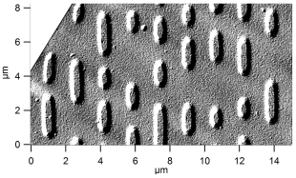
CDs and DVDs are encoded with information by burning small dot like divots onto the surface as seen in figure 11. This information is read by firing a laser through the disk in order to “read” these dots and extract information from the size and position of the dots. By removing the cover off a disk, students are able to fire a laser through the disk which will cause it to diffract based on the separation of the grooves that this data forms. These grooves are placed so close to one another they act as a diffraction grating, which is when there are multiple slits next to one other. The double slit equation applies to diffraction gratings as well as CD and DVDs and can be used to calculate the spacing between the grooves (Nöldeke 1990). Students will calculate that the grooves of a DVD are closer to one another which shows them that more data can fit on a DVD than a CD. Note the actual value of the spacing of a CD is about 1.6μm and a DVD is .74μm.
Equation 2
$$I\left(θ\right)=I_{0}{\left[\frac{2J_{1}(kd sinθ)}{kd sinθ}\right]}^{2}$$
$I$: light intensity
$I_{0}$: light intensity at the center
$k$: is the wavenumber
$d$: is the radius of the aperture (powder or cell)
$J_{1}$: is the Bessel function order 1
Figure 11
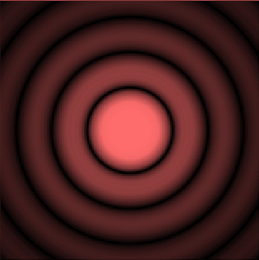
The next two experiments use very similar principles as the experiment before. However, it uses a circular shape to create a diffraction pattern. The lycopodium powder and the red blood cells both act as a collection of small circular apertures that will form a circular pattern as seen in figure 12. The big difference between this and a standard diffraction grading is the values of $m$ will not be simple integer values. The simple answer to why they are not integer values is that the radii of the minima and maxima spots are not evenly spaced like they are in other forms of diffraction. This uneven spacing causes the $m$ values to also not be even. The more complicated answer involves using equation 2 in order to solve for the maxima and minima locations which require the use of a Bessel function (Sethuraman 2014). Table 1 shows the values for $m$ to use in equation 1. The diameter of a lycopodium particle is around 36.8μm (Sehturaman 2014) and the diameter of a red blood cell can vary greatly but typically falls between 7.5 to 8.7 μm (Diez-Silva et. al. 2010).
Figure 12
m values for:
 | Minima | Maxima
1 | 1.220 | 1.635
2 | 2.233 | 2.679
3 | 3.238 | 3.690

Table 1
Materials and Safety Concerns
Each student group is going to need the following to complete all experiments. Simple office supplies like rulers, index cards, pencils and rubbers bands will be used as well. A class set of materials will cost around $100 not including the lasers which will depend greatly on the brand, style and power you purchase.
- Laser
  - Any color will work, but a variety of colors would be ideal so groups can see how different wavelengths affect the patterns.
  - A laser that sits flat with a toggle switch will make it easier for students to make the patterns.
  - https://laserclassroom.com/product/laser-blox-multi-3-pack/
- Fine Metal Meshes
  - These are often called metal mesh or wire cloth.
  - You need 3 different sizes.
  - A mesh count of 60 to 120 (number of wires crossings per square inch) should be enough.
  - https://www.amazon.com/Activists-Stainless-Steel-Screen-Filtration/dp/B07T5DWP99/ref=sr_1_20?keywords=Activists&qid=1572823108&sr=8-20
- Lycopodium Powder
  - https://www.fishersci.com/shop/products/lycopodium-4/S25396
- A slide with blood cells
  - https://www.carolina.com/histology-microscope-slides/human-blood-film-slide-smear-he/313152.pr?question=
- CD and DVD
  - Strip away the cover part of the disk, leaving it see- through.
  - The disk needs to have data.
- A sample holder
  - A wooden block with a slit cut into will work.
The main safety concern for the students conducting these experiments is the lasers. It is important to stress care while using lasers and students should be instructed on the main risks with using lasers. Of course, the number one concern is having the laser pointed into a student’s eye. One of the advantages of this lab is that laser will be held on a table rather than in their hands for the majority of experiments. If you do not have a laser that can sit flat on a table and a toggle switch, I would also suggest a holder for the laser in these labs. Something to keep a rounded laser flat on the table and to keep the laser on.
Lycopodium Powder should also be a consideration for safety. It is considered a category 1 flammable solid- combustible dust. We are using small amounts to make covered slides however it should be noted then when it is in a dust in air it is highly flammable. Protective googles should be used to avoid eye contact (Appendix E). Please read all safety information that is provided with the powder.
Experiments
The handouts with the instructions for students are found on appendices A through D. The guided experiments found on appendices A and C walk students through several observations of physical objects using diffraction and interference. The experiments in part A just require students to take a qualitative look, where they need to observe the relationship between the object and the pattern that it creates. This ends with the challenge on appendix B where they will need to create their own experiment using their understanding of this relationship. Appendix C starts the quantitative experiments where they need to take careful data and use equation 1 to find the size of objects. Likewise, in Appendix D students will need to use a similar technique to find the size of a red blood cell by creating their own experiment. The students’ ability to create and successfully analyze these experiments will help determine if they understand the material.

Experiment | Diagram of Setup | Image Diffraction Pattern | Purpose | Key Question(s)
Hair  (Appendix A) | ~2m  Whiteboard  Index Card  Laser  Index Card |  | Pre-assignment. Also to have students see a sample lab setup and a distinct diffraction pattern | How is diffraction related to the pattern you are seeing?  How is interference related to the pattern you are seeing?  How do you think the size of the object relates to the pattern created?
Pencils  (Appendix A) | 1 Loop in between  Slit | Wide opening:  Narrow Opening | Completely qualitative look at how the size of the object relates to the diffraction pattern. | How does the size of the slit relate to the pattern created?
Mesh  (Appendix A) | 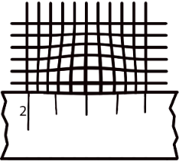  Ruler  Mesh  Lens | Coarse Mesh  Fine Mesh | A quantitative look to see how the size of the object relates to the diffraction pattern. | What is the mathematical relationship between the mesh size and the pattern separation?
Which Hair is bigger  (Appendix B) |  | Hair getting progressively smaller | Students make their own lab to test whether they understand the previous experiments. | Students should write a procedure and conclusion. Note whether they understood the relationship between the size of the object and the pattern.
DVD/ CD  (Appendix C) | CD/DVD  Laser  Screen  L  x |  | Students will learn how to use the equation 1 for a diffraction grating. | Using your data as evidence, how does a DVD store more data then a CD.
Lycopodium Powder  (Appendix C) | Slide  Laser  Screen  L  x |  | Students will learn how to use the equation 1 with a “correction” for circular apertures. | Using your data, what is the size of the powder.
Red-Blood Cell  (Appendix D) |  | 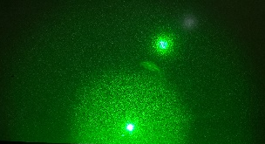 | Students make their own lab to find the size of a red-blood cell and whether they understand the previous experiments. | Students should create their own lab and find the size of a red blood cell.

Feedback:
Number of correct answers to the questions found in the first experiment compared to how they completed the two self-made experiments. I have about 90 students and my colleagues may also do this experiment which would add another 40 or so.
Anecdotal observations of the experiment.
Questions I may ask and student responses. Student questions that show understanding or lack thereof. Discussions I heard students make. And so on, when they are working on these experiments.
Conclusion: Waiting for results.

References:
Arons, A. B. (1997). Teaching introductory physics. New York: John Wiley & Sons.
Braun, G., Tierney, D., & Schmitzer, H. (2011). How Rosalind Franklin Discovered the Helical Structure of DNA: Experiments in Diffraction. The Physics Teacher,49(3), 140-143. doi:10.1119/1.3555496
Curry, S. M., & Schawlow, A. L. (1974). Measuring the Diameter of a Hair by Diffraction. American Journal of Physics,42(5), 412-413. doi:10.1119/1.1987713
Deweerd, A. J. (2016). CD, DVD, and Blu-Ray Disc Diffraction with a Laser Ray Box. The Physics Teacher,54(5), 300-301. doi:10.1119/1.4947160
Diez-Silva, M., Dao, M., Han, J., Lim, C.-T., & Suresh, S. (2010). Shape and Biomechanical Characteristics of Human Red Blood Cells in Health and Disease. MRS Bulletin, 35(5), 382–388. doi: 10.1557/mrs2010.571
Kim, H. (2016). Inquiry-based science and technology enrichment program for middle school-aged female students. Journal of Science Education and Technology, 25(2), 174-186. doi: 10.1119/1.5020051
Knight, R. D. (2013). Physics for scientists and engineers: a strategic approach. Boston, MA: Addison-Wesley.
Kruglak, H., & Campbell, D. (1983). Color perception with diffraction gratings. The Physics Teacher,21(5), 312-314. doi:10.1119/1.2341294
Messer, R. (2018). Single slit interference made easy with a strand of hair and a laser. The Physics Teacher,56(1), 58-59. doi:10.1119/1.5018699
Mungan E. Carl. (2009)“Approximation for the Rayleigh Resolution of a Circular Aperture.” The Physics Teacher, 47, 382–382., doi: 10.1119/1.3116839
Narayanan, V. Anantha. (1996) “Low‐Cost Diffraction Experiment.” The Physics Teacher, 34, 382–382., doi:10.1119/1.2344492.
New York State Education Department (2016) New York State P-12 Science Learning Standards. Retrieved October, 2019 from: http://www.nysed.gov/common/nysed/files/programs/curriculum-instruction/p-12-science-learning-standardshsupdated10-18.pdf
NGSS Lead States. (2013). Next Generation Science Standards: For States, By States. Washington, DC: The National Academies Press.
Nikitin S et al. (2010). On the problem of the diffraction pattern visibility in laser diffractometry of red blood cells. Quantum Electron ,40 , 1074. doi:10.1070/qe2010v040n12abeh014504.
Nöldeke, C. (1990). Compact disc diffraction. The Physics Teacher,28(7), 484-485. doi:10.1119/1.2343118
Renganathan, B., Viswanathan, A., Sastikumar, D., & Hameed, S. S. (2007, September). Measurement of particle size of Lycopodium powder using He-Ne laser. In Laser Science (p. LThB5). Optical Society of America.
Teng, B., Teng, P., & Hennekens, C. H. (2018). A Simple Way to Teach Single Slit Diffraction Based on Edge Diffraction. The Physics Teacher,56(6), 380-383. doi:10.1119/1.5051152
Sethuraman, J. (2014). Determination of Mean Particle Size of Lycopodium Powder - An Experiment. Salem, Tamil Nadu: Vinayaka Mission’s Kirupananda Variyar Engineering College
Thompson, J., Braun, G., Tierney, D., Wessels, L., Schmitzer, H., Rossa, B., . . . Dultz, W. (2018). Rosalind Franklins X-ray photo of DNA as an undergraduate optical diffraction experiment. American Journal of Physics,86(2), 95-104. doi:10.1119/1.5020051
Veal, W., & Sneed, K. (2014). Putting new life in an old lesson. The Science Teacher, 81(7), 47. doi: 10.2505/4/tst14_081_07_47
Velentzas, A. (2014). Teaching Diffraction of Light and Electrons: Classroom Analogies to Classic Experiments. The Physics Teacher,52(8), 493-496. doi:10.1119/1.4897589
Vokos, S., Shaffer, P. S., Ambrose, B. S., & Mcdermott, L. C. (2000). Student understanding of the wave nature of matter: Diffraction and interference of particles. American Journal of Physics, 68(S1). doi: 10.1119/1.19519

Qualitative Diffraction and Interference
Appendix A
The Strand of Hair:
Setup:
- Construct a sample holder using an index card with a square cut in it. Tape a piece of your hair so it goes across the opening. (shown below)
- Hold the sample about 2 meters away from a screen (our whiteboards).
- Fire the laser at through the hair and at the screen.
Cut out
Tape
Hair
Index Card
Whiteboard

Index Card
~2m
Questions:
Laser
- Sketch the pattern the laser makes on the screen when hitting the hair.

- Does the pattern on the screen just look like the “shadow” of the hair? Explain how it’s the same or different than just the “shadow.”
_______________________________________________________________________________________________________________________________________________________________________________________

- This experiment helps us see the property of waves known as diffraction. Explain what diffraction is and how we are seeing it in this experiment.
_______________________________________________________________________________________________________________________________________________________________________________________

- Rotate the hair by 90º and observe the pattern made by the laser now. How is the direction of the spread-out beam relative to the orientation of the hair?
__________________________________________________________________________________________________________________________
Two Pencils:
Setup:
- Construct a narrow slit by attaching two number 2 pencils together using two rubber bands. It’s important to have one section of the rubber bands in between the pencils. Wrap the band tightly so they are help closely together.
Slit
1 Loop in between

- Use the same setup as the last lab just replace the index card for the double pencils.
Questions:
- Sketch the pattern the laser makes on the screen going through the slit.

- Does the pattern on the screen just look like the “shadow” of the pencils? Explain how it’s the same or different than just the “shadow.”
__________________________________________________________________________________________________________________________

- Squeeze the pencils together to make the slit narrower. Describe how the pattern changes.
__________________________________________________________________________________________________________________________

- This experiment helps us see the property of waves known as interference. Explain what interference is and how we are seeing it in this experiment.
__________________________________________________________________________________________________________________________

- Describe the similarities between the pattern made by the hair and the one created by the slit.
__________________________________________________________________________________________________________________________
Wire Meshes:
Setup:
- Collect four different meshes. Use the provided sample holder and place them within them. Make a similar setup to the previous labs substituting for the mesh sample holder.
Measurements for Each Mesh:
- Using a ruler measure the separation between the bright spots of the pattern created on the screen.
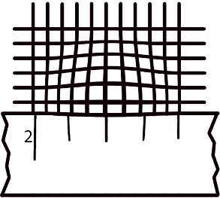
- Using the magnifying lens, and possibly the aid of your smart phone camera, measure how many wires are in one millimeter of the mesh
Ruler
Mesh
Lens

Questions:
- Sketch the pattern the laser makes on the screen going through coarsest mesh and the finest mesh.
Coarsest Mesh
Finest Mesh

- Complete the following data table based one your measurements
Mesh | Distance between nearest bright spots in the pattern (x) | Number of wires in one millimeter (n) | Distance between wires (d=1/n)
Coarse
Medium
Fine
Finest

- How does the pattern change as the wires get closer together? What type of mathematical relationship is this?
_______________________________________________________________________________________________________________________________________________________________________________________
Capstone Challenge: Who has the thickest hair:
Appendix B
Instructions: Construct and conduct an experiment to show which person in the group has the thickest hair and which has the thinnest.

- Procedure:

- Data/ Observations

- Analysis: Write about why your data is important and how you use it to prove your conclusion

- Conclusion

Quantitative Diffraction and Interference
Appendix C
DVD versus CD:
Background: CDs and DVDs act as a diffraction grating due to the incredibly small parallel tracks burned into them. We are going to attempt to find the spacing between these tracks and compare the size of CDs to DVDs.
Setup:
- Place the CD on the sample holder. Make sure that the bare section that is cut into the CD is visible.
- Place the CD with the holder close to the screen (about 20cm) and look for the pattern on the screen.
- NOTE: that small cracks in the CD can cause a second pattern from being formed, you are looking for the 3 to 5 dots being created.
Screen
z
θ
x
Laser
CD/DVD
θ
L

Measurements:
- With a ruler, measure the distance between the central dot and the first dot (x).
- Measure the distance between CD/ DVD and the screen (L).
Questions:
- Based on the diagram above, what trigonometric function should you use to relate x, L and θ? Write out the complete formula for θ in terms of x and L.
_________________
- Complete the data table below using your measurements and your trigonometric formula to find the angle.
Media | x (cm) | L (cm) | θ
CD
DVD
- Using the double slit equation $m*λ=d*Sin\left(θ\right)$ find the spacing between the tracks for the CD and DVD. Note that you can find the wavelength of your laser on the written on the laser. Show all work below.

CD track spacing: ______________ DVD track spacing: _______________
- Using the drawing below which shows CD under a microscope.
  - Measure the horizontal space between the tracks below.
  - Calculate the percent difference between your measurement here and your calculated value above.
  - Make a quick sketch on how you predict the DVD track spacing will look like given the value you found above.
CD DVD
*CD Image courtesy of Freiermensch under GNU Free Documentation license
CD track spacing: ______________

CD percent difference: __________
- A CD can store 0.65 gigabytes of information whereas a DVD can store 4.7 gigabytes of information. How do the data and calculations you made support this?
_______________________________________________________________________________________________________________________________________________________________________________________
Lycopodium Powder:
Background: Lycopodium powder is made up of spores from clubmoss plants. These are very small and highly flammable in air. They are also roughly circular in shape.
Setup:
- Sprinkle a very small amount of lycopodium powder onto a glass slide. Tilt the slide over a waste beaker to remove excess powder. You should be left with a slide that is lightly dusted with the powder.
- Use the laser to view the diffraction pattern of the powder.
Observation: Draw the pattern you are detecting on the board, make sure to note the bright (Maxima) and dim (Minima) areas.

Measurements:
- With a ruler, measure diameter (D) of the first minima circle.
- Measure the distance between the slide and the screen (L).
- Laser Wavelengths (λ) are found on the lasers.
Questions:
- Based on previous lab and your drawing above, what trigonometric function should you use to relate D (the diameter of the circles), L and θ? Write out the complete formula for θ in terms of D and L.
______________________

- Complete the data table below using your measurements and your trigonometric formula to find the angle.
Laser Color | λ (nm) | L (cm) | Diameter (cm) | θ
- What is the relationship between the wavelength and the diameter of the pattern?
__________________________________________________________________________________________________________________________

- Due to the fact that this is circular pattern, the $m$ values will not be whole and half integers in the diffraction formula: $m*λ=d*Sin\left(θ\right)$. Instead we use the values shown on the chart below. Based on the diameter (D) you measured what value of $m$ should you use?
m values for:
 | Minima | Maxima
1 | 1.220 | 1.635
2 | 2.233 | 2.679
3 | 3.238 | 3.690

____________

- Find using the data in your chart find the value for the diameter of the lycopodium powder spore ($d$) for each color of your laser. Show all work for the red laser.

Red Laser: _________ Green Laser: __________ Blue Laser: __________

- Take the average of $d$ and do a percent error calculation with the actual value of the diameter of a lycopodium powder spore (33 μm).

% Error: ______________

- If you were to test on an object that had a larger diameter, how would that change the interference pattern shown on the board? Do a quick sketch to show the pattern created by the lycopodium powder and this new bigger object to illustrate the difference.
Larger Circular Object
Lycopodium Powder
Capstone Challenge: Size of a Red Blood Cell:
Appendix D
Instructions: Construct and conduct an experiment to find the size of a red blood cell.
- Procedure

- Data/ Observations

- Analysis:

- Conclusion

- Question: Explain how diffraction and interference play a role in your experiment
____________________________________________________________________________________________________________________________________________________________________________________________________________________________________________________________________________
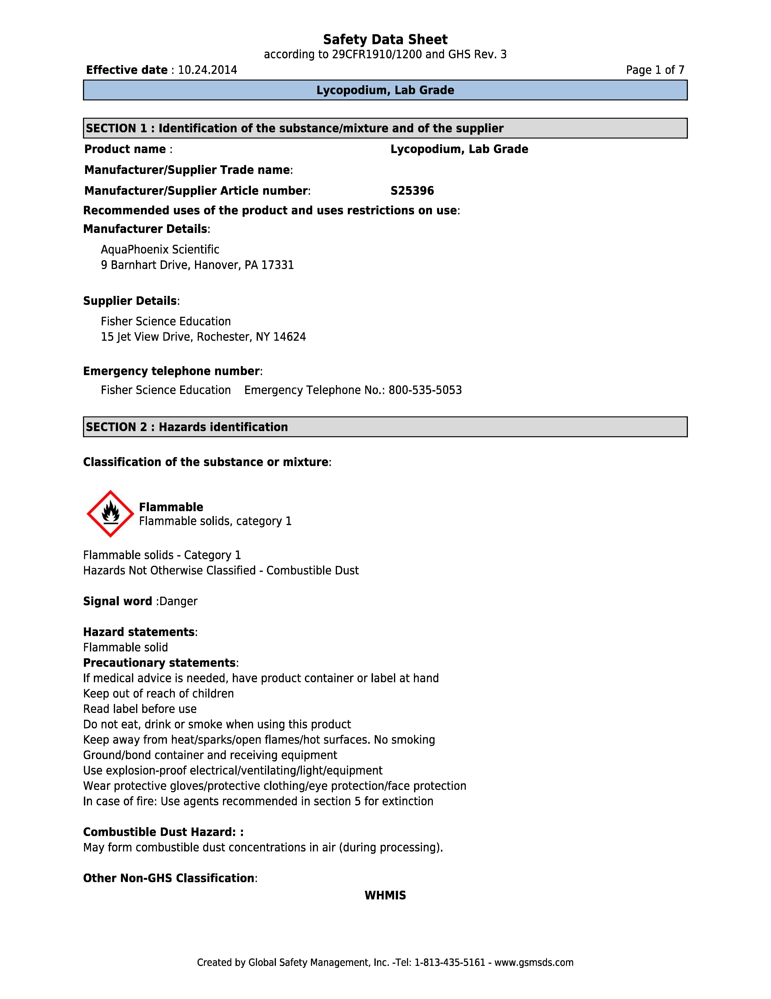
Appendix E

