Building an RC Circuit: Neon Bulb Relaxation Oscillator

Aaron Ward
PHYS 690

Abstract
Building a simple RC circuit is an effective way to teach how capacitors work. Known as a relaxation oscillator, this particular circuit causes a neon lamp to blink which allows students to observe this phenomenon and develop insight. This electric circuit is analogous to a Japanese garden fountain mechanical relaxation oscillator, the shishi-odoshi or “deer scarer”.

Bio
Aaron Ward has been an MSEd Candidate in Physics Education at SUNY Buffalo State Physics Education Department since January of 2013. Ward graduated from Alfred University in December of 2012 with a degree and NYS initial certification in Chemistry. He is currently a physics teacher at Mount Morris Central Schools in Mount Morris, New York.

Acknowledgements
This paper is submitted in partial fulfillment of the requirements necessary for PHY690: Masters Project at SUNY – Buffalo State College under the guidance of Dr. Dan MacIsaac. Much of this work is done using data and information collected by Stever Wilser and Dan MacIsaac.

Background
Although they are not featured in most basic Physics curricula, RC circuits can serve a purpose when teaching current electricity (Steinberg, 2011). A student misconception regarding capacitors is that the electrons "jump across" the capacitor after it has charged. This idea stems from not fully understanding how a parallel circuit works. Building your own RC neon bulb circuit can provide a thought provoking conversation, since the neon bulb is able to indicate direction of electron flow as it lights and should already be familiar to students from electrostatic investigation (Wilser & MacIsaac).

NYS Regents Physics Standards | 4.1n A circuit is a closed path in which a current can exist.  4.1o Circuit components may be connected in series or in parallel. Schematic diagrams are used to represent circuits and circuit elements.  (Physical Setting, 2015)
Modeling Physics Instructional Goals | Electricity, U3: Circuits  4. For simple series and parallel circuit arrangements, conservation of energy and charge can be demonstrated.  - The energy dissipated by resistive elements in a circuit equals the energy provided by the external source.  - The total quantity of charge moving in a circuit remains constant. The quantity of charge in a given branch is inversely proportional to the resistance in that branch.  6. Representational tools include:  - maps of surface charge distribution  - schematic diagrams to represent circuits.  (AMTA, 2014)
CASTLE Curriculum Instructional Goals | U2: Charge Flow and Sources of Charge Model  - Represent simple circuits with schematic diagrams.  - Identify the structure/parts of a capacitor.  - Indicate the direction of charge flow throughout a circuit during capacitor charging and discharging.  (Steinberg, 2011)
Constructing an RC Circuit
An RC circuit is a circuit which contains a resistor and a capacitor, hence the name RC. Here it is used as a tool to teach about capacitors as well as the behavior of current electricity. Upon observations of a RC circuit, students see a neon bulb that blinks. Additionally, because it is a neon bulb, the direction from which the current is flowing can be determined. Neon bulbs consist of two electrodes. Whatever side the current is flowing through the bulb from, the closer electrode will glow. Having students question why the light is blinking is what starts to provide insight into how capacitors work.
To construct the RC Circuit, you will need the materials listed in Figure 4 (MacIsaac and Wilser, Caplan 2008). For an external source, the easiest method is to use ten 9 Volt batteries connected together in series (Caplan, 2008). The circuit can be mounted on a piece of wood or particle board and should be the capacitor and the neon bulb wired in parallel with a resistor in series, as shown in Figure 1.
To address the Physics content of why the light is blinking an oscilloscope can be used to measure the voltage across the capacitor. As seen in Figure 2, there is a clear interval at which the capacitor has enough voltage to cause the light to “blink” at which point the capacitor loses some voltage (Wilser & MacIsaac). As the capacitor charges back up and the bulb remains unlit until it reaches the same voltage as the previous “blink”.

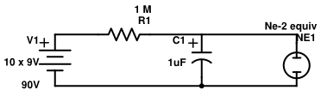
Figure 1: Relaxation Oscillator diagram

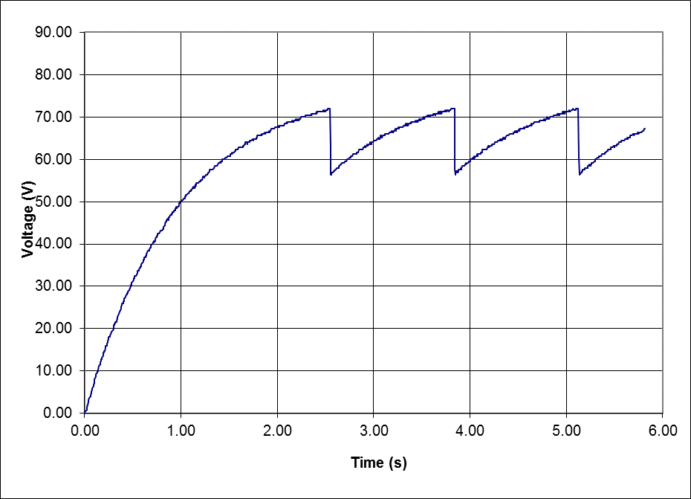
Math

Charging V_{c} = V₀(1-e^{-t/RC})

Discharging V_{c} = V₀(e^{-t/RC})

V_{c} =Voltage across Capacitor
V₀ = Supply Voltage
t = time since supply voltage applied
RC = time constant of RC circuit
(Resistance x Capacitance)

Figure 2: Time dependence of voltage
across capacitor (Wilser & MacIsaac)
R=1Mr *Time for RC circuit should be ≈ 1 second
C=1μF

The Shishi-Odoshi Analogy: A Mechanical Relaxation Oscillator
The term “relaxation oscillator” really means that the system is binary. The focal point of the oscillation is either on or it is off. An example of a mechanical relaxation oscillator is the Japanese garden fountain known as the shishi-odoshi. As seen in Figure 3, the shishi-odoshi is a tube which fills up with water and when the tube gets too full, it tips and the water comes pouring out. This comparison between the shishi-odoshi and the capacitor is a much more real world example that students can actually observe.

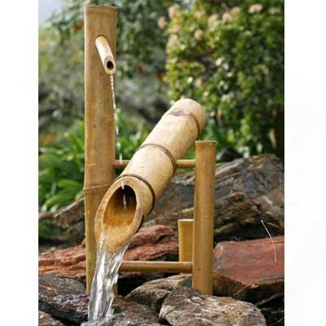
Figure 3.
http://www.japanesestyle.com/sites/default/files/deer_chaser.jpg
(Possibly replaced by a Buffalo State picture)

Shishi-Odoshi analogy
Where the analogy works
RC Circuit | Shishi-odoshi | Short explanation
Electrons | Water | Water flows through the apparatus similarly to the charge in a circuit
Capacitor | Fill tube | The fill tube holds a certain amount of water just as the capacitor holds a certain amount of charge
Discharging Capacitor | Emptying feedpipe | As both become full, they discharge and release the buildup of what has collect.
Charge | Mass | The circuit is driven by charge, this can be compared to how the fountain is driven by mass.
Electric Field | Gravity | The shishi-odoshi operates with earth’s gravitational field which provides gravitational potential energy to just as the circuit has an electric field and electric potential.
Limiting Resistor | Feedpipe | Both limit the size of the discharge that the system undergoes.
Where the analogy does not work
RC Circuit | Shishi-odoshi | Short explanation
Can’t remove charge | Manually remove water | Unlike a hose or a pipe, one cannot pick up a section of wire and shake all of the charge out of it.
Magnetic Field | No “water field” | The water flowing in the shishi-odoshi does not create a field like the magnetic field created by the current in the circuit.
Positive and Negative Charge | No “antiwater” | The water in the shishi-odoshi is simply water, there is no comparison to account for positive and negative charge in a circuit.
Current | Flow Rate | Current changes in the RC circuit but the flow rate stays constant in the shishi-odoshi.

Materials and where to get them:
Component | Price each | mouser.com | digikey.com
Ne-2 bulb (or equiv) | $0.34 | 606-A9A
1.0 MicroFarad 100V Capacitor | $0.32 | 581-BN154E0105K | 399-5455-1-ND
1 MegaOhm 1/4Watt carbon film resistor | $0.04 | 291-1M-RC | P1.0MBACT-ND
9V Batteries (10) |  | Old batteries from smoke detectors will work, Ask students to bring them from home.
Particle Board
Figure 4. (Wilser and MacIsaac, Caplan 2008)

Summary
Resistor Capacitor circuits can be used to address some common learning objectives that span across several different physics curricula. In discovering how a capacitor works students can begin to understand how circuits work in general. This can be aided by the usage of analogies to the RC circuit from the shishi-odoshi, which uses water analogous to charge well as ideas from mechanics that students should be much more familiar with.
Works Cited:
AMTA (2014) Modeling Instruction Curriculum: Physics. Retrieved October 1, 2015
Caplan, G. M. (2008, January). Simple DC Power Supply [Electronic version]. The Physics Teacher, 46, 57. doi:10.1119/1.2824005.

Gubanski, Z. (1971, February). Apparatus For Teaching Physics: Capacitance by Relaxation Oscillations [Electronic version]. The Physics Teacher, 9, 104. doi:10.1119/1.2351597

Neon Relaxation Oscillator. (n.d.). In Oberlin.edu.

Physical Setting/Physics: Core Curriculum.(n.d.) www.emsc.nysed.gov. Retrieved October 1, 2015

RC time constant. (n.d.). In Wikipedia. Retrieved November 30, 2015.

Smith, J. (2010, January 1). Relaxation Oscillator. In Clifton Laboratories. Retrieved September 19, 2015, from www.cliftonlaboratories.com/relaxation_oscillator.htm

Relaxation Oscillator. (n.d.). In Wikipedia. Retrieved September 14, 2015.

Steinberg, M. S. (2011). Capacitor-Aided System for Teaching and Learning Electricity. In Electricity Visualized: The CASTLE Project.

Wilser, S., & MacIsaac, D. (n.d.). The Low Cost Ne Bulb and 9V Battery RC "Blinky" Relaxation Oscillator. Retrieved from Buffalo State Physics Publication.
<http://physicsed.buffalostate.edu/pubs/StudentIndepStudy/WilserBlinky/>

Wood, H. T. (1993, September). The RC circuit-A multipurpose laboratory experiment [Electronic version]. The Physics Teacher, 31, 372-373. doi:10.1119/1.2343803

