Building an RC Circuit: Neon Bulb Relaxation Oscillator

Aaron Ward
PHYS 690

Abstract
Building a simple resistor capacitor circuit is an effective way to teach how capacitors work. Known as a Relaxation Oscillator, this particular circuit causes a lightbulb to blink which allows students to observe this phenomenon and make predictions about capacitors.
Bio
Aaron Ward has been a part of the Buffalo State Physics Education Department since January of 2013 and is expected to finish the program at the end of 2015. Ward graduated from Alfred University in December of 2012 with a degree and NYS initial certification in Chemistry. He is currently a Physics teacher at Mount Morris Central Schools in Mount Morris, New York.
Background
Although they are not featured in most basic Physics curricula, capacitors can serve a purpose when teaching current electricity. A student misconception regarding capacitors is that the electrons "jump across" the capacitor after it has charged. This idea stems from not fully understanding how a parallel circuit works. Building your own RC neon bulb circuit can provide a thought provoking conversation, since the neon bulb is able to indicate direction of electron flow as it lights.
NYS Regents Physics Standards
4.1n A circuit is a closed path in which a current can exist.
4.1o Circuit components may be connected in series or in parallel. Schematic diagrams are used to represent circuits and circuit elements.

Modeling Physics Instructional Goals
Electricity, U3: Circuits
4. For simple series and parallel circuit arrangements, conservation of energy and charge can be demonstrated.
- The energy dissipated by resistive elements in a circuit equals the energy provided by the external source.
- The total quantity of charge moving in a circuit remains constant. The quantity of charge in a given branch is inversely proportional to the resistance in that branch.

6. Representational tools include:
- maps of surface charge distribution
- schematic diagrams to represent circuits.

CASTLE Curriculum Instructional Goals
U2: Charge Flow and Sources of Charge Model
- Represent simple circuits with schematic diagrams.
- Identify the structure/parts of a capacitor.
- Indicate the direction of charge flow throughout a circuit during capacitor charging and discharging.

Constructing an RC Circuit
An RC circuit is a circuit which contains a resistor and a capacitor, hence the name RC. It can be used as a tool to teach about capacitors as well as the behavior of current electricity. Upon observations of a RC circuit, one will see a neon bulb that blinks. Additionally, because it is a neon bulb, the direction from which the current is flowing can be determined. Having students question why the light is blinking is what starts to provide insight into how capacitors work.
To construct the RC Circuit, you will need the materials listed in Figure 1 (MacIsaac and Wilser, Caplan 2008). For an external source, the easiest method is to use a number of 9 Volt batteries connected together in series (Caplan, 2008). The circuit can be mounted on a piece of wood or particle board and should be the capacitor and the neon bulb wired in parallel with a resistor in series, as shown in figure 2 (Gubanski, 1971).
To address the Physics content of why the light is blinking an oscilloscope can be used to measure the voltage across the capacitor . As seen in Figure 3, there is a clear interval at which the capacitor has enough voltage to cause the light to “blink” at which point the capacitor loses some voltage. (Gubanski, 1971) As the capacitor charges back up and the bulb remains unlit until it reaches the same voltage as the previous “blink”.
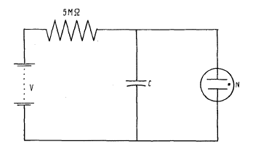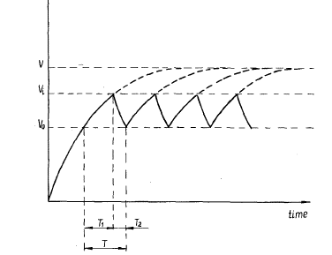
Figure 2: Relaxation Oscillator diagram (Gubanski, 1971) Figure 3: Time dependence of voltage across capacitor (Gubanski, 1971)
Mechanical Relaxation Oscillator
The term “Relaxation Oscillator” really means that the system is binary. The focal point of the oscillation is either on or it is off. An example of a mechanical relaxation oscillator is the Japanese garden fountain known as the shishi-odoshi. As seen in Figure 4, the shishi-odoshi is a tube which fills up with water and when the tube gets too full, it tips and the water comes pouring out. This comparison between the shishi-odoshi and the capacitor is a much more real world example that students can actually observe.

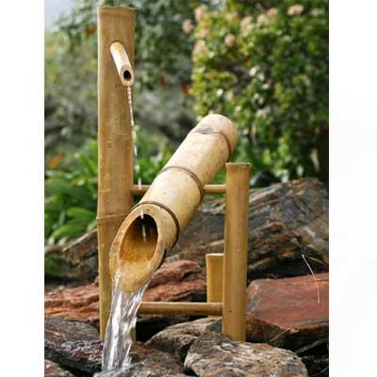
http://www.japanesestyle.com/sites/default/files/deer_chaser.jpg

Materials and where to get them:
Component | Price each | mouser.com | digikey.com
Ne-2 bulb (or equiv) | $0.34 | 606-A9A
1.0 MicroFarad 100V Capacitor | $0.32 | 581-BN154E0105K | 399-5455-1-ND
1 MegaOhm 1/4Watt carbon film resistor | $0.04 | 291-1M-RC | P1.0MBACT-ND
9V Batteries
Particle Board
Figure 1. (Wilser and MacIsaac, Caplan 2008)
Works Cited:
Caplan, G. M. (2008, January). Simple DC Power Supply [Electronic version]. The Physics Teacher, 46, 57. doi:10.1119/1.2824005.

Gubanski, Z. (1971, February). Apparatus For Teaching Physics: Capacitance by Relaxation Oscillations [Electronic version]. The Physics Teacher, 9, 104. doi:10.1119/1.2351597

Neon Relaxation Oscillator. (n.d.). In Oberlin.edu.

Pearson-Anson effect. (n.d.). In Wikipedia. Retrieved September 14, 2015.

Physical Setting/Physics: Core Curriculum.(n.d.) www.emsc.nysed.gov. Retrieved October 1, 2015

Smith, J. (2010, January 1). Relaxation Oscillator. In Clifton Laboratories. Retrieved September 19, 2015, from www.cliftonlaboratories.com/relaxation_oscillator.htm

Relaxation Oscillator. (n.d.). In Wikipedia. Retrieved September 14, 2015.

Steinberg, M. S. (n.d.). Capacitor-Aided System for Teaching and Learning Electricity. In Electricity Visualized: The CASTLE Project.

Wilser, S., & MacIsaac, D. (n.d.). The Low Cost Ne Bulb and 9V Battery RC "Blinky" Relaxation Oscillator. Retrieved from Buffalo State Physics Publication.

Wood, H. T. (1993, September). The RC circuit-A multipurpose laboratory experiment [Electronic version]. The Physics Teacher, 31, 372-373. doi:10.1119/1.2343803

