A Digital Scanner – Introductory Physics Students Engineer
a Photoreceptor Engineering Design Challenge Using Off-The-Shelf LEDs

Justin Worboys, SUNY Buffalo State College Physics,
Justin.Worboys@gmail.com

Abstract
I describe an activity for students to design and engineer a photoreceptor apparatus, corresponding to the New York State Science Learning Standards (NYSSLS) 3-Dimensional learning topics found within Waves and Electromagnetic Radiation. I show that students can create an apparatus that mimics the engineering of scanning devices and long distance fiber optics, and that this can be done with materials found in a common physics classroom. Handouts and an annotated bibliography are also provided.

Bio: Justin Worboys graduated St. John Fisher College with a B.A. in Adolescent Education and a B.A. in Chemical Education. He has 5 years of teaching experience in public schools in New York State including Cuba-Rushford CSD and Genesee Valley CSD, and is currently teaching Advanced Placement Chemistry, Advanced Placement Physics 1, Next Generation Science Standards Physical Science standards and a Robotics course in Thailand.

Acknowledgement: This manuscript was written in partial fulfillment of a PHY690: Masters Project for the M.S.Ed. (Physics) degree program at SUNY Buffalo State College Department of Physics, under the guidance of Associate Professor Dan MacIsaac.

Introduction

Light is a vital source of information for navigating the world. Eyesight relies on photons of light reaching biological photoreceptors called rods and cones (Berg, 2002) on the eye’s retina. Modern day internet technology requires enormous amounts of information to be sent around the world in the form of photonic light signals through undersea fiber optic cables (Optical Fiber Cables, 2019). Light signals through fiber optics is the current preferred method for the transfer of this information because of the unique properties of light. Research is being done to create more effective light sensing material for medical imaging purposes (Labram, 2009). For our technology purposes, we are able to send photons of light with various durations and frequencies of light which can then be received and interpreted as useful information.
The NYSSLS, a New York State adaptation of the Next Generation Science Standards, includes four components in the standards: Performance Expectations, Disciplinary Core Ideas, Science and Engineering Practices, and Cross-Cutting concepts (NYSED, 2016). The performance expectations are the assessable statements that students should know and be able to do. The Disciplinary Core Ideas are the most essential ideas that students should understand. Teachers are encouraged to utilize several practices from Science and Engineering Practices throughout their lessons. The Crosscutting Concepts provide suggestions of topics that can connect Performance Expectations throughout a grade level. The focuses of this lesson can be seen in Table 1.

Component of NYSSLS | Excerpt from NYSSLS
Performance Expectations | HS-PS4-5, “Communicate technical information about how some technological devices use the principles of wave behavior and wave interactions with matter to transmit and capture information and energy.”
Science and Engineering Practices | Asking Questions and Defining Problems: Evaluate the suitability of a design.
Disciplinary Core Ideas | PS4.C: Information Technologies and Instrumentation. Multiple technologies based on the understanding of waves and their interactions with matter are part of the everyday experiences in the modern world and in scientific research. They are essential tools for producing, transmitting, and capturing signals and for storing and interpreting the information contained in them.
Crosscutting concepts | Cause and Effect: Systems can be designed to cause a desired effect.  Connections to Engineering, Technology and Applications of Science.  Influence of Engineering, Technology and Science on Society and the Natural World: Engineers continuously modify these technological systems by applying scientific knowledge and engineering design practices to increase benefits while decreasing costs and risks.
Table 1: Components of NYSLS used for this lesson.

This activity relied on using Light Emitting Diodes (LEDs) to send and receive specific wavelengths of light. Etkina and Planinšic (2014) provided a list of many ways LEDs can be used in a physics classroom (2014). They had students study LED properties using their Investigative Science Learning Environment method (Etkina and Planinšic, 2014). One example included creating a circuit with an LED and voltmeter to show the photoelectric properties of LEDs to students. This activity used different colored LEDs to perform this task, which showed students how photons of light with differing frequency interacted with different photoreceptive substances. The students were given a goal to create an apparatus that interpreted: the color of light being sent, the duration of the signal and the photon signals across a distance.
Structure of an LED
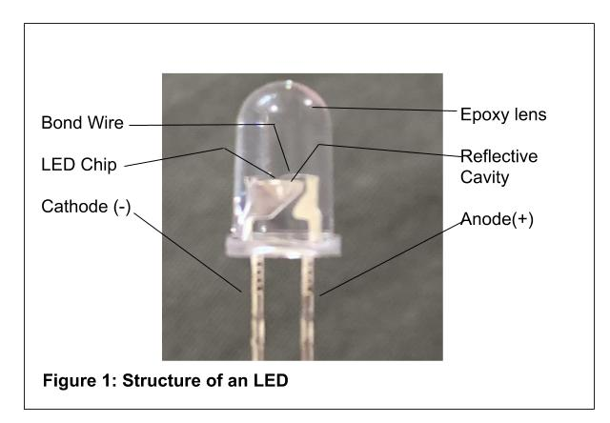
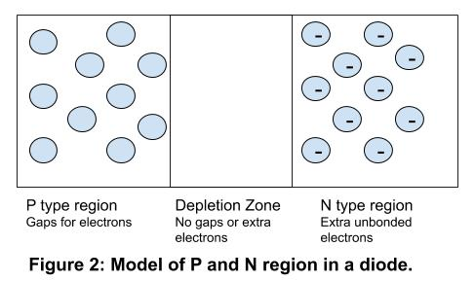
LEDs are sold in a wide range of colors, but the fundamental structure of them is consistent: a diode surrounded by an epoxy lens. A diode is a component which only allows for electrons to flow one direction. Universidad de Granada created a fantastic video to explain the structure of a diode at the atomic, molecular and macro scale (Teaching Innovation Project 11-293 of Universidad de Granada, 2013). The PN junction of the diode essentially has three regions: a positive “P type” region, a negative “N type” region, and in the middle is a portion called the “depletion zone.” A basic N type region consists of a combination of Silicon and Phosphorus. This results in free electrons without a bond. A basic P type region consists of a combination of Silicon and Boron. This results in a gap where electrons could eventually join to complete a bond. The depletion zone is where the free electrons from the N region will drift and start to fill in the gaps in the P region, but this process continues until equilibrium is reached.
This structure causes the electrical current to only flow in one direction. If a voltage is applied to the diode forcing electrons in the diode from the P region towards the N region, then the depleted region grows and the electrical current will not flow. If the voltage is reversed the depletion zone shrinks to zero and electrons will flow.

Photon Induced Electron+Hole Pair Production and Electron+Hole Recombination and Photoemission
The structure of the diode allows some electrons that can be moved toward the P type region and fill the electron gaps, and it also allows some electrons to be removed from bonds in the depletion zone to be moved towards the N type region. When a voltage is applied from the N region to the P region, the extra non-bonded electrons in the N region are moved and when they reach a P region, they will lower their energy to fill in the bond, this process is called carrier recombination and photo emission. The energy lost by the electron during recombination (“falling into” a hole) releases a photon of light matching this amount of energy. Different materials will have a different amount of energy change during recombination and this results in a photon of different amount of energy. The amount of energy is related to the frequency of the photon times Planck’s constant, E = hf. The epoxy used does not dictate the color light released by the diode, instead it is based on the material used at the p and n regions. The epoxy may provide a collimating element, filter or an aesthetic.
The recombination / photoemission process occurs in reverse as well; if an LED is hooked up to a voltmeter and the specific frequency of light hits electrons at the PN junction, photon absorption will cause some electrons to increase in energy, separate leaving a hole behind and then drift towards the N region. This process is called carrier pair (electron +hole) generation and photo absorption. The electron and hole drift during carrier generation causes the voltmeter to measure a change in voltage. The greater the intensity of light, the greater the voltage reading. If a voltmeter is connected with one orientation it will result in a positive reading of voltage. If the voltage is connected in reverse, it will read the same number, but negative.
Now that LEDs can be made from many different materials and can emit (and absorb) a wide variety of frequencies, depending on the materials used, we can now treat them as “pseudo” rods and cones like those in animal eyes. LEDs made with different materials and different frequencies can be purchased online (Hughes, 2018). Pointing those LEDs towards different sources of light will provide a different reading for the voltmeter connected to each LED.

The materials collected can be found in Table 2.
Table 2: Material source and costs.
Item | Approximate Price | Location
LEDs - VKmaker E15 3mm and 5mm White Yellow Red Green Blue Assorted LED Light Emitting Diodes 5 Colors Pack of 300 | $8 | Amazon.com
Voltmeters | $10-$20 | Amazon.com
Wires (with clips on each end) – 30 pack | $10 | Amazon.com
9v batteries – 8 pack | $15 | Amazon.com
Craft making supplies: Tape, rulers, scissors, glue/hot glue, cardboard, plastic bottles | Usually found commonly in classroom supplies

Lesson Progression
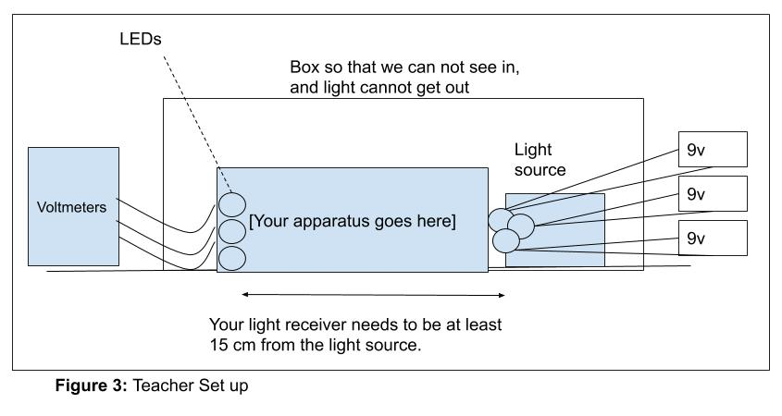
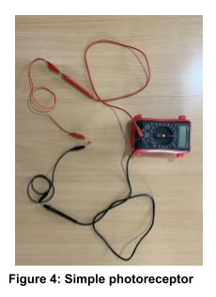
To start, I made a light source with 3 different LEDs. Each LED will need its own 9V battery. It is important to recognize that the cathode and anode parts of the battery must be aligned correctly with the LED, the material in the diode will only allow electrons to flow in one direction. If you have switches available add them in series this can be useful later on when selectively choosing a light and a duration, but they are not necessary. An example is shown in Figure 3.
Then the students were shown how to make a simple photoreceptor with one LED and a voltmeter. Students were then asked to make some preliminary observations about the positioning of the LED and the reading of the voltage. Simple observations should show that when they surround the LED with their hands, they get a voltage reading of 0 volts. As they point the LED in circuit closer to a light source, or if they place it near a similar color light source, it will give a higher voltage reading. Some examples could be the lights in the ceiling, the sunlight, the light from the cell phone flashlight, or even the light that comes from the screen on devices. Students were then eventually instructed to point their LED at a shining LED from the teacher’s LED light source. They can repeat this process for LEDs of different colors to determine how the LED of different materials get voltage readings. An example is shown in Figure 4.
Table 3: Example Voltage readings (LED as detector).
Color LED | Peak Voltage reading in open room | Peak Voltage reading up close
Red to Red | 2 mV | 90mV
Blue to Blue | 2 mV | 2 V
Yellow to Yellow | 6 mV | 0.5 V

After students became familiar with the functions of the LED photoreceptor, I prompted them with these questions: Compare the voltage reading as you move the LED closer and further from a light source and compare the voltage reading as you point the LED at different colors of light from a light source. The students were then given this challenge: Make a photoreceptor apparatus that will accurately read and interpret a secret signal sent from the teacher’s light source. This signal will be sent under cover, so the student will only be able to interpret the signal from the volt meters they are provided. They will need to interpret the signal at a distance. I have settled on 15 cm, but depending on the amount of challenge you want to provide, you can adjust your distance accordingly. Then the entire area was covered with a box or sheet so that the students can only see the voltmeters. When they are ready to test, I sent a signal or series of signals. A likely signal from the teacher might be “red for 1 second and then blue for 2 seconds” and based on the challenge you want to provide to your students you could send more simple or more complicated sets of signals.
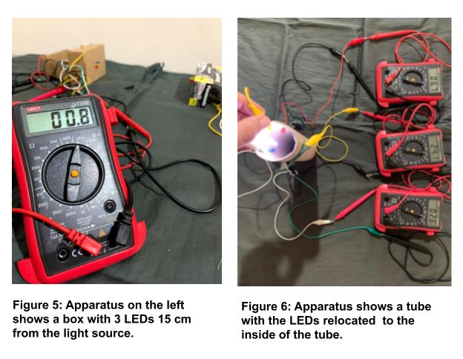
In Figure 5, the picture on the left shows it set up at a distance of about 15 cm from the source. Pictured is only 1 of the voltmeters, but the student would have 2 or 3 voltmeters attached so that the signal for LED 1, 2 and 3 could be read simultaneously.
The students can also have the option to add materials to the inside of the cardboard tube or they could also set up a tube of water (a water bottle), or anything else between the light source and the LEDs. This would allow the students to consider creative ways they could engineer their apparatus to transfer the signal across the distance more effectively.
Enhancements can be made for further learning. If the students are able to achieve simple signals at a distance of 15 cm then you can either send combination of light at one time or send longer more complex signals or increase the distance. If you want further exploration, the students can use this as a way to create a code where a signal corresponds to a letter (similar to a Morse code). Following the engineering design cycle the students will create a basic functioning apparatus. The students can repeat the cycle and either on their own, or with teacher assistance, and can find current technology that is being used as inspiration for enhancing their current project.
Conclusion
I believe that this lesson sufficiently addresses many of the Engineering Design standards proposed in the NYSSLS. The students created an apparatus that measures the absorption of photon of different frequencies. The students were actively engaged in performance tasks that actively forced them to consider engineering principles as it relates to the properties of light. Students can be challenged to make the apparatus work more efficiently and consider further material properties that will allow signals to be received at even greater distances. Students might not consider fiber optic cable during this project, but they might consider making a tube with reflective materials on the inside in order to keep a high photon intensity and this can be a transition for a teacher to talk about fiber optic cable, or have the students research the topic themselves. This lesson fits within a unit where students are learning about frequency/wavelength, energy, electricity/electrical energy, and how modern technology relies on sending coded information.
This topic can even be extended into the biology classroom to learn more about these properties as it relates to biological photoreceptors, and possibly propose technological ideas that would help people restore lost vision. The development of this apparatus through a design engineering cycle will provide a jump off point for students to see physics in action and begin looking into further applications beyond their classroom. After the students have completed the engineering cycle, the teacher can elect to have the students start researching into topics where this device can be used to detect pixel values based on their voltage inputs and then compile them to create a full image.
Needs stronger conclusion: what did your student think of these activities? What did you learn from their interactions with these activities? Did the students find this activity attractive? Engaging?? Empowering???

References
Baird, W., Hack, W., Tran, K., Vira, Z., & Pickett, M. (2011). The Light-Emitting Diode as
a Light Detector. Physics Teacher, 49(3), 171–174. https://doi.org/10.1119/1.3555506
Berg JM, Tymoczko JL, Stryer L. Biochemistry. 5th edition. New York: W H Freeman; 2002. Section 32.3,
Photoreceptor Molecules in the Eye Detect Visible Light. Available from: https://www.ncbi.nlm.nih.gov/books/NBK22541/
Design Step 1: Identify the Need - Activity. (2019, June 18). Retrieved December 10, 2019, from
https://www.teachengineering.org/activities/view/cub_creative_activity1.Etkina, E., & Planinšic, G. (2014). Light-Emitting Diodes: Exploration of Underlying
Physics. Physics Teacher, 52(4), 212–218. https://doi.org/10.1119/1.4868933
Garver, W. (2006). The photoelectric effect using LEDs as light sources. The Physics
Teacher, 44(5), 272–275. https://doi.org/10.1119/1.2195395
How Undersea Internet Cables Carry The Internet Across The Ocean | Earth Lab
https://www.youtube.com/watch?v=Pfr0XCTMhXE
How to Read the Next Generation Science Standards (NGSS). (2013, April). Retrieved December 10, 2019, from
https://www.nextgenscience.org/sites/default/files/How to Read NGSS - Final 4-19-13.pdf.Hughes, L. (2018, August 2).
Pick the Perfect LED with our Color Guide. Retrieved from
https://www.arrow.com/en/research-and-events/videos/led-colors-by-wavelength.
Jewett, J. W. (1991). Get the LED out. The Physics Teacher, 29(8), 530–534. Doi:
10.1119/1.2343411
Kraftmakher, Y. (2011). Experiments with light-emitting diodes.
American Journal of Physics, 79(8), 825–830. https://doi.org/10.1119/1.3599072
Kutzner, M., Wright, R., & Kutzner, E. (2010). An inexpensive LED light sensor.
The Physics Teacher, 48(5), 341–343. doi: 10.1119/1.3393072
Labram, J. (2009). Light-sensing circuits fabricated using new phototransistors. SPIE Newsroom. doi: 10.1117/2.1200908.1768
New York State Education Department. (2016). The New York State standards for science. HS waves and electromagnetic radiation. Retrieved from http://www.nysed.gov/common/nysed/files/programs/curriculum-instruction/p-12-science-learning-standards.pdf
Nieves, L., Spavieri, G., Fernandez, B., & Guevara, R. A. (1997). Measuring the Planck
constant with LED’s. The Physics Teacher, 35(2), 108–109. Doi: 10.1119/1.2344608
Optical fiber cables, how do they work? | ICT #3
https://www.youtube.com/watch?v=jZOg39v73c4
Planinšič, G., & Etkina, E. (2015). Light-Emitting Diodes: Learning New Physics. The
Physics Teacher, 53(4), 210–216. doi: 10.1119/1.4914558
Planinšič, G., & Etkina, E. (2014). Light-Emitting Diodes: A Hidden Treasure. The
Physics Teacher, 52(2), 94–99. doi: 10.1119/1.4862113
Teaching Innovation Project 11-293 of Universidad de Granada. (2013, May 4). The PN
Junction. Retrieved from https://www.youtube.com/watch?v=JBtEckh3L9Q.
Undersea Cables Power The Internet
https://www.youtube.com/watch?v=IlAJJI-qG2k
What is an LED? (n.d.). Retrieved from
https://www.colorkinetics.com/global/learn/what-is-an-led.

Appendix A. Student Handout
Name: _____________________________
Creating a Digital Photo Receiver
Introduction:
In the past, we relied on light in order to see the world around us. The properties of light and biology of our eyes allow us to see light all around us and turn that into the image we create in our heads. In our modern world, we’ve built up even more dependence on using the properties of light. Right now there are cables that span across the world’s oceans, these cables are sending all of the global internet data with which people around the entire world interact. These cables are specifically designed to allow light signals to be sent and then interpreted by computers which communicate the data that we upload onto our devices.
You will do some preliminary tests to introduce a method by which light signals can be sent and received at a distance of 15 cm. After that you will be tasked with creating a photo receiver which can interpret light signals and receive messages.
Preliminary tests:
- Connect a 9v battery to the various colors of LEDs. Notice that the battery has a positive end and a negative end. Notice that the LED has a longer metal piece and a shorter metal piece. The LED will only work in one orientation; if the LED doesn’t light after connecting, try switching the connecting wires between the positive and negative ends.
- Connect an LED to a voltmeter.
  - Observe the reading of the voltmeter when your hand surrounds the LED.
  - Compare the reading on the voltmeter when you move closer or further from a light source.
  - Compare the reading on the voltmeter when you point the LED at different colors of light.
- Connect a different color LED to the voltmeter and repeat 2abc

Engineering Design Challenge
Consider this setup:
Your teacher will send a series of light signals from the light source and your apparatus needs to be able to carry the signal from the light source to your receiver. You need to be able to know:
- What color of light did the teacher turn on?
- How long did the teacher turn on the light?
An example signal might be: “Blue light for 1 second and then red light for 1 second.”

You will not be able to see into the box, you will only be able to see the Voltmeters and use their values to determine your answer.

Your challenge: Make a photoreceptor apparatus that will accurately read and interpret a secret signal sent from the teacher’s light source.

Start by making becoming familiar with the problem, your resources and make a simple sketch of the apparatus you are going to make.

Following the Design Engineering Cycle:
On a separate sheet of paper, answer each of the following:

Step 1-2:
Explain the problem you are being asked to solve and list the materials you have available.
What do you know about concepts involved in this project already?
What further can you research to help prepare you for success?

Step 3-4:
Create a preliminary design sketch for your apparatus.
Write a description of the problems you are solving with each part you include in your design.
Image 1 https://www.teachengineering.org/activities/view/cub_creative_activity1

Step 5:
Build a working apparatus

Step 6:
Test with your teacher. Record the results from your first test.
What worked?
What didn’t work?
What could be done to make it work even better?

Step 7:
At this point, we restart out Engineering Cycle – Redesign so that it works more efficiently.
Make design changes and include a description that explains how each change will be helpful to improve your design.
Reflect on the changes you have made.
(Repeat these steps until Student or Teacher decides the design process is complete)

*If the students able to achieve simple signals at a distance of 15 cm then you can either send combination of light at one time or send longer more complex signals or increase the distance. If you want further addition, the students can use this as a way to create a code where a signal corresponds to a letter (similar to a Morse code).

APPENDIX B: Annotated Bibliography
Baird, W., Hack, W., Tran, K., Vira, Z., & Pickett, M. (2011). The Light-Emitting Diode as a Light Detector. Physics Teacher, 49(3), 171–174. https://doi.org/10.1119/1.3555506
Uses LEDs in an array and with a circuit to detect light in various situations.
(Baird, Hack, Tran, Vira, & Pickett, 2011)

Etkina, E., & Planinšic, G. (2014). Light-Emitting Diodes: Exploration of Underlying Physics. Physics Teacher, 52(4), 212–218. https://doi.org/10.1119/1.4868933
2nd paper. Following an ISLE, Investigative Science Learning Environment, they set up experiments that allow students to investigate the LED. They observe LEDs in a circuit with the current and voltage. They observe the structure in a microscope. They observe the photo-receptive property of the LED. They measure voltage to signal and they measure the peak emitted wavelength.
(Etkina & Planinšič, 2014)

Garver, W. (2006). The photoelectric effect using LEDs as light sources. The Physics Teacher, 44(5), 272–275. https://doi.org/10.1119/1.2195395
Using an LED set up and measuring voltages with frequencies to determine Planck’s constant.
(Garver, 2006)

Hughes, L. (2018, August 2). Pick the Perfect LED with our Color Guide. Retrieved from https://www.arrow.com/en/research-and-events/videos/led-colors-by-wavelength.
Website gives information about LED options that can be bought now.
(Hughes, 2018)

Jewett, J. W. (1991). Get the LED out. The Physics Teacher, 29(8), 530–534. doi: 10.1119/1.2343411
Describes the structural process that LEDs have occurred and the general structure of the LED circa 1991 and are generally still true today. They then go on to describe the various ways LEDs can be used in scientific experiments, and 1 example is to use LEDs to detect light.
(Jewett, 1991)

Kraftmakher, Y. (2011). Experiments with light-emitting diodes. (Author abstract). American Journal of Physics, 79(8), 825–830. https://doi.org/10.1119/1.3599072
Measuring outputs from LEDs: frequencies and intensities.
(Kraftmakher, 2011)

Kutzner, M., Wright, R., & Kutzner, E. (2010). An inexpensive LED light sensor. The Physics Teacher, 48(5), 341–343. doi: 10.1119/1.3393072
Uses a set where the LED can detect wavelengths of light (especially close to the wavelength they emit). They use the LED light detector to find the relationship in a polarized light experiment.
(Kutzner, Wright, & Kutzner, 2010)

New York State Education Department. (2016). The New York State standards for science. HS waves and electromagnetic radiation. Retrieved from http://www.nysed.gov/common/nysed/files/programs/curriculum-instruction/p-12-science-learning-standards.pdf
(The New York State Standards for Science, 2016, p.59)

Nieves, L., Spavieri, G., Fernandez, B., & Guevara, R. A. (1997). Measuring the Planck constant with LED’s. The Physics Teacher, 35(2), 108–109. doi: 10.1119/1.2344608
Using LEDs they measure the emitted wavelength and calculate Planck’s constant with the voltages compared to the frequencies.
(Nieves, Spavieri, Fernandez, & Guevara, 1997)

Planinšič, G., & Etkina, E. (2015). Light-Emitting Diodes: Learning New Physics. The Physics Teacher, 53(4), 210–216. doi: 10.1119/1.4914558
3rd paper from Etkina and Planinsic. They look at some further investigation that can happen to the functioning of an LED: temperature and fluorescence.
(Planinšič & Etkina, 2015)

Planinšič, G., & Etkina, E. (2014). Light-Emitting Diodes: A Hidden Treasure. The Physics Teacher, 52(2), 94–99. doi: 10.1119/1.4862113
1st paper. History of LEDs and provides a long list of uses for LEDS in simple physics experiments. Mentions using LEDs attached to voltmeter to measure characteristic wavelengths.
(Planinšič & Etkina, 2014)

Teaching Innovation Project 11-293 of Universidad de Granada. (2013, May 4). The PN Junction. Retrieved from https://www.youtube.com/watch?v=JBtEckh3L9Q.
Video showing the layers of understanding involved with LEDs. The atoms of silicon and the positive or negative doping from other elements allow for a region of loose electrons and a region of positive/electron “gaps.” The “P” and “N” regions coming together means that there’s a region in the middle where they blend together called “The band gap.” If electrons flow in 1 directions then the current will flow, and if the electrons encounter the opposite voltage, the band gap tightens but doesn’t allow a current flow.
(Teaching Innovation Project 11-293 of Universidad de Granada, 2013)

What is an LED? (n.d.). Retrieved from https://www.colorkinetics.com/global/learn/what-is-an-led.
Website that sells a product using LEDs. Shows the general structure of LEDs (P and N region and the “junction.”
*No author or year...so no way to do an in text citation

