Analyzing Simple Electric Motors in the Classroom

Keywords: electromagnetic, motor, modeling

PACS codes: 01.50M, 41.01A, 85.90

Abstract:

Electromagnetic phenomena and devices such as motors are typically unfamiliar to both teachers and students. To better visualize and illustrate the abstract concepts (such as magnetic fields) underlying electricity and magnetism, we suggest that students construct and analyze the operation of a simply-constructed Johnson electric motor. In this paper, we describe a classroom activity that elicits student analysis to aid the comprehension and retention of electromagnetic interactions. (REF1)

The motivation for teaching electricity and magnetism using experiential and hands-on activities is that by seeing and feeling the effects, students contextualize the information in reality and everyday experience (REF2; REF3). Magnetic field lines, electron flow, and cross products are abstract concepts and models that are often easier to present for memorization than to internalize in context. If students are kinesthetically supported in their learning by directly observing and touching concrete applications of concepts, the abstract and arcane becomes reality. Building and observing a simple motor will foster conceptual development and help students assimilate electromagnetism. (REF4) Students typically consider electric motors to be black boxes. Even individuals who have disassembled simple motors can have difficulty understanding the relationship between the wire coils, the magnets, and the electricity (REF5). Construction and operation of their own personal motor will not only empower the students, it will confirm the reliability of the physical principles. If students with no previous motor expertise are able to construct functioning motors, then the concepts cannot possibly be too complex to understand. Instructional goals for this activity include the right hand rule and interaction of magnetic fields in devices.

Materials for this activity are available from various vendors. The ceramic magnets shown are part number CB60 from Master Magnetics (http://www.magnetsource.com). Motor wire is widely available, and should be approximately 14-16 gauge, enamel coated, solid copper wire. Inexpensive wire may also be available (in shorter lengths) from a local motor winding factory. Standard D-Cell batteries and large paperclips are also necessary for this activity. D-Cell batteries are capable of supplying 5-8 amps of current during a short circuit, so please be careful.

To construct a Johnson (REF6) motor, wrap insulated wire around a D cell battery forming a coil, extend the two wire ends outward from the loop for armatures, and selectively remove the insulation from the armatures. Current runs through the coil from paperclips connecting the two poles of the D cell battery to the armatures, and a magnet stuck to the side of the battery supplies a fixed magnetic field. To expedite the activity, these coils can be pre-wrapped and prepared by a teacher or student assistant. There is a certain level of difficulty in winding multiple armatures. Perfect symmetry and weight balance are not essential, but the armature needs to be fairly balanced to function. While it is rewarding to see misshapen armatures spin, it requires a certain amount of practice and repetition to be able to create very reliable armatures. However, if students have sufficient time and guidance for building their own armatures, they are able to observe the construction process from start to finish, and may find complete construction more educational. Another solution to save time is to pre-fabricate all of the armatures, but manufacture one in front of the class.

The students should be told to leave an interrupter (an area of intact insulation on one or both of the armatures) which will reduce the tendency of the armature to lock up in a specific position (REF7). This concept can be addressed later in the class discussion. Once basic armatures are fabricated and observed, variations include increasing or decreasing the number of loops in the coil, creating a bigger or smaller loop, and altering the shape of the coil. The benefit of these changes are to allow the students to make empirical observations, compare the behaviors with the standard motor, and begin to figure out how the different variables relate to each other. This is a precursor step to deriving equations based on their knowledge and experience. After initial observations and experiments have been made, a permanent fixture can be constructed or given to allow hands-free observations and manipulation.

As a prerequisite activity to the Johnson motor, students should be made familiar with magnetic field lines by having used compasses to map and sketch magnetic fields from permanent magnets. In a similar fashion, students should have mapped magnetic fields created by a current carrying wire to connect electrical current to magnetism. Using suspended iron fillings, a ferro-fluid, or several compasses, students will map the area surrounding a wire. A third pre-requisite hands-on activity is kinesthetically feeling the forces and resulting torques induced when two magnets are brought close together in various alignments. Following this activity, students should be given the opportunity to disassemble commercial motors and attempt to explain how they work. This can be used to confirm their understanding. (REF8, REF9)

Activities and class procedure can proceed as follows: After the students assemble the motor apparatus, (Insert Figure 1) they make simple qualitative observations about the motor. If the teacher is intentionally non-specific regarding the orientation of the magnet, the contacts, the battery, and the armature, different students will have different orientations, which can lead to later discussion. The students describe the motion of the motor when spinning freely, then manually hold the motor at various positions and describe the force, or “push,” that they feel from the motor. A guiding question from the teacher can prompt the students to try reversing the magnet, the battery, the armature, or any combinations of these factors. Students can also try adding additional magnets or batteries in alignment with or against the original set. Each of these modifications will lead to additional qualitative observations that can be documented and used for reference when developing a working model for how and why the motors work.

Advanced students can do further and more in-depth investigation into the technical aspects of the motor. For electrical circuit analysis, the load, amperage, and circuitry of the system can be analyzed. For a more thorough investigation of Gauss’s, Faraday’s, and Lenz’s laws, the back electromagnetic field (magnetic field and/or current generated by the motion of the armature) can be calculated and compared to the actual value. Computerized visualizations of electric and magnetic fields are available from the MIT TEAL studio. (REF13)

Classroom or laboratory analysis of the Johnson motor not only connects the subjects of electricity and magnetism, it will provide real-world applications and contexts for the physics concepts. Taking the mystery out of motors and dynamos will not only improve student understanding but also reduce the apprehension towards technology.

Teaching the unit can be done through a whiteboarding discussion (REF10). The following questions (and solutions) can be freely distributed (REF11, REF12).
Q1: My motor armature had a resistance of 0.015 ohms. Assuming the 1.5V battery could drive a constant current through this coil at rest, what would the current be?
Q2: An actual measured current flow through the coil is about 5 A. What magnetic field does this produce in an ideal coil? Draw the direction of this field in a diagram showing the coil. | 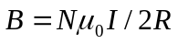  For coils used in this experiment:  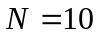  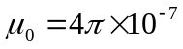  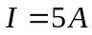  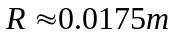  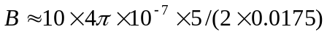  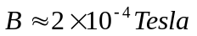  (Insert) Figure 2: Magnetic field produced by current carrying coil
Q3: Why is the permanent magnet stuck to the D cell needed in our motor? | The permanent magnet provides an external field for the field produced by the coil to oppose. It is the interaction of the two fields that exerts a torque on the coil.

Q4: Sketch and describe the magnetic fields in this motor at different points during the rotation. | (Insert) Figure 3: Magnetic fields and resultant torques
Q5: View the motor in the dark. What do you see at the paper clip/armature connections? Why? | It is possible to see a small arc between the paper clip and armature. This is evidence that current is flowing through the coil.
Q6: An engineer could claim that this motor should simply lock itself into a single position, and the motor does have a tendency to do so. What is this (electrically powered) position? Why does our motor not continuously lock in this position? | The “lock” position is when the coil is perpendicular to the field of the permanent magnet such that the two fields are anti-parallel. If the current through the coil was constant, any displacement from this position would result in a field interaction creating a torque that would tend to oppose the motion of the coil. These motors do not lock in this position because the enamel insulation is removed from only half of the armature. When the motor reaches this position the current is interrupted and the coil rotates through the second half of its cycle due to its rotational inertia (angular momentum.
Q7: If locked and not rotating, where would the electrical energy from the battery go? | The energy would primarily raise the temperature of the copper coil.

Q8: A second magnet can be brought beneath the coil and can either slow or accelerate the armature's rotation (see below). Explain why, using a diagram. | (Insert) Figure 4: Interaction of induced and permanent magnetic fields.  (For scale, magnetic interaction with steel battery casing is ignored.)

References:

REF1: M. Wells, D. Hestenes, & G. Swackhamer, “A Modeling Method for High School Physics Instruction,” American Journal of Physics, 64, pp. 114-119, (1995).

REF2: A. Arons, Teaching Introductory Physics, (John Wiley & Sons, New York, 1997).

REF3: R. Hake, “Interactive-engagement vs. traditional methods: A six-thousand-student survey of mechanics test data for introductory physics courses,” American Journal of Physics, 66(1), pp. 64-74, (1998).

REF4: J. Piaget, R. Garcia, Psychogenesis and the history of science, (Cambridge University Press, New York, 1989).

REF5: C. Chiaverina, C. “The Simplest Motor?” The Physics Teacher, 42, pg. 553, (2004).

REF6: D. Johnson, “The Johnson D.C. Electric Motor Recipe,” Journal of College Science Teachers, 26(6), pp. 437-438, (1997).

REF7: A. Klittnick, M. Rickard, “Mystery Motor Demystified,” The Physics Teacher, 39, pp. 174-175, (2001).

REF8: W. Dindorf, “Unconventional Dynamo,” The Physics Teacher, 40, pp. 220-221, (2002).

REF9: J. Johnson, F. Miller, “A motor is a generator and vice versa,” The Physics Teacher, 14, pp. 36-37, (1976).

REF10: D. MacIsaac, K. Falconer, “Whiteboarding in the Classroom,” Manuscript in preparation, available from the author, (2004).

REF11: D. MacIsaac, Small Motors: Faraday's Law and Lenz's Law. Retrieved April 28, 2003, from Physics Education at Buffalo State College, Web site: http://physicsed.buffalostate.edu/SeatExpts/EandM/motor/index.htm

REF12: Similar activities are used in the second semester of the Arizona State University Modeling Physics Cirriculum.

REF13: Massachusetts Institute of Technology TEAL (Technology Enabled Active Learning) Studio Physics project, Website: <http://ocw.mit.edu>

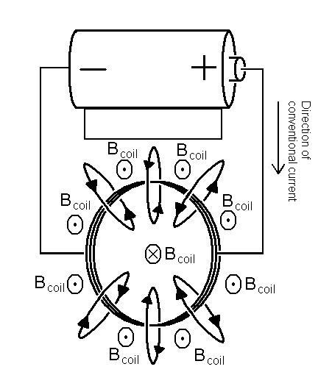
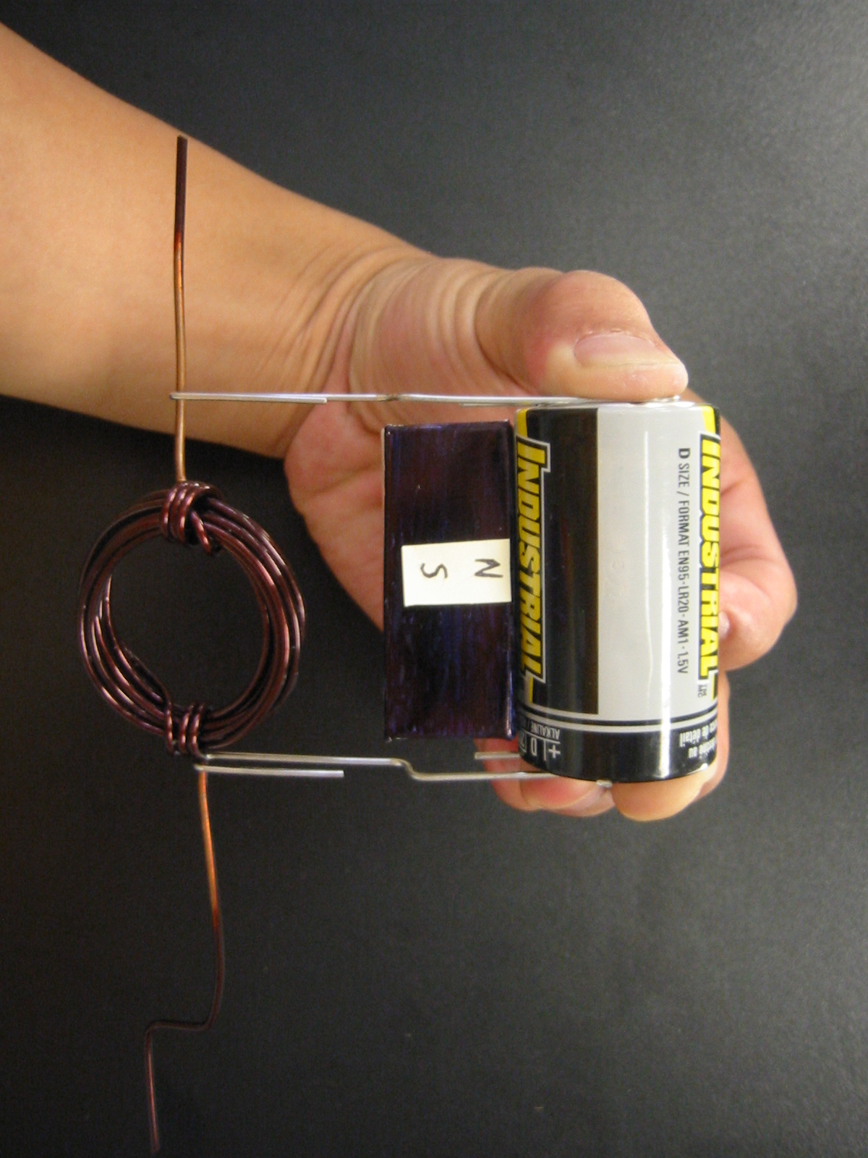
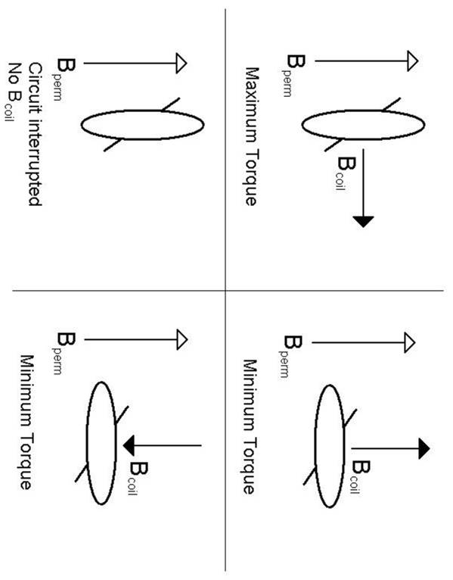
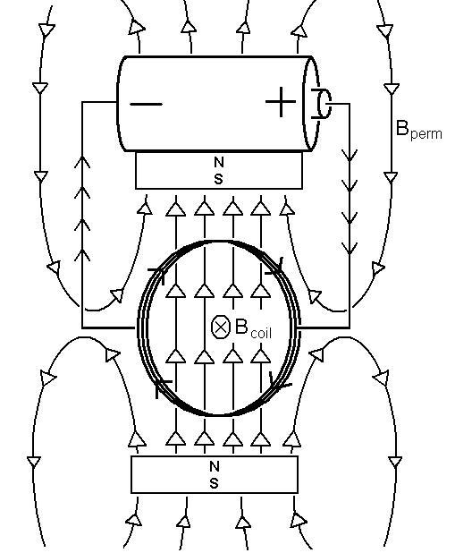
Figure 1: Assembled Motor Apparatus.
Figure 2: Magnetic field produced by current carrying coil.
Figure 3: Magnetic fields and resultant torques.
Figure 4: Interaction of induced and permanent magnetic fields.

