Misconceptions about Chemical Bonding in Science Education

John M. Zamojski

SUNY Buffalo State

PHY 690

Dr. Dan MacIsaac

Introduction
There appears to be a deep-seated misconception that develops within students about the nature of chemical bonding, specifically that energy is released when bonds are broken. A recent paper published by Dreyfus, Sawtelle, Turpen, Gouvea, and Redish (2014) from the University of Maryland’s Department of Physics explores this misconception, specifically students’ reasoning about “high-energy” bonds and the energy associated with ATP hydrolysis, through a case study of an undergraduate introductory physics course. The case study and its results will be summarized, but since the case study focused on only one course and on a specific concept within that course, this paper will take a more general approach that may be useful to middle school and high school science teachers. The misconception about chemical bonding energy and its apparent sources will be presented followed by activities teachers can use to help their students better understand the nature of chemical bonding.
Case Study at the University of Maryland – Interdisciplinary Reconciliation
The work of Dreyfus et al. (2014) involves a case study of students in a specially designed introductory physics course for undergraduate life science students, and the focus of the case study is the apparent contradiction students encounter between the energy released when the oxygen-phosphate bond in ATP is broken and the idea that an energy is input is required to break a bond. Previous work by this team shows that some students see a difference between energy as it is presented in biology and energy as it is presented in physics, so in a unit on thermodynamics in this course, the students explore ATP hydrolysis due to its relevance to both science disciplines. Students are provided an initial multiple choice quiz to reveal their understanding about the energy associated with the phosphate bond in ATP, interviewed after this initial quiz to reveal their reasoning, allowed to discuss their misunderstandings in class with the professor and within small groups, and finally given a capstone essay question at the end of the unit that asks students to either correct or reconcile two apparently opposing explanations of ATP hydrolysis.
Dreyfus et al. (2014) conclude this misconception about bond breaking releasing energy does not come from misunderstanding but rather from the conflicting descriptions of the same process based on the context of which science discipline students are studying. For example, one interview reveals a student perception that in biology the release of energy from the overall process of ATP hydrolysis is most relevant while in physics understanding the specific steps of bond breaking and bond formation within ATP hydrolysis is most relevant. Because each approach is correct within its specific science discipline yet seems to contradict with its analogous explanation, Dreyfus et al. (2014) advocate a model of student learning called interdisciplinary reconciliation (IDR). IDR is unique as a framework in science education because each disciplinary idea is considered canonically correct within its own discipline, so that a correct idea in one discipline is not considered incorrect in another discipline. Through IDR students learn to build coherent connections between concepts from different disciplines while understanding each concept in its own disciplinary context.
The Prevalent Misconception
The idea that energy is released when chemical bonds are broken is a well-established misconception in science education. Prior to the case study performed by Dreyfus et al. (2014), the most noteworthy study and analysis of this misconception was executed by Dr. William Galley, a chemistry professor at McGill University. In a survey of over 600 of his biochemistry and physiology students over the course of several years at the beginning of a course in introductory physical chemistry, Galley (2004) provided two questions about the energy associated with ATP hydrolysis and a simple combustion reaction. From those questions over 85% of students selected an incorrect response that stated bond breaking is exothermic for the ATP hydrolysis question and over 80% of students selected an incorrect response that stated bond breaking of the reactants to be the source of energy release in a simple combustion reaction. The fact that all of these students have a background in college-level science coursework reveals how deeply ingrained the misconception is. While Dr. Galley’s article was the only published research in the Journal of Chemical Education about this misconception, an exploration of email list archives from the Phys-L mailing list and the NSTA chemistry mailing list reinforce the pervasiveness of this exothermic bond breaking misconception. The prevalence of this misconception is an interdisciplinary problem in science education as bonding is important in all of the major subjects. Bonding is studied in biological molecules, bonding is central to the study of chemistry, and energy flow and the electrostatics associated with chemical bonding are both studied in physics.
When Does the Misconception Begin?
As a follow up to his initial survey to his students, Dr. Galley conducted a second survey to discover the origin of this misconception that bond breaking releases energy. Galley (2004) found that students identify their high school and junior college level biology coursework as providing an incorrect picture of the energetics of bond rupture and formation and of the ADP to ATP conversion in particular. The language used when students are learning about ATP hydrolysis contributes as the term “high-energy phosphate bond” or as the statement “a phosphate group is cleaved off resulting in a release of energy” is easily misinterpreted to mean that the energy from the chemical reaction comes from the phosphate bond. However, biology instruction is not the only source of this misconception because Galley (2004) reveals that 40% of students stated that they felt they were told in their high-school, junior-college, or even university level chemistry instruction that bond breaking was exothermic. The language used when learning contributes once again since the term “energy stored in chemical bonds” is widely used in chemistry texts, which can be easily misinterpreted to convey the meaning that energy is available to be released when the bond is broken.
The Language of the Misconception
Confusing or ambiguous language, oversimplified explanation, and even teacher misunderstanding seem to contribute to the misconception at all levels. Regardless of the course, the language used to describe chemical bonding contributes greatly to this misconception, and unfortunately, published standards use the same misleading or ambiguous language. Below are a few examples with a further description of how the language used to describe the concept could be misleading.
New York State Intermediate Level Science Core Curriculum
Standard 4, Key Idea 1, Performance Indicator 1.2:
1.2d – During respiration cells use oxygen to release the energy stored in food.
- The phrase “energy stored in food” can easily be interpreted to mean that the energy is already present in the food and available to be released.
New York State: The Living Environment Core Curriculum
Standard 4, Key Idea 5, Performance Indicator 5.1:
5.1d – In all organisms, the energy stored in organic molecules may be released during cellular respiration. The energy is temporarily stored in ATP molecules.
- Both sentences of the subsection of the performance indicator convey that the energy is stored within the molecule. While the standard does not present an incorrect statement such as “The breaking of bonds in those molecules is the source of the energy that is released”, by saying “released during cellular respiration” it is not explicit enough about the source of the energy released.
Next Generation Science Standards
HS-LS1: From Molecules to Organisms: Structures and Processes
HS-LS1-j: Cellular respiration is a chemical process whereby the bonds of food molecules and oxygen molecules are broken and the bonds in new compounds are formed resulting in a net transfer of energy.
- This statement is an improvement upon the previous one from the New York State Living Environment Standards since the process of bond breaking and forming new compounds is stated to lead to a net transfer of energy. However, there needs to be a more explicit description about the energy requirement for bond breaking and the energy release from bond formation.
The Facts about Chemical Bonding
Due to the apparent lack of understanding about the nature of the chemical bond and about the bonding process that occurs during chemical reactions, a brief explanation of chemical bonding will be presented followed by a brief explanation of the breaking and formation of chemical bonds in a chemical reaction. While this presentation of facts comes from published scientific literature, comparable explanations of the key concepts are likely to be found in any high school chemistry textbook.
The Chemical Bond
Although it is often portrayed in models as a physical link between two atoms, a chemical bond is not a tangible thing. A chemical bond is an electrostatic interaction between atoms, specifically between the valence electrons and nuclei of the bonding atoms. When the electrostatic attraction between the positively-charged nucleus of one atom and the negatively-charged valence electrons of another atom is greater than the electrostatic repulsion among the negatively-charged electrons of the two atoms and between the positively-charged nuclei of the two atoms, a chemical bond is formed. The electrons are exposed to twice as much positive charge within their clouds than in the separated atoms, and this increased attractive force is stronger than the repulsive forces between the nuclei and between the electrons (Weisskopf, 1985). This electrostatic attraction is most noticeable in ionic bonding where valence electrons are completed transferred from their parent atom to the more electronegative atom, and two ions are formed leading to a strong electrostatic attraction between the positive cation and the negative anion. In a covalent bond the electrons are not completed transferred, but the electrostatic attraction between the two atoms is strong enough that it keeps the atoms in close proximity to each other.
Because a chemical bond is the result of an attractive force, energy must be supplied in order to overcome the attraction between the two bonded atoms in the same way that launching a rocket requires an input of energy in order to overcome the attraction due to gravity between the rocket and the Earth. Since the initial attachment of a chemical bond can only exist if the forces of interaction between the component atoms are predominantly attractive, energy must be expended to separate two bonded atoms (Sanderson, 1964).
A Chemical Reaction Is a Process
Another key reason there is a misconception is that teachers and students look at bond breaking only and not the bond breaking-bond forming process. A chemical reaction is a process in which existing bonds are broken and new bonds are formed (Mickey, 1980).

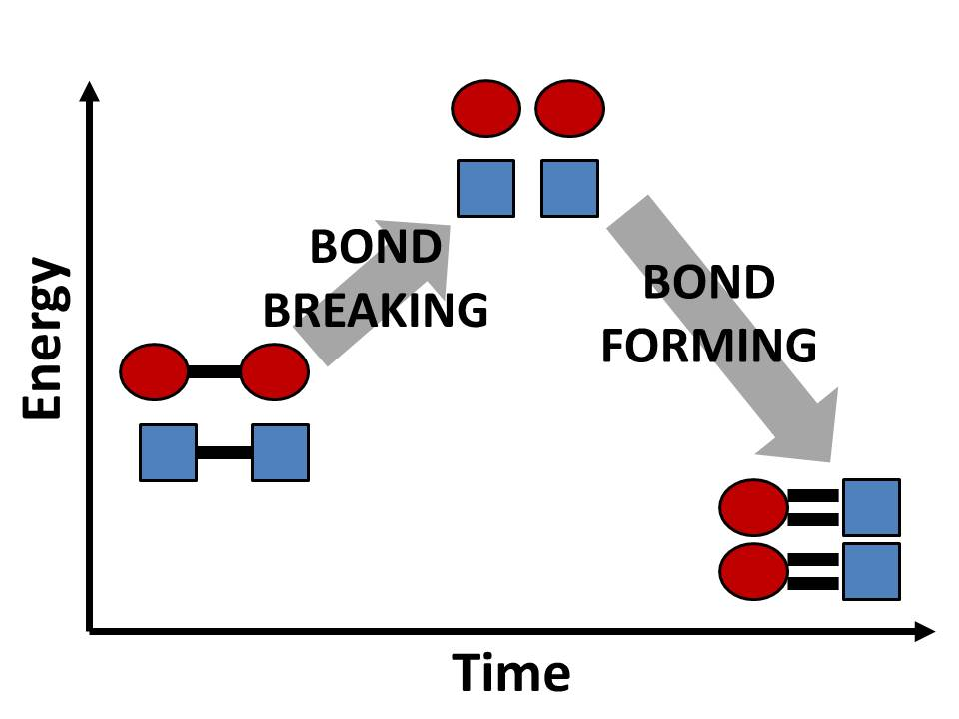
Figure 1. This is a highly simplified representation of the bonding process for a chemical reaction. For all chemical reactions energy is required in order to break a chemical bond, and then energy is released when a new chemical bond is formed. The new bonds formed are typically stronger than the initial bonds in the reactants.

An energy barrier prevents most reactions from proceeding rapidly at ordinary temperatures, and the quantity of energy required to overcome the barrier is known as activation energy. The necessity to break bonds during the course of a reaction means that energy is required to activate a reaction even if the net process is exothermic (Mickey, 1980). Very simply the activation energy is the energy required to break the chemical bonds in the reactant molecules. This energy is supplied by the collisions between atoms or molecules, and the collisions can have more energy, and therefore the rate of reaction can increase, when certain reaction conditions change such an increase in temperature.

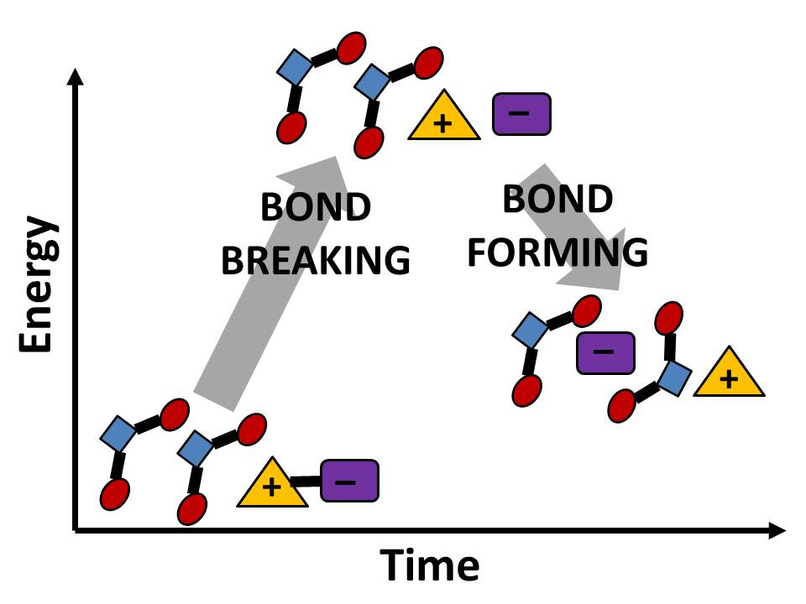
Figure 2. For processes and reactions that are endothermic where there is a net gain of energy, there is still energy absorbed to break bonds and energy released to form new bonds.

A key tool for understanding the bonding process is the potential energy diagram that students first encounter when they study kinetics in high school chemistry. The regions of a potential energy diagram for a chemical reaction show the potential energy of the reactants, the potential energy of the products, and a hump or spike that represents the activation energy of the reaction. Regardless of whether a reaction is exothermic (the energy of the reactants is higher than the energy of the products) or endothermic (the energy of the reactants is lower than the energy of the products), there is always an increase in energy on the potential energy diagram before the products are formed.
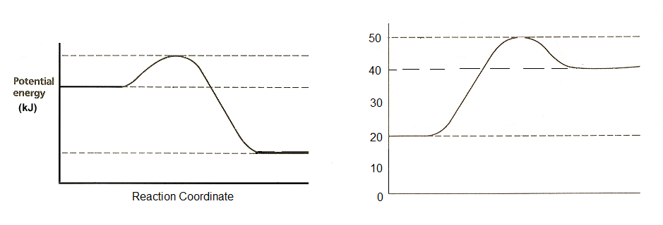
Figure 3. Two potential energy diagram representing exothermic (left diagram) and endothermic (right diagram) reactions. Regardless of whether the reactants or products have more energy, in both reactions energy is required initially until there is an energy peak, and after that point energy is released. If there is a net gain in energy, then the reaction is endothermic. If there is a net loss of energy, then the reaction is exothermic.

The potential energy diagram demonstrates that there are two distinct parts in a chemical reaction and that bond breaking is always endothermic or requires energy while bond formation is always exothermic or releases energy.
Practical Methods to Address This Misconception
Dr. Galley’s Approach
Despite the strength and prevalence of this misconception, it can be effectively addressed and eliminated with time and providing students with the appropriate tools. In his study of his own chemistry students, Dr. Galley (2004) uses three methods. He provides students the correct answers to his initial survey, contrasting these answers with the exothermic bond breaking misconception. Next he presents an electronic energy diagram (refer to the PhET simulation on p. 15 for potential energy diagrams) that shows the large potential energy well that exists between the less energetic covalently-bonded diatomic hydrogen molecule and the more energetic two unbonded hydrogen atoms. Then he uses a detailed potential energy diagram for ATP hydrolysis that displays structural formulas and bond enthalpies for the reactants, intermediates, and products to emphasize that the overall exothermic reaction is the balance of endothermic bond breaking and exothermic bond formation (Galley, 2004).
According to Dr. Galley (2004) this method largely resolves the exothermic bond breaking misconception. This resolution seems to result from the fact that Dr. Galley confronts the misconception directly, challenges the students’ understanding of chemical bonding, and provides visual evidence to aid his students’ learning by means of graphs and diagrams that emphasize the energy requirement for bond breaking.
Examples
Examples of common, easily observable chemical reactions with a special emphasis placed on the bond breaking-bond forming process can also be used to improve student comprehension of the flow of energy through a chemical reaction. Developing a lesson that incorporates a demonstration of a chemical reaction, an energy diagram modeled after the one used by Galley, and student calculations of the bond energies of all molecules in the reaction, is an effective, multimodal approach to help students develop a correct and thorough understanding of the energy of bond breaking, bond formation, and chemical reactions overall. A sequence of calculations and an energy diagram is presented below for the combustion of methane.
Combustion of Methane
Combustion is an ideal example because of the students’ experience with this type of reaction. Because a spark or flame is required to light a Bunsen burner, students have witnessed that energy is required to initiate the following chemical reaction between methane, the primary component of natural gas, and oxygen:
CH₄ + 2O₂ CO₂ + 2H₂O.
The heat energy from the flame or spark is used to overcome the attractive forces between the carbon and hydrogen atoms in methane and between the oxygen atoms in the diatomic oxygen molecules and therefore, break the chemical bonds. Students also have observed that a lit Bunsen burner gives off heat, which is due to the formation of new chemical bonds between carbon and oxygen atoms in carbon dioxide and between hydrogen and oxygen atoms in water. These two observations are reinforced by calculations using the bond energies of the molecules involved in the combustion reaction. The calculations below were completed by Dr. Sanderson (1968).
CH₄ + 2O₂ CO₂ + 2H₂O
Bond energy of CH₄ = 397.2 kcal/mol  Bond energy of O₂ = 119.2 kcal/mol | Bond energy of CO₂ = 383.8 kcal/mol  Bond energy of H₂O = 223.6 kcal/mol
$$Total Bond Breaking Energy={∆H}_{CH4}+2{∆H}_{O2}$$
$$Total Bond Breaking Energy=\left(1 mol\right)\left(397.2\frac{kcal}{mol}\right)+\left(2 mol\right)\left(119.2\frac{kcal}{mol}\right)$$
$Total Bond Breaking Energy=397.2 kcal+238.4 kcal=$635.6 kcal
$$Total Bond Forming Energy={-∆H}_{CO2}+(-2{∆H}_{H2O})$$
$$Total Bond Forming Energy=-\left(1 mol\right)\left(383.8\frac{kcal}{mol}\right)-\left(2 mol\right)\left(223.6\frac{kcal}{mol}\right)$$
$Total Bond Forming Energy=-383.8 kcal-447.2 kcal=$ –831.0 kcal
$${∆H}_{combustion}=Total Bonding Breaking Energy+$$
$$Total Bond Forming Energy$$
${∆H}_{combustion}=635.6 kcal-831.0 kcal=$ –194.6 kcal

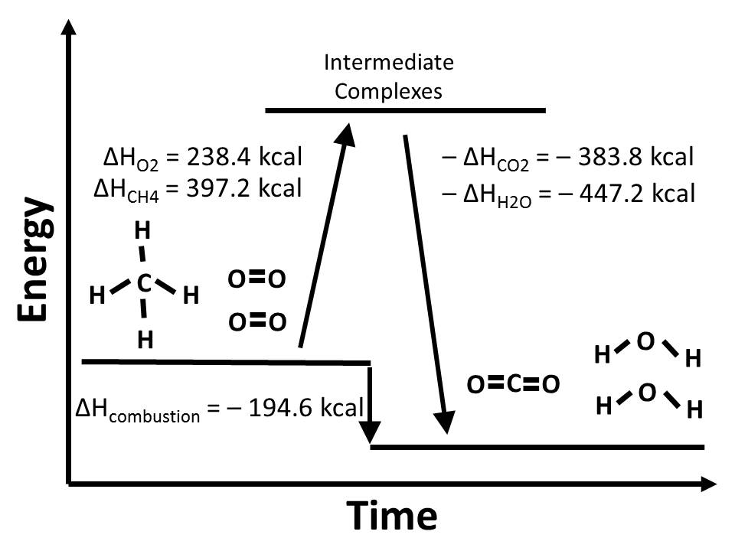
Figure 4. The heat of combustion of methane (ΔH_{combustion}) is represented in terms of approximate total bond energies for the reactants and products. The calculated quantities for the total bond energies come from Sanderson’s per mole calculations multiplied by the coefficients in the balanced chemical equation for the combustion of methane. Negative energy values signify that energy is released, and positive energy values signify that energy is absorbed. While the combustion of one mole of methane results in the release of 195 kcal of energy, this exothermic reaction is the combination of endothermic bond breaking and exothermic bond formation. Intermediate complexes are not shown for simplicity due to the fact that a large variety of intermediate complexes are formed during the chemical reaction.

ATP Hydrolysis
In his study of chemical bonding with his students Dr. Galley (2004) presents the reaction process of ATP hydrolysis in an energy diagram and graphs the reactants, products, and intermediate complexes based on their energy values for bond enthalpy.
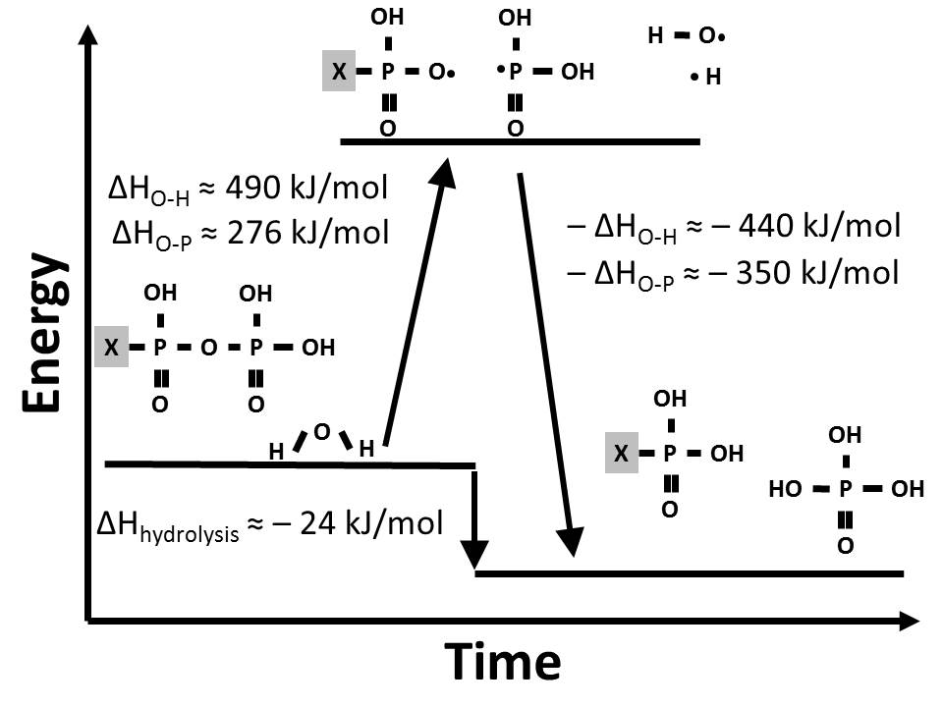
Figure 5. This diagram displays the reactants, intermediate complexes, and products for ATP hydrolysis and their respective bond enthalpies. The X represents the rest of the ATP molecule, which does not participate in this chemical reaction. This visual, stepwise representation of ATP hydrolysis clearly indicates that while there is a net release of energy (ΔH_{hydrolysis} ≈ -24 kJ/mol), energy is required to break the oxygen-phosphorus bond in ATP and the oxygen-hydrogen bond in water.

Activities & Demonstrations
Incorporating hands-on activities into lessons on chemical bonding can help reinforce the basic concept that energy is required to break a chemical bond and that energy is released when a bond is formed. Two examples are presented below.
- Bar Magnets: While the use of bar magnets is an oversimplified model of chemical bonding, the use of bar magnets is basic enough for any grade level to demonstrate the fact that a bond is the result of an attractive force and the fact that energy is required to break a bond. In order to pull the magnets apart, energy is required. Furthermore, if the magnets are put close enough together, then the magnetic attractive force between the opposite poles of the magnet overcomes any frictional force resulting from the surface of a desk or table, and a bond is formed. The energy released in the formation of this bond is in the form of the motion of the magnets towards each other and the noise they make when they collide.
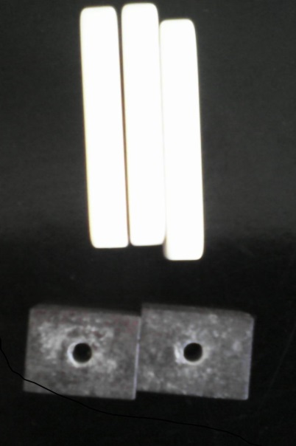
Figure __. Two ceramic magnets are separated by three dominoes. When the dominoes are removed, the magnets spontaneously move towards each other.

- PhETTM simulation – Atomic Interactions: This free, interactive, online simulation from phet.colorado.edu is effective because the simulation represents both electrostatic forces present between two atoms and the potential energy of both atoms. Select the simulation and refer to the Teacher Resources at the bottom of the page. Under Teacher Ideas there ready-to-go lessons made by instructors who use this simulation in their classrooms. “Introduction to the Covalent Bond” by Roberto Marrero is most relevant to the topic discussed in this paper.
References

Dreyfus, B.W., Sawtelle, V., Turpen, C., Gouvea, J., and Redish, E.F. (2014). Students’ reasoning about “high-energy” bonds and ATP: A vision of interdisciplinary education. Physical Review of Special Topics – Physics Education Research, 10, 010115-1-15.

Galley, W.C. (2004). Exothermic bond breaking: A persistent misconception. Journal of Chemical Education, 81 (4), 523-525.

Mickey, C. D. (1980). Chemical kinetics: Reaction rates. Journal of Chemical Education, 57(9), 659-663.

NGSS Lead States (2013). HS-LS1: From molecules to organisms: Structures and processes. Next Generation Science Standards: For States, By States. Washington, DC: The National Academies Press. Retrieved from <http://www.nextgenscience.org>

Sanderson, R. T. (1964). Principles of chemical reaction. Journal of Chemical Education, 41 (1), 13-22.

Sanderson, R. T. (1968). Why does methane burn? Journal of Chemical Education, 45(6), 423-425.

The State Education Department of the University of the State of New York. Standard 4, Key idea 1. Intermediate Level Science Core Curriculum Grades 5-8. Retrieved from <http://www.p12.nysed.gov>

The State Education Department of the University of the State of New York. Standard 4, Key idea 5. The Living Environment Core Curriculum. Retrieved from <http://www.p12.nysed.gov>

Weisskopf, V. F. (1985). Search for simplicity: The molecular bond. American Journal of Physics, 53 (5), 399-400.

