Exploring Chemical Bonding & Energy

Standards Addressed

***AP® Chemistry: Curriculum Framework 2013-2014***

**Big Idea 5:**

The laws of thermodynamics describe the essential role of energy and explain and predict the direction of changes in matter.

**Enduring understanding 5.C: Breaking bonds requires energy, and making bonds releases energy.**

*Essential knowledge 5.C.2:* The net energy change during a reaction is the sum of the energy required to break the bonds in the reactant molecules and the energy released in forming the bonds of the product molecules. The net change in energy may be positive for endothermic reactions where energy is required, or negative for exothermic reactions where energy is released.

### *Next Generation Science Standards 2013*

### HS-PS1 Matter and Its Interactions

**HS-PS1-4.** Develop a model to illustrate that the release or absorption of energy from a chemical reaction system depends upon the changes in total bond energy.

[Clarification Statement: Emphasis is on the idea that a chemical reaction is a system that affects the energy change. Examples of models could include molecular-level drawings and diagrams of reactions, graphs showing the relative energies of reactants and products, and representations showing energy is conserved.]

[Assessment Boundary: Assessment does not include calculating the total bond energy changes during a chemical reaction from the bond energies of reactants and products.]

### Disciplinary Core Ideas

### [PS1.A: Structure and Properties of Matter](http://www.nap.edu/openbook.php?record_id=13165&page=106)

* [A stable molecule has less energy than the same set of atoms separated; one must provide at least this energy in order to take the molecule apart.](http://www.nap.edu/openbook.php?record_id=13165&page=106)

### [PS1.B: Chemical Reactions](http://www.nap.edu/openbook.php?record_id=13165&page=109)

* [Chemical processes, their rates, and whether or not energy is stored or released can be understood in terms of the collisions of molecules and the rearrangements of atoms into new molecules, with consequent changes in the sum of all bond energies in the set of molecules that are matched by changes in kinetic energy.](http://www.nap.edu/openbook.php?record_id=13165&page=109)

Name: ________________________________________________ Date: _____________

Exploring Chemical Bonding & Energy

**Part I:** Working with Magnets

*Instructions:* Take a pair of ceramic magnets and play with them for a few minutes. Then answer the questions below.

1) Put the magnets together. If you lift up one magnet, what happens to the other magnet? Does it move up as well or fall to the ground?

__________________________________________________________________________________________

2) Based on your answer to the previous question are the magnets attracted to each other or repelling each other?

__________________________________________________________________________________________

3) Pull the magnets apart. Describe any sensory experiences that you had while pulling the magnets apart. Was it easy or difficult to pull them apart?

__________________________________________________________________________________________

__________________________________________________________________________________________

4) Did you have to add energy to the magnets to pull them apart or did energy come from the magnets into the surroundings?

__________________________________________________________________________________________

*****

An attraction between two objects is a bond. The bond is caused by some sort of attractive force whether it is gravitational, electrostatic, or magnetic. For example, you are bonded to Earth. Both you and the Earth have mass and the attractive force is gravity.

|  |  |
| --- | --- |
|  |  |
| From PhET: Atomic Interactions | From PhET: Gravity and Orbits |
| phet.colorado.edu | |

5) Move the magnets far enough apart, so that they do not move toward each other. Then hold them by their ends and slowly move them toward each other until you feel the attractive force between the two magnets. What do you think will happen when you let go of the magnets?

________________________________________________________________________________________

6) Be careful that you do not get your fingers in between the magnets. Let go of the magnets. Describe any sensory experiences you had after releasing the magnets. Did you have to push the magnets together or did they come together on their own?

________________________________________________________________________________________

7) Did you have to add energy to the magnets to put them together or did energy come from the magnets into the surroundings?

________________________________________________________________________________________

While the magnetic force you have experienced is distinct from the electrostatic forces that dictate bonding between atoms, the same principles apply.

* In order to separate two objects that are bonded, energy must be ________________.
* When two separate objects form a bond, energy must be ___________________.

*****

8) Now acquire 4 dominoes. Place all four dominoes between the two magnets, so that the dominoes are stuck sandwiched between the two magnets. Now pull the magnets apart. Note the amount of energy you used to pull the magnets apart (i.e. effortless, easy, moderate, challenging, impossible).

________________________________________________________________________________________

9) Take 3 dominoes and repeat the process. Now pull the magnets apart. Note the amount of energy you used to pull the magnets apart (was it easier, harder, or the same as the previous attempt?).

________________________________________________________________________________________

10) Take 2 dominoes and repeat the process. Now pull the magnets apart. Note the amount of energy you used to pull the magnets apart (was it easier, harder, or the same as the previous attempt?).

________________________________________________________________________________________

11) Take 1 domino and repeat the process. Now pull the magnets apart. Note the amount of energy you used to pull the magnets apart (was it easier, harder, or the same as the previous attempt?).

________________________________________________________________________________________

12) Which situation was the easiest to separate? Would you consider this the strongest or weakest bond (attraction)?

________________________________________________________________________________________

13) Which situation was the hardest to separate? Would you consider this the strongest or weakest bond (attraction)?

________________________________________________________________________________________

14) Go back to 4 dominoes between the magnets. Pull the magnets apart and then return them to sandwich the dominoes. Now with the help of a partner hold the magnets in place and then remove 3 dominoes. After the magnets come together pull the magnets apart.

Note the difference in energy between the 4 domino bond and the 1 domino bond. In general chemical reaction involve adding energy to break bonds and then energy is released to form a different, stronger bond. The difference in the work required to break and make bonds produces the net energy of reaction.

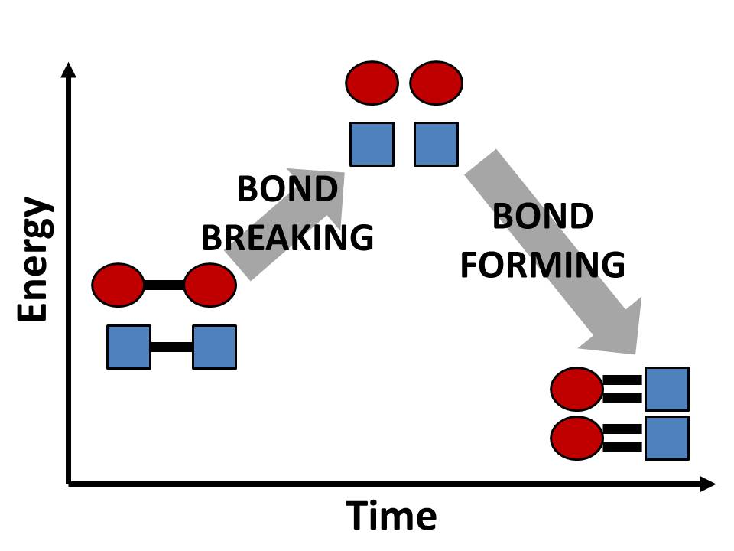

Draw a similar diagram for the 4 dominoes going to 1 domino.

Unit: Chemical Bonding or Chemical Reactions

Lesson: Exploring Chemical Bonds & Energy

Length: 50 minutes

**Instructional Objectives:**

Students will be able to

1. State and explain that bond breaking requires energy and bond forming gives off energy
2. Determine the strength of a bond based on position of two objects
3. Represent the changes of energy in a chemical reaction in multiple ways

**Assessment:**

Students who demonstrate understanding can

1. Answer two multiple choice questions and provide an explanation in a free response question that bond breaking requires an input of energy and bond forming release energy.
2. Rank the strength of interaction for four scenarios with dominoes and magnets where the strongest interaction occurs when the magnets are closest together and the weakest interaction occurs when the magnets are farthest apart.
3. Calculate the energy used in bond breaking and bond forming and use those values to calculate the change in energy of the system and then represent these calculations pictorially or graphically.

**Standards:**

***AP® Chemistry: Curriculum Framework 2013-2014***

**Big Idea 5:**

The laws of thermodynamics describe the essential role of energy and explain and predict the direction of changes in matter.

**Enduring understanding 5.C: Breaking bonds requires energy, and making bonds releases energy.**

*Essential knowledge 5.C.2:* The net energy change during a reaction is the sum of the energy required to break the bonds in the reactant molecules and the energy released in forming the bonds of the product molecules. The net change in energy may be positive for endothermic reactions where energy is required, or negative for exothermic reactions where energy is released.

### *Next Generation Science Standards 2013*

### HS-PS1 Matter and Its Interactions

**HS-PS1-4.** Develop a model to illustrate that the release or absorption of energy from a chemical reaction system depends upon the changes in total bond energy.

### Disciplinary Core Ideas

### [PS1.A: Structure and Properties of Matter](http://www.nap.edu/openbook.php?record_id=13165&page=106)

* [A stable molecule has less energy than the same set of atoms separated; one must provide at least this energy in order to take the molecule apart.](http://www.nap.edu/openbook.php?record_id=13165&page=106)

### [PS1.B: Chemical Reactions](http://www.nap.edu/openbook.php?record_id=13165&page=109)

* [Chemical processes, their rates, and whether or not energy is stored or released can be understood in terms of the collisions of molecules and the rearrangements of atoms into new molecules, with consequent changes in the sum of all bond energies in the set of molecules that are matched by changes in kinetic energy.](http://www.nap.edu/openbook.php?record_id=13165&page=109)

**Materials:**

* Pen/pencil
* Exploring Chemical Bonding & Energy Handout
* Two ceramic magnets
* 4 dominoes
* calculator

**Part II:** Energy Calculations of Bond Making and Bond Breaking





**Figure 5.** Calculations completed by Dr. Sanderson (1968) for the bond energies of methane, oxygen, carbon dioxide, and water for the combustion of methane.

|  |  |
| --- | --- |
| CH4 (g) + O2 (g) 🡪 CO2 (g) + H2O(g) | |
| **Reactants** – Bonds Will Be Broken | **Products** – Bonds Will Be Formed |
| Total Bond energy of CH4 = 1662 kJ/mol  Total Bond energy of O2 = 498.7 kJ/mol | Total Bond energy of CO2 = 1606 kJ/mol  Total Bond energy of H2O = 935.5 kJ/mol |
| $$Total Bond Breaking Energy={∆H}_{CH4}+2{∆H}_{O2}$$ $$Total Bond Breaking Energy=\left(1 mol\right)\left(1662\frac{kJ}{mol}\right)+\left(2 mol\right)\left(498.7\frac{kJ}{mol}\right)$$ $Total Bond Breaking Energy=1662 kJ+997.4 kJ=$**2659 kJ** | |
| $$Total Bond Forming Energy={-(∆H}_{CO2}+2{∆H}_{H2O})$$ $$Total Bond Forming Energy=-(\left(1 mol\right)\left(1606\frac{kJ}{mol}\right)+\left(2 mol\right)\left(935.5\frac{kJ}{mol}\right))$$ $Total Bond Forming Energy=-(1606 kJ+1871.0 kJ)=$**–3477 kJ** | |
| $${∆H}_{combustion}=Total Bonding Breaking Energy+Total Bond Forming Energy$$ ${∆H}_{combustion}=2659 kJ-3477 kJ=$**–818 kJ** | |

Draw a step-wise potential energy diagram like the one below for the reaction using your calculated values.

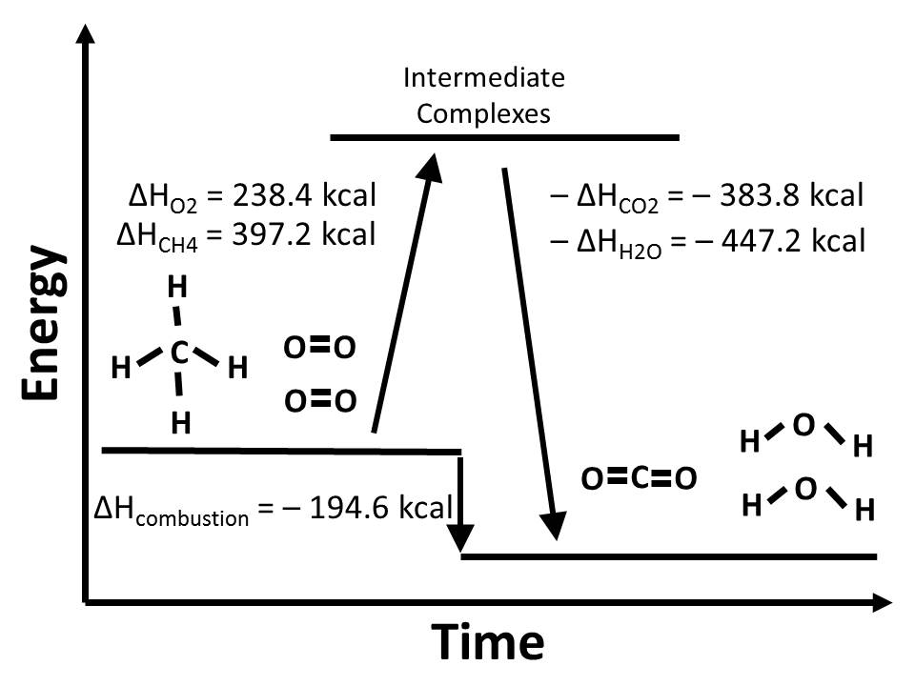

**Part III:** Free-Response Question

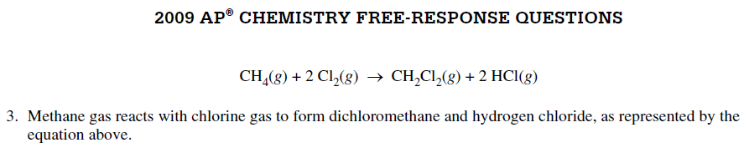





5)



|  |  |  |
| --- | --- | --- |
| **NYS Regents Exam** | **Question** | **Answer** |
| June 2012 |  |  |
| June 2014 |  |  |