A Simple Classroom Demonstration RC Circuit:
The Neon Bulb Relaxation Oscillator

Dan MacIsaac, Aaron Ward and Stephen Wilser
SUNY-Buffalo State College Department of Physics

Abstract
We discuss simple and inexpensive RC circuit apparatus for a classroom demonstration. Known as a Neon lamp relaxation oscillator, our circuit causes a Ne lamp to visibly blink with a period on the order of about a second, which allows students to directly observe this phenomenon, vary resistances and capacitances (by clipping in additional components with alligator clips) to see effects on the period and develop insight even without using an oscilloscope. We also promote comparison to a famous analogous Japanese garden fountain mechanical relaxation oscillator, the “Shishi-odoshi” or “deer scarer.”

Bios
Dr. Dan MacIsaac is an Associate Professor of Physics specializing in physics teacher preparation at SUNY Buffalo State College Physics.

Aaron Ward completed his M.S.Ed. in Physics Education at SUNY Buffalo State Physics Education Department in 2015. Aaron graduated from Alfred University in December of 2012 with a degree and NYS initial certification in Chemistry. He is currently a physics teacher at Mount Morris Central Schools in Mount Morris, New York.

Stephen Wilser completed his M.S.Ed. in Physics Education at SUNY Buffalo State in 2011, before taking a degree in Computer Science at SUNY University at Buffalo. He resides in Buffalo.

Background

Resistance-capacitance or RC (pronounced Are-See) circuits are standard fare in introductory college and university physics courses, as well as International Baccalaureate (IB) and Advanced Placement (AP) physics when teaching current electricity (Steinberg, 2011). There are standard HS curricula addressing RC circuit activities -- particularly the American Modeling Teacher’s Modeling Physics Curriculum and the Castle curriculum from Pasco scientific. RC circuits can also be used to address many New York State Science Learning Standards in High School Physical Science, as described in Table 1 below.

NYS Science Learning Standards for  HS Physical Science Physics from  <thewonderofscience.com/  nyssls-hs-standards> | Forces and Interactions:  HS-PS2-4: Gravitational and Electrostatic Forces Between Objects  Energy:  HS-PS3-1: Energy Change in Components of a System  HS-PS3-2: Macroscopic Energy Due to Particle Position and Motion  HS-PS3-3: Energy Conversion Device Design  HS-PS3-5: Energy Change Due to Interacting Fields  HS-PS3-6: Ohm's Law*
AMTA Modeling Physics Instructional Goals  (AMTA, 2014) | Electricity, U3: Circuits  4. For simple series and parallel circuit arrangements, conservation of energy and charge can be demonstrated.  - The energy dissipated by resistive elements in a circuit equals the energy provided by the external source.  - The total quantity of charge moving in a circuit remains constant. The quantity of charge in a given branch is inversely proportional to the resistance in that branch.  6. Representational tools include:  - maps of surface charge distribution  - schematic diagrams to represent circuits.
Capacitor-Aided System for Teaching and Learning Electricity (CASTLE) Curriculum Instructional Goals  (Steinberg, 2011) | U2: Charge Flow and Sources of Charge Model  - Represent simple circuits with schematic diagrams.  - Identify the structure/parts of a capacitor.  - Indicate the direction of charge flow throughout a circuit during capacitor charging and discharging.
Table 1: NYSSLS, Modeling Physics and CASTLE curriculum RC requirements / treatments

Our RC Circuit: The Classic Neon bulb “blinky”

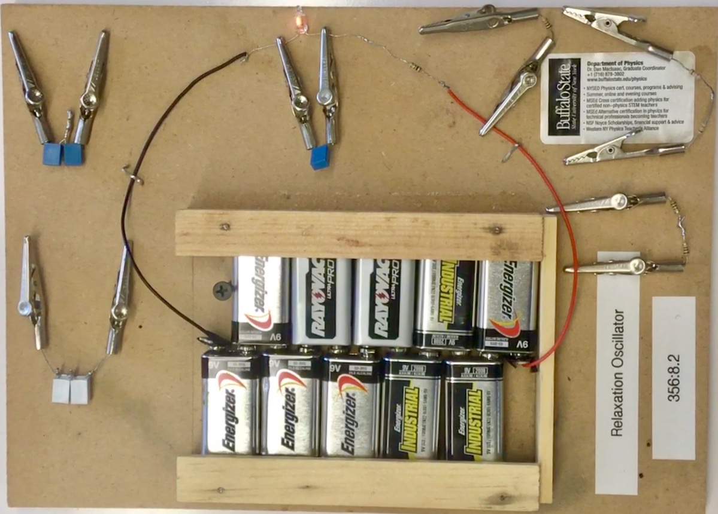
Photo 1: Our RC Neon bulb “blinky” circuit with
additional clip-in Capacitors and Resistors for experimentation

Component | Price each | mouser.com | digikey.com
Ne-2 bulb (any rude equivalent will suffice) | $0.34 (drops by half when purchased in bulk) | 606-A9A
1.0 MicroFarad  100V Capacitor | $0.32 | 581-BN154E0105K | 399-5455-1-ND
1 MegaOhm 1/4Watt carbon film resistor | $0.04 | 291-1M-RC | P1.0MBACT-ND
9V Batteries (10) | Use old mostly depleted batteries | Old batteries from smoke detectors will work, ask students to bring them from home.
Particle Board base,  9V clip (if desired)  alligator clips (if desired) | $0 | scrap
Table 2: Bill of Materials / Parts List (see also Caplan, 2008)

Our circuit (Figure 1 and Photo 1) consists of a soldered series loop of a 90V battery constructed from ten 9V transistor batteries in series (these need not be fresh), a 1 million ohm or 1 megaohm resistor (R = 1M$Ω$ = 10⁶$Ω$ $),$ and a Ne-2 family Neon bulb. Added across the bulb (and in parallel with the Ne bulb) with alligator clips is a 1 microFarad capacitor
(C = 1μF = 10⁻⁶F = 10⁻⁶s/$Ω$), such that time constant τ = RC ~ 1.0 sec. The circuit functions as follows: the 90V battery creates an electric field within the wire, driving electrons from the negative (electron surplus) battery terminal onto one plate of the initially neutral balanced unenergized capacitor, and the building field between plates causes other electrons to flow off the opposite plate of the capacitor back to the positive (electron depleted) terminal of the battery. This continues at a declining rate as shown in Equation 1: as the electron imbalance accumulates across the capacitor plates, a second electric field is created by the capacitor and an electric potential arises across the capacitor plates that is opposed to the initial driving battery field and voltage.

If the Ne bulb wasn’t in the circuit, the electric potential across the capacitor would continue to rise until it reached 90V (oppositely polarized), when the electric fields due to the energized (we prefer the term energized rather then charged) capacitor and the battery would be equal and opposite, and current would cease to flow (be throttled off). This last case is in fact, a standard HS experiment in the Modeling Physics and CASTLE curricula.

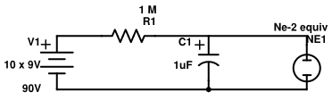
Figure 1: The Relaxation Oscillator (Neon blinky) circuit diagram

However, the Ne bulb is there, and while the bulb initially presents a high resistance, when a characteristic voltage limit is reached (about 72V for this batch of Ne bulbs) the electric field between the bulb electrodes becomes high enough to ionize the low pressure Ne gas in the bulb. This is called “striking an arc, ” and the ionized Ne gas and loose electrons in the bulb form a highly conductive path (the arc) that allows the capacitor to discharge (electrons flow from one side to the other through the bulb) until the bulb electrode electric field drops to the point where it is too weak to sustain the arc (about 57V here), and the arc self-extinguishes. We see the arc (actually we see e⁻ - Ne⁺ recombination emitting photons and Ne electron transitions) as a discrete orange-red Ne flash (Sherwood and Chabay, 2015). Given the electrodes in an Ne-2 bulb are roughly about 2mm apart, the electric field strengths for striking and extinguishing the arc inside the Ne-2 bulb are very rudely about:
72V / 0.002m = 36,000V/m (36kV/m or 36kN/C) to strike, and
57V / 0.002m = 28,500V/m (29kV/m or 29kN/C) to extinguish.

The RC Circuit Equations

Charging V_{c} = V₀(1-e^{-t/RC}) (Eq1)

Discharging V_{c} = V₀(e^{-t/RC}) (Eq2)

V_{c} = Voltage across Capacitor
V₀ = External Supply Voltage (90V)
t = time since supply voltage applied
RC = time constant of RC circuit
(Resistance x Capacitance = sec)

Figure 2: Capacitor potential V vs t for 1M$Ω \& 1μF$
(Digital oscilloscope data by S. Wilser)

R = 1M$Ω$ = 10⁶$Ω$ *Time for RC circuit should be ≈ 1 second; this capacitor
C = 1μF = 10⁻⁶F = 10⁻⁶s/$Ω$ was “shorted” for the first cycle shown so Vc initially rose
from 0V and the first cycle was “anomalously” longer.

While 29-36 kV/m might seem like a strong field, in fact static electric charge imbalances in excess of 10-30kV are readily produced on your fingers sliding around the floor on a dry winter’s day – but very low currents keeps the power (energy dissipation) due to resulting sparks practically unnoticeable to your touch. Hence Ne bulbs are often used when teaching electrostatics to detect and assign charge signs to static charges on electrophori, sticky tape, charged plastic, Van de Graaff domes etc. We also use the circuit without any added capacitor earlier in the semester to demonstrate that the negative-most side of a Ne bulb preferably glows (follow through to the labelled battery terminals) and can then use Ne bulbs to assign charge signs to static electric phenomena by careful bulb observation and exploration.

Caveat: It is SUPER common for students to believe that ordinarily electrons pass through a capacitor’s dielectric, this is neither true for ordinary, nondestructive circuits nor required in the above explanations, which can be student-developed through Modeling Physics and CASTLE lab activities if desired.

In essence, this circuit is an oscillator accumulating electrostatic potential energy between the capacitor plates and parallel Ne bulb electrodes, accreting this energy as electrons flow onto one plate (and off the opposite plate) and the capacitor voltage between plates rises. When enough energy is stored, a limit is reached at which new physics (here the conduction characteristics of the Ne bulb) intervenes and “relaxes” the system (hence the term relaxation oscillator) to a lower stored energy state and the cycle begins again. This produces the characteristic rising exponential-sawtooth seen in Figure 2; the spark discharge is much too fast for us to see as anything but a vertical drop at normal scales. We detect the very short duration light flashes mainly as afterimages (and flashes are hence hard to photograph).

The values of R and C here were chosen to create a time constant of about a second, so we see the Ne bulb flash about once a second. We can manipulate the flashing rate by adding more 1M$Ω$ resistors in parallel (with alligator clips) to the original 1M$Ω$ resistor, this will lower total resistance and increase the rate of flow of electrons (the current) onto and off of capacitor plates and energize the capacitor in a shorter time, making the bulb flash faster. Contrarily, one can add more 1μFd capacitors in parallel with the original capacitor increasing capacitance and plate area that must take on electrons on one side and push them off on the other before the capacitor internal field and external potential (voltage) can rise sufficiently to discharge the bulb. Slower rises means more time between flashes, so adding C in parallel slows the oscillator down, adding R in parallel speeds up the oscillator, and students can readily play with and reason through both.

Safety Considerations

This circuit typically runs at under one mA (90V / 1M$Ω=90μA \sim 100μA=0.1mA)$, but one can span the energized capacitor with fingers of the same hand and briefly feel a 70V sting on discharge (1-2 older 9V batteries in the chain will eliminate this by restricting total current). Peak power is about 0.1mA * 90V = 9mW so barely sensible / quite safe for dry skin, no wires driven through skin etc. As fresh 9V batteries are expensive and unnecessary for these very low currents, we recommend that teachers ask students for backup batteries from family smoke detectors when these are annually or semi-annually replaced (often New Year’s or when time changes from daylight savings to standard time and back).

The Shishi-odoshi Analogy: A Mechanical Relaxation Oscillator

Mechanical relaxation oscillators also exist and are more intuitive to follow (you can watch the water flow, and see water levels and hence gravitational potential energy change by eye). The famous Japanese “deer scarer” or Shishi-odoshi (Wikipedia; pronounced She-she-oh-dough-she) water feature consists of a tipping bamboo bucket that fills from a small stream of water (usually carried to the bucket lip with a small bamboo pipe). The bucket accumulates water over time (storing increasing gravitational potential energy) until it has filled enough to tip over (new physics enters via mechanical instability) and then dumps the water, relaxing the system. The device makes a thump noise for scaring wild animals when it tips and bumps a rock or peg. Then the cycle repeats as the bucket refills. Obviously the period of the thump depends on how fast water flows into the bucket, and the bucket volume capacity -- how tall / big the bucket and where the center of mass and pivot/support are placed. We usually show a live running Shishi-odoshi to our students (they can be bought cheaply online, or just show a video) and ask students to formulate the relevant situational analogies and the limitations to these analogies (where the mappings are wrong).

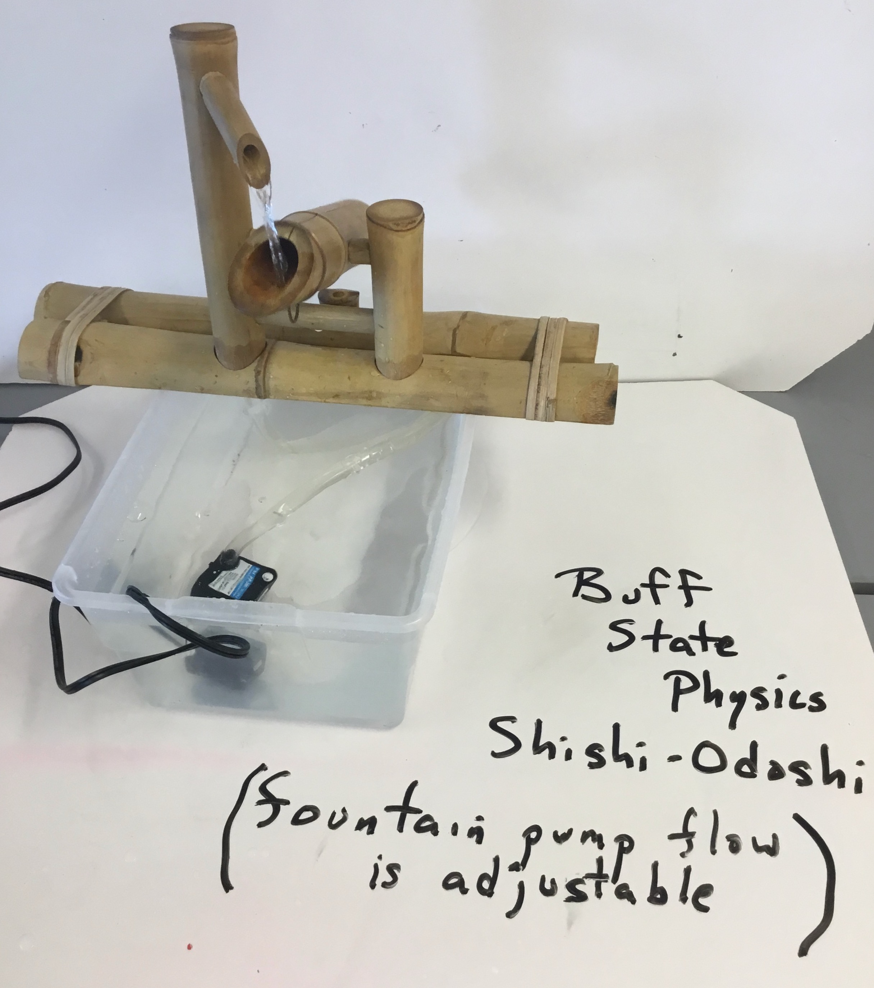
Picture 2: Shishi-odoshi mechanical relaxation oscillator

RC Circuit “Blinky” | Shishi-odoshi | Short explanation
Electrons | Water | Water mass flows through the apparatus similarly to the e⁻ charge eventually moves through a circuit
Capacitor | Bamboo bucket or tube | The bucket stores a certain amount of water and the capacitor stores a certain amount of charge, limiting the oscillation rate
Capacitor discharge through Ne bulb | Tipped emptying bucket | At the limit, both discharge and release the buildup of accreted energy, charge or mass, lowering local stored energy by relaxing
Charge | Mass | The circuit is driven by charge, this can be compared to how the fountain is driven by mass
Electric Field | Gravitational Field | The Shishi-odoshi operates with earth’s gravitational field which provides gravitational potential energy to just as the circuit has an electric field and electric potential energy
Limiting Resistor | Feedpipe Diameter | Both limit the energy fill rate for the system and hence eventually the discharge and oscillation rate
Table 3: Sample Shishi-odoshi analogies to Ne “blinky” RC circuit -- Where the analogy “works”

RC Circuit “Blinky” | Shishi-odoshi | Short explanation
Doesn’t remove excess electrons or charge, only moves e⁻ imbalances around producing local + and –deficits and surpluses of e⁻ | Can actually manually remove water | Unlike a hose or a pipe, one cannot pick up a section of wire and shake all of the electrons out of it
Magnetic Field exists outside wire | Nothing analogous at all --  no “water field” outside the pipe | The water flowing in the Shishi-odoshi does not create a field like the magnetic field created by the current within a circuit
Positive and Negative Charge areas both exist in circuit, moving electrons creates local + and - imbalances | No “antiwater,” mass is positive only (no negative mass), so no imbalance possible below zero water | The water in the Shishi-odoshi is simply water, there is no comparison to account for positive and negative charged areas in a circuit
Exponential Electric Current (exponential sawtooth in time) | Linear Water Mass Flow (linear sawtooth in time) | Current changes exponentially in the RC circuit due to push-back capacitor E field but the inflow rate stays constant in the Shishi-odoshi
Table 4: Some example limitations to / breakdowns of the analogy

We encourage a lot of student-generated learning by analogy (including discussing domain and ranges of analogies) when teaching electricity and magnetism. Knowing the limits of such analogies is very important.

Summary
Resistor-capacitor circuits can be used to address some common learning objectives that span many different electricity and magnetism physics curricula. RC circuits are common in nature (e.g. our heartbeat) and in electronic and mechanical applications (e.g. vehicle turn signals). This can be aided by the usage of analogies to the RC circuit from the Shishi-odoshi, which uses crosscutting ideas and energy themes with parallels from mechanics that physics students should become more familiar with (Saeli & MacIsaac, 2007).

References

AMTA (2017). Modeling Instruction Curriculum: Physics Second Semester E&M. modelinginstruction.org, registration required. Retrieved Nov 5, 2019.

Caplan, G. M. (2008, January). Simple DC Power Supply. The Physics Teacher, 46, 57.

Chabay, R. & Sherwood, B. (2015) (4/e). Matter & Interactions Vol II: Electric and
Magnetic Interactions. NY: Wiley. See Ch20: Sparks in Air.

Gubanski, Z. (1971, February). Apparatus For Teaching Physics: Capacitance by Relaxation Oscillations. The Physics Teacher, 9, 104.

RC time constant. (n.d.). In Wikipedia. Retrieved Nov 5, 2019.

Relaxation Oscillator. (n.d.). In Wikipedia. Retrieved Nov 5, 2019.

Saeli, S. & MacIsaac, D.L. (2007). Using gravitational analogies to introduce elementary electrical field theory concepts. The Physics Teacher, 45(2), 104-108.

Shishi-odoshi. (n.d.). In Wikipedia. Retrieved Nov 5, 2019.

Steinberg, M. S. (2011). Capacitor-Aided System for Teaching and Learning Electricity. In Electricity Visualized: The CASTLE Project.

Wilser, S., & MacIsaac, D. (n.d.). The Low Cost Ne Bulb and 9V Battery RC "Blinky" Relaxation Oscillator. <physicsed.buffalostate.edu/pubs/StudentIndepStudy/WilserBlinky/>

Wood, H. T. (1993, September). The RC circuit-A multipurpose laboratory experiment. The Physics Teacher, 31, 372-373.

