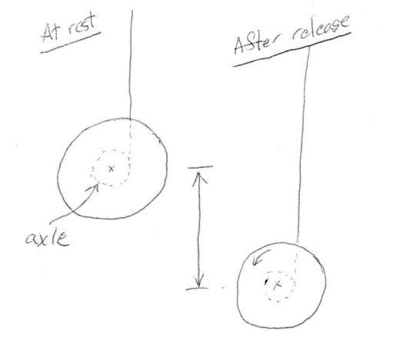
In this iPad lab, you will take video of a spool as it unrolls and descends. As usual, you will track the position of a point on the object- this time it’s the center of the spool. You will use the position and velocity information from the video to figure out the moment of inertia of the spool.
Example Problem #1
A 100 gram yoyo is released from rest. It slowly begins to descend and unwind. By the time yoyo has traveled 20 cm down from its initial position, the spool has made eight full rotations and center of the spool is moving downward at 10 cm/sec.
- For the yoyo in the lab, it will be almost impossible to get a ruler anywhere near the axle- so you’ll need an indirect way to “measure” the radius. Use the information above to find the radius of the axle of the 100 gram yoyo from the information given. (Hint: The yoyo unrolls without slipping).

- Use the information give to figure out the moment of inertia of the 100 gram yoyo. (Hint: Use conservation of energy and keep in mind that the yoyo has both translational and rotational kinetic energy).

Example Problem #2
Notice that this is identical to Example Problem #1, except numbers have been replaced by “letters.”
A yoyo of mass $M$is released from rest. It slowly begins to descend and unwind. By the time yoyo has traveled a distance $∆y$ down from its initial position, the spool has made $N$ full rotations and center of the spool is moving downward at speed $v$.
- Find an algebraic expression for the radius of the axle. Your answer for $r$ should be in terms of some (or perhaps all) of the other “given” quantities: $M$, $∆y$, $N$, $v$ and perhaps $g$. (If you’re not quite sure what to do, look at the steps you followed to get the answer to Example Problem #1).

- Find an algebraic expression for the moment of inertia of the yoyo. Your answer should be in terms of $M$, $∆y$, $N$, $v$ and perhaps $g$.

