Whiteboard Key for Series/Parallel Circuits

- Any reduced circuit drawing. [1 pt]
- Any reduced circuit drawing. [1 pt]

- Total resistance is 56.7Ω or 57 Ω. [1 pt]

R2 and R3 are parallel and must be added first. Let R(23) equal R2 and R3 added together

1/R(23) = 1/R2 + 1/R3
1/R(23) = 1/20 Ω + 1/10 Ω
1/R(23) = 3/20 Ω
1/R(23) = .15 1/Ω
R(23) = 6.7 Ω

Replacing R(23) for R2 and R3 we can now add all resistors in series.

R1 + R(23) + R4 + R5 = Total Resistance
20 Ω + 6.7 Ω + 20 Ω + 10 Ω = 56.7 Ω
Total Resistance = 56.7 Ω or 57 Ω

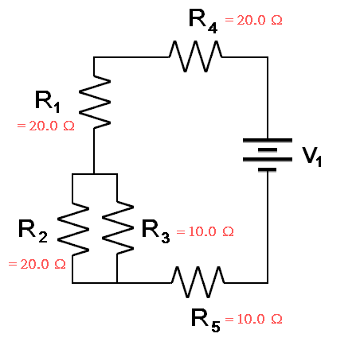

- Total current through the battery is 0.18 A. [1 pt]

V = IR
10 V = I (56.7 Ω)
I = 10 V/56.7 Ω
I = .176 A

- R1, R4, R23, and R5, all have .18 A of current.

For R1, R4, and R5
I(R1) = I(T) = .176 A

R2 and R3 must be found individually using the Voltage drop across R23:

V23 = I23*R23
V23 = .176 A (6.7 Ω)
V23 = 1.18 V
This voltage drop is the same for R2 and R3, therefore:
V23 = I2 * R2
1.18 V = I2 * 20Ω
I2 = .059 A

V23 = I3 * R3
1.18V = I3 * 10Ω
I3 = .118 A

- Voltage drop for each resistor must equal total voltage drop for entire system, which is 10 V.
Therefore:

For R1, and R4 V = IR
V = .176 A * 20Ω
V = 3.52 V

For R5, V = IR
V = .176 A * 10Ω
V = 1.76 V

For R23, V = IR
V = .176 A * 6.7Ω
V = 1.18 V

Because R2 and R3 are in parallel you must use their combined resistance to find the voltage drop over each individual resistor.

For R2, V = IR
V = .059 A * 6.7Ω
V = .40 V

For R3, V = IR
V = .118 A * 6.7Ω
V = .80

All voltages add up to the total voltage drop across the battery.
3.52 V + 3.52 V + 1.76V + .40 V + .80 V = 10 V

WHITEBOARD KEY (for original 17Feb00 S/P circuit):
Series/Parallel resistor combination from PHY112 98 MTEx2

