Whiteboard: Series/Parallel Circuits

The below circuit consists of an ideal battery and five resistors as shown.
R1, R2 and R4 are all 20.0 Ω, and R3 and R5 are both 10.0 Ω. V1 provides 10.0 VDC.

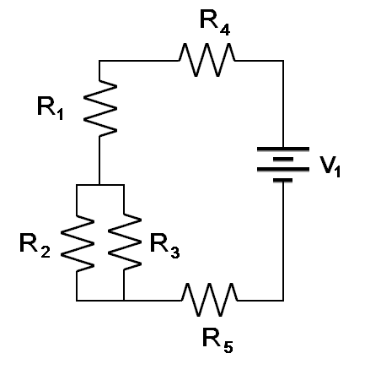

- Draw a simplified circuit with only series circuit elements.
- Draw a simplified circuit with only ONE series resistor.
- Find the total equivalent resistance for all resistors in this circuit.
- What current flows through the battery?
- What current flows through each resistor?
- What is the potential difference (voltage drop) across each resistor?

Reference:

MacIsaac, D.L. (1999). NAU PHY 112 Midterm Exam. Available from the author.

