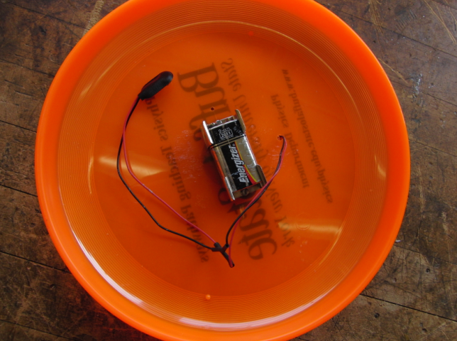
Materials
Frisbee
Buzzer
Battery Brackets (2) (to hold 9V Battery)
9V Battery
9V Battery Clip + Wires
Heatshrink Pieces (2, each about 1” long)
#4 x ¾” Screws (2)
#4 Nuts (2)
Solder
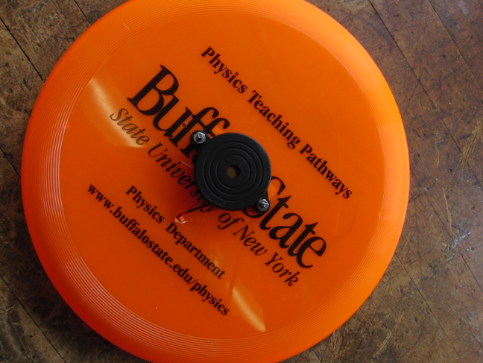
Duct Tape (Optional)
Tools
Template
Soldering iron
1/4” nut driver
1/8” clearance drill bit
Electric drill

Step 1: Locate middle of Frisbee, and align it to the black dot in the middle of your template. Drill three 1/8” holes at the locations indicated on the template.

Step 2: Using screws, attach the brackets to the underside of the Frisbee, facing inward towards one another so that a 9V battery can fit between both of them. Feed screws up from the bottom of the Frisbee and through the holes in the ears of the buzzer. Use bolt driver to secure the bolts over the screws.

Step 3: Feed wires from buzzer through the third hole to the bottom of the Frisbee. Slip a piece of heat shrink over each buzzer wire, and then attach buzzer wires to the wires from the Battery Clip. Solder together. Slip the heat shrink over the solder join and heat the Heatshrink to secure it.

Step 4: Place 9V battery between battery brackets and, if desired, secure everything in place with a piece of duct tape. Now the buzzer can be easily activated by attaching the battery clip to the battery.
Step 5: Play (outdoors, preferably)! Listen to the difference in pitch between when the Frisbee is at rest, flying away from you and flying toward you.

